Supplementary Tables and Figures
Analytical Assessment of Physical Characteristics, Metabolic Processes, and Molecular Investigations of Selected Wheat (Triticum spp.) Cultivars
Dina H. M. Shahata ¹, Mohamed M. El-Mahdy², Mohamed Ibrahim¹*, Magda M. I. EL Araby ¹, Somia S. El -Akkad ¹ , Faten Y. Ellmouni³*
¹ Department of Botany, Faculty of Science, Ain Shams University, Cairo, Egypt
² Agricultural Genetic Engineering Research Institute, Agricultural Research Centre (ARC), Giza, Egypt
³ Botany Department, Faculty of Science, Fayoum University, Fayoum 63514, Egypt
*Correspondence: fyl00@fayoum.edu.eg (F.Y.E.) ORCID no. 0000-0002-9463-0008;
m.shehata@sci.asu.edu.eg (M.I.) ORCID no. 0000-0002-5401-5115

Supplementary Table S1 Grain dimensions of nine wheat cultivars. The cultivars include seven Egyptian cultivars (Benisuif 6, Gemmiza 9, Giza 168, Misr 1, Misr 2, Sakha 94, and Sohag 5) and two foreign cultivars (Russian and Ukrainian). Data represent the mean of ten replicates with standard deviation (SD) included.

Cultivars | Width (mm) | Thickness (mm) | Length (mm)
Giza 168 | 2.52 ± 0.14^{ab} | 1.94 ± 0.04^{c} | 5.36 ± 0.06e
Sohag 5 | 2.48 ± 0.06^{ab} | 2.21 ± 0.05^{b} | 6.40 ± 0.14^{b}
Gemmiza 9 | 2.40 ± 0.12^{bc} | 1.9 ± 0.12^{c} | 6.11± 0.19^{c}
Misr 1 | 2.41 ± 0.17^{bc} | 1.98 ± 0.17^{c} | 5.75 ± 0.19^{d}
Misr 2 | 2.61 ± 0.14ª | 1.98 ± 0.09^{c} | 5.71 ± 0.22^{d}
Sakha 94 | 2.31 ± 0.15^{c} | 1.92 ± 0.06^{c} | 5.09 ± 0.18^{f}
Benisuif 6 | 2.51 ± 0.16^{ab} | 2.34 ± 0.08ª | 7.32 ± 0.15ª
Russian | 1.89 ± 0.26^{d} | 1.85 ± 0.19^{c} | 5.83 ± 0.38^{d}
Ukrainian | 1.85 ± 0.26^{d} | 1.91 ± 0.09^{c} | 5.90 ± 0.23^{d}

Supplementary Table S2 Physical analyses of grains and whole wheat flour of nine wheat cultivars. The cultivars include seven Egyptian cultivars (Benisuif 6, Gemmiza 9, Giza 168, Misr 1, Misr 2, Sakha 94, and Sohag 5) and two foreign cultivars (Russian and Ukrainian). Data represent the meaning of three replicates with standard deviation (SD) included.
Cultivars | Thousand Grain Weight (Gram) | Moisture (%) | Ash Content (%) | Gluten (%) | Dry Gluten (%) | Gluten Index (%)
Giza 168 | 44.07 ± 0.15^{c} | 11.87 ± 0.42^{c} | 1.49 ± 0.16^{bcd} | 28.30 ± 0.30^{b} | 9.35 ± 0.15de | 28.22 ± 2.53^{d}
Sohag 5 | 50.37 ± 0.65^{b} | 12.37 ± 0.49^{b} | 1.67 ± 0.08ª | 26.30 ± 0.10^{cd} | 12.90 ± 0.30ª | 92.17 ± 0.15ª
Gemmiza 9 | 58.50 ± 1.50ª | 12.53 ± 0.32^{b} | 1.63 ± 0.09^{ab} | 29.50 ± 0.30ª | 9.10 ± 0.10e | 64.47 ± 12.05^{c}
Misr 1 | 44.40 ± 0.90^{c} | 10.60 ± 0.36^{d} | 1.5 ± 0.03^{bcd} | 29.80 ± 0.60ª | 9.75 ± 0.25^{cde} | 83.00 ± 5.70^{b}
Misr 2 | 44.37 ± 0.95^{c} | 10.87 ± 0.21^{d} | 1.46 ± 0.04^{cd} | 26.80 ± 0.40^{cd} | 8.75 ± 0.45e | 75.90 ± 1.70^{b}
Sakha 94 | 45.50 ± 1.20^{c} | 13.30 ± 0.10ª | 1.38 ± 0.04^{d} | 27.07 ± 1.05^{c} | 10.97 ± 1.65^{bc} | 74.80 ± 0.60^{b}
Benisuif 6 | 58.77 ± 1.25ª | 12.40 ± 0.00^{b} | 1.43 ± 0.05^{cd} | 26.00 ± 0.70^{d} | 10.70 ± 0.30^{bcd} | 56.70 ± 2.89^{c}
Russian | 36.90 ± 0.10e | 10.93 ± 0.06^{d} | 1.55 ± 0.05^{abc} | 22.30 ± 0.10^{f} | 9.47 ± 0.75de | 95.50 ± 0.29ª
Ukrainian | 40.57 ± 0.85^{d} | 11.47 ± 0.06^{d} | 1.55 ± 0.01^{abc} | 24.97 ± 0.25e | 11.40± 1.30^{b} | 98.20 ± 0.12ª

Supplementary Table S3 Physical analyses (Purity%, Impurity% and Fallen number) of grains and whole wheat flour of nine wheat cultivars. The cultivars include seven Egyptian cultivars (Benisuif 6, Gemmiza 9, Giza 168, Misr 1, Misr 2, Sakha 94, and Sohag 5) and two foreign cultivars (Russian and Ukrainian).

Cultivars | Purity (%) | Impurity (%) | Falling number (sec.)
Giza 168 | 98.8 | 1.20 | 339
Sohag 5 | 99.04 | 0.96 | 413
Gemmiza 9 | 99.90 | 0.10 | 344
Misr 1 | 97.60 | 2.40 | 309
Misr 2 | 97.30 | 2.70 | 381
Sakha 94 | 99.48 | 0.52 | 165
Benisuif 6 | 99.30 | 0.70 | 366
Russian | 97.50 | 2.50 | 402
Ukrainian | 98.80 | 1.20 | 308

Supplementary Table S4 Biochemical analyses of whole wheat flour of nine wheat cultivars. The cultivars include seven Egyptian cultivars (Benisuif 6, Gemmiza 9, Giza 168, Misr 1, Misr 2, Sakha 94, and Sohag 5) and two foreign cultivars (Russian and Ukrainian). The table shows the content of total carbohydrates (reducing sugars, non-reducing sugars, polysaccharide and starch) and total soluble protein. Values represent the meaning of four replicates with standard deviation (SD) included.

Cultivars | Reducing sugar (mg/g) | Non-reducing sugar (mg/g) | Polysaccharide (mg/g) | Starch (mg/g) | Total carbohydrate (mg/g) | Protein (mg/g)
Giza 168 | 10.31 ± 1.25^{b} | 1.94 ± 0.07^{bc} | 262.03 ± 1.20ª | 476.91 ± 14.09^{b} | 751.19 | 13.90 ± 0.75ª
Sohag 5 | 7.43 ± 0.66de | 1.86 ± 0.01^{d} | 134.07 ± 3.32^{f} | 476.91 ± 10.89^{b} | 620.27 | 13.00 ± 0.29^{ab}
Gemmiza 9 | 8.38 ± 0.61^{cd} | 2.00 ± 0.05^{b} | 239.55 ± 22.12^{b} | 430.87 ± 17.59^{c} | 680.8 | 14.40 ± 0.31ª
Misr 1 | 11.76 ± 0.88ª | 2.47 ± 0.02ª | 149.57 ± 6.61e | 534.53 ± 71.85ª | 698.33 | 11.94 ± 0.98^{b}
Misr 2 | 8.72 ± 0.82^{c} | 2.41 ± 0.03ª | 128.97 ± 4.82^{f} | 474.65 ± 15.85^{b} | 614.75 | 11.83 ± 0.74^{b}
Sakha 94 | 9.99 ± 0.71^{b} | 1.84 ± .01^{d} | 193.20 ± 4.97^{d} | 427.66 ± 1.61^{c} | 632.69 | 13.63 ± 2.54ª
Benisuif 6 | 7.35 ± 1.00de | 1.65 ± 0.05e | 77.66 ± 4.64^{g} | 461.94 ± 0.64^{bc} | 548.6 | 13.13 ± 0.31^{ab}
Russian | 6.31 ± 0.67e | 1.68 ± 0.07e | 222.98 ± 7.99^{c} | 421.38 ± 10.99^{c} | 652.35 | 14.39 ± 1.14ª
Ukrainian | 4.60 ± 0.06^{f} | 1.89 ± 0.04^{cd} | 68.41 ± 0.72^{g} | 526.96 ± 3.58ª | 601.86 | 14.14 ± 0.25ª

Supplementary Table S5 Minerals content (mg/g) of whole wheat flour of nine wheat cultivars (seven Egyptian cultivars; Benisuif 6, Gemmiza 9, Giza 168, Misr 1, Misr 2, Sakha 94, and Sohag 5) and two foreign cultivars; Russian and Ukrainian).

Cultivars | Minerals (mg/g)
Cultivars | Mg | Cu | Fe | P | Zn | Ca | Se
Benisuif 6 | 2.25 | 0.12 | 1.01 | 0.0075 | 1.54 | 20.88 | 0.0011
Gemmiza 9 | 2.63 | 0.08 | 0.08 | 0.0030 | 1.14 | 26.87 | 0.0011
Giza 168 | 1.88 | 0.08 | 0.13 | 0.0055 | 1.55 | 14.99 | 0.0832
Misr 1 | 1.88 | 0.09 | 0.23 | 0.0075 | 1.59 | 21.57 | 0.0011
Misr 2 | 2.00 | 0.15 | 0.06 | 0.0080 | 1.65 | 20.25 | 0.0011
Sakha 94 | 2.13 | 0.18 | 0.10 | 0.0010 | 1.38 | 18.08 | 0.0220
Sohag 5 | 2.75 | 0.06 | 0.14 | 0.0040 | 1.72 | 22.04 | 0.0700
Russian | 2.63 | 0.09 | 1.24 | 0.0040 | 1.19 | 20.67 | 0.0011
Ukrainian | 1.75 | 0.06 | 0.11 | 0.0095 | 1.12 | 18.86 | 0.0220

Supplementary Table S6 Vitamins content (mg/g) of whole wheat flour of nine wheat cultivars (seven Egyptian cultivars; Benisuif 6, Gemmiza 9, Giza 168, Misr 1, Misr 2, Sakha 94 and Sohag 5, and two foreign cultivars; Russian and Ukrainian).

Cultivars | Vitamins (mg/g)
Cultivars | Thiamine (B1) | Niacin (B3) | Pyridoxine (B6) | Folic acid (B9)
Benisuif 6 | 0.0208 | 0.8850 | 0.3488 | 0.7041
Gemmiza 9 | 0.0035 | 1.4821 | 0.5547 | 0.2971
Giza 168 | 0.0011 | 1.5330 | 0.3194 | 0.1625
Misr 1 | 0.0025 | 0.2764 | 0.0929 | 0.0387
Misr 2 | 0.0009 | 0.2394 | 0.2356 | 0.0002
Sakha 94 | 0.0015 | 1.3388 | 0.6544 | 0.5573
Sohag 5 | 0.0058 | 0.8182 | 0.2420 | 0.2692
Russian | 0.0190 | 0.1130 | 0.0530 | 0.1520
Ukrainian | 0.0315 | 0.1543 | 0.4883 | 0.0435

Supplementary Table S7 Gel analysis of total proteins (TPs) in nine wheat cultivars (seven Egyptian cultivars; Giza 168, Sohag 5, Gemmiza 9, Misr 1, Misr 2, Sakha 94, Benisuif 6, and two foreign cultivars; Russian and Ukrainian)
Row no. | Cultivars |  |  |  |  |  |  |  |  | Frequency | Polymorphism
Row no. | Giza 168 | Sohag 5 | Gemmiza 9 | Misr 1 | Misr 2 | Sakha 94 | Benisuif 6 | Russian | Ukrainian | Frequency | Polymorphism
Row no. | 1 | 2 | 3 | 4 | 5 | 6 | 7 | 8 | 9 | Frequency | Polymorphism
1 | 1 | 0 | 1 | 1 | 1 | 1 | 0 | 1 | 1 | 0.78 | Polymorphic
2 | 1 | 1 | 1 | 1 | 1 | 1 | 1 | 1 | 0 | 0.89 | Polymorphic -U (NUB)
3 | 1 | 1 | 1 | 1 | 1 | 1 | 1 | 1 | 1 | 1 | Monomorphic
4 | 0 | 1 | 0 | 0 | 0 | 0 | 1 | 1 | 1 | 0.44 | Polymorphic
5 | 1 | 0 | 1 | 1 | 1 | 1 | 0 | 0 | 1 | 0.67 | Polymorphic
6 | 1 | 1 | 1 | 1 | 1 | 1 | 1 | 1 | 0 | 0.89 | Polymorphic -U (NUB)
7 | 1 | 1 | 1 | 1 | 1 | 1 | 1 | 1 | 1 | 1 | Monomorphic
8 | 1 | 1 | 1 | 1 | 1 | 1 | 1 | 1 | 1 | 1 | Monomorphic
9 | 1 | 1 | 1 | 1 | 1 | 1 | 1 | 1 | 1 | 1 | Monomorphic
10 | 1 | 1 | 1 | 1 | 1 | 1 | 1 | 1 | 1 | 1 | Monomorphic
11 | 1 | 1 | 1 | 1 | 1 | 1 | 1 | 1 | 1 | 1 | Monomorphic
12 | 1 | 1 | 1 | 1 | 1 | 1 | 1 | 1 | 1 | 1 | Monomorphic
13 | 1 | 1 | 1 | 1 | 1 | 1 | 1 | 0 | 0 | 0.78 | Polymorphic
14 | 1 | 1 | 1 | 1 | 1 | 1 | 0 | 1 | 1 | 0.89 | Polymorphic -U (NUB)
15 | 1 | 0 | 1 | 0 | 0 | 1 | 0 | 1 | 1 | 0.56 | Polymorphic
16 | 1 | 1 | 1 | 1 | 1 | 1 | 1 | 1 | 1 | 1 | Monomorphic
17 | 0 | 1 | 0 | 0 | 0 | 0 | 1 | 0 | 0 | 0.22 | Polymorphic
18 | 1 | 1 | 1 | 1 | 1 | 1 | 1 | 1 | 1 | 1 | Monomorphic
19 | 1 | 0 | 0 | 1 | 1 | 0 | 1 | 1 | 1 | 0.67 | Polymorphic
20 | 0 | 1 | 0 | 1 | 1 | 0 | 1 | 0 | 0 | 0.44 | Polymorphic
21 | 0 | 1 | 0 | 0 | 0 | 0 | 1 | 1 | 1 | 0.44 | Polymorphic
22 | 1 | 0 | 1 | 1 | 1 | 1 | 0 | 0 | 1 | 0.67 | Polymorphic
23 | 0 | 0 | 1 | 1 | 0 | 0 | 0 | 1 | 0 | 0.33 | Polymorphic
24 | 1 | 1 | 1 | 1 | 0 | 1 | 1 | 1 | 1 | 0.89 | Polymorphic -U (NUB)
25 | 1 | 0 | 1 | 1 | 1 | 1 | 1 | 1 | 1 | 0.89 | Polymorphic -U (NUB)
26 | 0 | 1 | 1 | 1 | 1 | 1 | 1 | 0 | 1 | 0.78 | Polymorphic
27 | 1 | 1 | 1 | 1 | 1 | 1 | 0 | 1 | 0 | 0.78 | Polymorphic
28 | 0 | 0 | 0 | 0 | 0 | 1 | 1 | 1 | 1 | 0.44 | Polymorphic
29 | 1 | 1 | 1 | 1 | 1 | 1 | 1 | 0 | 0 | 0.78 | Polymorphic
30 | 0 | 0 | 1 | 1 | 1 | 1 | 0 | 1 | 1 | 0.67 | Polymorphic
31 | 1 | 1 | 0 | 1 | 1 | 0 | 1 | 0 | 1 | 0.56 | Polymorphic
32 | 1 | 1 | 1 | 1 | 1 | 1 | 0 | 1 | 0 | 0.78 | Polymorphic
33 | 0 | 0 | 1 | 0 | 0 | 0 | 0 | 0 | 1 | 0.22 | Polymorphic
34 | 1 | 0 | 1 | 1 | 1 | 1 | 1 | 1 | 1 | 0.89 | Polymorphic -U (NUB)
35 | 1 | 1 | 0 | 1 | 1 | 1 | 1 | 1 | 1 | 0.89 | Polymorphic -U (NUB)
36 | 0 | 1 | 1 | 0 | 0 | 1 | 0 | 0 | 0 | 0.33 | Polymorphic
37 | 1 | 1 | 1 | 1 | 1 | 0 | 1 | 1 | 1 | 0.89 | Polymorphic -U (NUB)
38 | 1 | 1 | 0 | 0 | 0 | 0 | 0 | 0 | 0 | 0.22 | Polymorphic
39 | 0 | 0 | 0 | 0 | 1 | 1 | 1 | 0 | 1 | 0.44 | Polymorphic
40 | 1 | 1 | 1 | 1 | 0 | 0 | 0 | 1 | 0 | 0.56 | Polymorphic
41 | 0 | 0 | 0 | 0 | 1 | 1 | 1 | 1 | 1 | 0.56 | Polymorphic
42 | 1 | 1 | 1 | 1 | 0 | 1 | 1 | 0 | 0 | 0.67 | Polymorphic
43 | 1 | 1 | 1 | 1 | 1 | 1 | 1 | 1 | 1 | 1 | Monomorphic
44 | 1 | 1 | 1 | 1 | 1 | 0 | 0 | 1 | 1 | 0.78 | Polymorphic
Monomorphic bands |  |  |  |  |  |  |  |  |  | 10
Polymorphic (without Unique) |  |  |  |  |  |  |  |  |  | 26
Unique bands |  |  |  |  |  |  |  |  |  | 8
Polymorphic (with Unique) |  |  |  |  |  |  |  |  |  | 34
Total number of bands |  |  |  |  |  |  |  |  |  | 44
Polymorphism (%) |  |  |  |  |  |  |  |  |  | 77.27%
Mean of band frequency |  |  |  |  |  |  |  |  |  | 0.72

Supplementary Fig. S1 Photographs of wheat grains of the seven Egyptian cultivars (1-7) and two foreign cultivars (8-9) under stereomicroscope. 1 represents Giza 168, 2 represents Sohag 5, 3 represents Gemmiza 9, 4 represents Misr 1, 5 represents Misr 2, 6 represents Sakha 94, 7 represents Benisuif 6, 8 represents Russian and 9 represents Ukrainian.

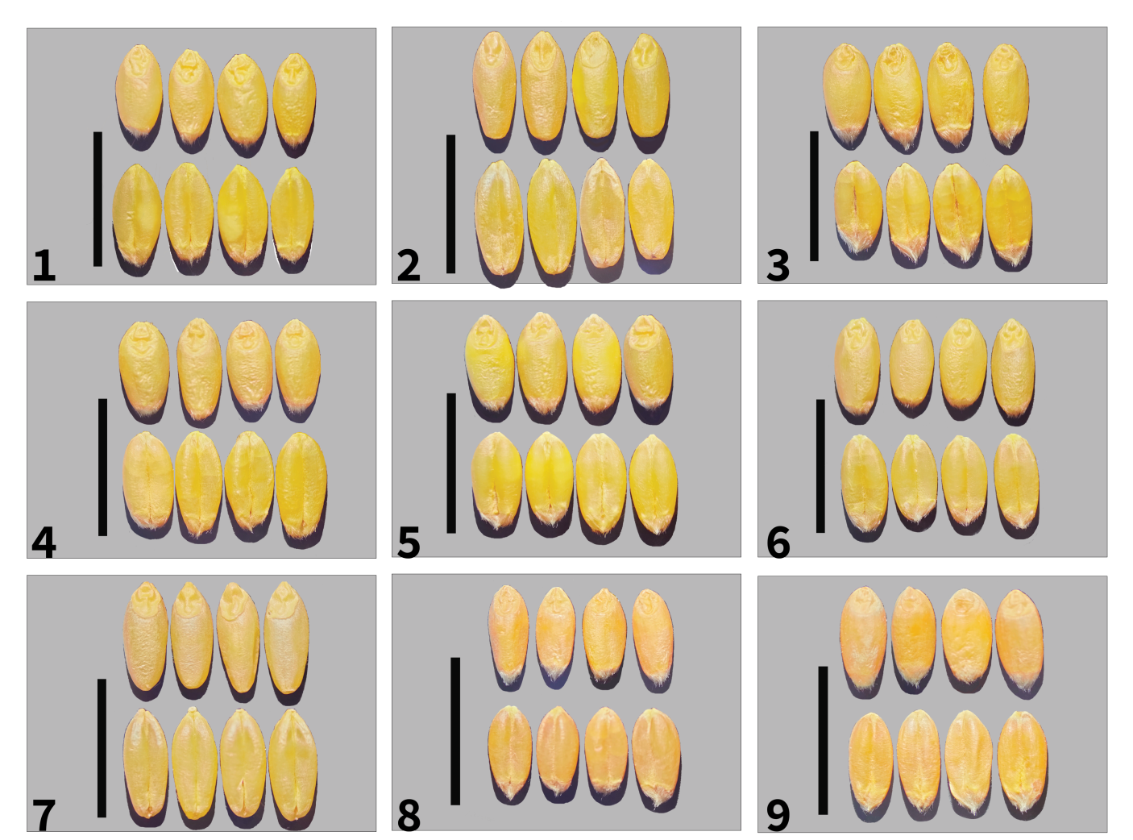

Supplementary Fig. S2 Amplification of DNA barcoding loci of rbcL gene. Agarose gel electrophoresis of the specific PCR products of rbcL was shown. Blue arrowheads indicate the gel front (starting from the slot wells), the full running pattern of the DNA size marker, and the gel end. Also, the molecular size of DNA size marker is denoted by the numbers left-handed of the agarose gel shown. (Chloroplast DNA barcoding fully uncropped figure

