SCoT ( O-11, O-12, O-13 )
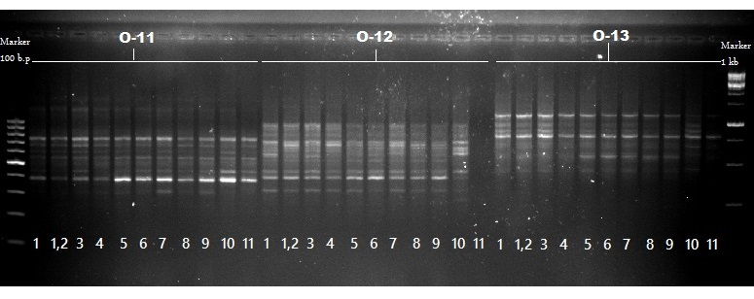
SCoT ( O-14, O-15, O-16 )
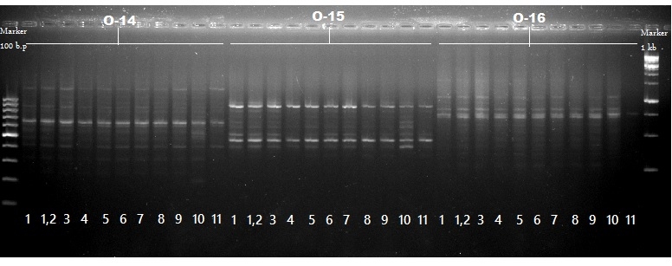
SCoT ( O-18, O-19, O-20 )
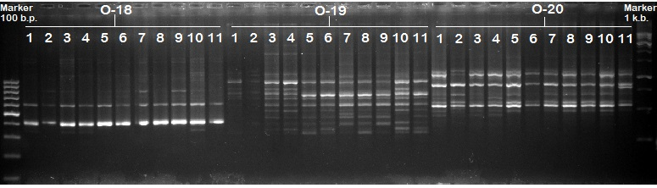
Figure S1. PCR profile of nine SCoT primers (SCoT-O11 to SCoT-O20) among eleven wheat genotypes. M = DNA size marker (100bps), Lanes 1-11 DNA samples of Sids1, S 36, S 83, S 107, Sids12, S 129, S 144, S 167, S 193, Giza168, and G 218, respectively.

