Characterization of Indigenous Populations of Cannabis in Iran: A Morphological and Phenological Study
Mehdi Babaei^{1, 2, 3, 4, 5}, Hossein Nemati^{1, *}, Hossein Arouiee¹, Davoud Torkamaneh ^{2, 3, 4, 5}
¹ Department of Horticultural Sciences, Ferdowsi University of Mashhad, Azadi Square, Mashhad, 9177948974, Razavi Khorasan, Iran.
² Département de Phytologie, Université Laval, Rue de l'Université, Québec City, G1V 0A6, Québec, Canada.
³ Institut de Biologie Intégrative et des Systèmes (IBIS), Université Laval, Rue de l'Université, Québec City, G1V 0A6, Québec, Canada.
⁴ Centre de recherche et d’innovation sur les végétaux (CRIV), Université Laval, Rue de l'Agriculture Québec City, G1V 0A6, Québec, Canada.
⁵ Institute Intelligence and Data (IID), Université Laval, Rue de l'Agriculture Québec City, G1V 0A6, Québec, Canada.
*Corresponding author. E-mail: nemati@um.ac.ir
Contributing authors : mehdi.babaei.1@ulaval.ca; aroiee@um.ac.ir; davoud.torkamaneh.1@ulaval.ca

Assessing the germination performance of 25 indigenous cannabis populations
The seed germination experiment for 25 indigenous populations from Iran was assessed according to the International Seed Testing Association (ISTA) standards in a completely randomized design (CRD) with 3 replications and 25 observations. Each Petri dish (9 cm) contained 25 seeds, and the germination process took place in a germinator for 7 days under controlled conditions (22 °C, 70% humidity, 16:08h light: dark photoperiod). Germinated seed counts were conducted daily, and for this purpose, seeds with root lengths of at least 2 mm were considered germinated. Three germination parameters were determined using the following equations: Final Germination Percentage (FGP) (equation (S1)), Germination Rate (GR) (equation (S2)), and Mean Germination Time (MGT) (equation (S3)).
$$FGP (\%)=(\frac{n}{N}) ×100$$ | (S1)
$$GR (seed/day)=\sum{(\frac{n_{i}}{t_{i}}})$$ | (S2)
$$MGT (day)=\frac{\sum{(n_{i}t_{i})}}{\sum{n}}$$ | (S3)
where:
n = The number of germinated seeds
N = The total number of seeds
$t_{i}$= The number of days from the start of the experiment to the end of the period
$n_{i}$= The number of germinated seeds on the i-th day

The analysis of variance and mean comparison (LSD) showed significant differences (p ≤ 0.001) in germination traits, including the Final Germination Percentage (FGP), Germination Rate (GR), and Mean Germination Time (MGT) (Fig S1). Thus, as shown in Fig S1A, 100% germination occurred in populations IR3329, IR5494, and IR2385. While population IR3776 had the lowest germination percentage at 30.66%. In terms of germination rate, populations IR3329, IR2385 and IR4457 displayed the highest rates at 20.88, 20.55, and 19.73 (seed/day), respectively, while population IR3776 had the lowest rate at 4.13 (seed/day) (Fig S1B). The quickest mean germination times were observed in populations IR3329, IR2385 and IR4457, with 1.34, 1.4 and 1.49 days, respectively, while the highest mean germination time for a duration of 2.6 days was observed in population IR2845 (Fig S1C).

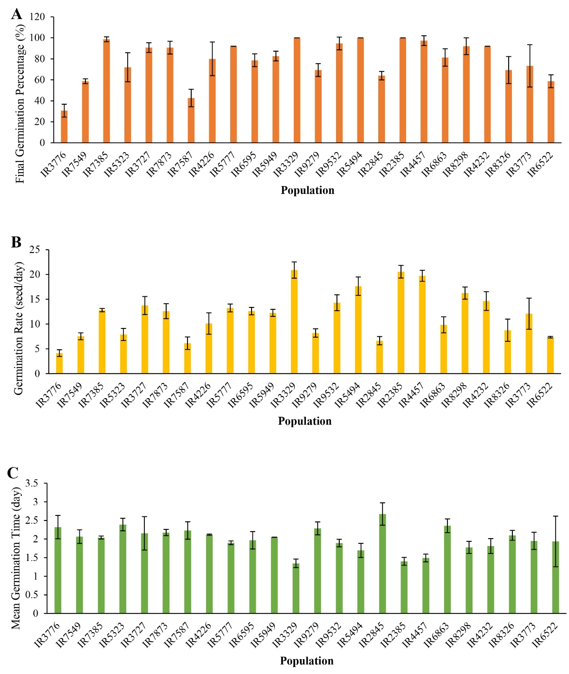
Fig S1. Comparison of 25 native cannabis populations from Iran based on Final Germination Percentage (FGP) (A, LSD _{0.01}= 17.5), Germination Rate (GR) (B, LSD _{0.01}= 3.2) and Mean Germination Time (MGT) (C, LSD _{0.01}= 0.5).

