Supplementary Material

Transcriptomic and metabolomic analyses reveal the differential accumulation of phenylpropanoids and terpenoids in hemp autotetraploid and its diploid progenitor
Qing Tang^{1,2}, Ying Xu¹, Feng Gao³, Ying Xu¹(YGX), Chaohua Cheng^{1,2}, Canhui Deng¹, Jiquan Chen¹, Xiaoge Yuan¹, Xiaoyu Zhang¹, Jianguang Su^{1,2*}
¹ Institute of Bast Fiber Crops, Chinese Academy of Agricultural Sciences, Changsha 410205, Hunan, China
² Center for Industrial Hemp Science and Technology Innovation, Institute of Bast Fiber Crops, Chinese Academy of Agricultural Sciences, Changsha 410205, Hunan, China
³ Yunnan Academy of Industrial Hemp, Kunming 650214, Yunnan, China

* Correspondence: Jianguang Su: jgsu2016@163.com

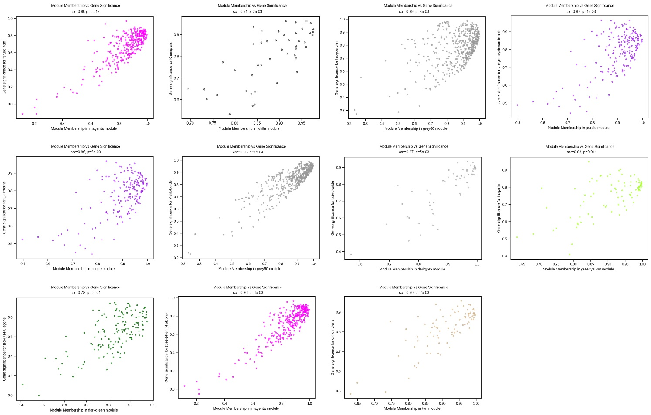
Supplementary Figure 1. Scatterplot of gene significance score versus module membership.

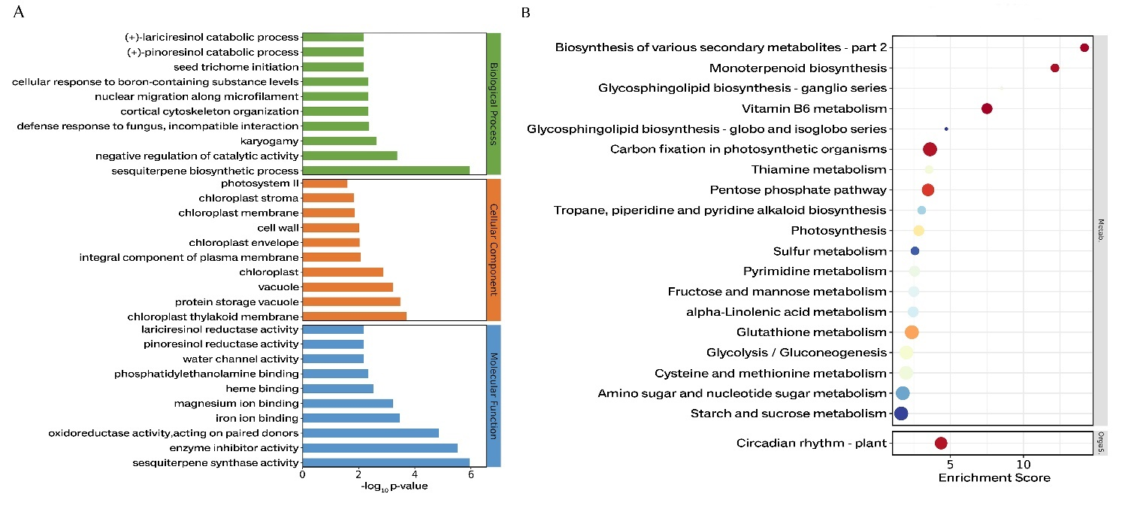
Supplementary Figure 2. GO and KEGG enrichment of genes in the grey60 module. (A) GO enrichment. (B) KEGG pathway. Copyright permission has been granted for related KEGG images.

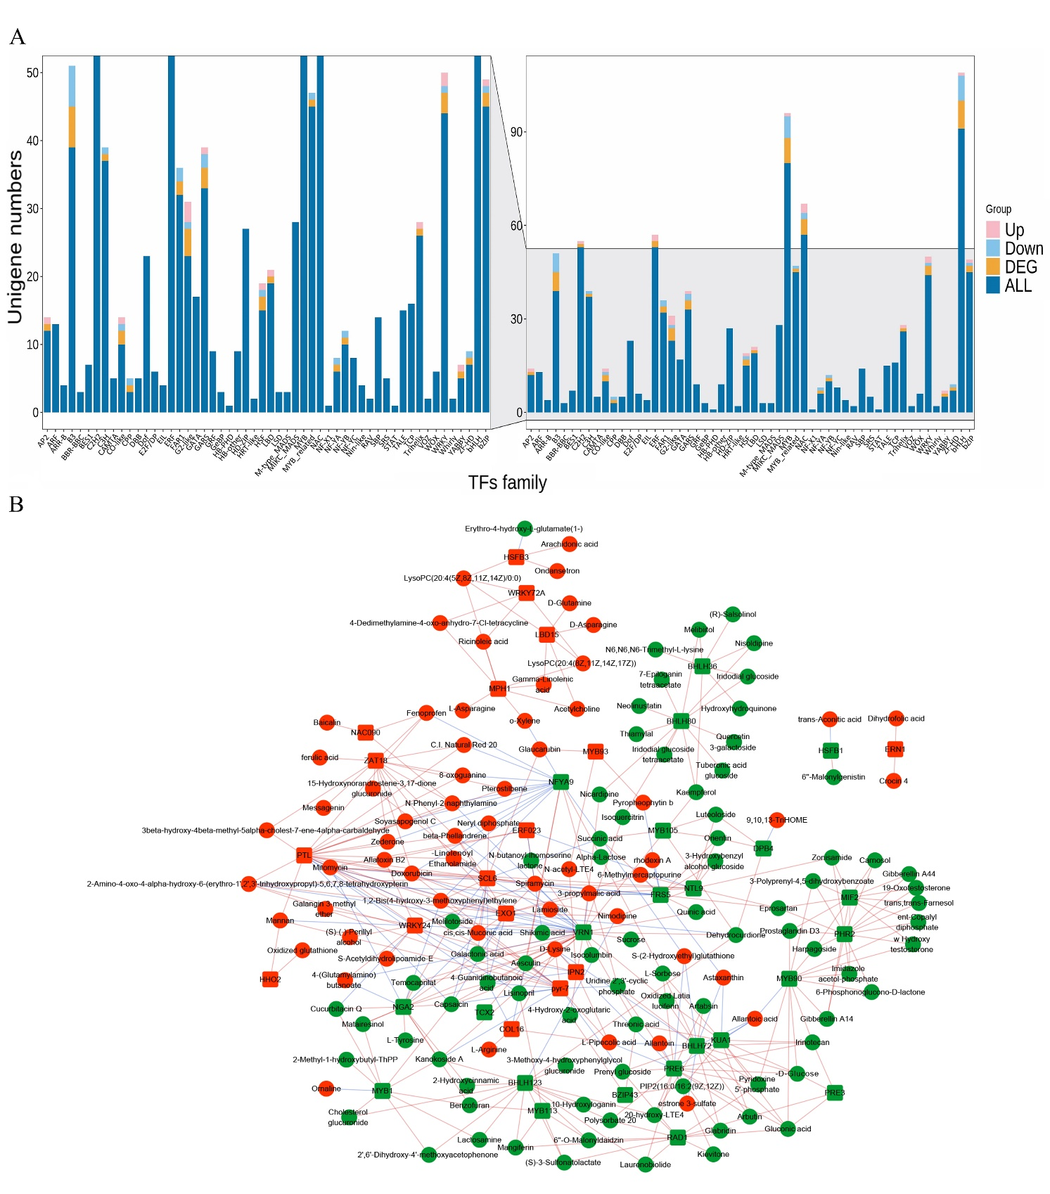
Supplementary Figure 3. Analysis of transcription factors (TFs) associated with polyploidization. (A) Classification of polyploidy-altered TFs. (B) Network of polyploidy-altered TFs and metabolites (|PCC |> 0.917). The red and green patterns represent upregulated and downregulated TFs or metabolites. DEG, differentially expressed genes.

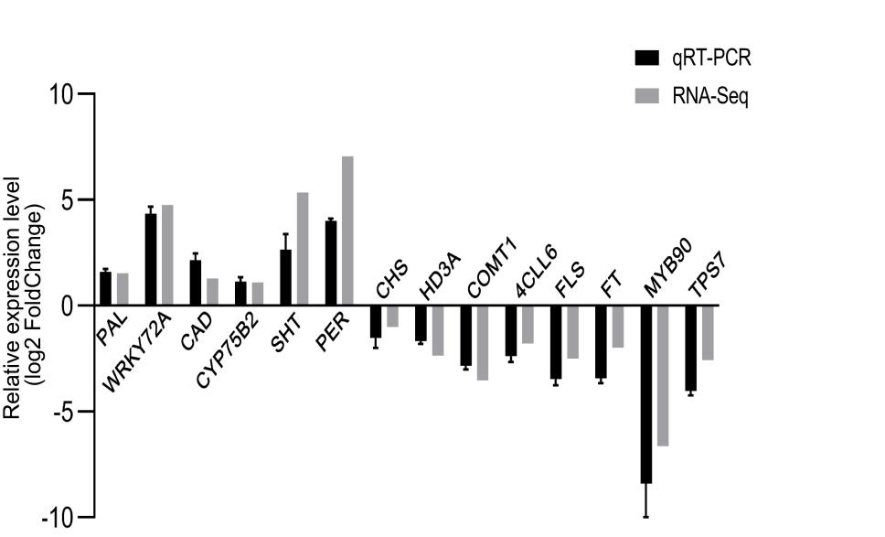
Supplementary Figure 4. Quantitative real-time polymerase chain reaction (qRT-PCR) validation of selected genes.

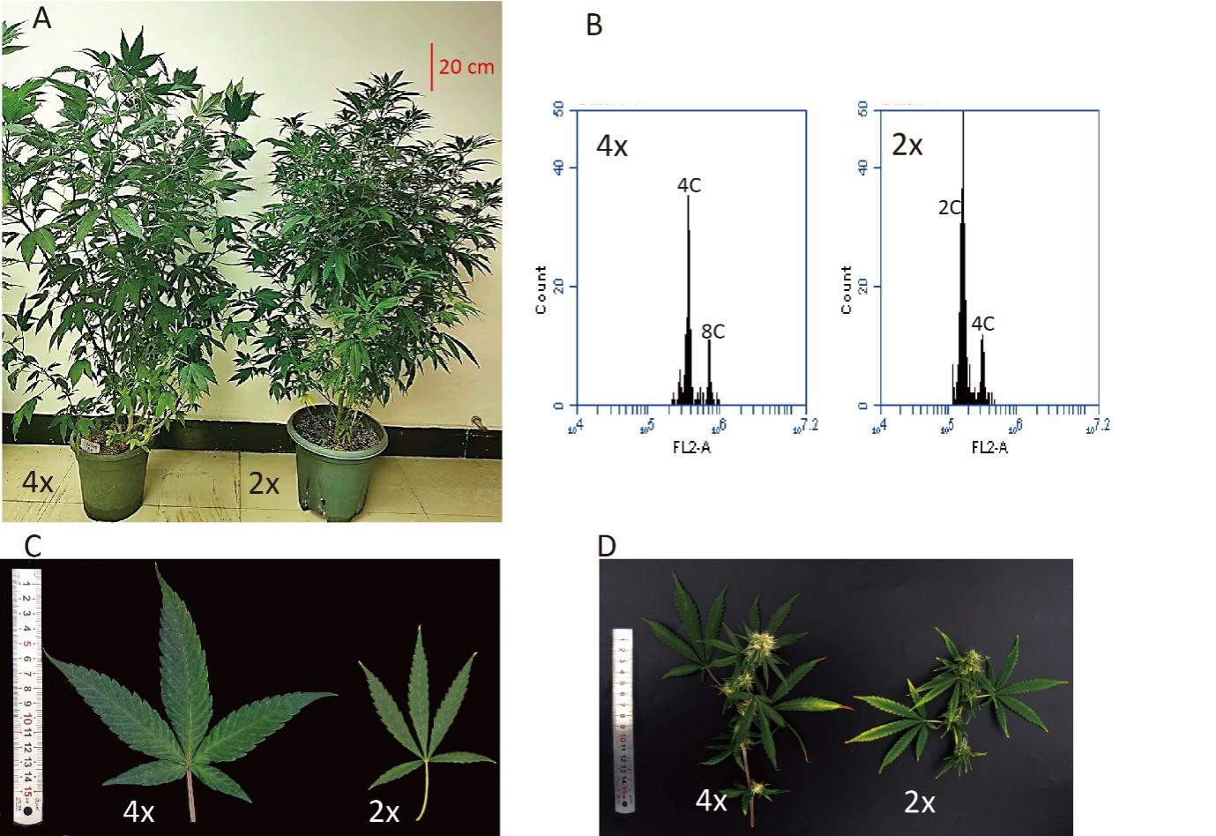
Supplementary Figure 5. Morphological characteristics of Cannabis sativa autotetraploid and its diploid progenitor. (A) The autotetraploid (4x) plant and its diploid (2x). (B) Result of flow cytometric analysis. (C) Comparison of leaf between autotetraploid and its diploid. (D) Comparison of flowers of autotetraploid and diploid plants.
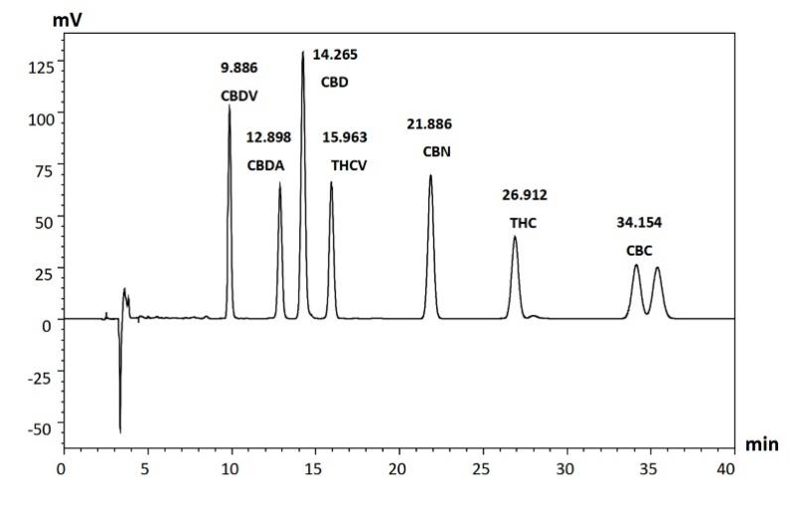
Supplementary Figure 6. The typical chromatogram of several cannabinoids.

Supplementary Table 1. Cannabinoids content (mean ± SE) for dried flower material of Cannabis sativa diploids and atutotetraploids analyzed in duplicated (n=9) by HPLC.
Cannabinoid | Content (mg/g)
 | Cs2x | Cs4x
CBD | 66.3±2.2 | 66.2±0.1.3
THC | 2.8±0.1 | 2.8±0.1
CBDV | 4.5±0.1 | 3.5±0.3
THCV | 1.7±0.1 | 1.1±0.1
CBN | 0.8±0.1 | 0.8±0.2
CBC | 0.6±0 | 0.7±0.1

Supplementary Table 4. DEGs related to phenylpropanoid biosynthesis.
Gene id | Gene symbol | log2 Fold Change | Annotation
LOC115711262 | PAL | 1.526 | phenylalanine ammonia-lyase-like
LOC115703767 | COMT1 | -3.536 | caffeic acid 3-O-methyltransferase-like
LOC115716906 | COMT1 | 2.362 | caffeic acid 3-O-methyltransferase-like
LOC115708264 | COMT1 | -2.484 | caffeic acid 3-O-methyltransferase-like
LOC115715671 | 4CLL6 | -1.7790 | 4-coumarate--CoA ligase-like 6
LOC115702688 | SALAT | -7.851 | salutaridinol 7-O-acetyltransferase-like
LOC115703085 | SALAT | -9.210 | salutaridinol 7-O-acetyltransferase-like
LOC115704377 | SALAT | -6.8880 | salutaridinol 7-O-acetyltransferase-like
LOC115704444 | SAT | -2.521 | stemmadenine O-acetyltransferase-like
LOC115707958 | HST | -1.298 | shikimate O-hydroxycinnamoyltransferase-like
LOC115721427 | HST | 2.719 | shikimate O-hydroxycinnamoyltransferase-like
LOC115716544 | SHT | 5.3469 | spermidine hydroxycinnamoyl transferase-like
LOC115712971 | FAOMT | 1.074 | flavonoid 3',5'-methyltransferase-like isoform X2
LOC115724170 | CHS | -1.007 | naringenin-chalcone synthase
LOC115702751 | CAD | 1.284 | probable cinnamyl alcohol dehydrogenase
LOC115709902 | BGLU44 | -1.795 | beta-glucosidase 44-like isoform X1
LOC115698821 |  | 1.655 | peroxidase P7-like
LOC115700070 | PER16 | -1.015 | peroxidase 16-like
LOC115707710 | PER29 | 1.183 | peroxidase 29-like
LOC115707258 | PER10 | 3.057 | peroxidase 10-like
LOC115712307 |  | 5.191 | peroxidase 5-like
LOC115708062 |  | -4.673 | peroxidase 4-like
LOC115719602 |  | 1.113 | peroxidase 4-like
LOC115716054 |  | -3.382 | peroxidase 5-like
LOC115722136 |  | 1.678 | peroxidase 5-like
LOC115723064 |  | 7.046 | lignin-forming anionic peroxidase-like
LOC115717395 | FLS | -2.504 | flavonol synthase/flavanone 3-hydroxylase
LOC115709313 | CYP75B2 | -1.435 | flavonoid 3'-monooxygenase
LOC115709845 | CYP75B2 | 1.098 | flavonoid 3'-monooxygenase-like isoform X1
LOC115716756 | ANS | -1.320 | leucoanthocyanidin dioxygenase-like

Supplementary Table 5. DEGs related to monoterpenoid, and sesquiterpenoid and triterpenoid biosynthesis pathways.
Gene id | log2 Fold Change | Gene symbol | Annotation | Pathway description
LOC115704491 | -2.315 | SDR1 | uncharacterized protein LOC115704491 | Monoterpenoid biosynthesis
LOC115706549 | -2.040 | SDR1 | uncharacterized protein LOC115704491 | Monoterpenoid biosynthesis
LOC115695567 | -3.701 |  | (-)-germacrene D synthase-like | Sesquiterpenoid and triterpenoid biosynthesis
LOC115707439 | -2.581 | TPS7 | (E,E)-alpha-farnesene synthase-like | Sesquiterpenoid and triterpenoid biosynthesis
LOC115714620 | -7.314 | OSCBPY | beta-amyrin synthase-like | Sesquiterpenoid and triterpenoid biosynthesis
LOC115719748 | -1.208 | OSCBPY | beta-amyrin synthase-like isoform X1 | Sesquiterpenoid and triterpenoid biosynthesis
LOC115719749 | -1.277 | OSCBPY | beta-amyrin synthase-like | Sesquiterpenoid and triterpenoid biosynthesis

Supplementary Table 9. The primers of genes for qRT-PCR.
Gene id | Gene symbol | Primer name | Sequence (5' to 3')
LOC115708959 | MYB90 (CsMYB82*) | q Cs 89592F | GCTCTGCACCAGTACCACAT
 | MYB90 (CsMYB82*) | q Cs 8959 2R | TCCTCGCTGTCGATCATGTC
LOC115724170 | CHS | q Cs 4170 1F | GCCAGGCCCTATTTGGTGAT
 | CHS | q Cs 4170 1R | ATAGTTTGGGCCGCAGAGAC
LOC115711262 | PAL | q Cs 1262 1F | AGAGTCATGCCACACTCTGC
 | PAL | q Cs 1262 1R | TTGGCCATGGCTTCCAAGAT
LOC115715671 | 4CLL6 | q Cs 5671 1F | ATTGCTCCTGCGGATTTGGA
 | 4CLL6 | q Cs 5671 1R | GCCACTGGTATTTCCCCACA
LOC115703767 | COMT1 | q Cs 3767 1F | AGATGTTGGGGGTGGTTTGG
 | COMT1 | q Cs 3767 1R | TGTCTCCACCCACATGTTCG
LOC115709845 | CYP75B2 | q Cs 9845 2F | CCTTTCGTCTACACCCGTCC
 | CYP75B2 | q Cs 9845 2R | GGTCAGTCCATTGGTCTGGG
LOC115717395 | FLS | q Cs 7395 1F | CCCCAATGATGTCCCTGGTC
 | FLS | q Cs 7395 1R | CTGGGCCTGATCACCAATGT
LOC115716544 | SHT | q Cs 6544 2F | CGAGTCTCTCCCAATCCACG
 | SHT | q Cs 6544 2R | ACGCTCAGTCCATCAACGAG
LOC115723064 | PER | q Cs 3064 1F | CGGAGTTGTTTCTTGTGCCG
 | PER | q Cs 3064 1R | AAGATCGCTCTCAGCTTCGG
LOC115702751 | CAD | q Cs 2751 2F | AATGAACACTACTGCGCCGA
 | CAD | q Cs 2751 2R | TGCTTACGCTTGGTGAACCA
LOC115707439 | TPS7 | q Cs 7439 1F | GCCCGAAAGCATATCCGAGA
 | TPS7 | q Cs 7439 1R | ACTCGAGCAGTGTTAAGGGC
LOC115709155 | WRKY72A | q Cs 9155 1F | AAGATGTGCGGACGACATGT
 | WRKY72A | q Cs 9155 1R | TTGTTGAACCGGAGAGGAGC
LOC115709185 | FT | q Cs 9185 1F | GCTCCTAACCCTAGCGAACC
 | FT | q Cs 9185 1R | GAATTCCCACCGTCGGTCTT
LOC115696989 | HD3A | q Cs 6989 1F | TTTGGTCATGGTGGATCCGG
 | HD3A | q Cs 6989 1R | CGTAGCACACCACCTCTTGT
LOC115725285 | TUB | q Cs TUB-F | CTCGGCTGAGAAAGCATACC
 | TUB | q Cs TUB-R | CCATGCCTAGGGTCACACTT
* The name is according to the Bassolino et al., annotation. Reference: Bassolino L, Buti M, Fulvio F, Pennesi A, Mandolino G, Milc J, Francia E, Paris R. In silico identification of MYB and bHLH families reveals candidate transcription factors for secondary metabolic pathways in Cannabis sativa L. Plants. 2020;9(11):1540.

