Additional file 7: Figure S3 for

A comprehensive genomic pan-cancer classification using The Cancer Genome Atlas gene expression data
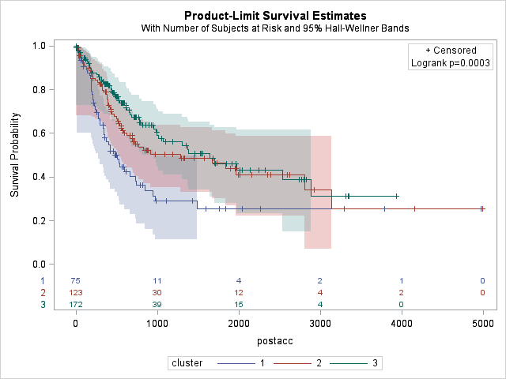
- Adrenocortical carcinoma (ACC)

- Bladder urothelial carcinoma (BLCA)

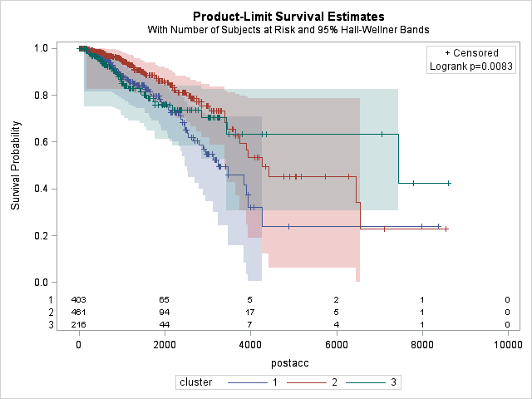
- Breast invasive carcinoma (BRCA)

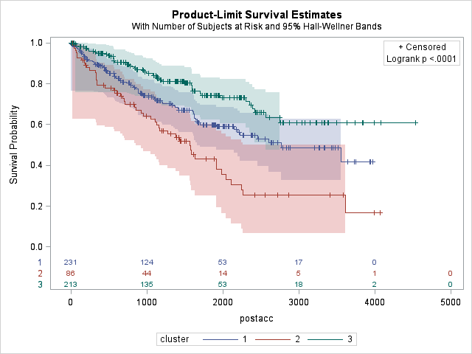
- Kidney renal clear cell carcinoma (KIRC)

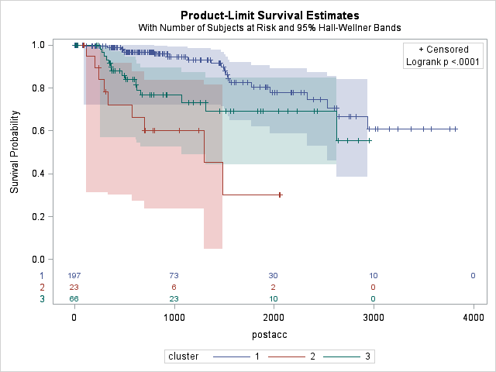
- Kidney renal papillary cell carcinoma (KIRP)

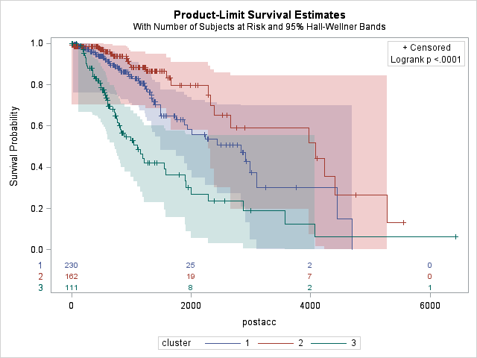
- Brain lower grade glioma (LGG)

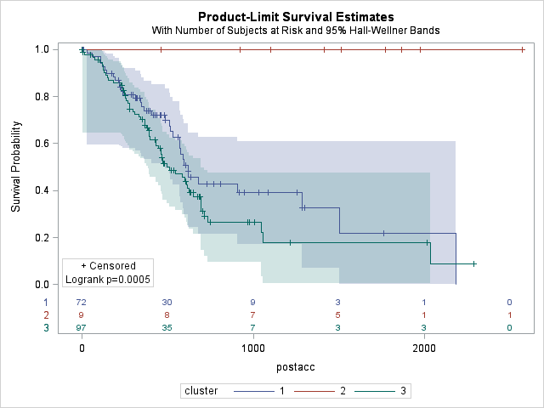
- Pancreatic agenocarcinoma (PAAD)
Figure S3 Post-procurement survival probability for patients in the three subtypes of (a) ACC (b) BLCA, (c) BRCA, (d) KIRC, (e) KIRP, (f) LGG, and (g) PAAD tumors identified by k-means analysis based on RNA-seq expression data of the top 50 genes.

