Additional file 6: Figure S2 for

A comprehensive genomic pan-cancer classification using The Cancer Genome Atlas gene expression data
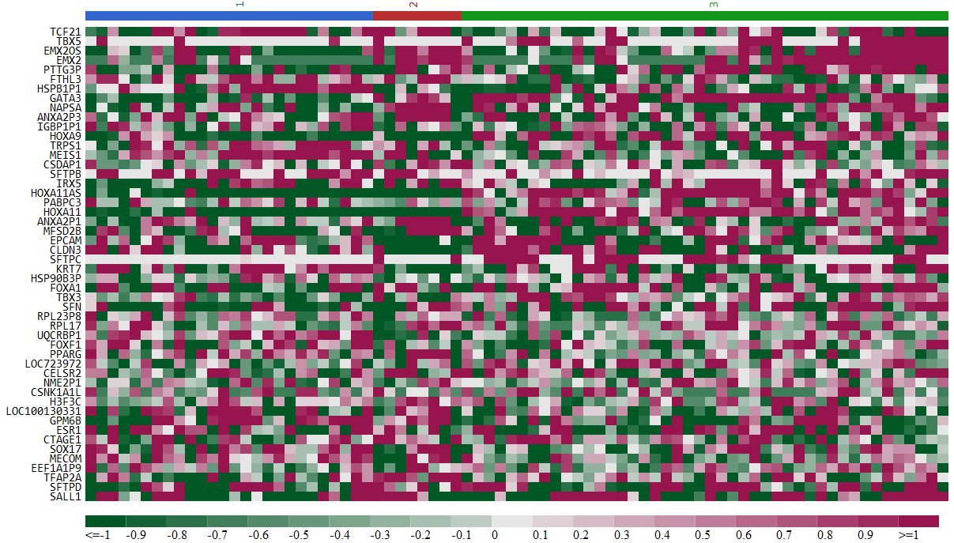
- Adrenocortical carcinoma (ACC)
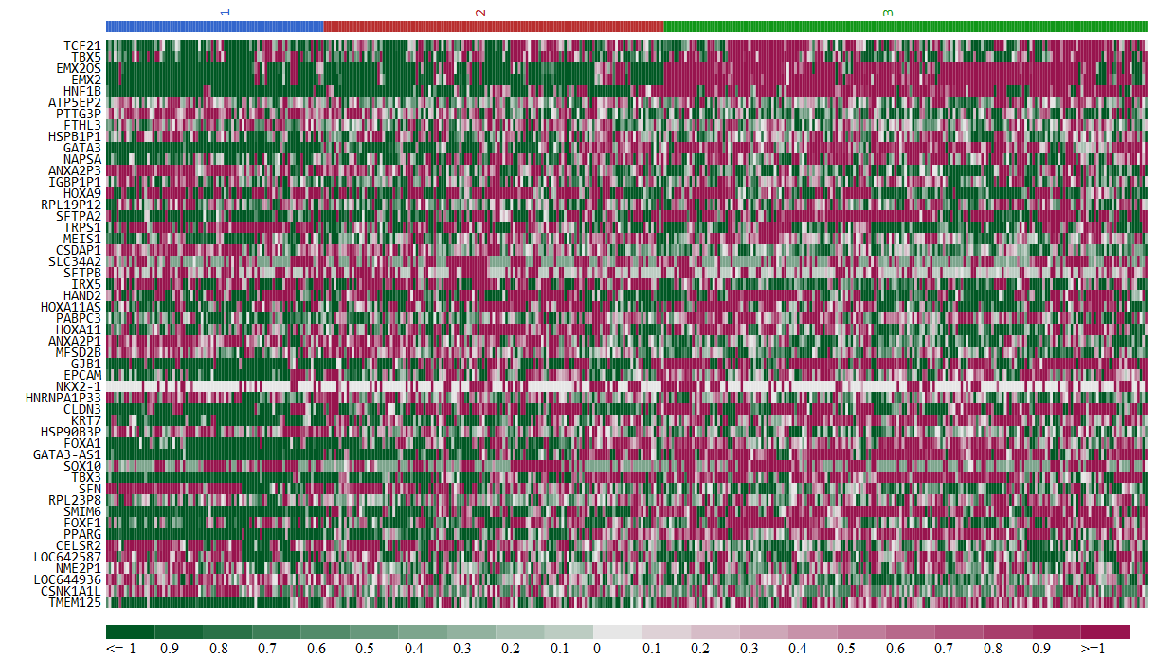
- Bladder urothelial carcinoma (BLCA)
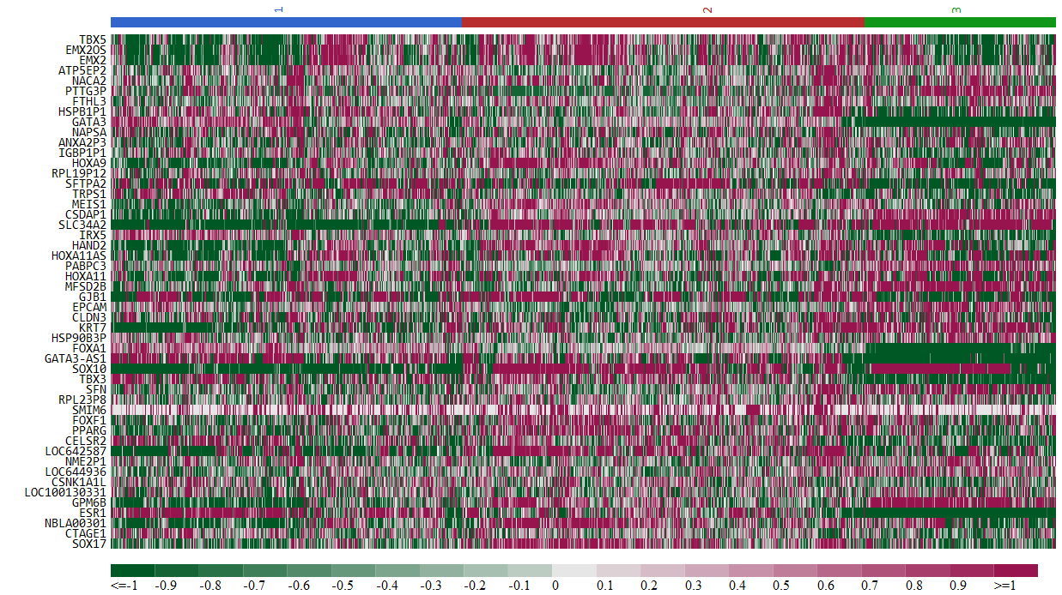
- Breast invasive carcinoma (BRCA)
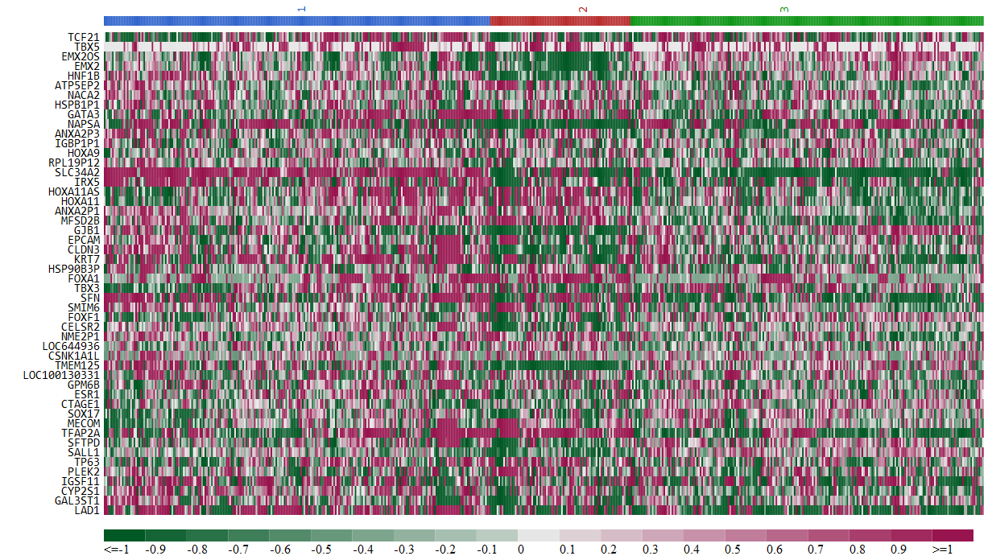
- Kidney renal clear cell carcinoma (KIRC)
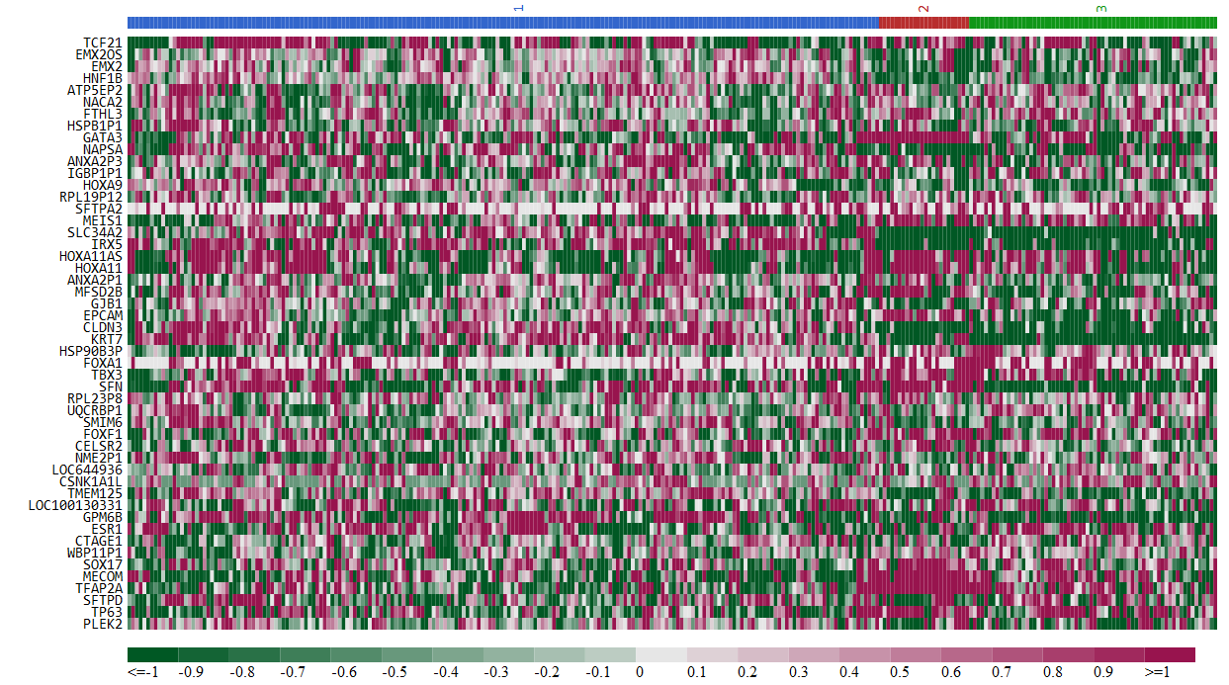
- Kidney renal papillary cell carcinoma (KIRP)
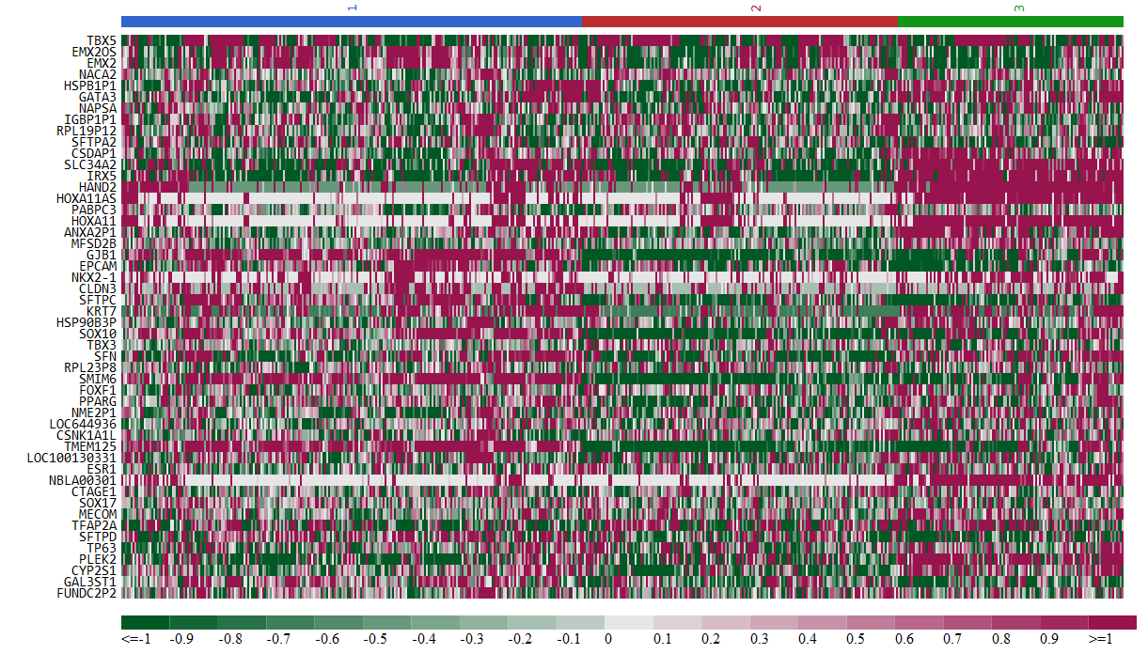
- Brain lower grade glioma (LGG)
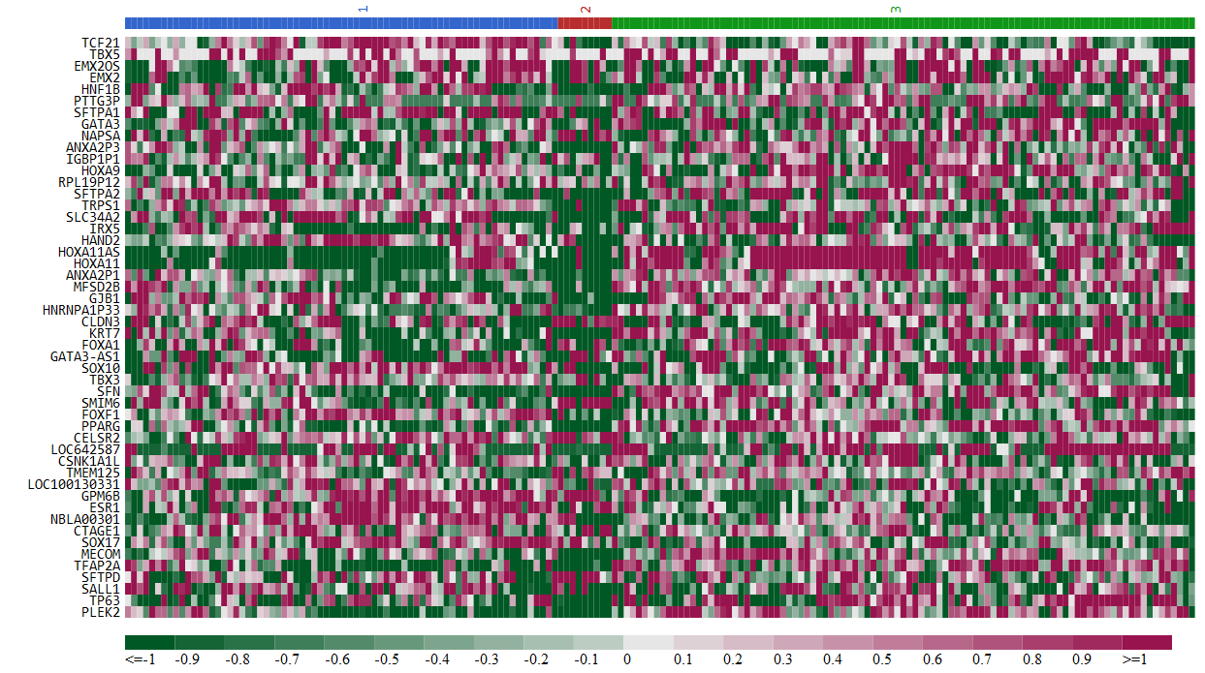
- Pancreatic adenocarcinoma (PAAD)
Figures S2 Heatmap representation of the expression patterns of the top 50 genes across all (a) ACC (b) BLCA, (c) BRCA, (d) KIRC, (e) KIRP, (f) LGG, and (g) PAAD samples. See Figure 3 legend for details. The colors of the horizontal bar represent the subgroups identified by k-means clustering analysis.

