Additional file 4: Figure S1 for

A comprehensive genomic pan-cancer classification using The Cancer Genome Atlas gene expression data
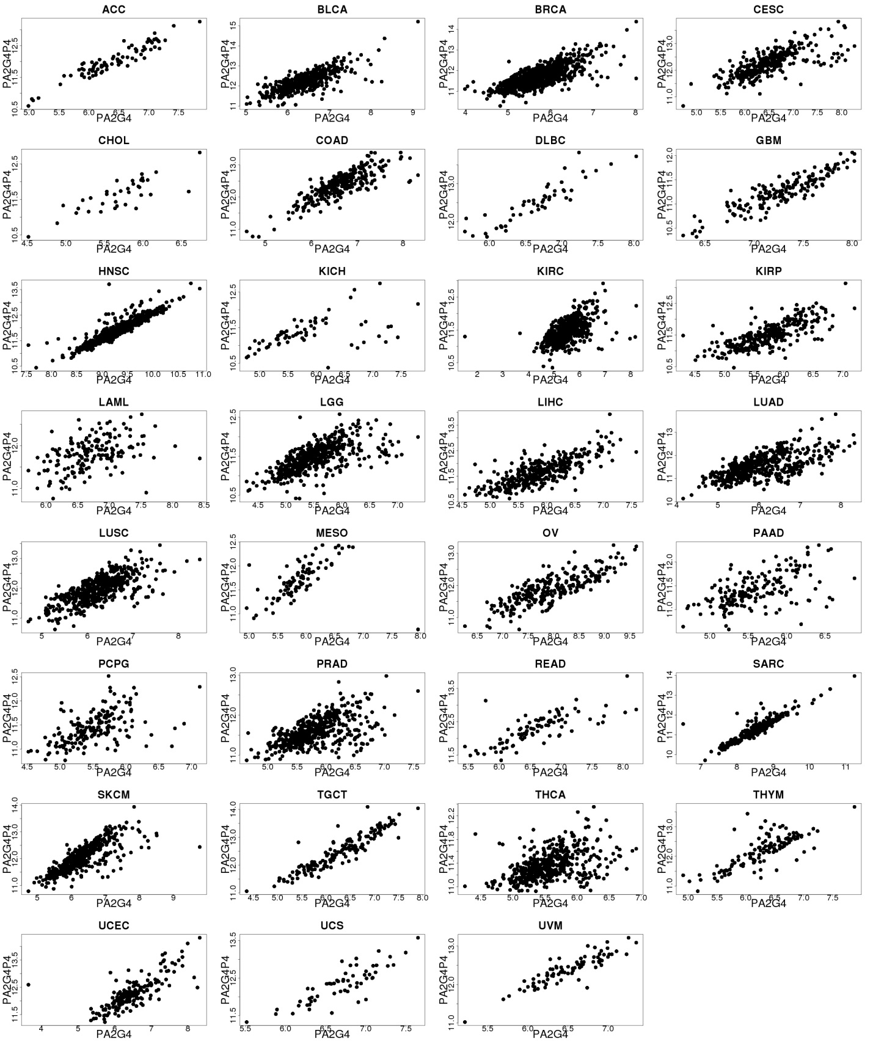
Figure S1 Scatterplots of expression levels of PA2G4 and PA2G4P4 across all tumor types.

