Additional file 15: Figure S5 for

A comprehensive genomic pan-cancer classification using The Cancer Genome Atlas gene expression data
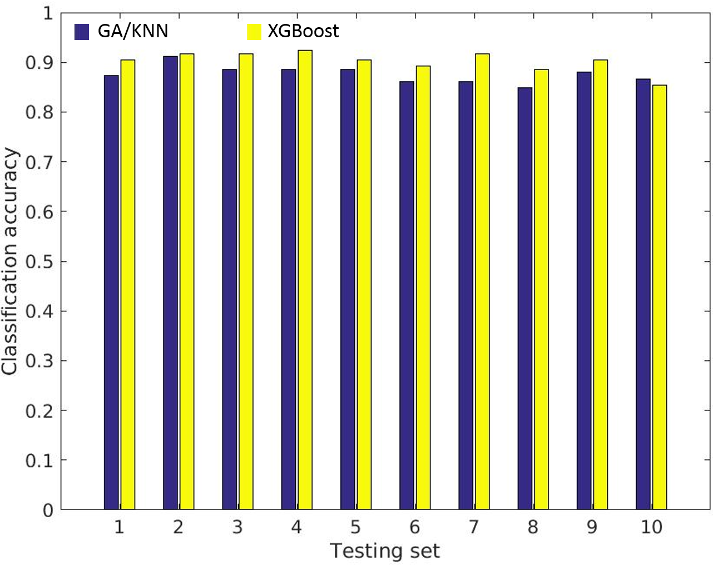
Figure S5 Classification accuracies between GA/KNN and XGBoost for 10 testing sets.

