Additional file 14: Figure S9 for

A comprehensive genomic pan-cancer classification using The Cancer Genome Atlas gene expression data
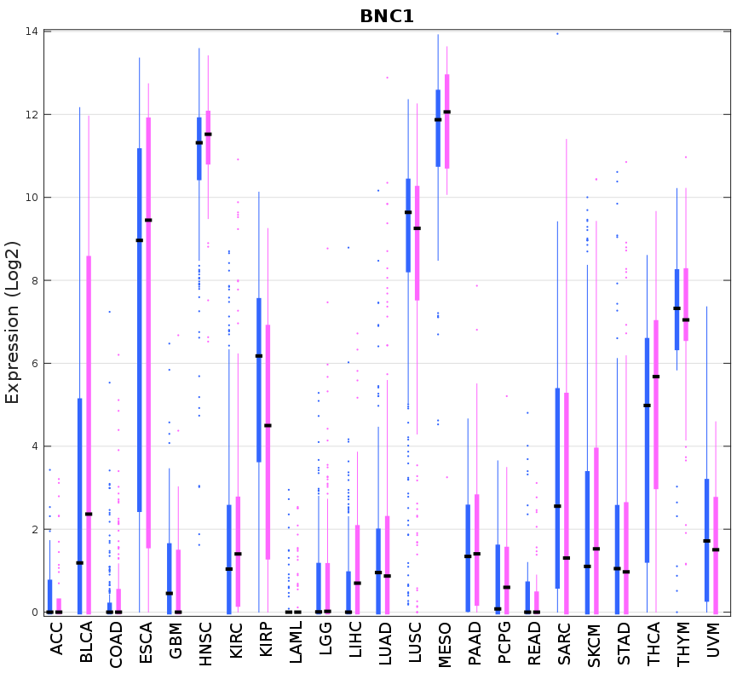
Figure S9 Boxplot BNC1 expression data in the 23 sex non-specific tumors from males (blue) and females (pink).

