Additional file 12: Supplementary Figure S4 for

A comprehensive genomic pan-cancer classification using The Cancer Genome Atlas gene expression data
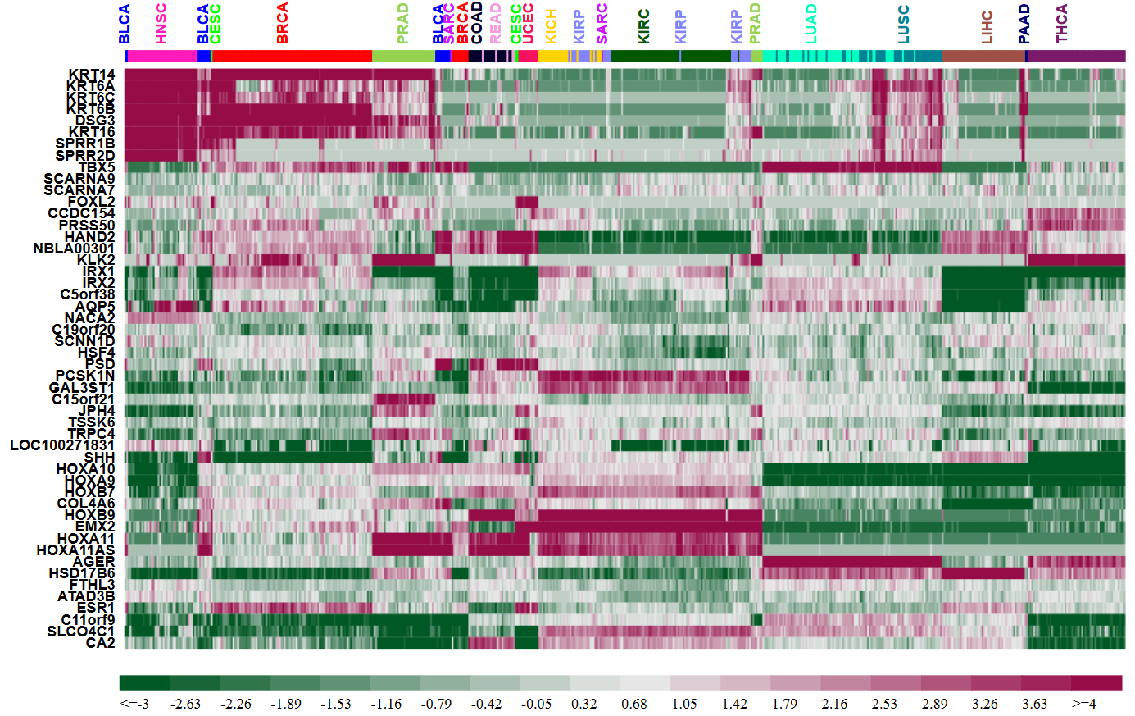
Figure S4 Heatmap representation of the expression patterns of the top 50 genes selected by GA/KNN across all 602 “normal” samples taken adjacent to tumors from 17 tumor types. Each row (gene) was centered by the median expression value across all samples. A hierarchical clustering analysis was carried out for both samples and genes using the Euclidean distance as the similarity metric.

