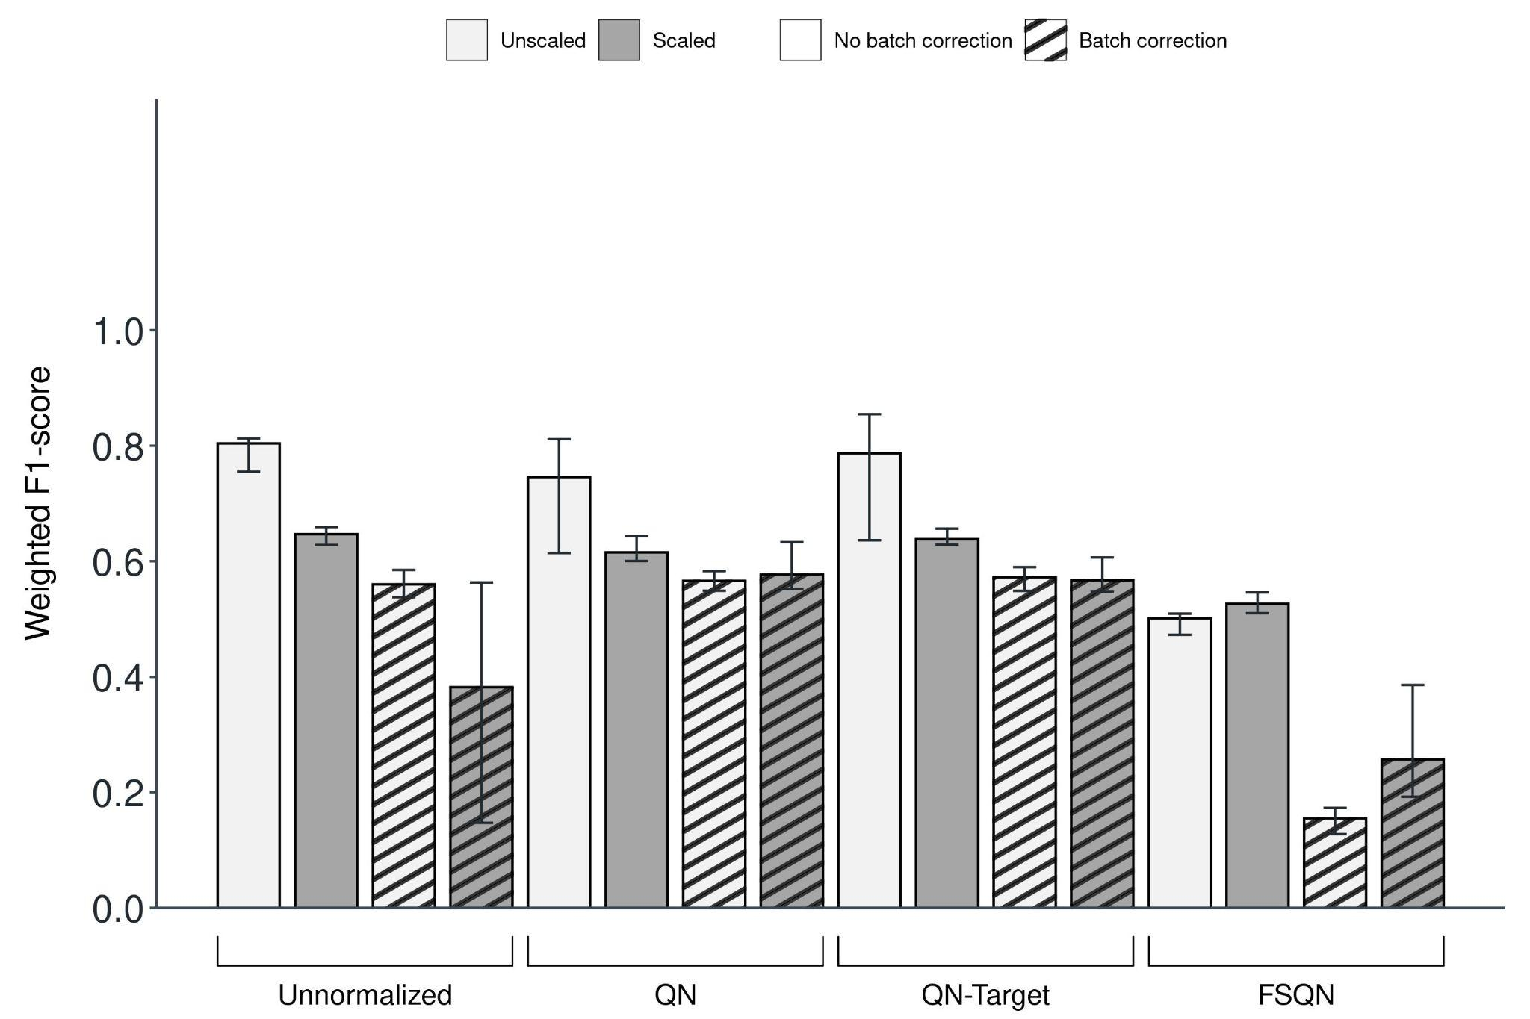
[Figure A5] Poor classifier performance after Limma's batch effect correction against the ICGC/GEO test set with GTEx used in the batch correction step. Weighted F1-scores as determined by SVM classifier loaded with the original dataset (left-most bar) versus the modified datasets after combinations of normalization (Unnormalized, QN [Quantile Normalization], QN-Target [Quantile Normalization with Target], FSQN [Feature-Specific Quantile Normalization]), batch effect correction (No batch correction, Batch correction) and data scaling (Unscaled, Scaled). The training and independent test datasets were TCGA and ICGC/GEO, respectively. The batch effect correction algorithm used was Limma and all three types of batches (Protocol batch effect, Disease batch effect, and Consortium batch effect) were adjusted. The GTEx was used in the batch correction step rather than ICGC/GEO dataset. Bars indicate the median values of each group that consisted of five models evaluated from the outer folds of cross-validation. Error bars represent the 95% confidence interval.

