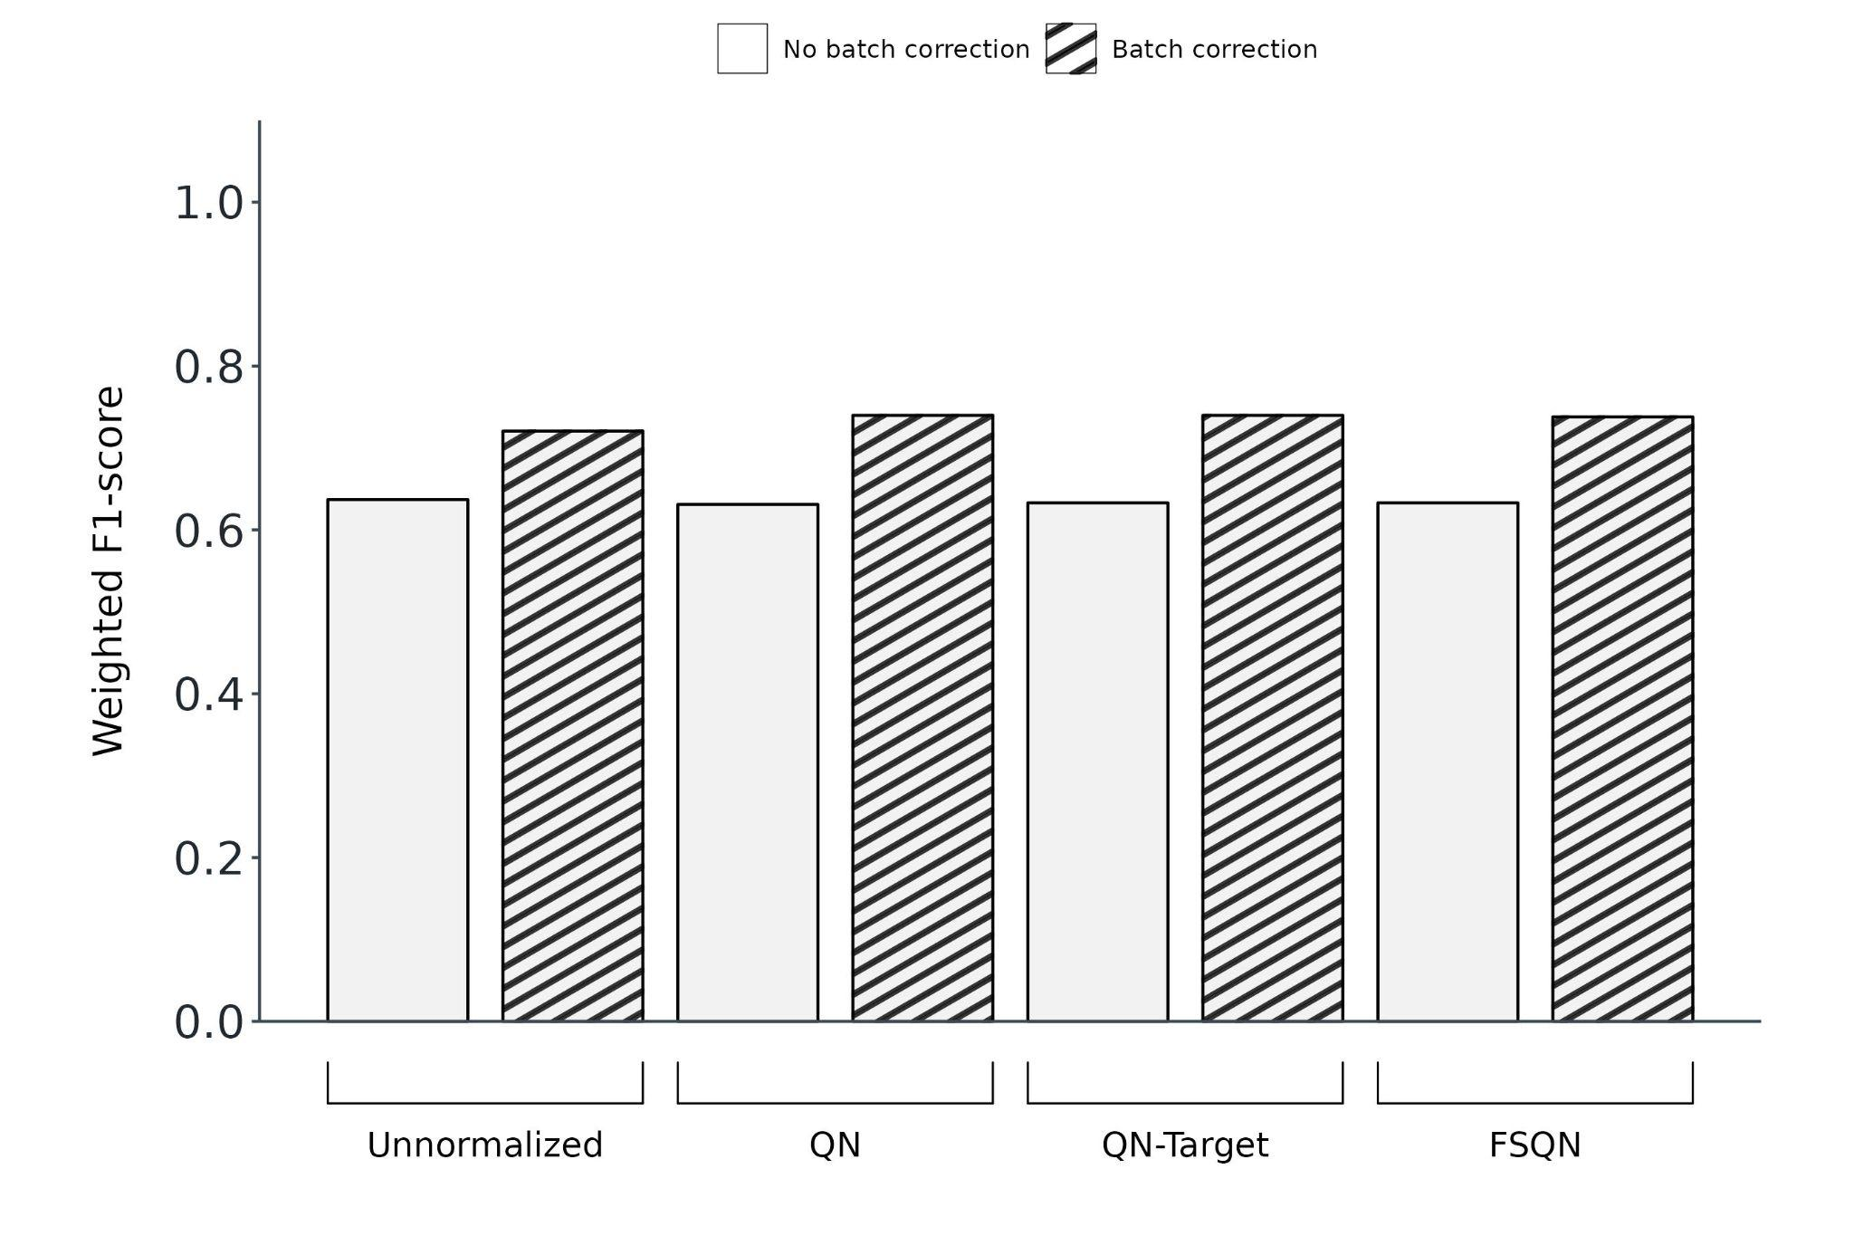
[Figure A2] TULIP classifier performance against the GTEx test set. Weighted F1-scores as determined by TULIP's convoluted neural network classifier tested with the original dataset (left-most bar) versus the modified datasets after combinations of normalization (Unnormalized, QN [Quantile Normalization], QN-Target [Quantile Normalization with Target], FSQN [Feature-Specific Quantile Normalization]), and batch effect correction (No batch correction, Batch correction). All datasets were unscaled. The batch effect correction algorithm used was Limma and all three types of batches (Protocol batch effect, Disease batch effect, and Consortium batch effect) were adjusted.

