Supplementary Materials

Supplementary Table 1: GEO dataset information

GEO accession number | Total number of samples | Primary site and comment
GSE113019 | 55 | Liver- primary, tumor adjacent and metastasis
GSE113904 | 232 | COAD- age related drift study. no cancer data, all normal
GSE38240 | 12 | Prostate- metastatic
GSE58999 | 88 | Metastatic breast
GSE66313 | 55 | Ductal carcinoma breast
GSE67116 | 96 | Uterine metastasis

Supplementary Table 2: Performance of CancerNet, CancerLocator, and a model based on random forest (RF model) in classifying 14 cancers encompassing hard tumors of the abdominal and thoracic cavities that were investigated in CancerLocator or RF model or both these studies. Performance was assessed using the overall accuracy metric F-measure. Highest F-measure value among the three methods is shown in boldface for each cancer type, as well as for the normal class. “x” denotes no value for a cancer (or normal) that was not included in the classification by a method.
Type | RF model | CancerLocator | CancerNet
Urothelial Bladder Carcinoma | 0.673 | x | 0.999
Breast Invasive Carcinoma | 0.979 | 0.476 | 0.998
Colon Adenocarcinoma | 1.000 | x | 0.989
Esophagial Carcinoma | 0.336 | x | 0.989
Head and Neck Squamous Cell Carcinoma | 0.720 | x | 0.992
Kidney Renal Clear Cell | 0.739 | x | 0.998
Kidney Renal Papillary Cell | 0.695 | x | 0.998
Liver Hepatocellular carcinoma | 0.965 | 0.847 | 0.998
Lung Squamous Cell Carcinoma | 0.406 | x | 0.995
Lung Adenocarcinoma | 0.773 | 0.612 | 0.997
Pancreatic Adenocarcinoma | 0.712 | x | 0.997
Prostate Adenocarcinoma | 1.000 | x | 0.997
Thyroid carcinoma | 0.992 | x | 0.999
Uterine Corpus Endometrial Carcinoma | 0.918 | x | 0.994
Normal | x | 0.795 | 0.988

Supplementary Figures 1 – 38: Misclassification rates for cancers that were misclassified to one or more other cancer(s).

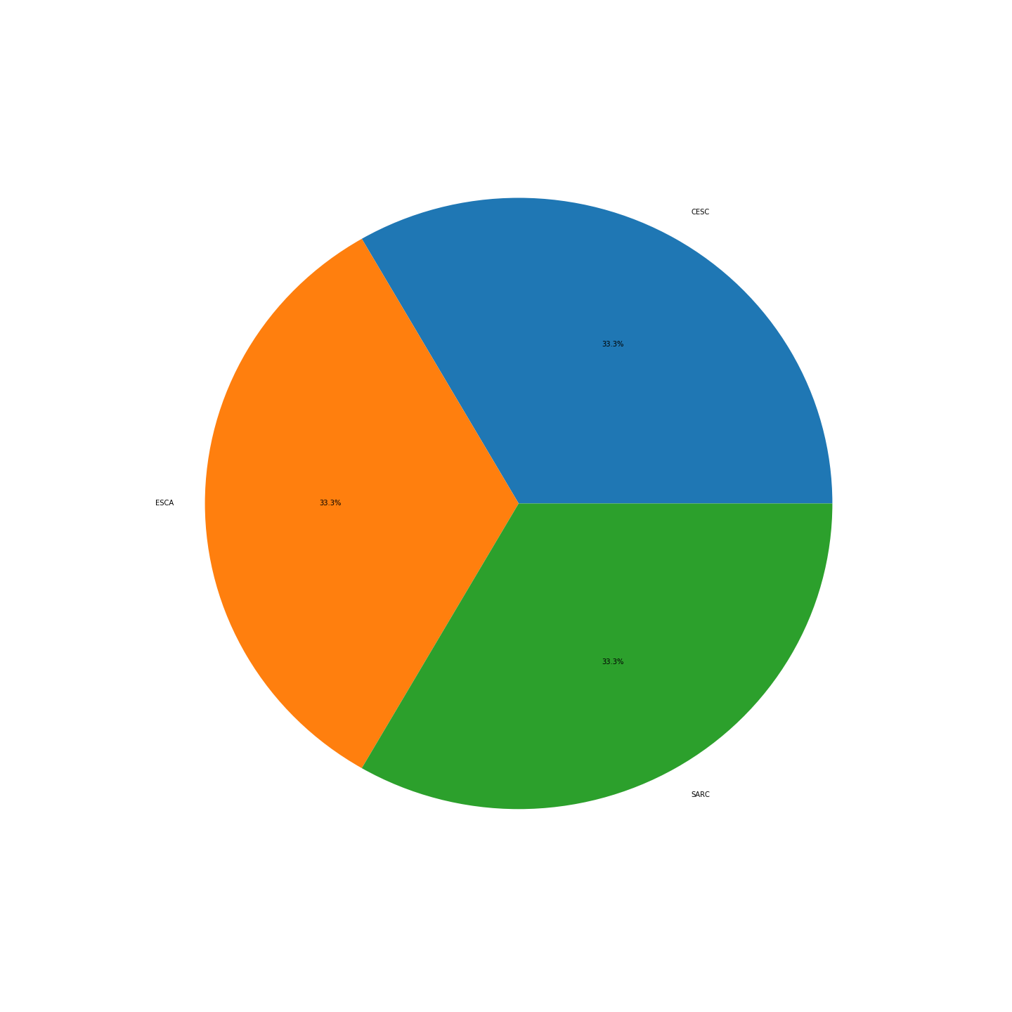
Supplementary Figure 1: BLCA
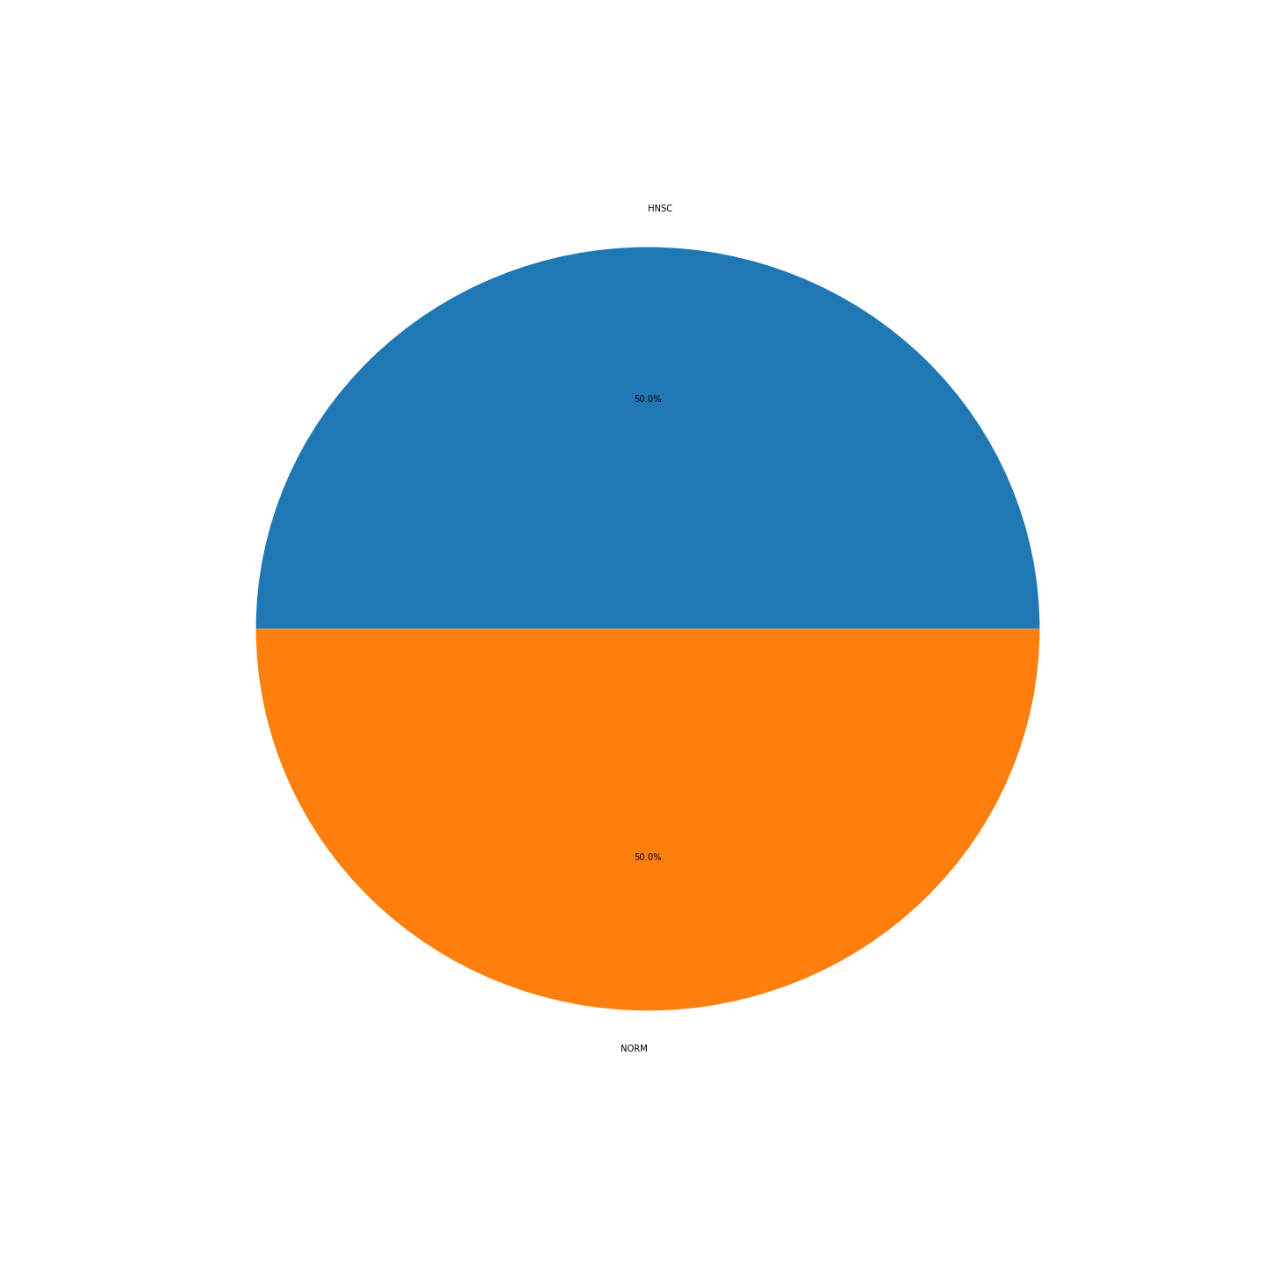
Supplementary Figure 2: BRCA
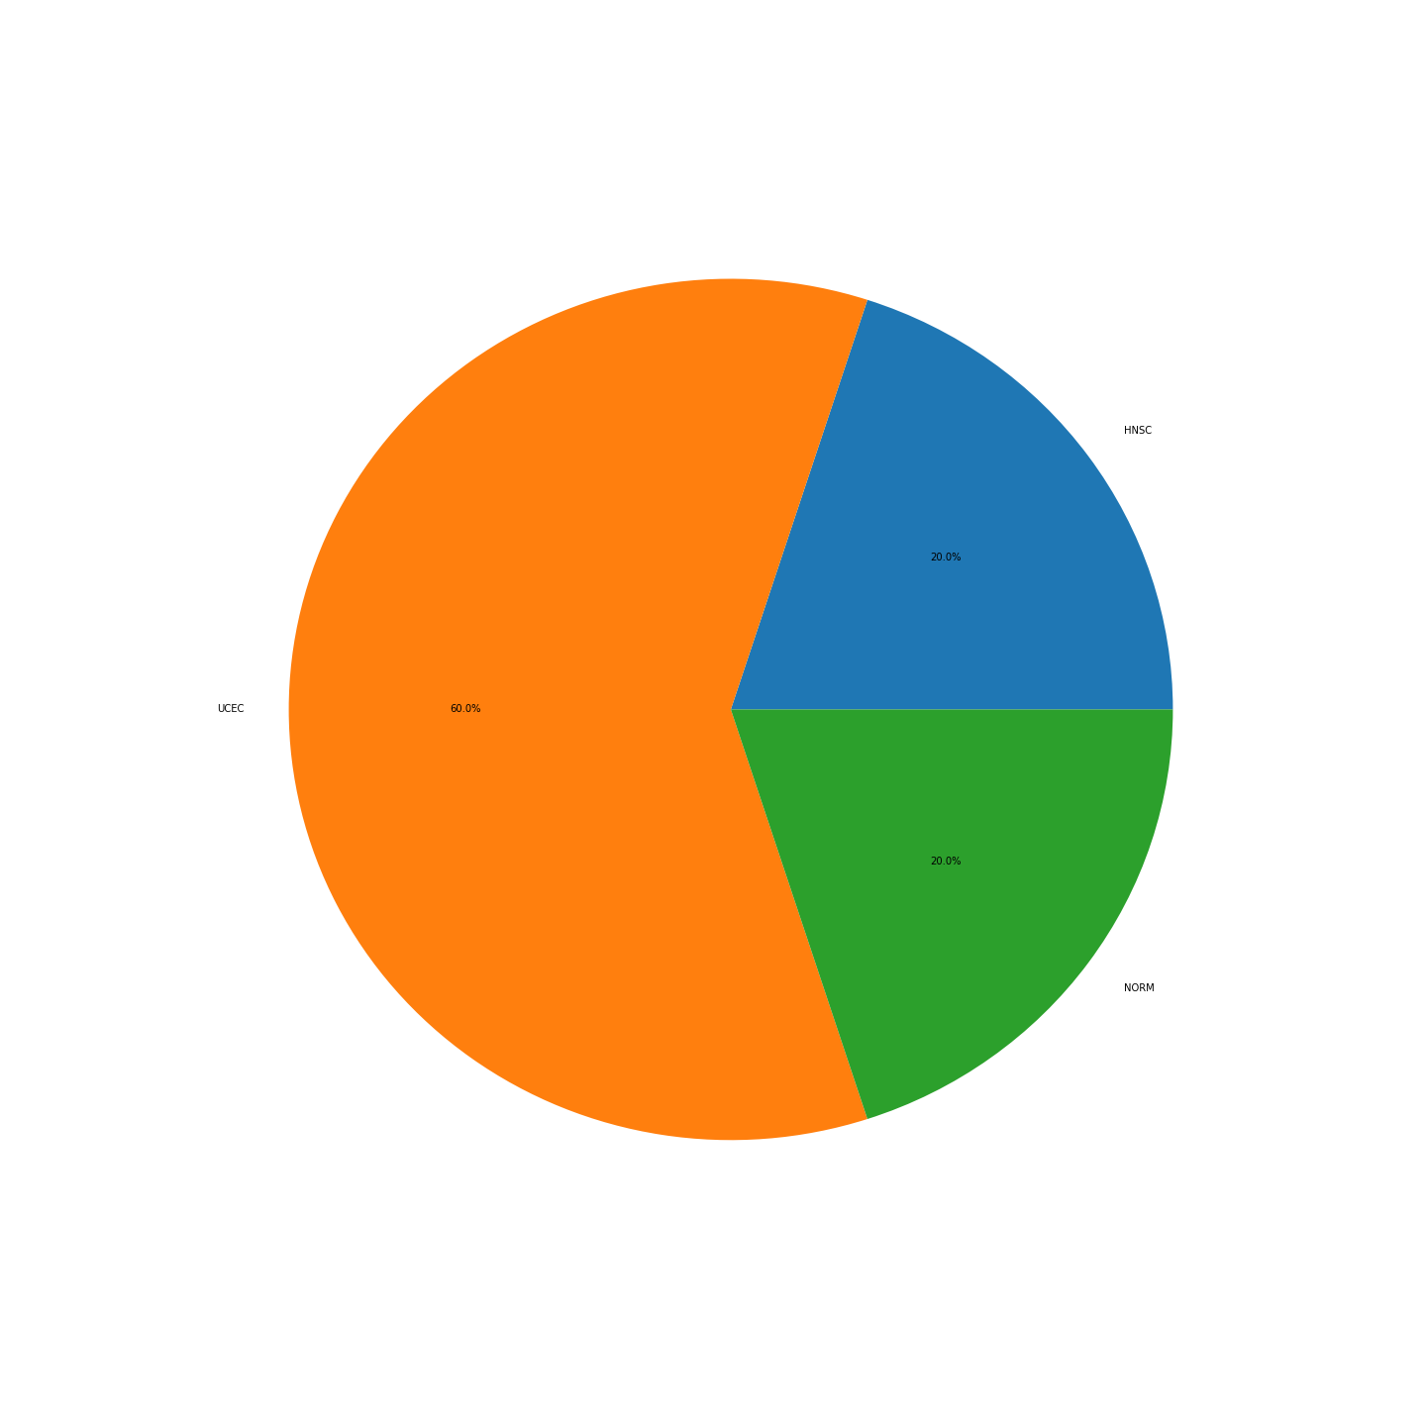
Supplementary Figure 3:CESC
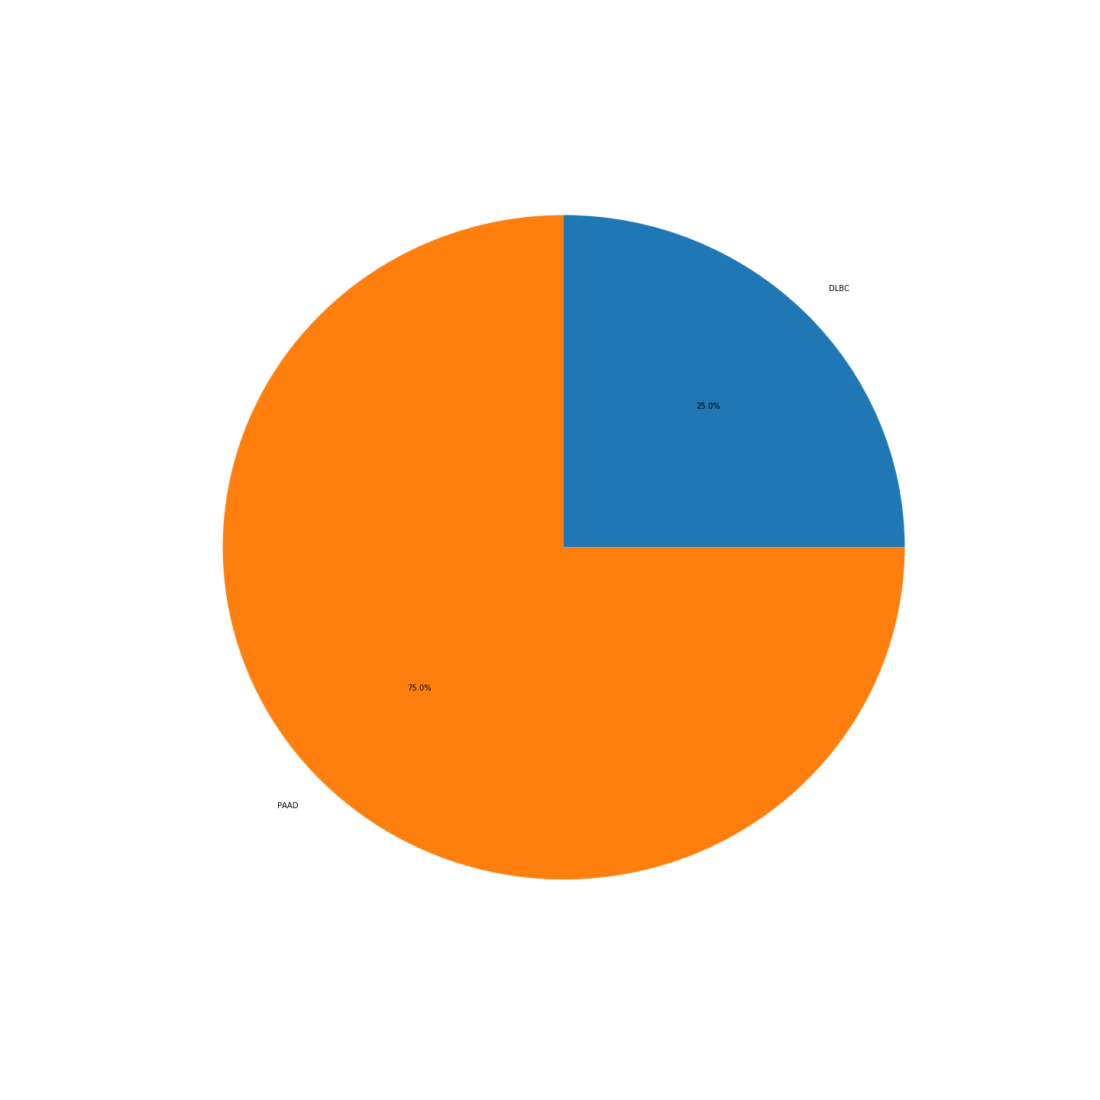
Supplementary Figure 4: CHOL
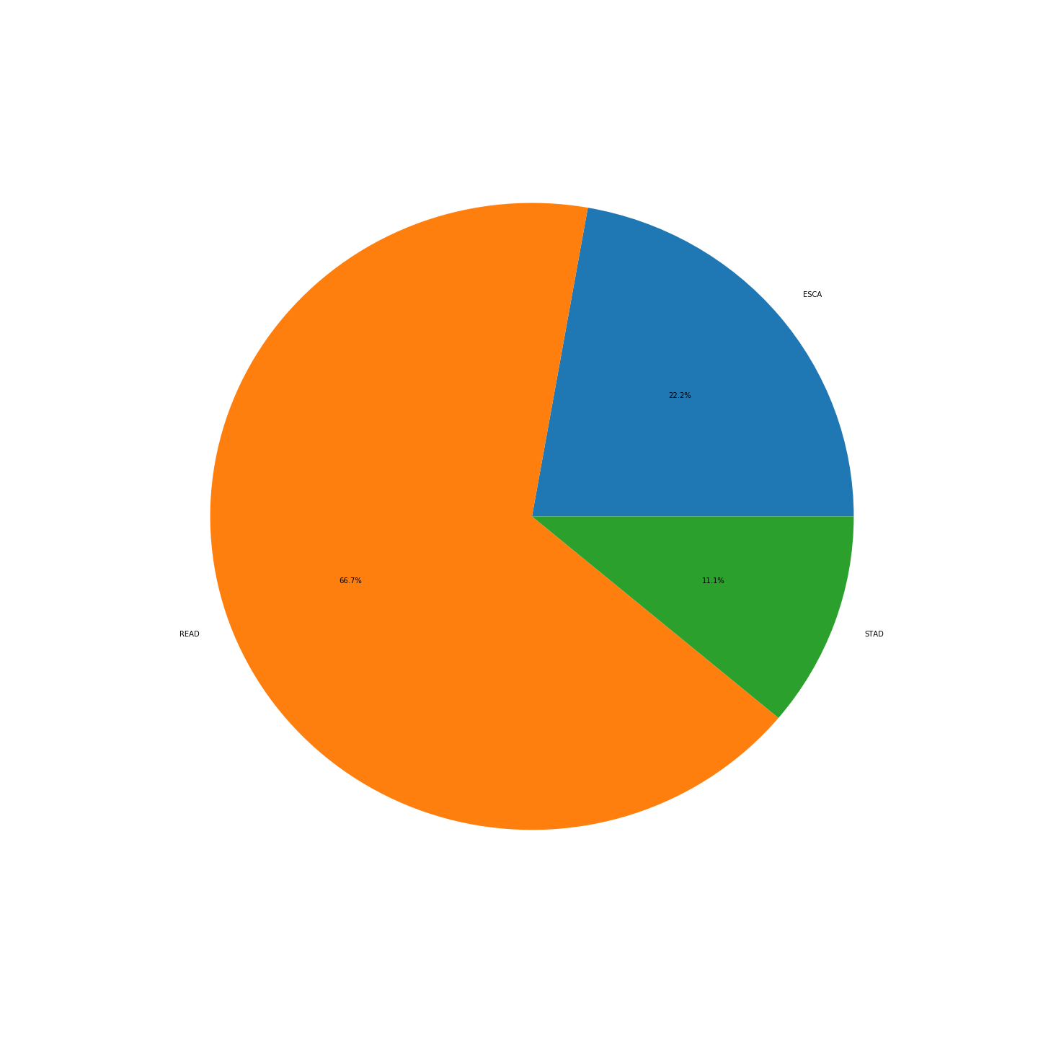
Supplementary Figure 5: COAD
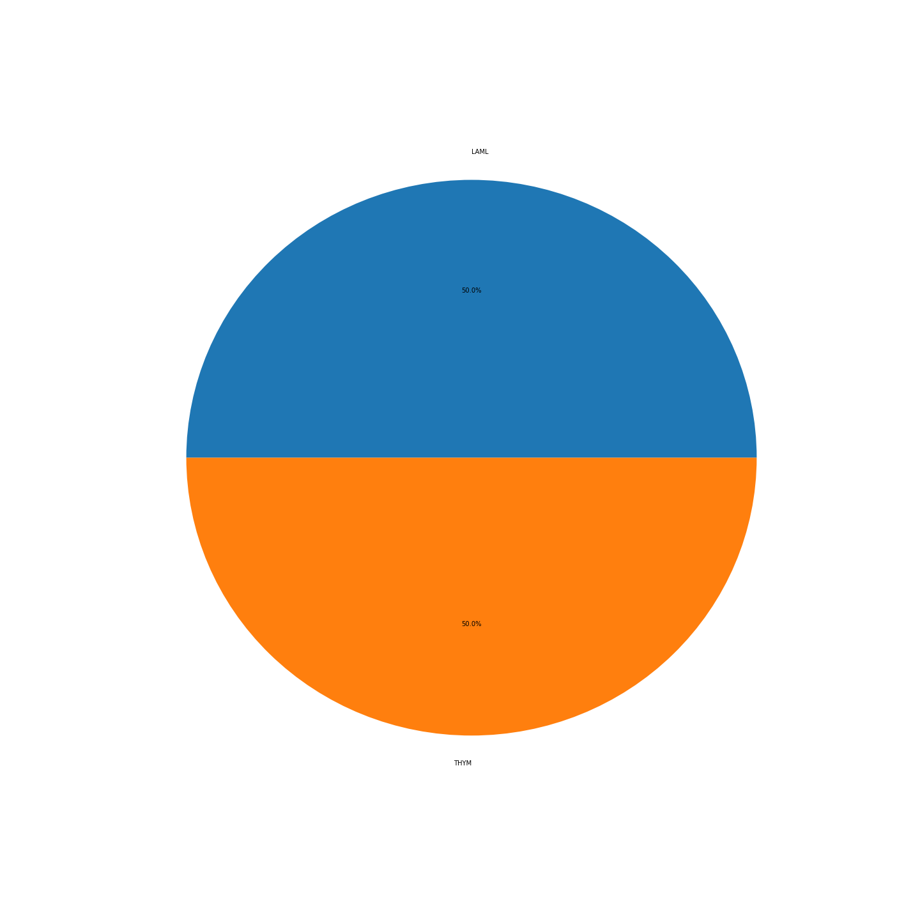
Supplementary Figure 6: DLBC
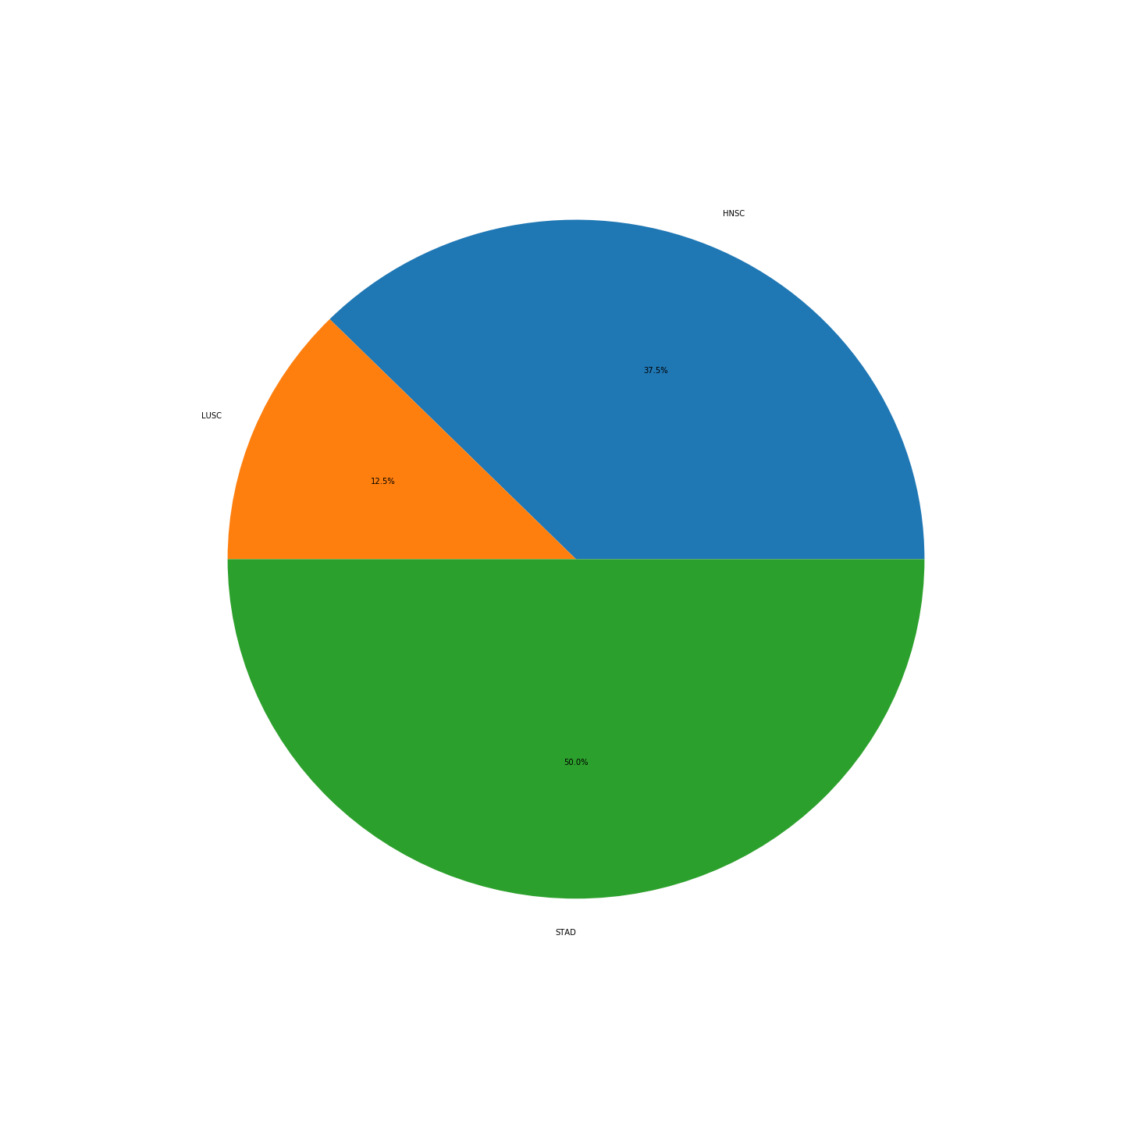
Supplementary Figure 7: ESCA
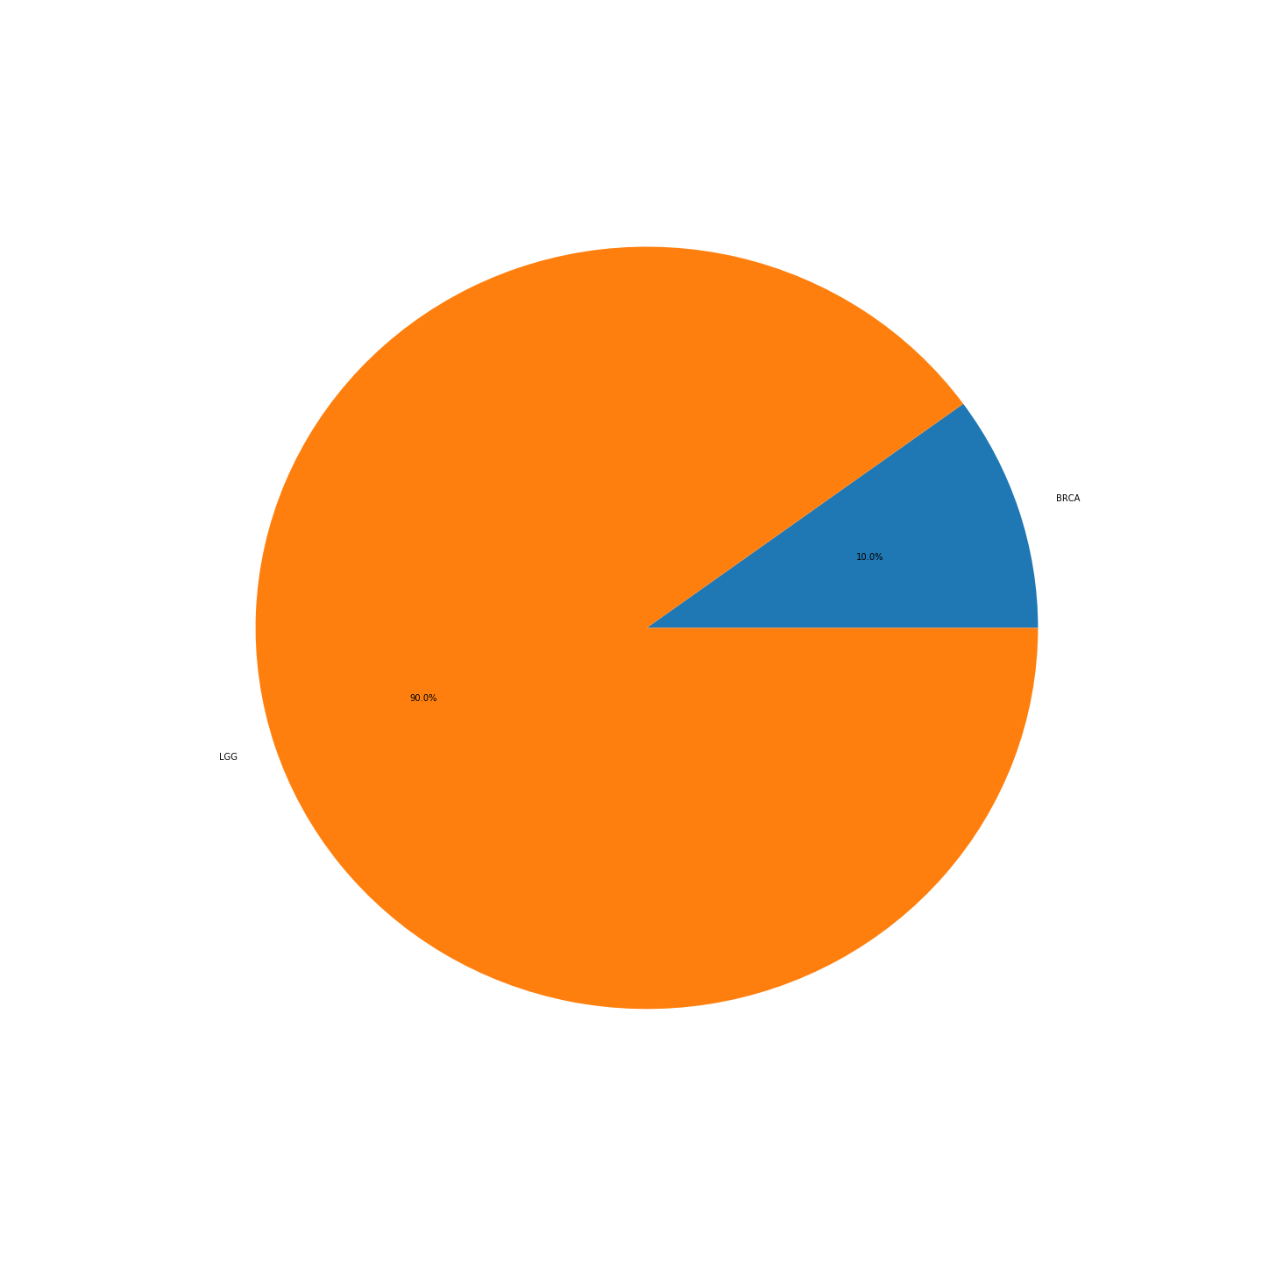
Supplementary Figure 8: GBM
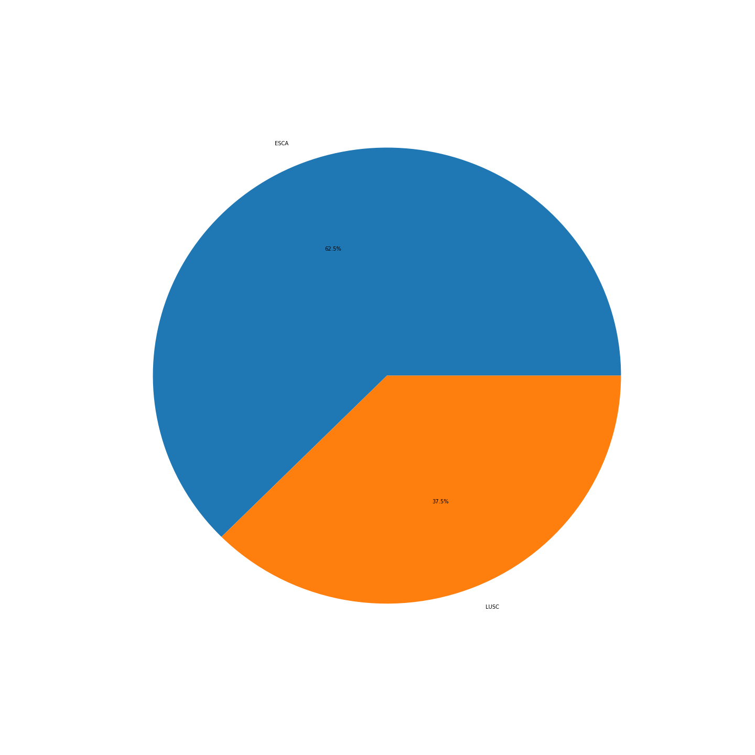
Supplementary Figure 9: HNSC
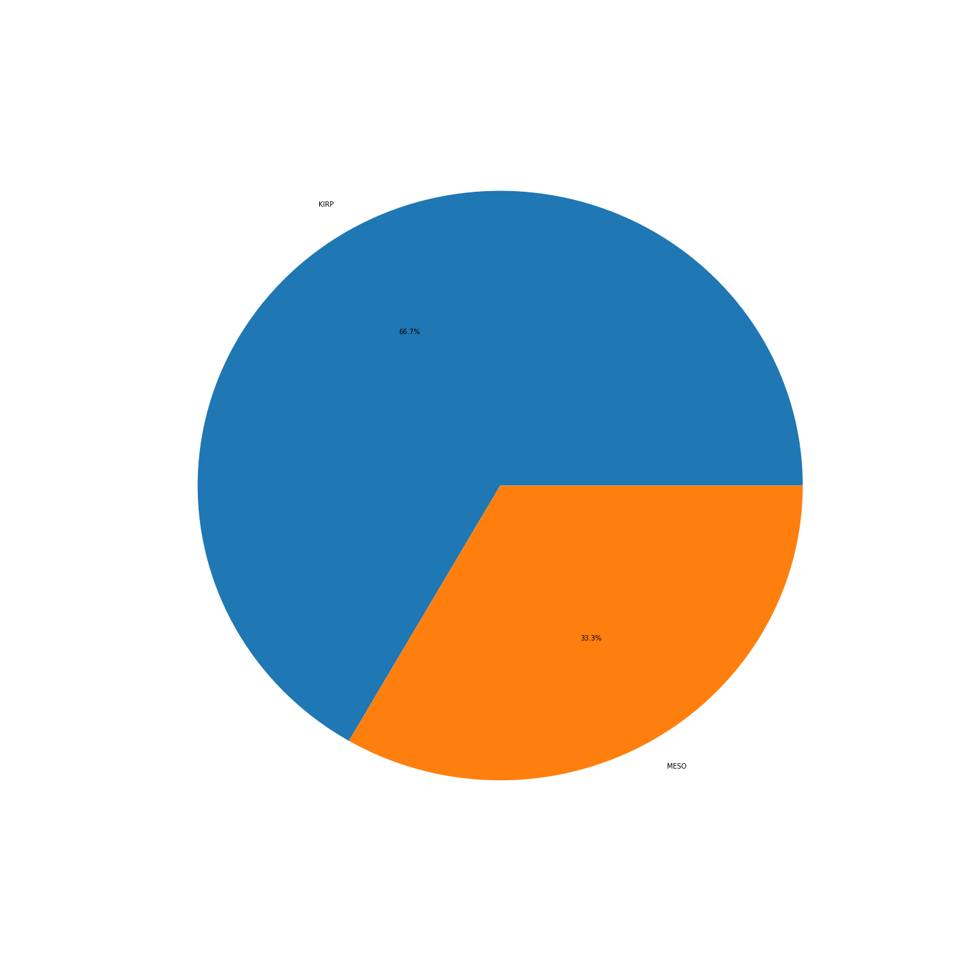
Supplementary Figure 10: KIRC
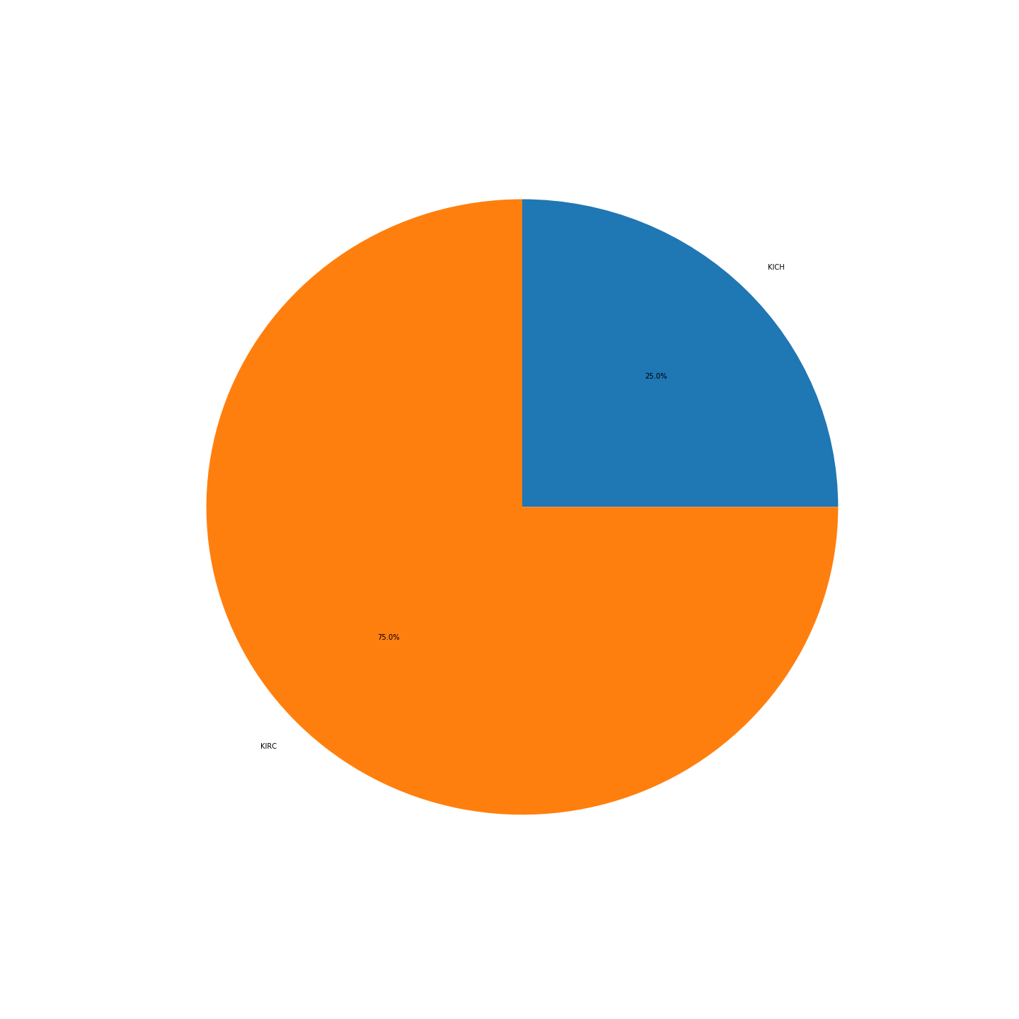
Supplementary Figure 11: KIRP
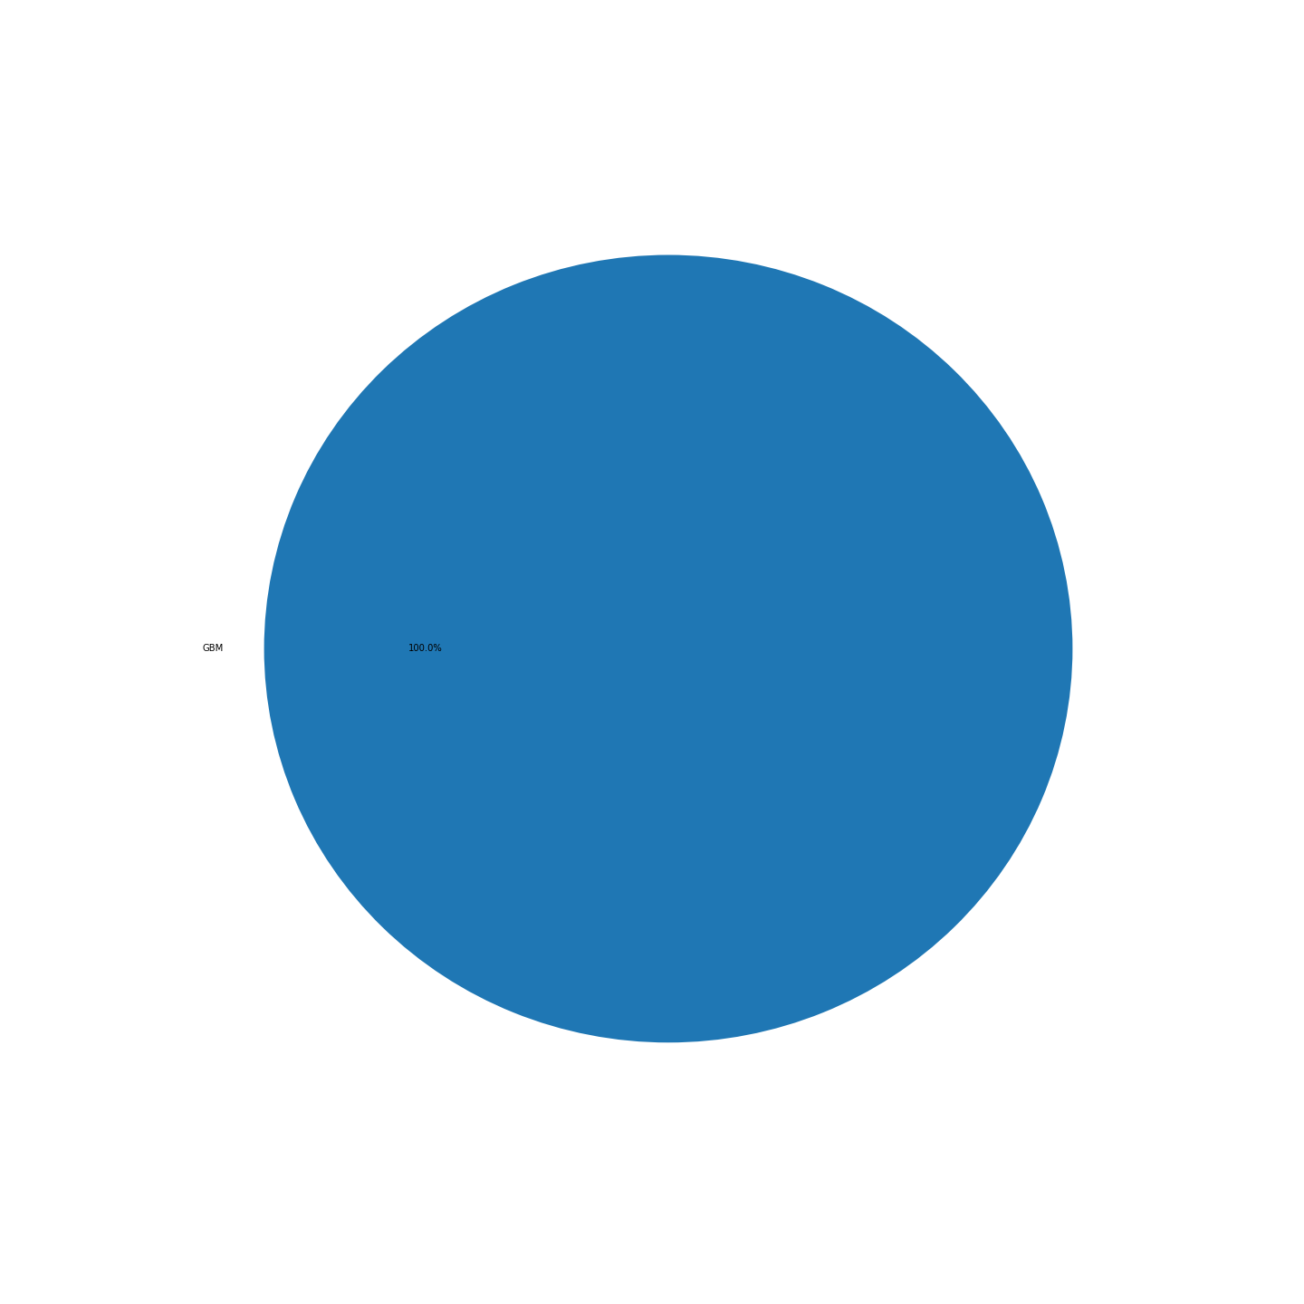
Supplementary Figure 12:LGG
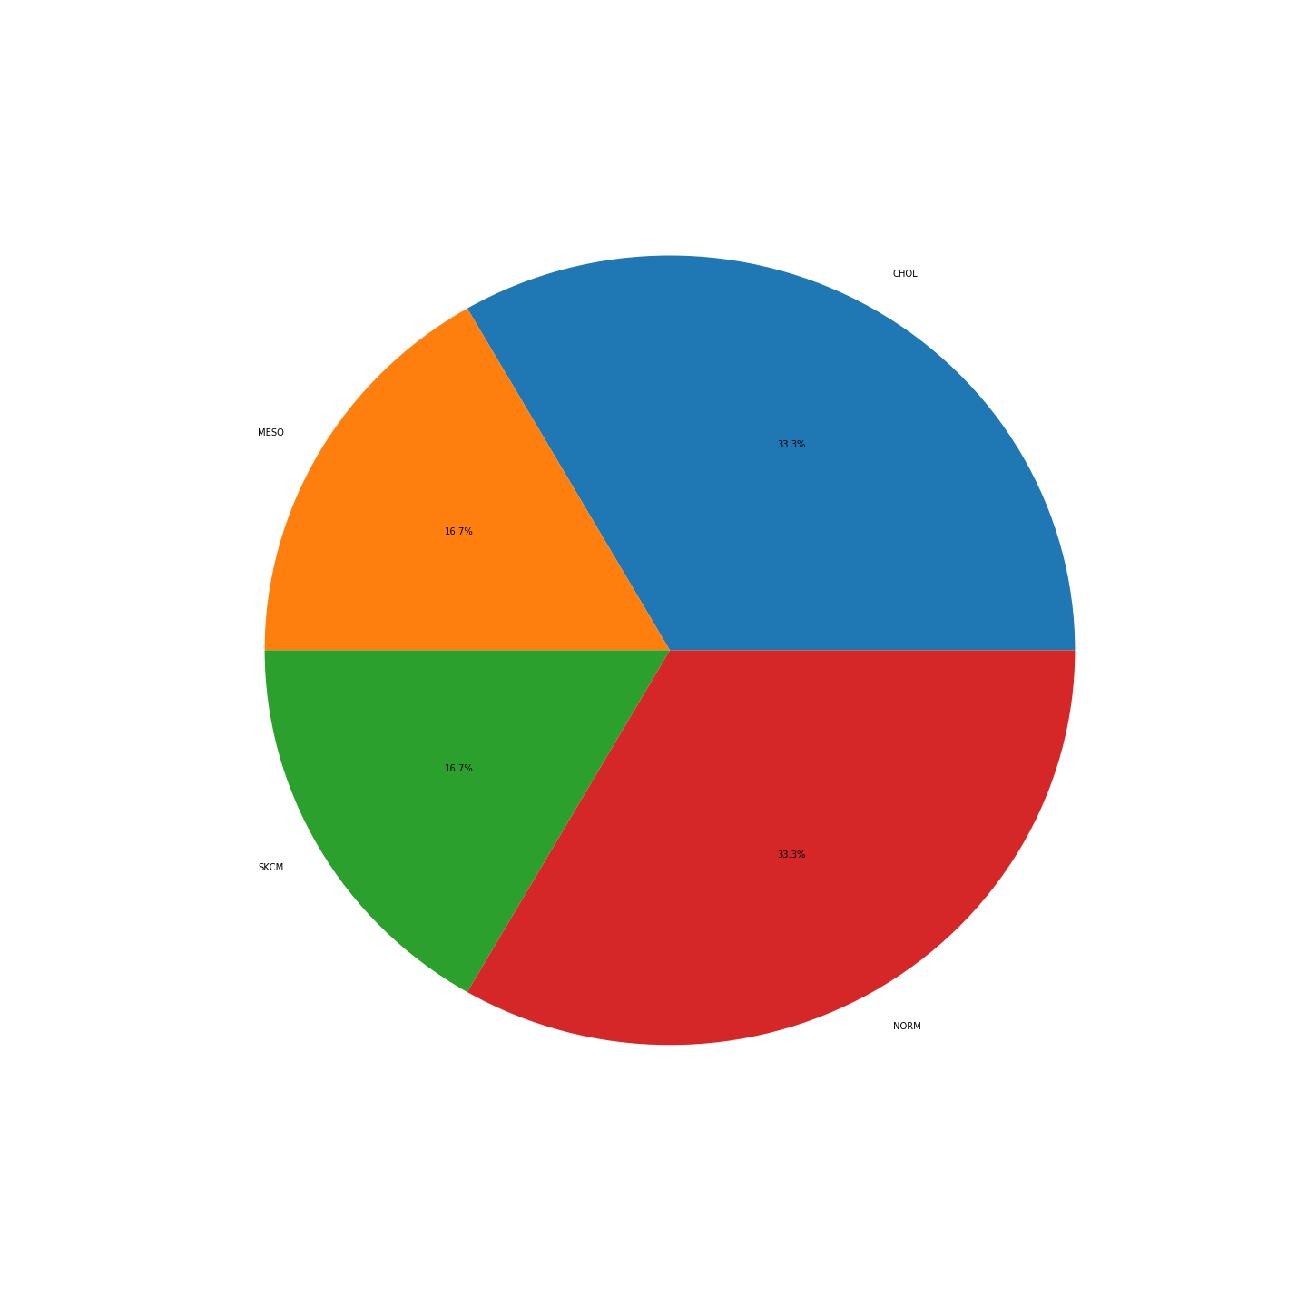
Supplementary Figure 13: LIHC
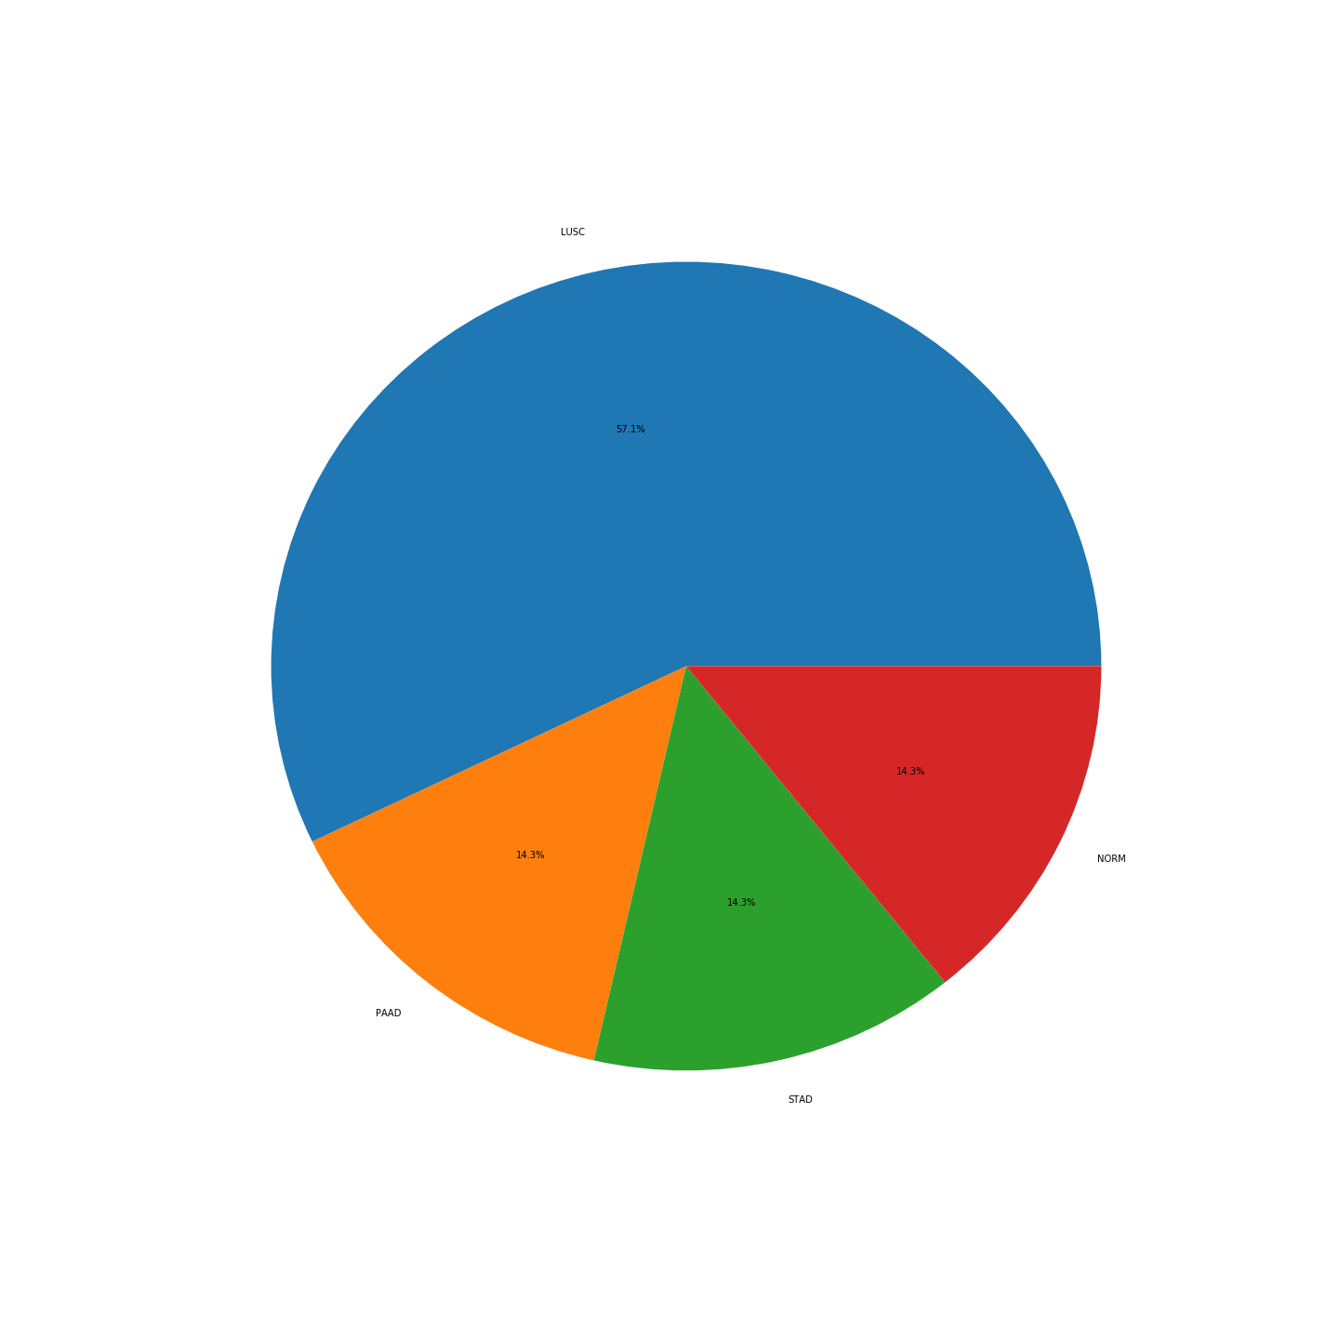
Supplementary Figure 14:LUAD
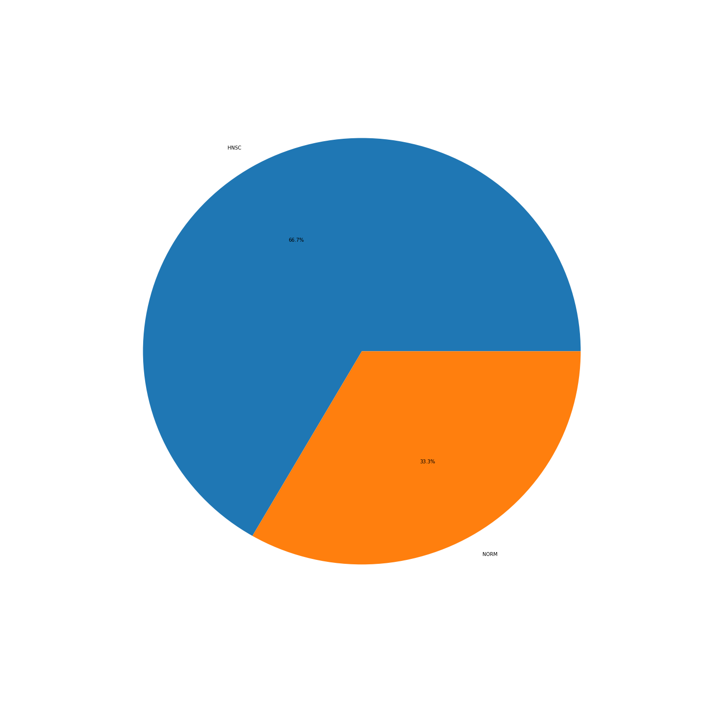
Supplementary Figure 15: LUSC
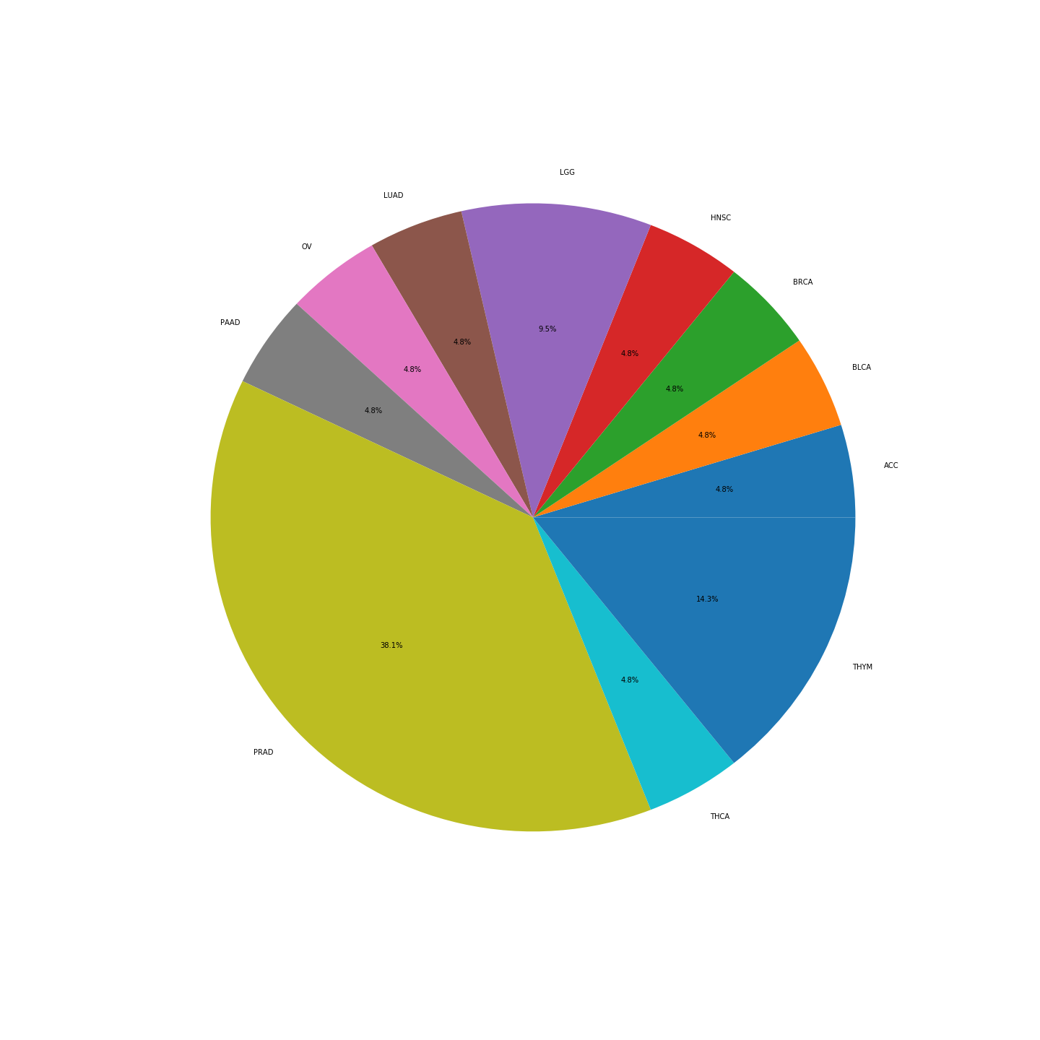
Supplementary Figure 16: NORM
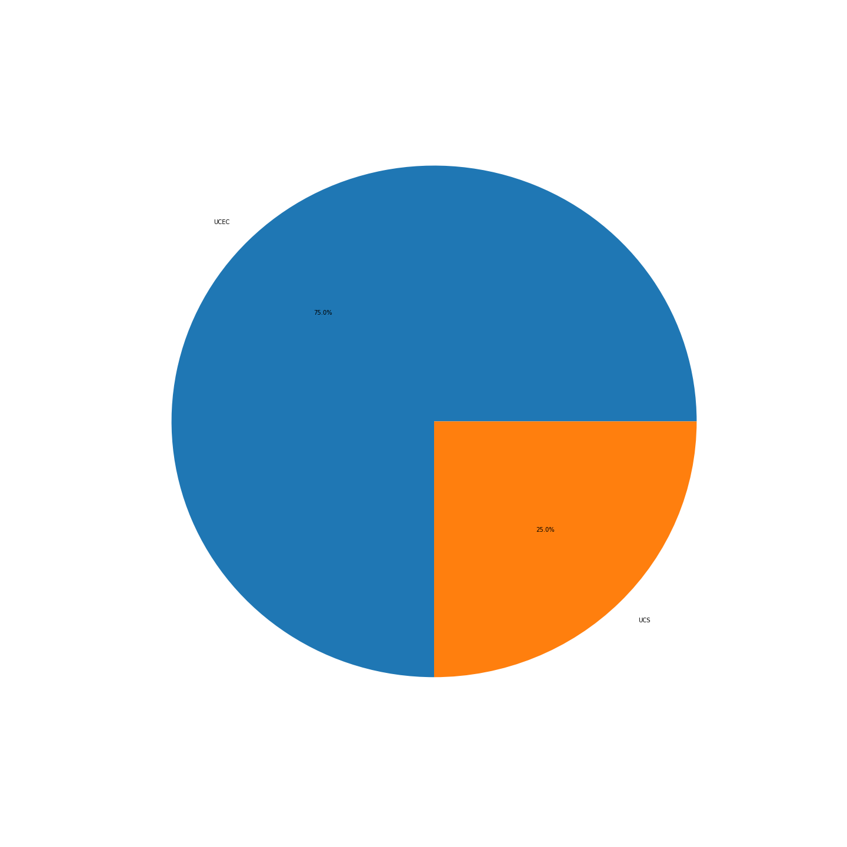
Supplementary Figure 17: OV
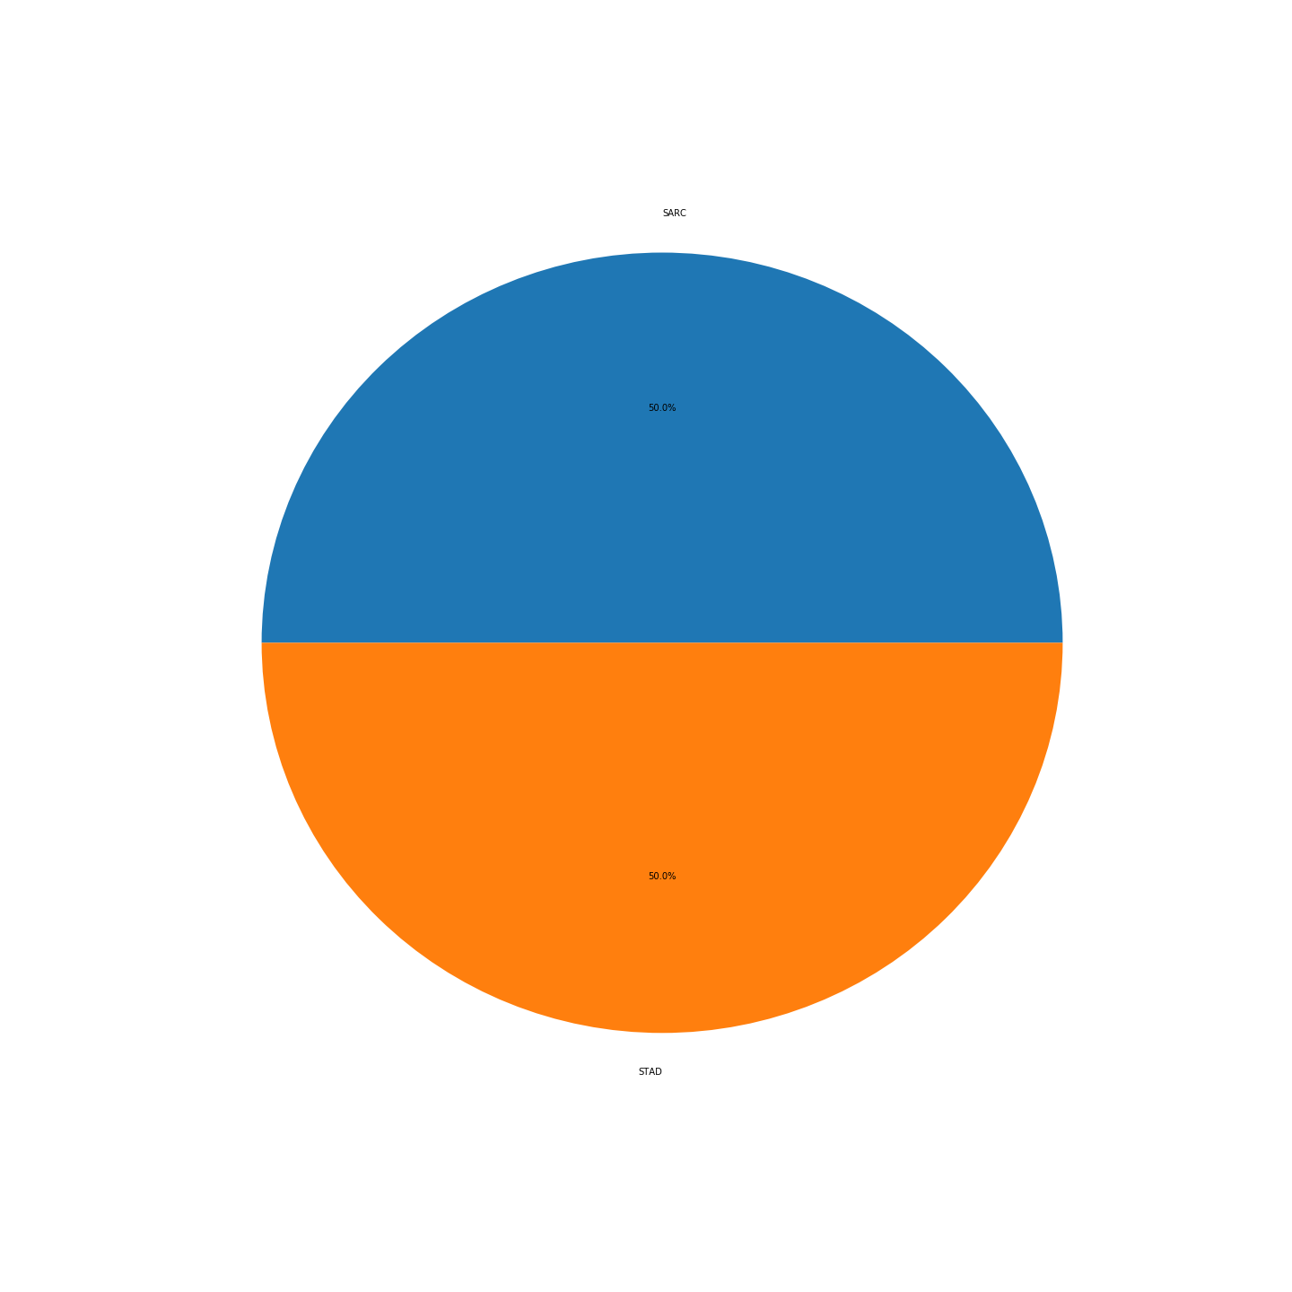
Supplementary Figure 18: PAAD
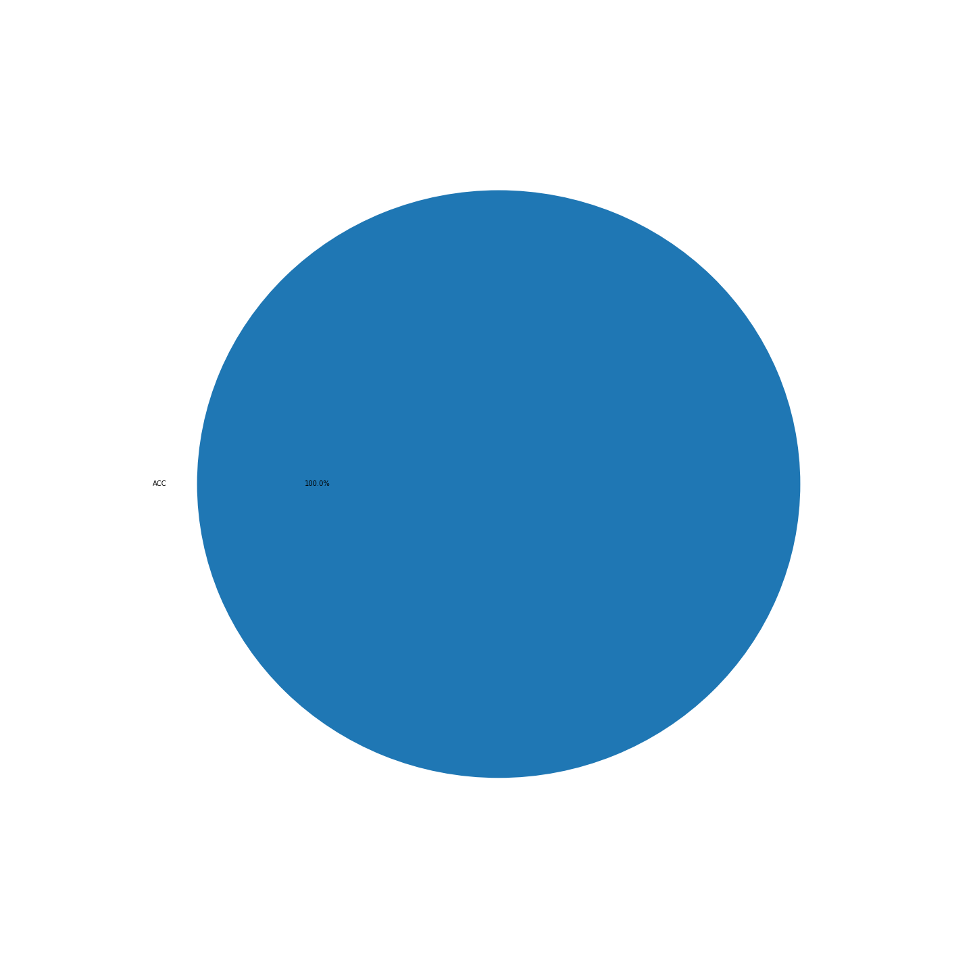
Supplementary Figure 19:PCPG
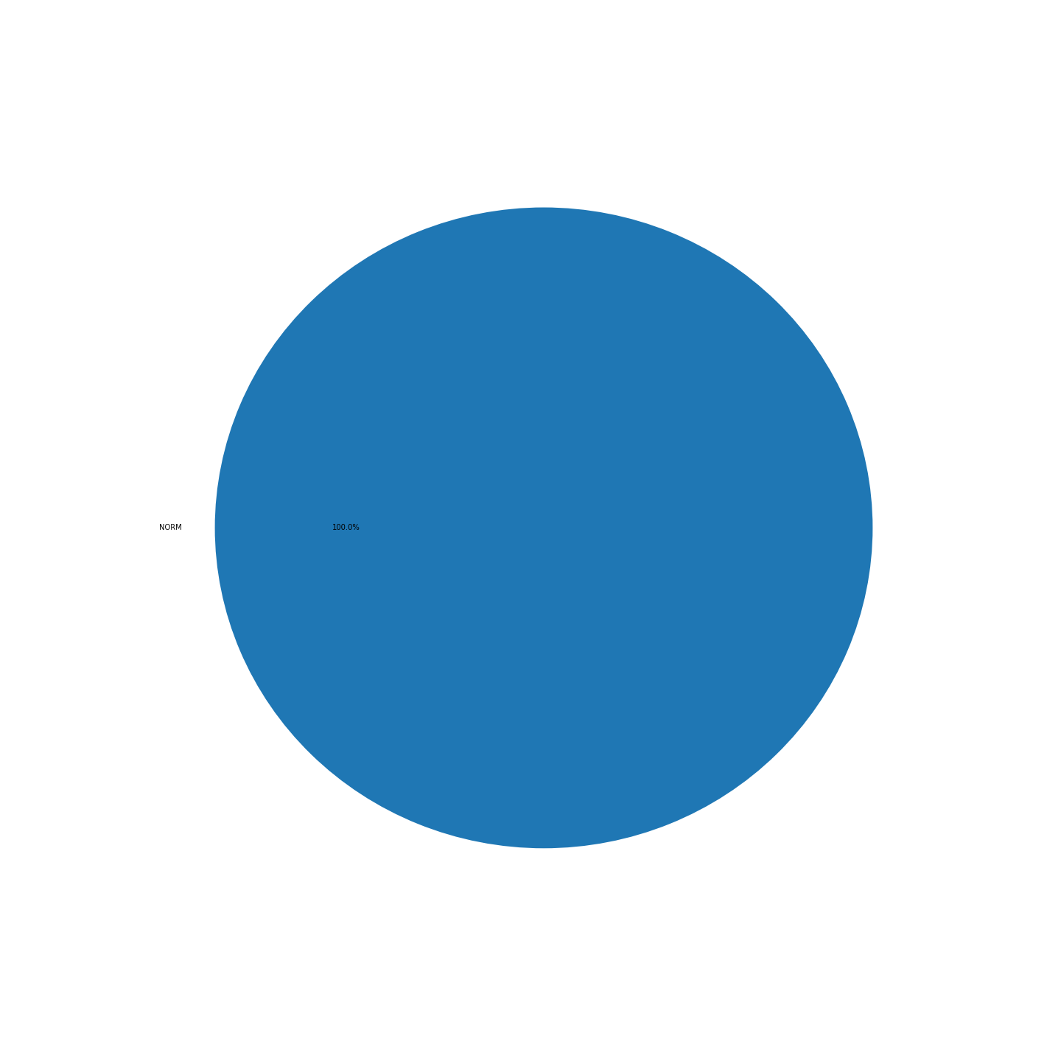
Supplementary Figure 20:PRAD
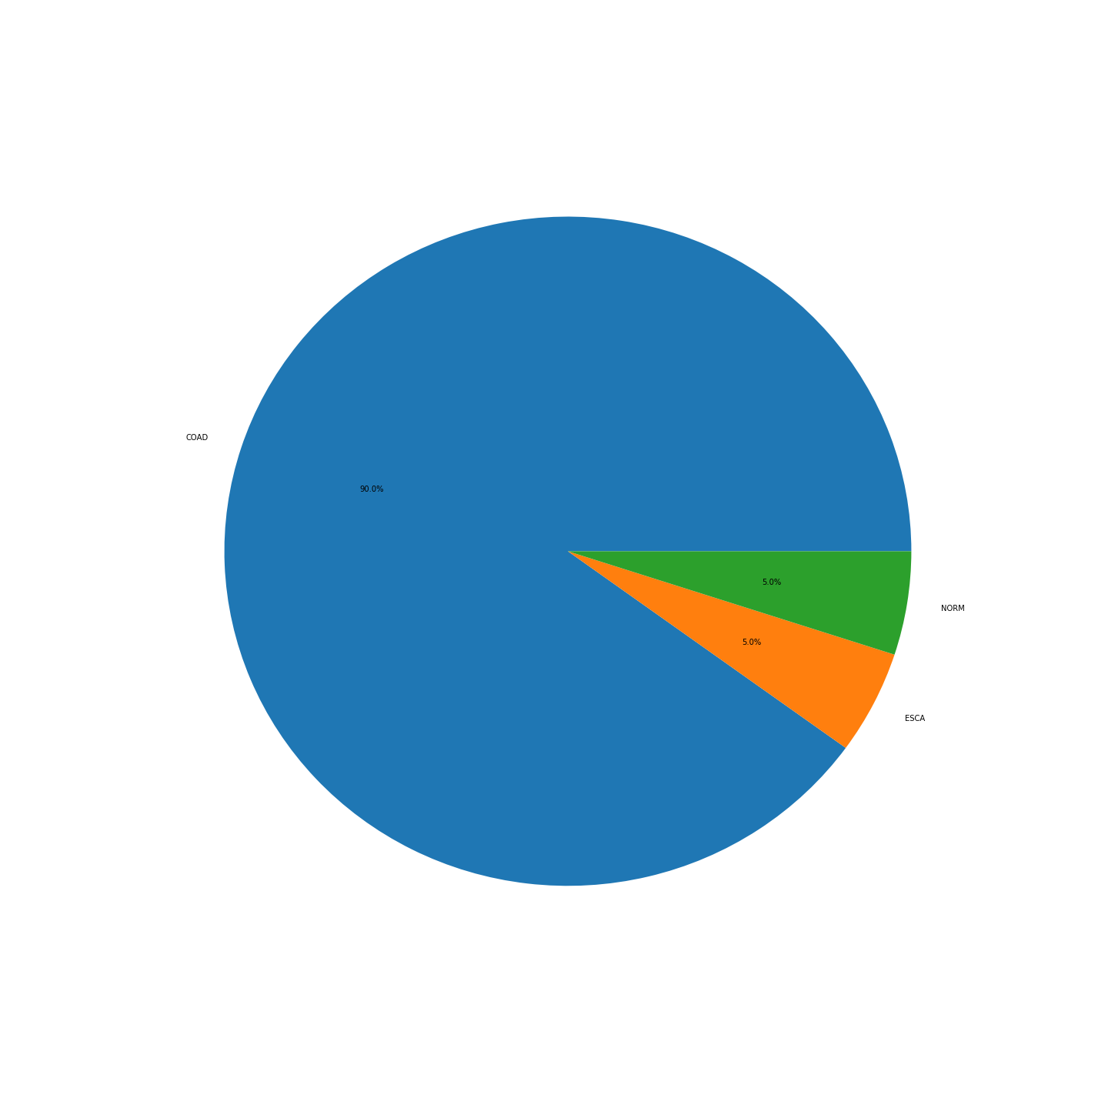
Supplementary Figure 21: READ
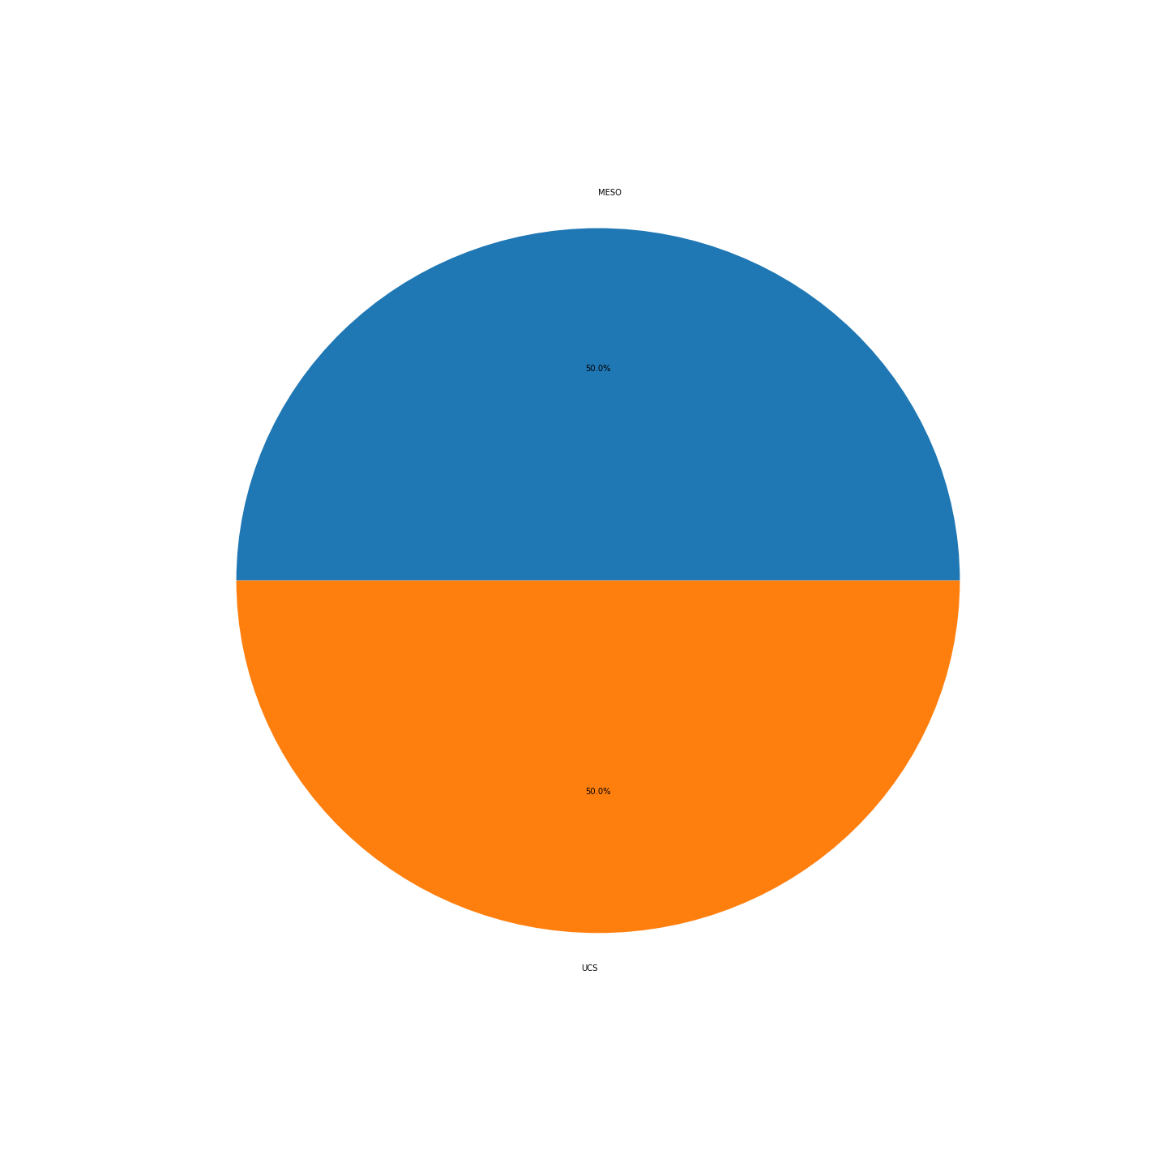
Supplementary Figure 22:SARC
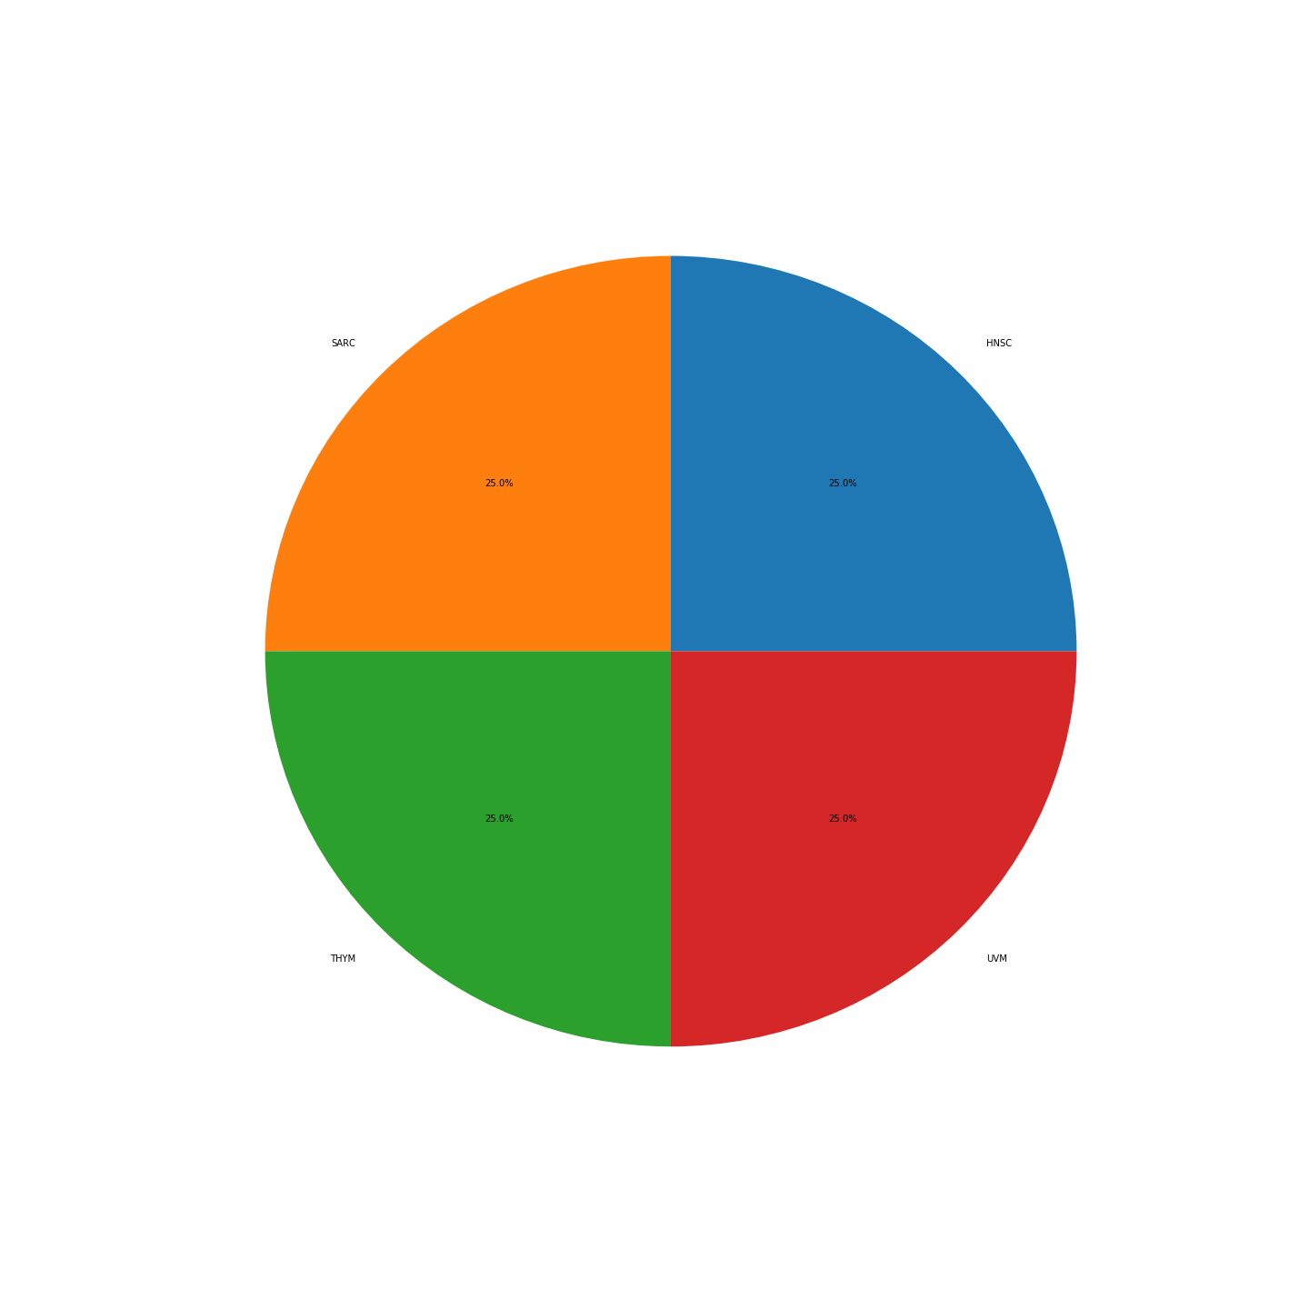
Supplementary Figure 23:SKCM
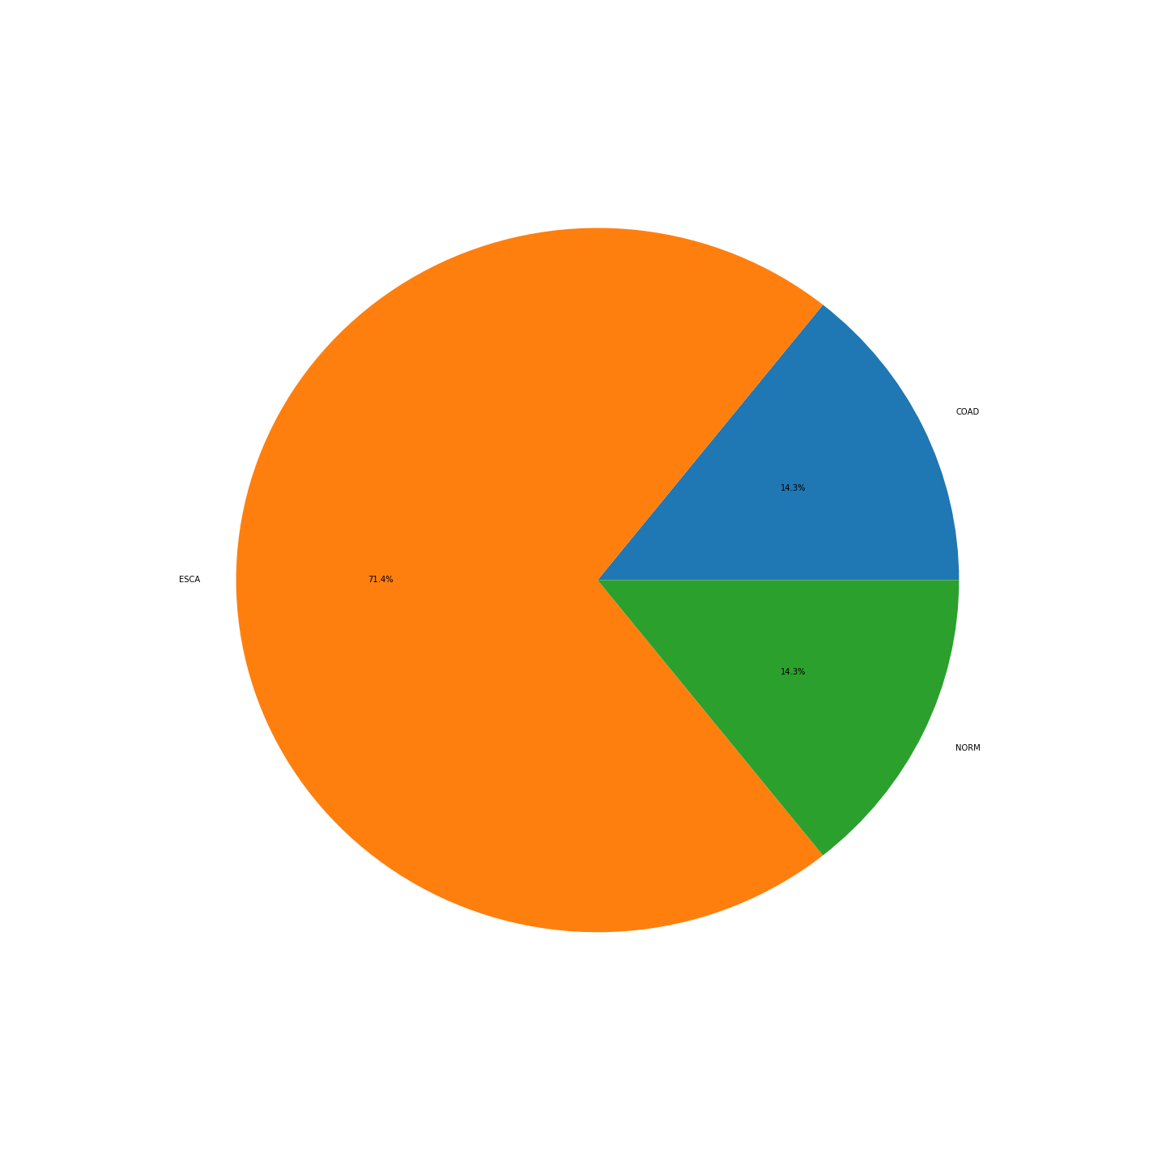
Supplementary Figure 24:STAD
Supplementary Figure 25:THCA
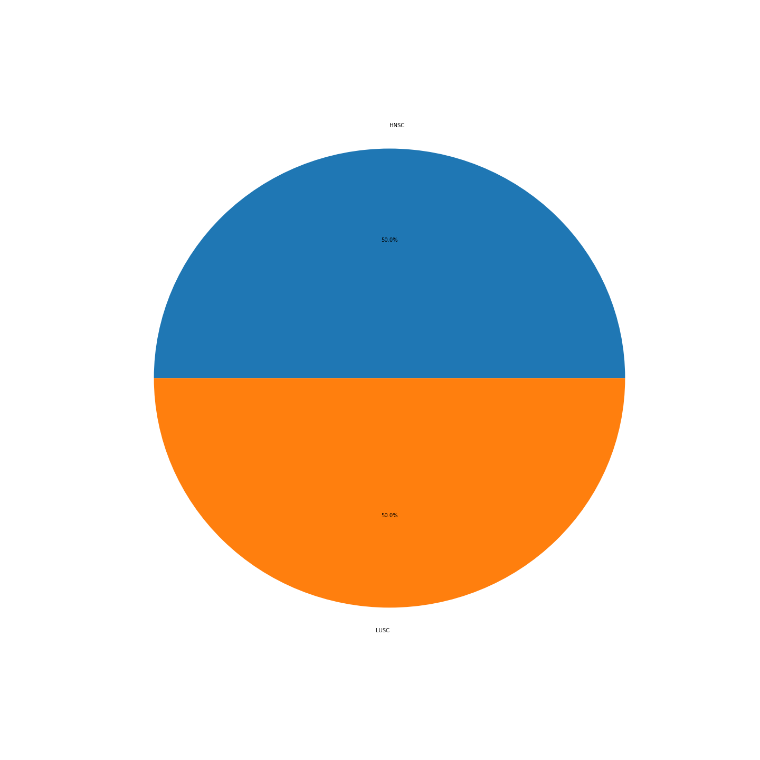
Supplementary Figure 26: THYM
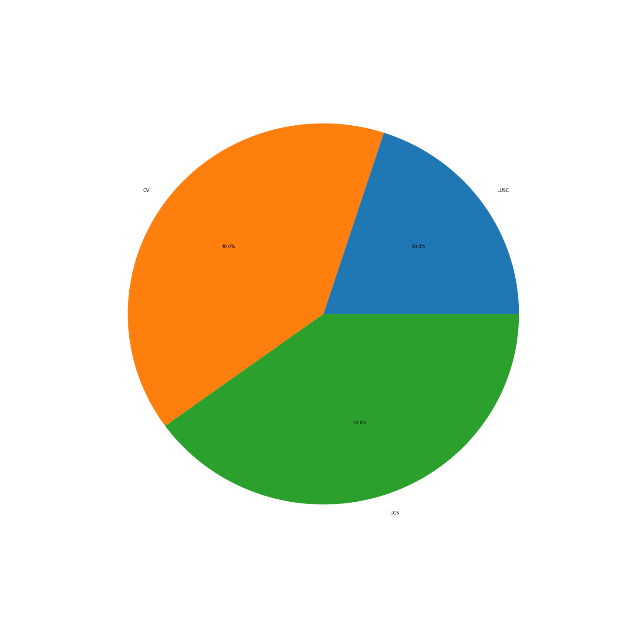
Supplementary Figure 27:UCEC
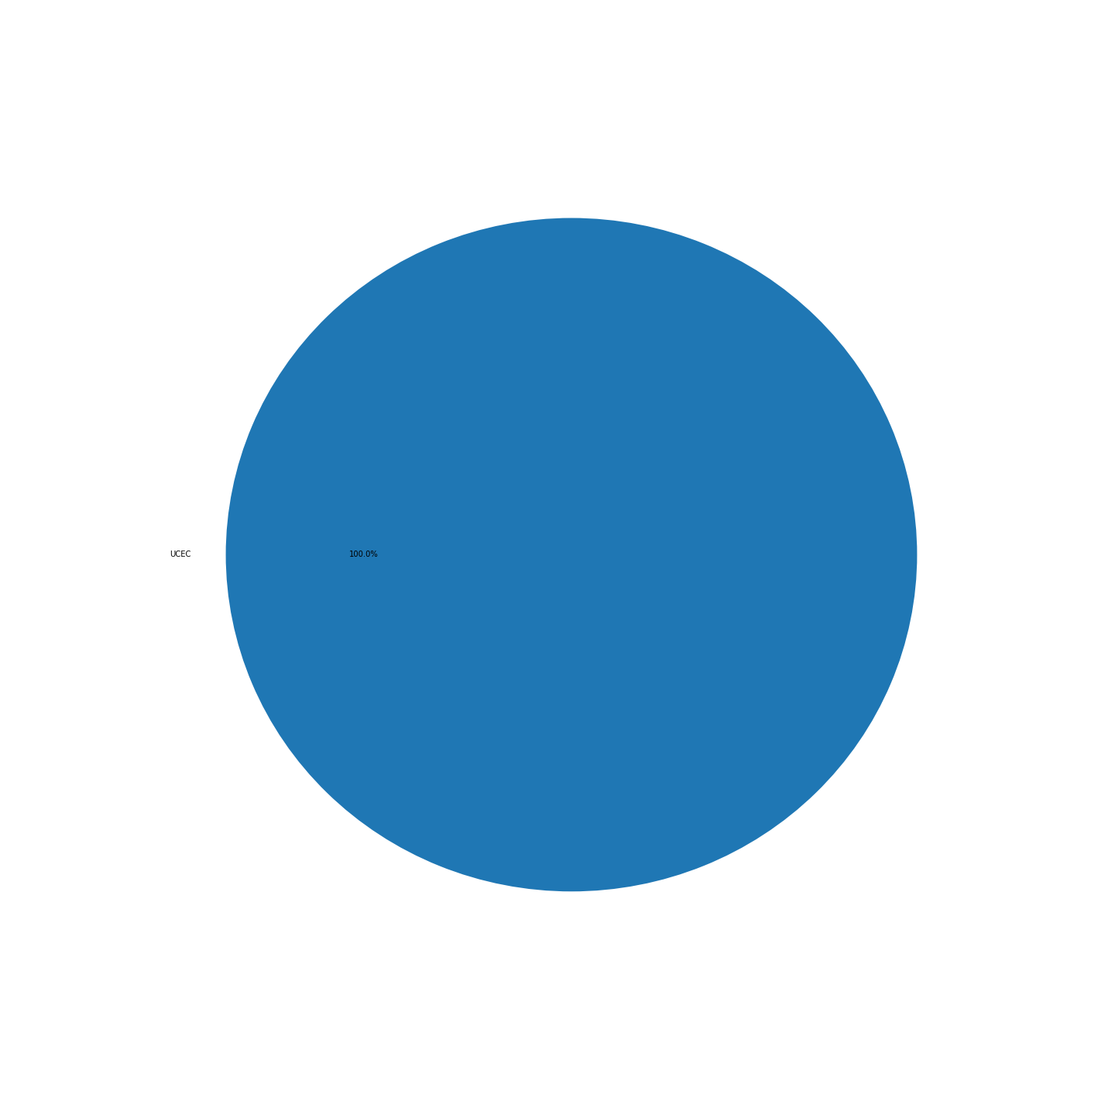
Supplementary Figure 28: UCS

Supplementary Figures 29 – 63: Latent space locations of each sample by class
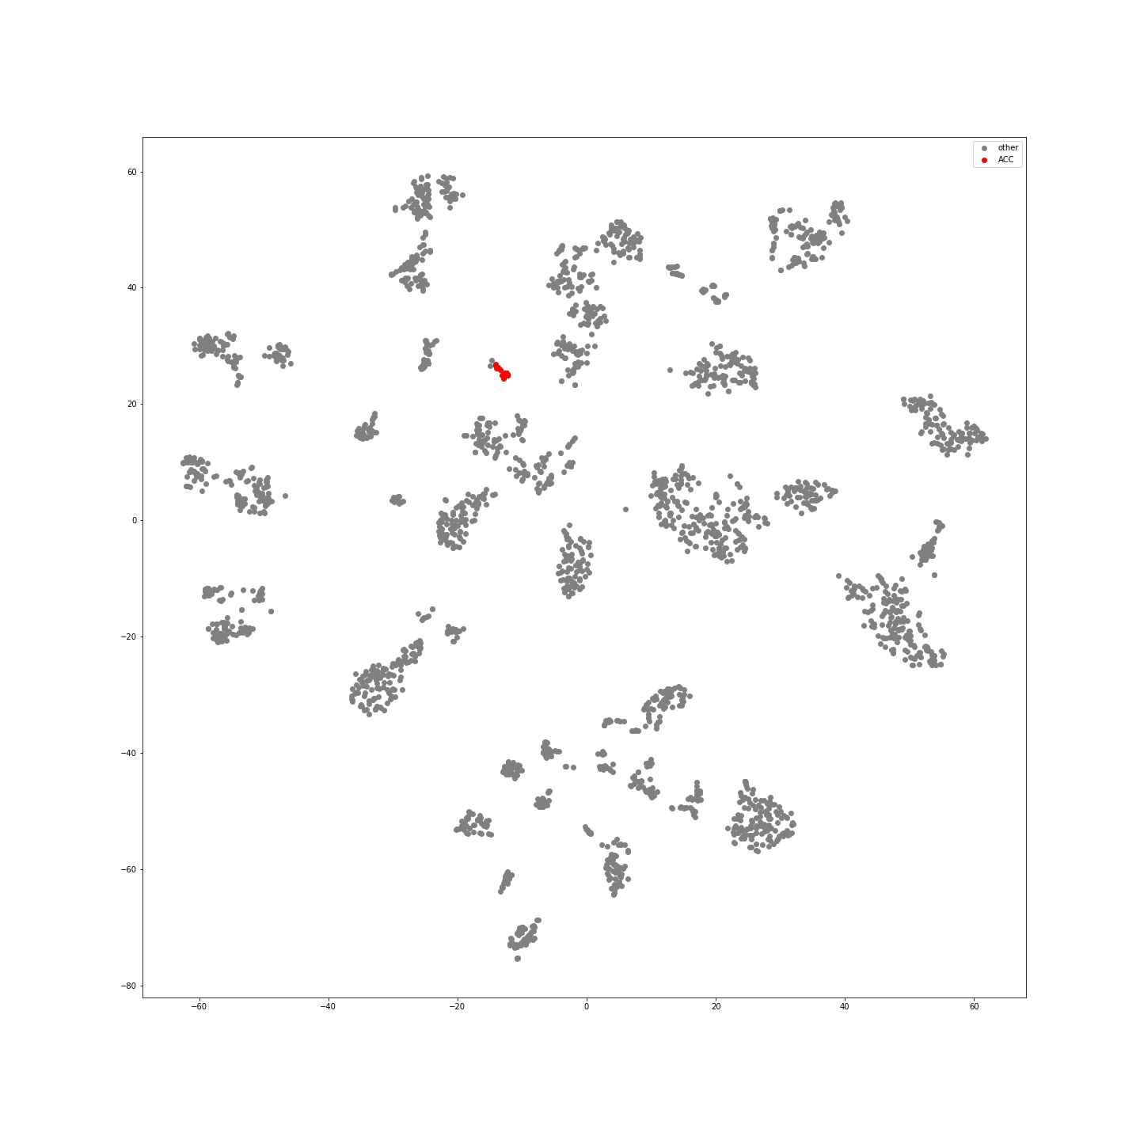
Supplementary Figure 29: ACC Samples in Latent Space
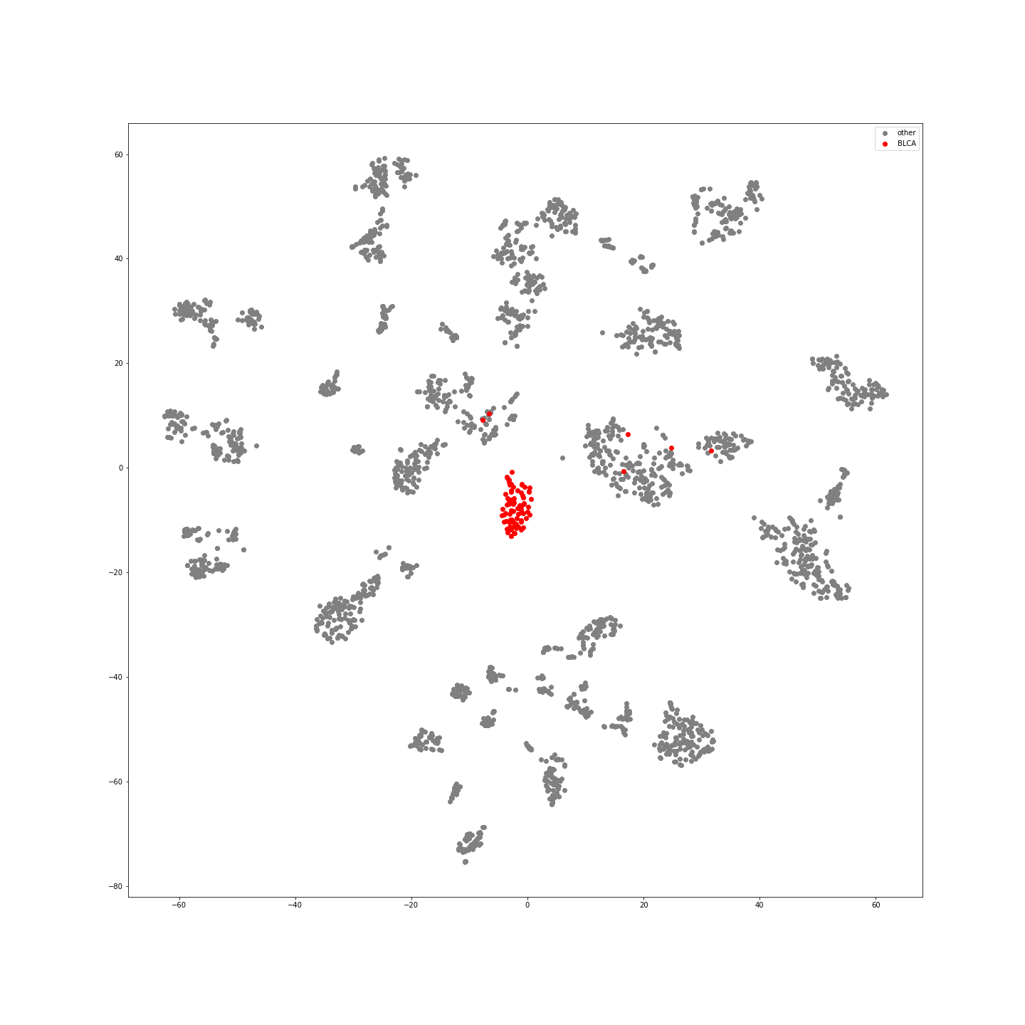
Supplementary Figure 30: BLCA Samples in Latent Space
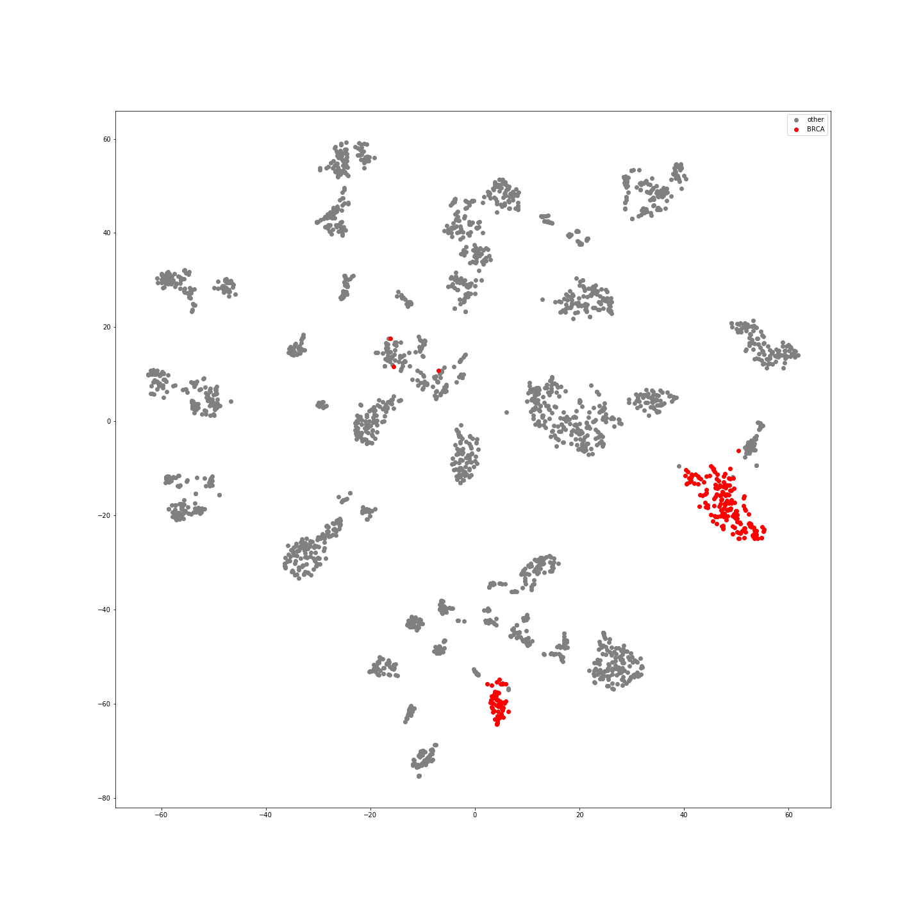
Supplementary Figure 31: BLCA Samples in Latent Space
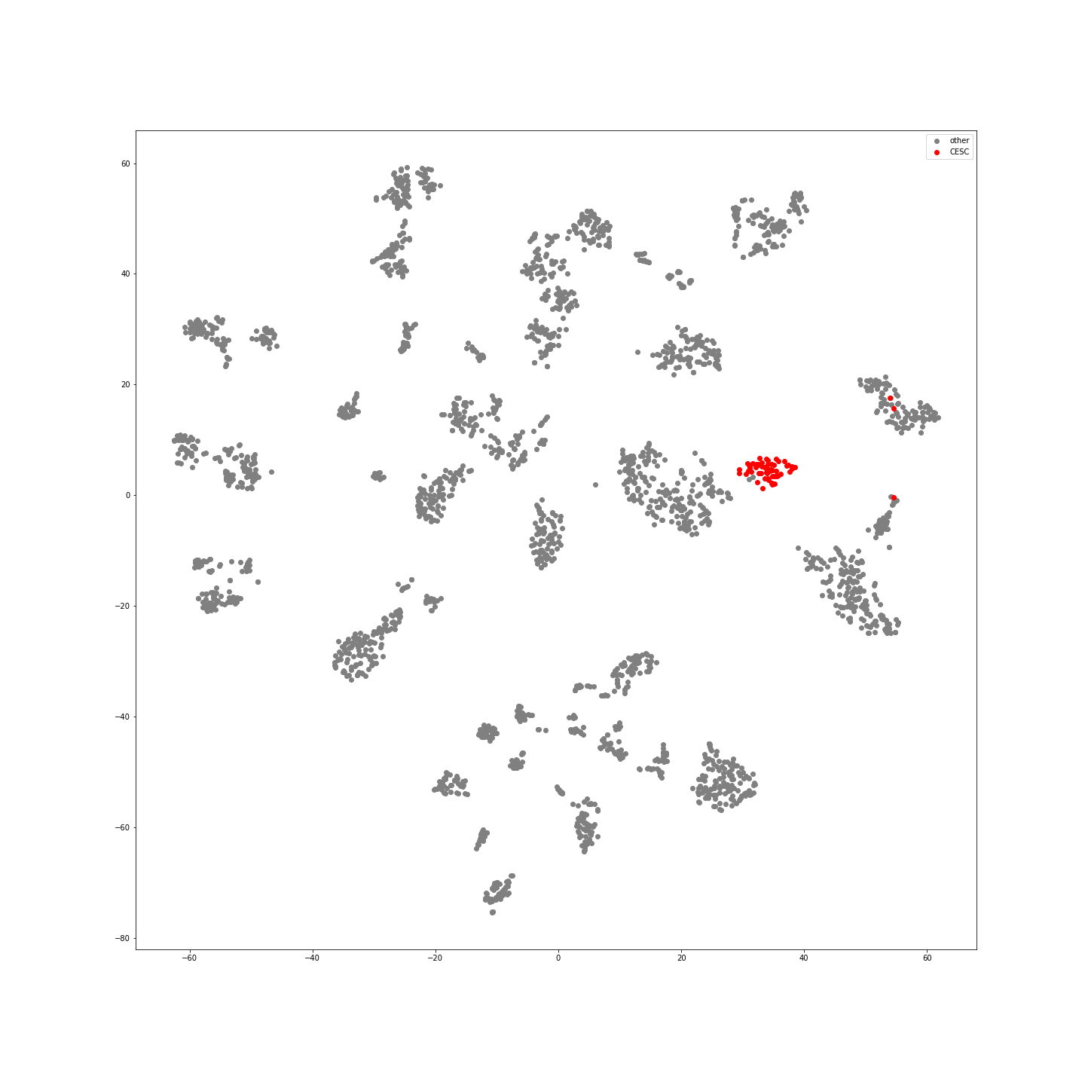
Supplementary Figure 32: CESC Samples in Latent Space
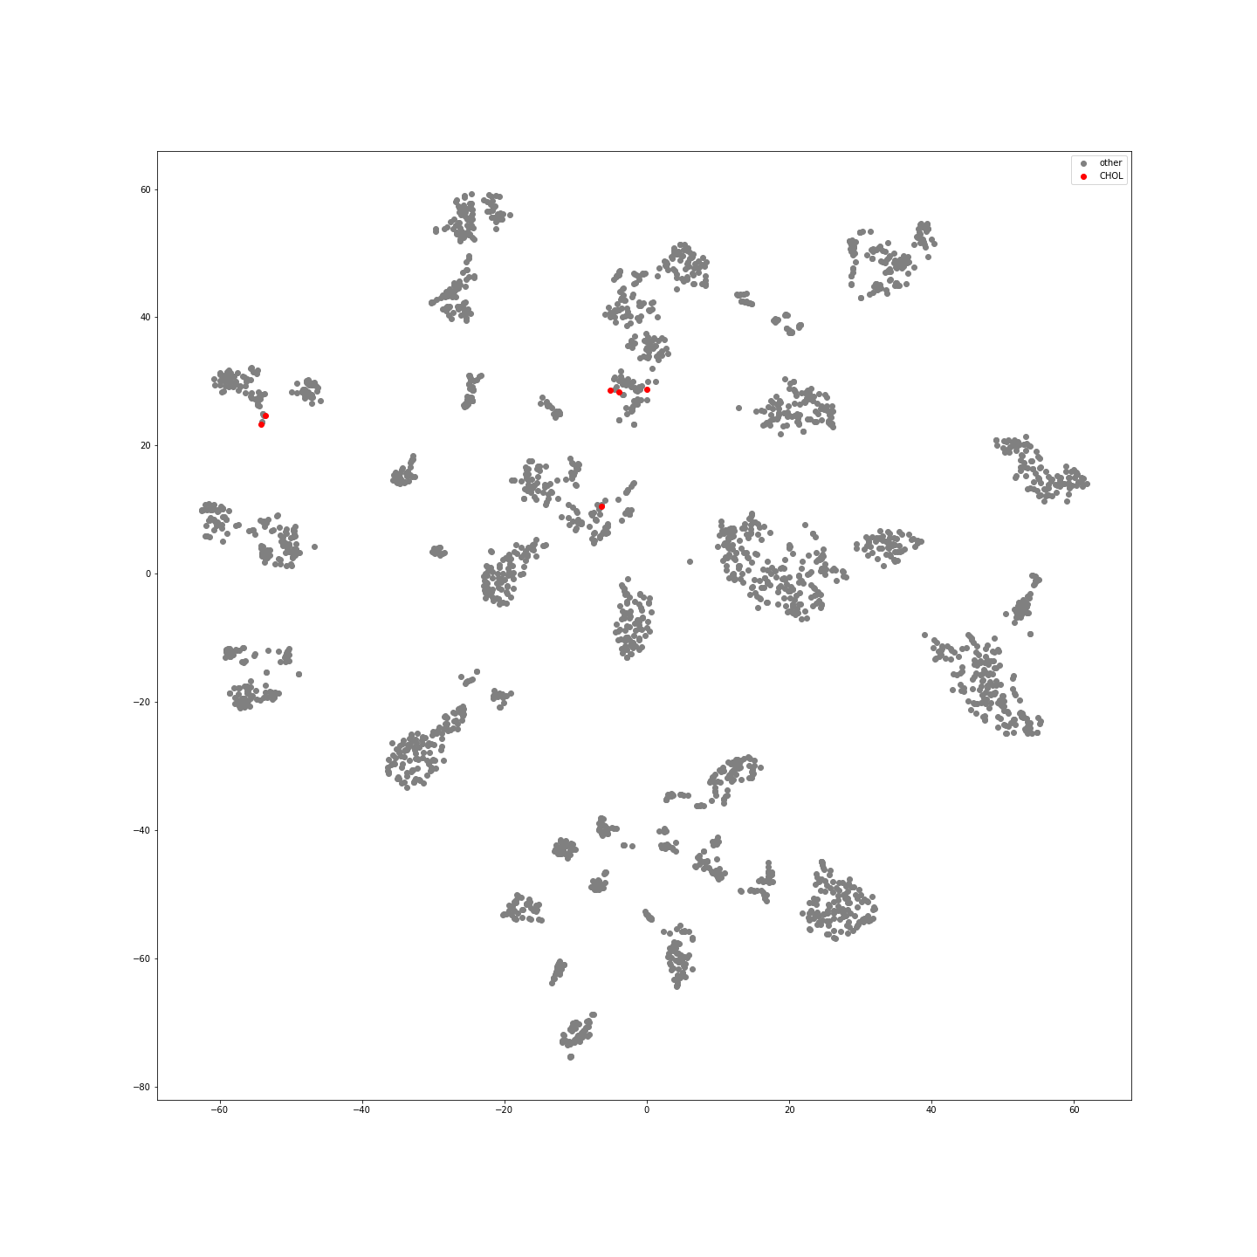
Supplementary Figure 33: CHOL Samples in Latent Space
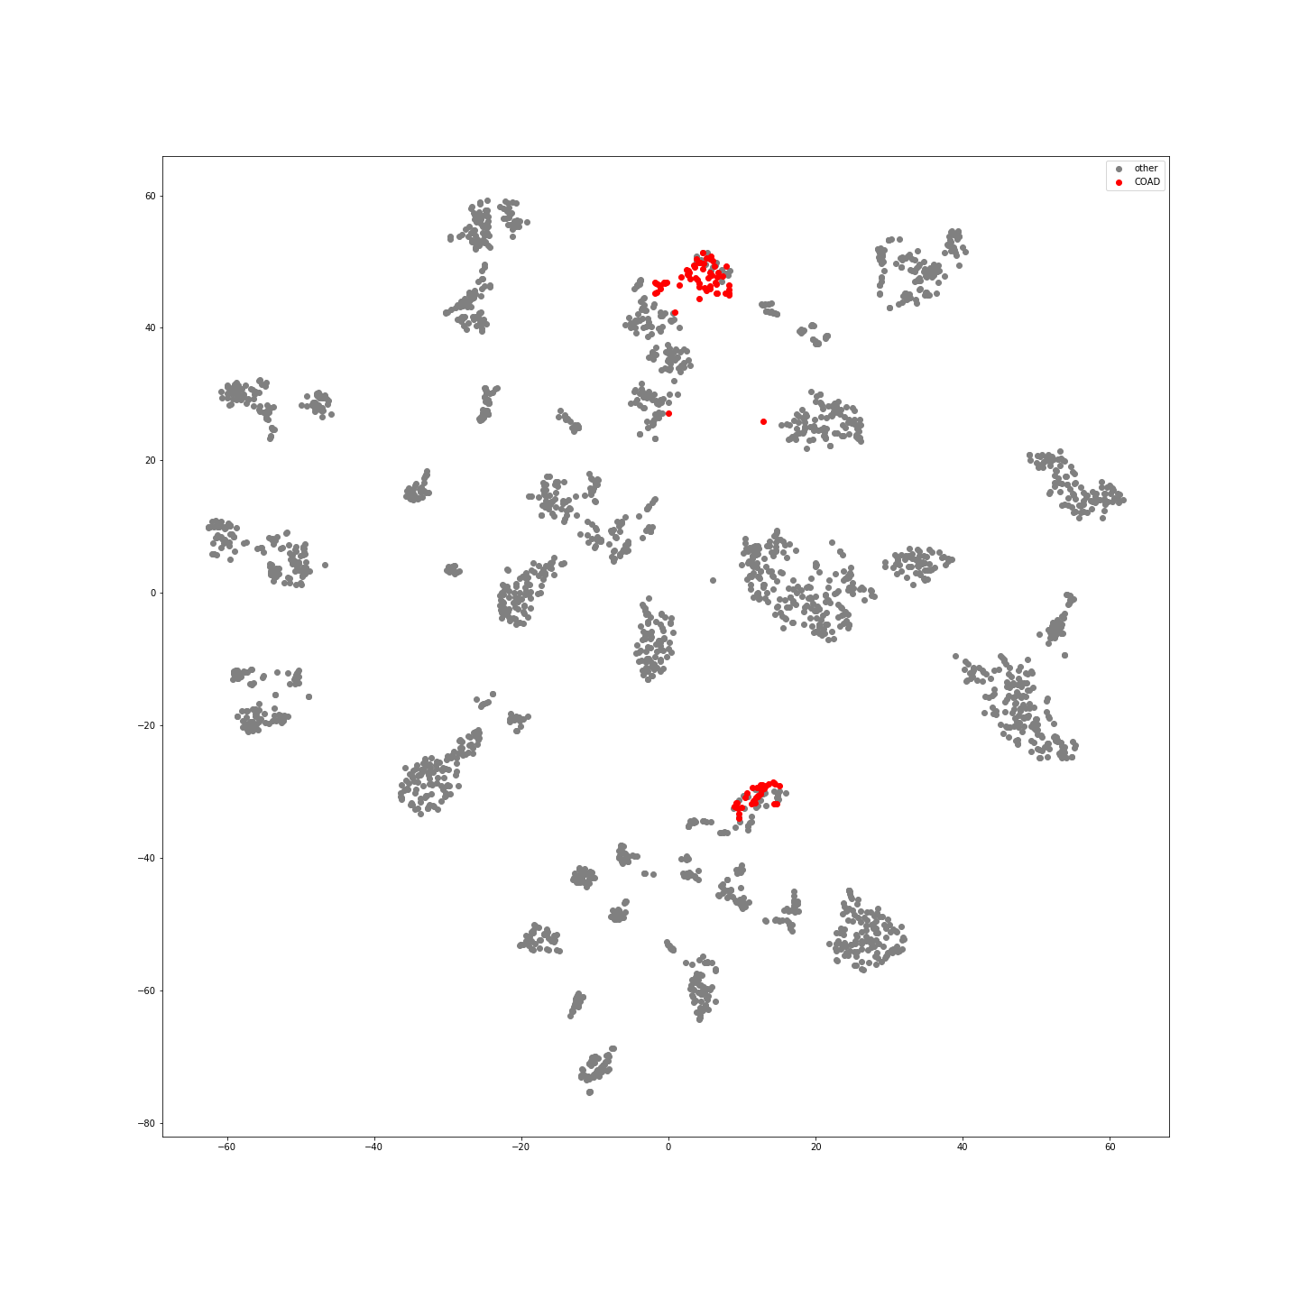
Supplementary Figure 34: COAD Samples in Latent Space
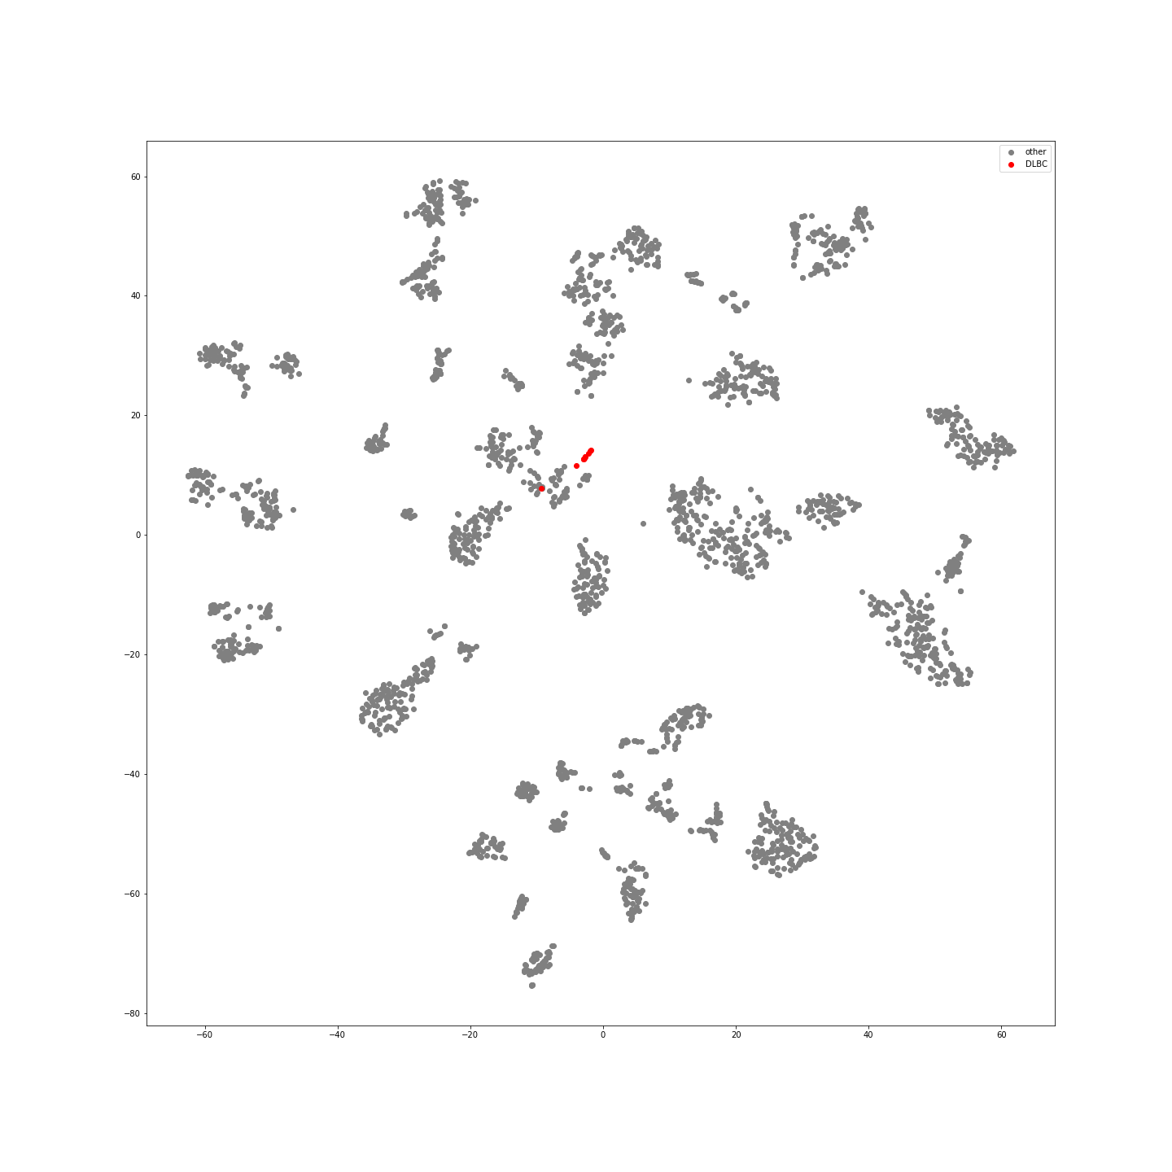
Supplementary Figure 35: DLBC Samples in Latent Space
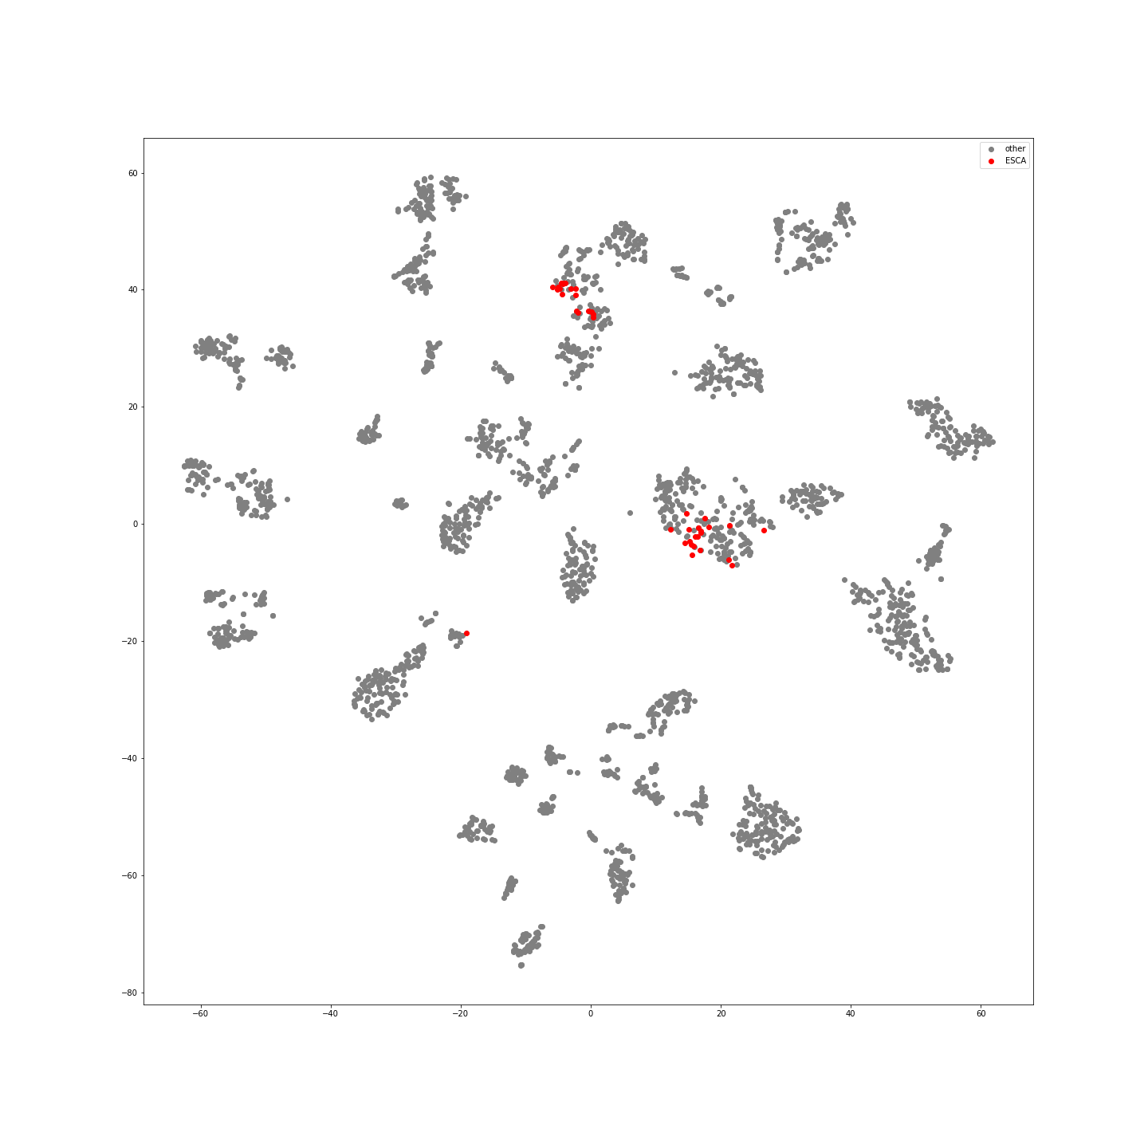
Supplementary Figure 36: ESCA Samples in Latent Space
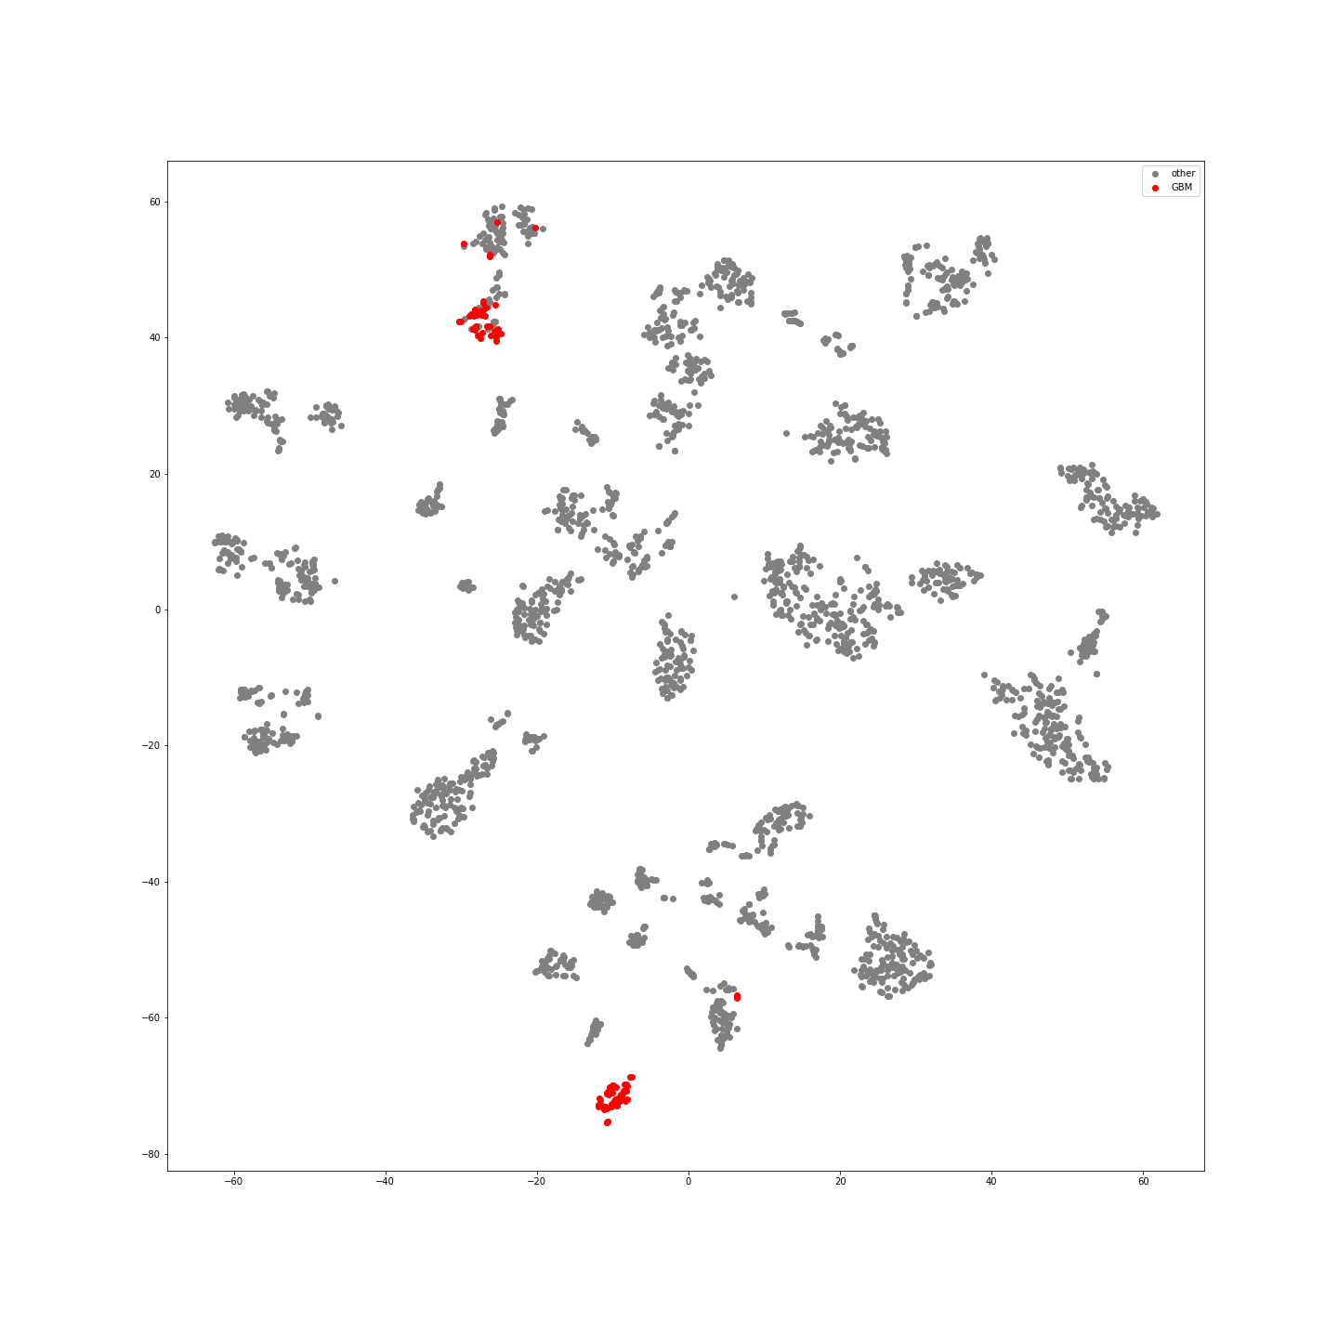
Supplementary Figure 37:GBM Samples in Latent Space
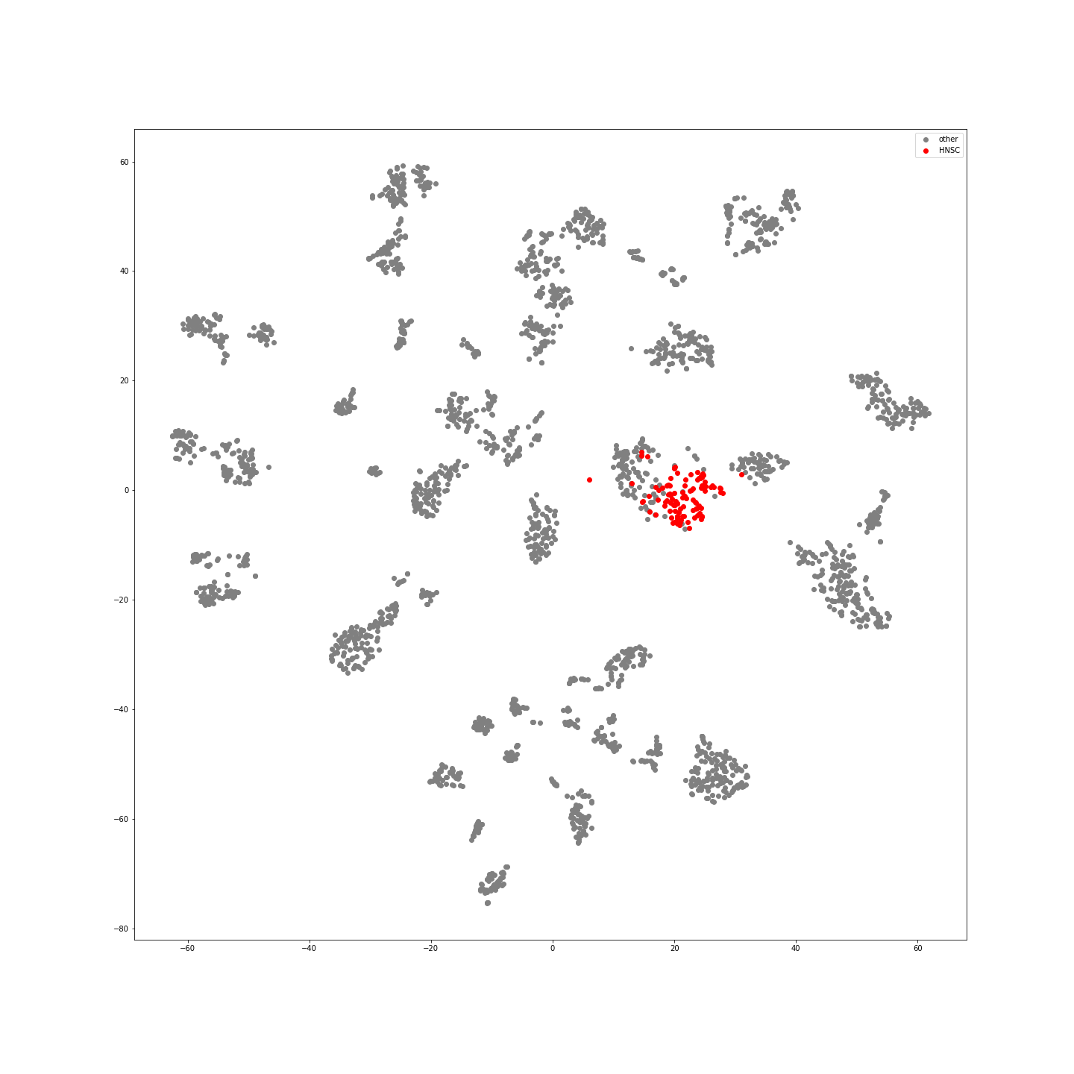
Supplementary Figure 38: HNSC Samples in Latent Space
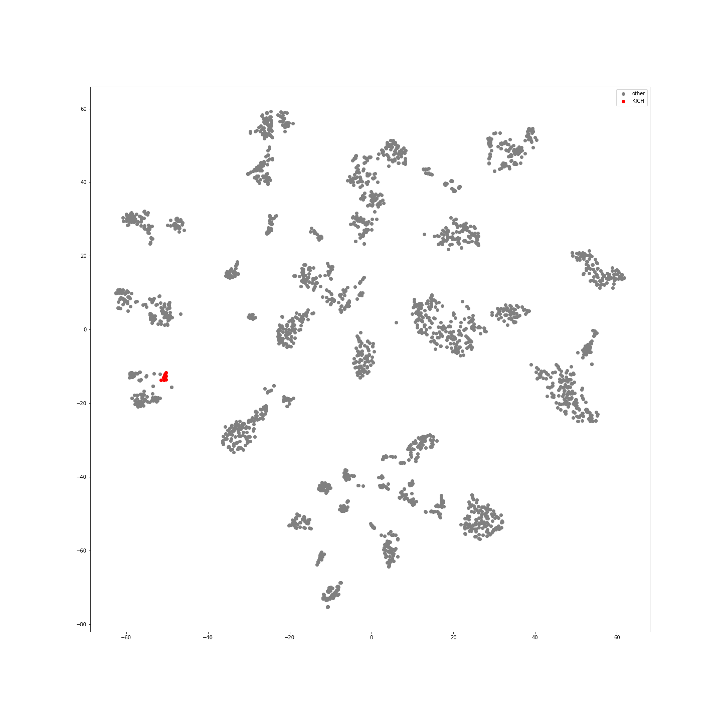
Supplementary Figure 39:KCH Samples in Latent Space
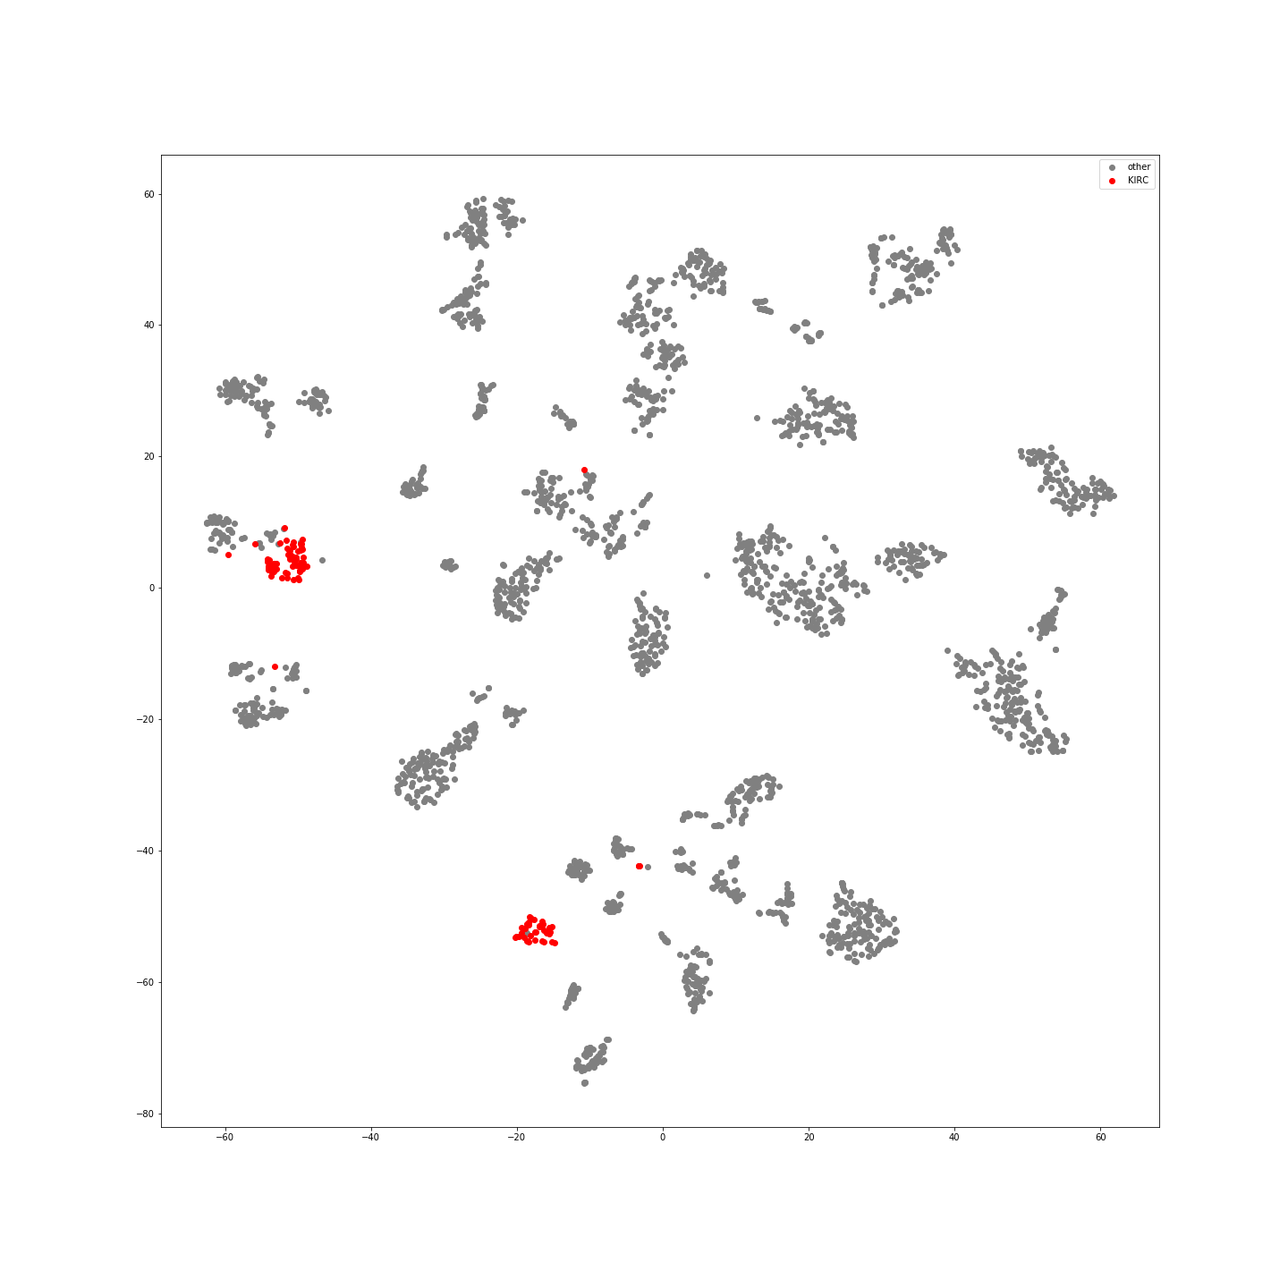
Supplementary Figure 40:KIRC Samples in Latent Space
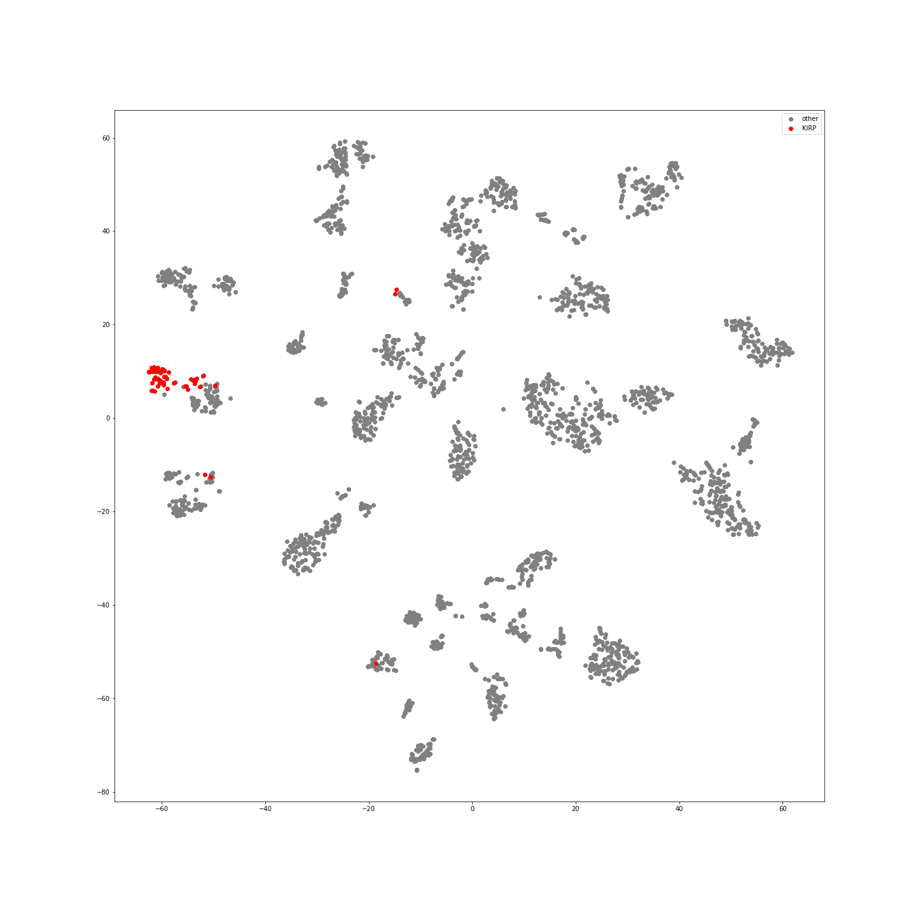
Supplementary Figure 41: KIRP Samples in Latent Space
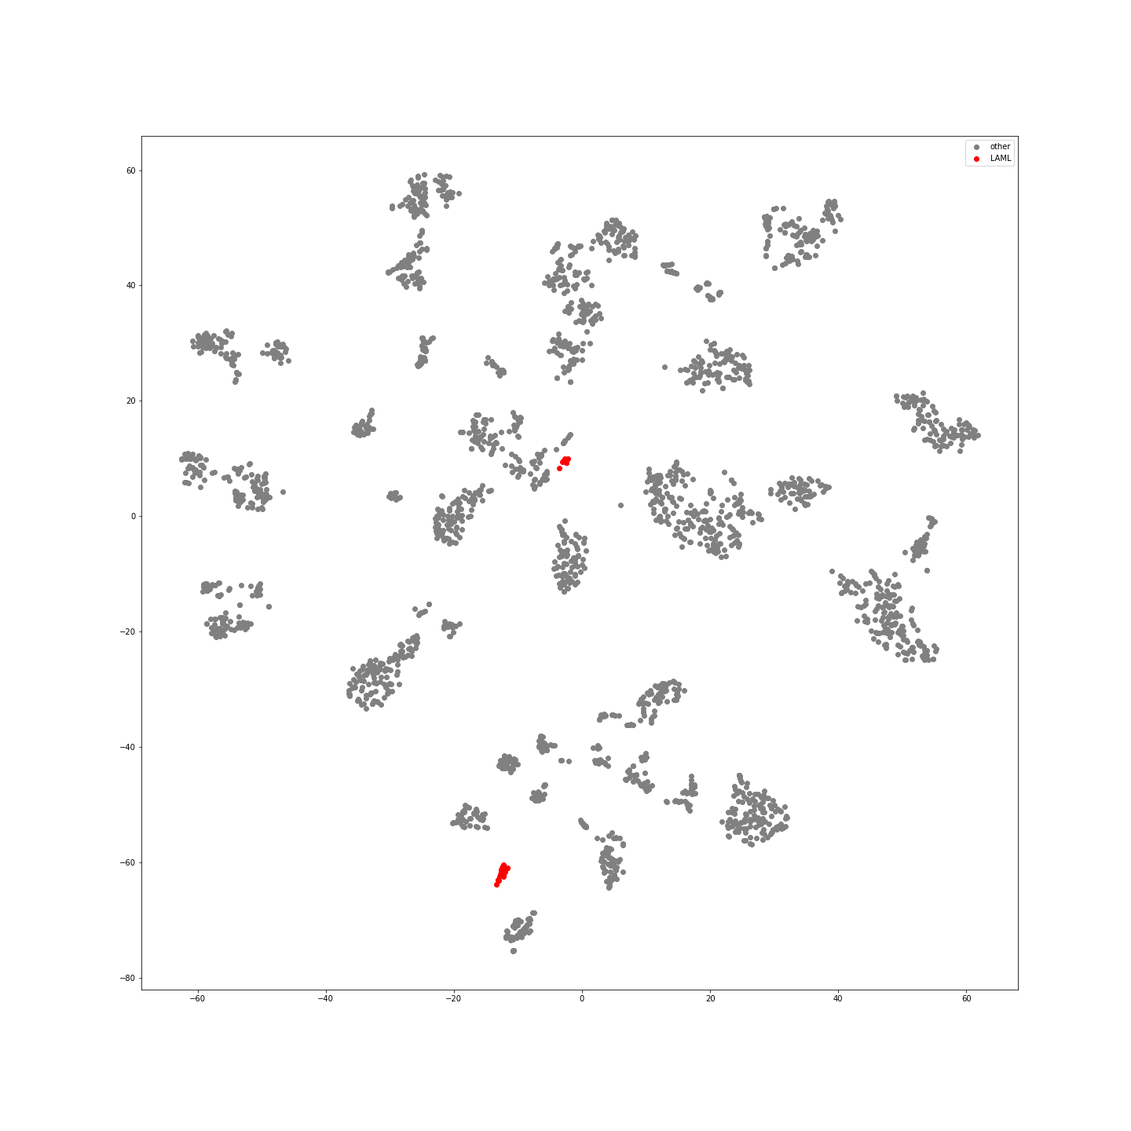
Supplementary Figure 42: LAML Samples in Latent Space
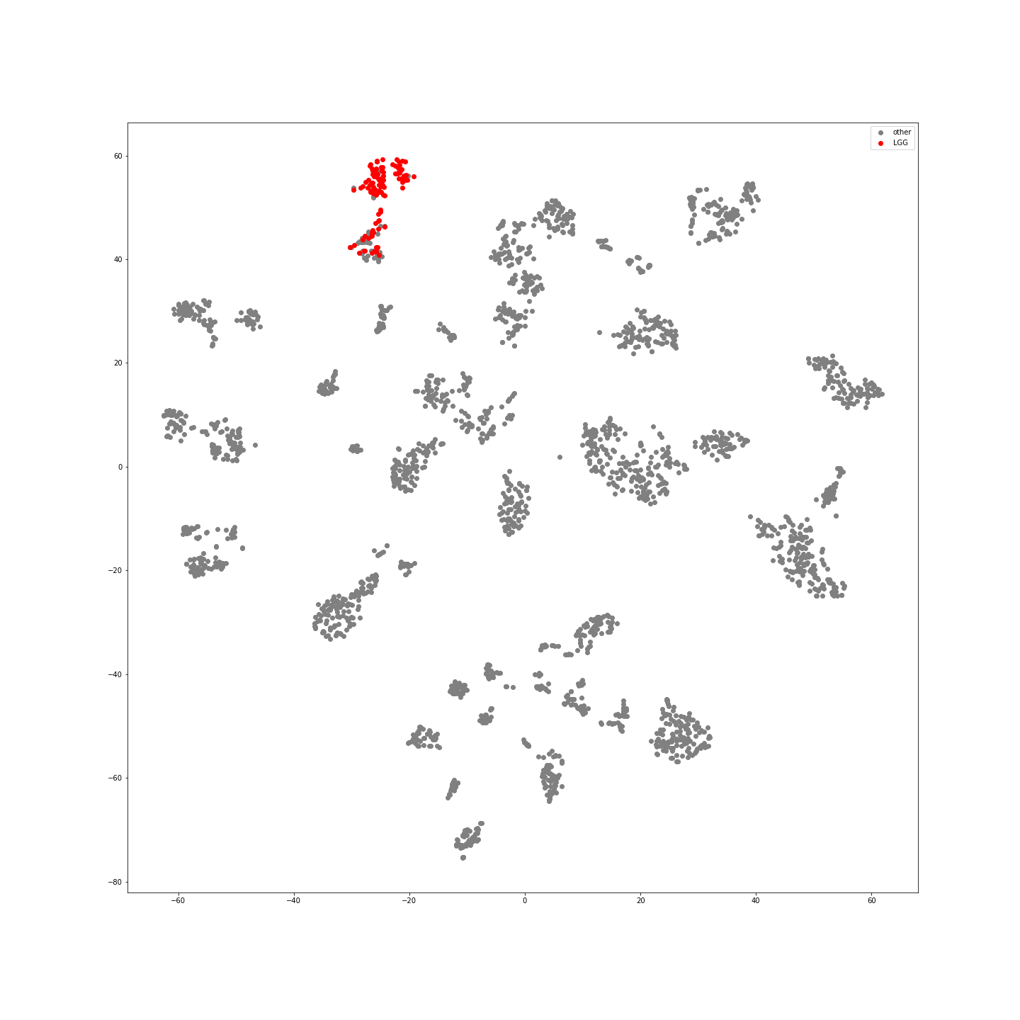
Supplementary Figure 43: LGG Samples in Latent Space
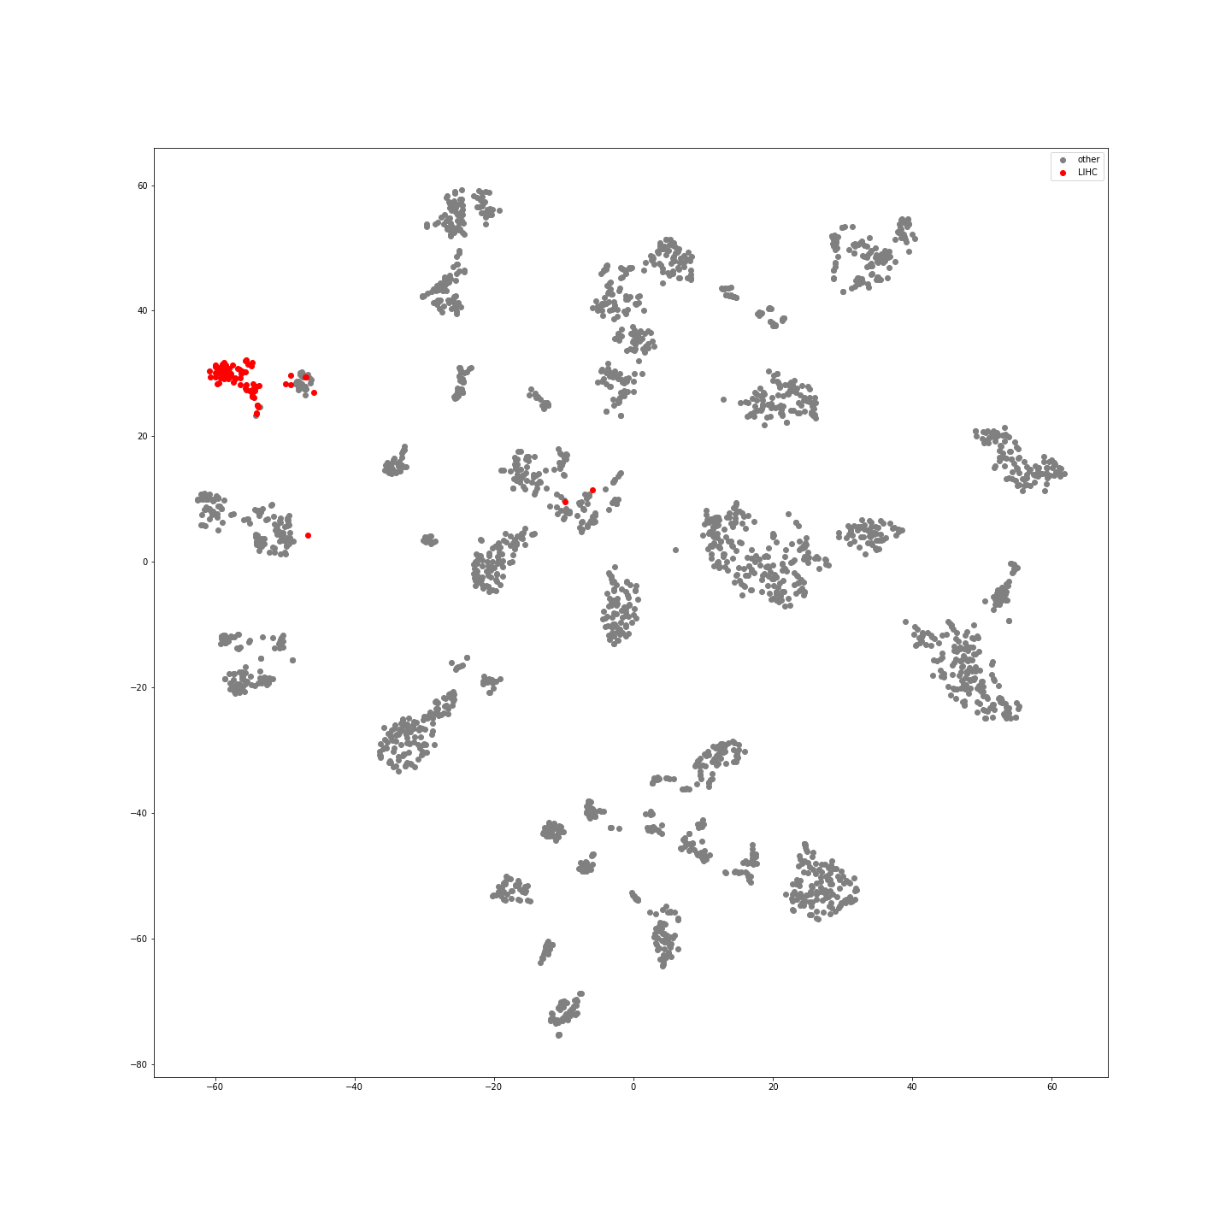
Supplementary Figure 44: LIHC Samples in Latent Space
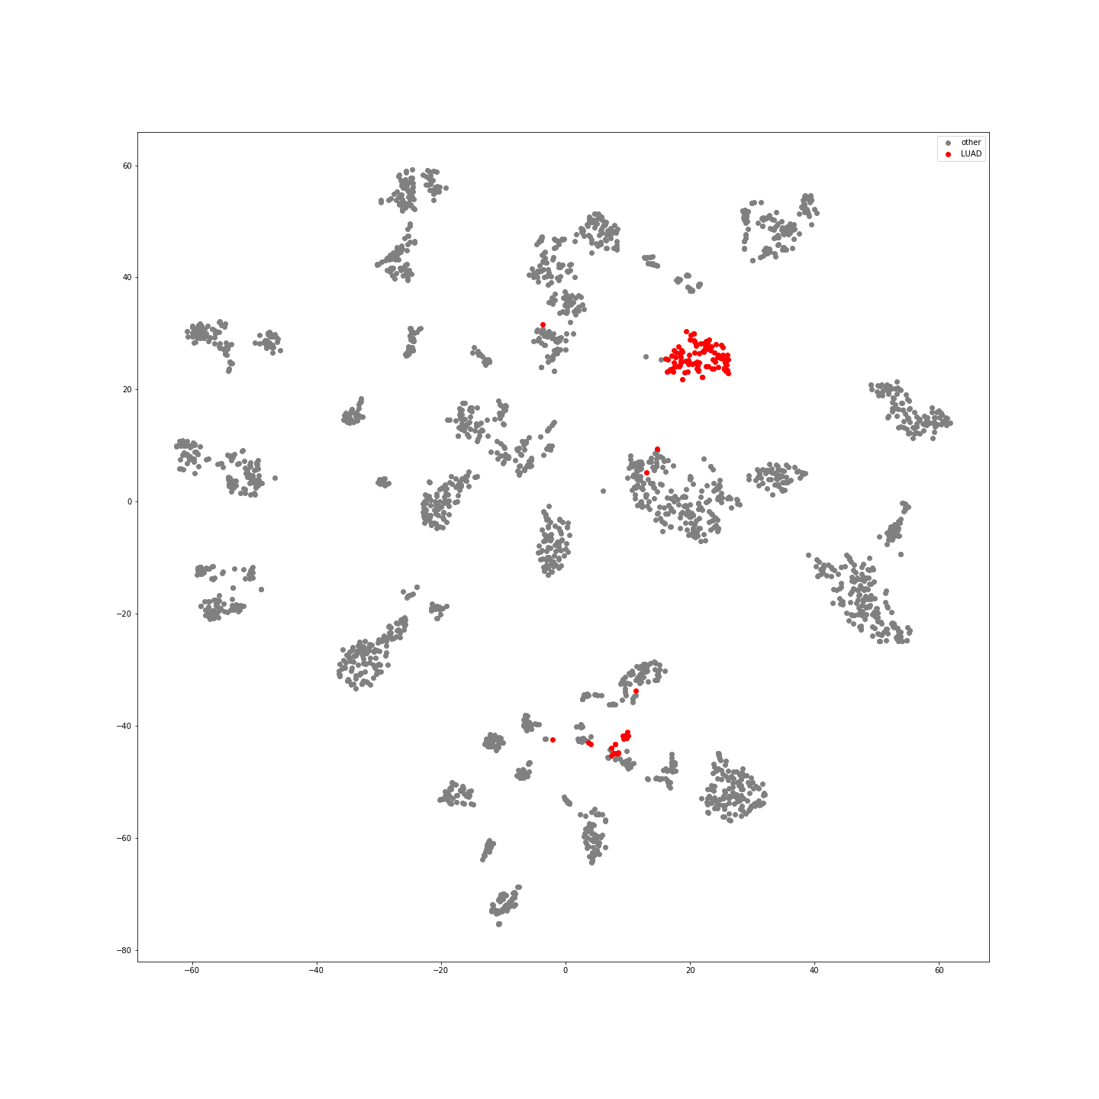
Supplementary Figure 45: LUAD Samples in Latent Space
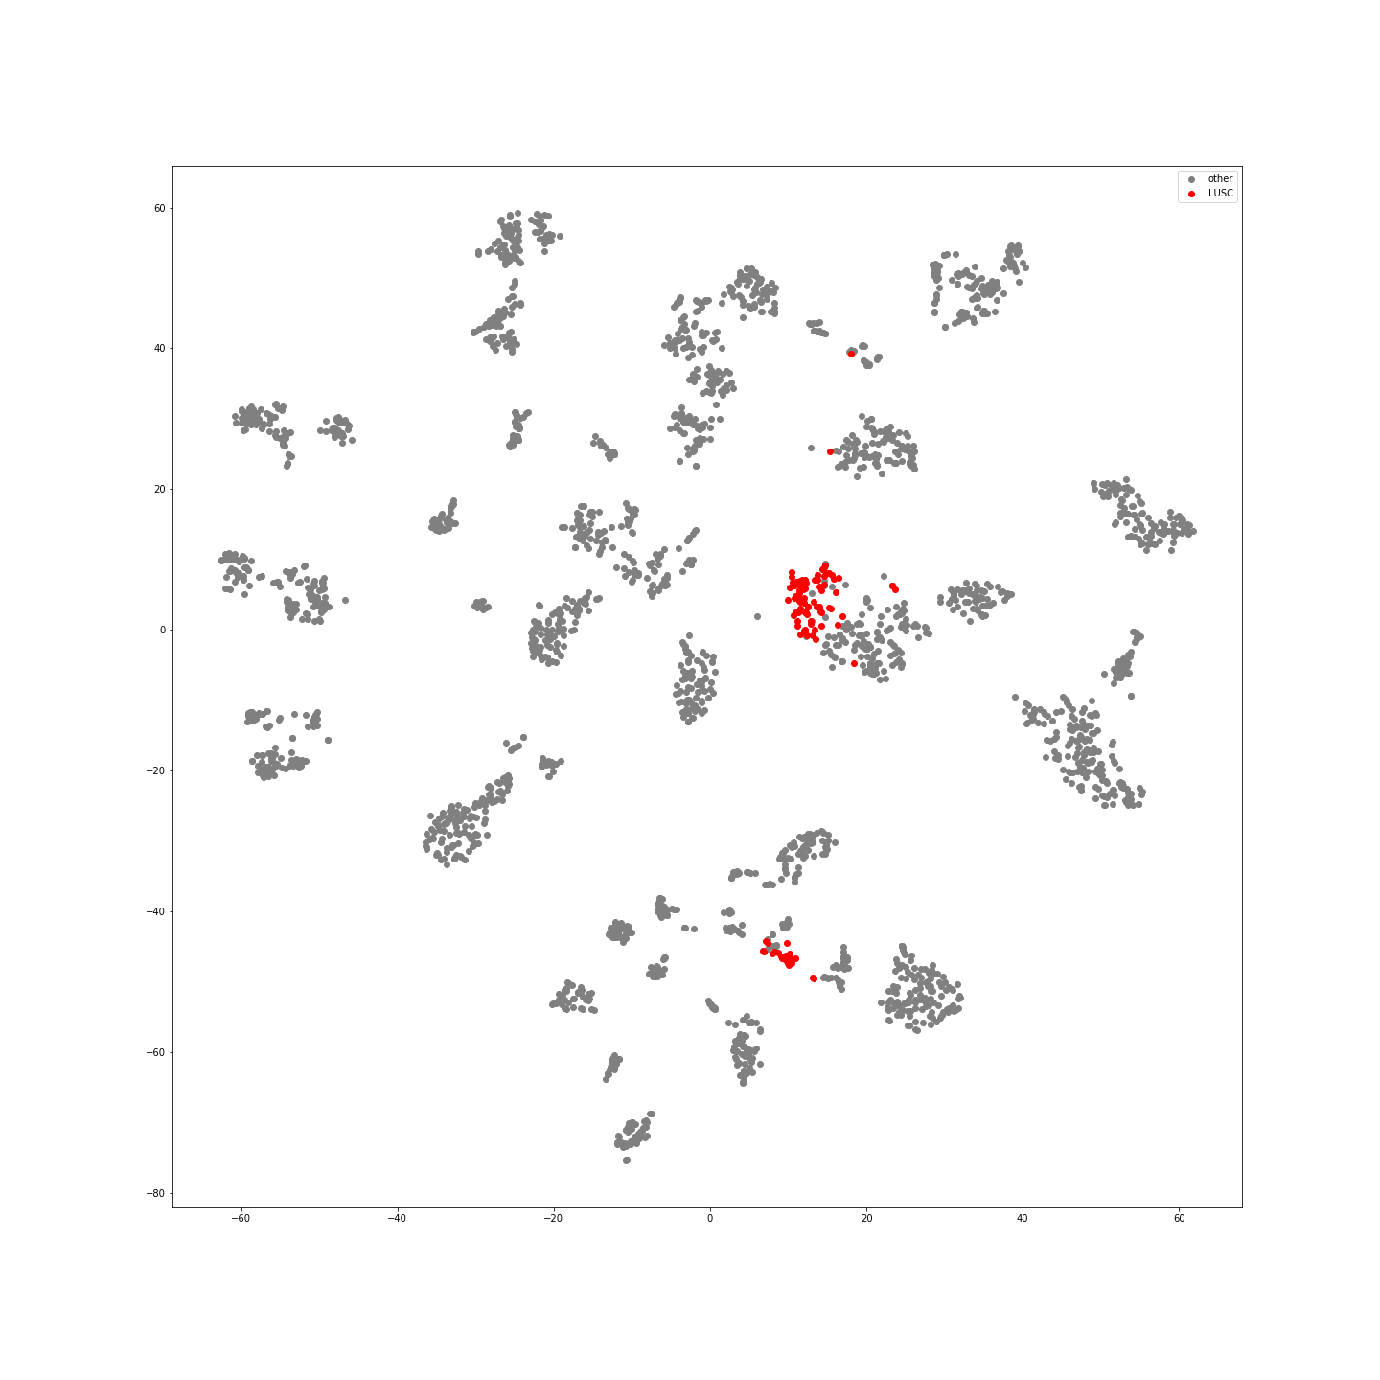
Supplementary Figure 46: LUSC Samples in Latent Space
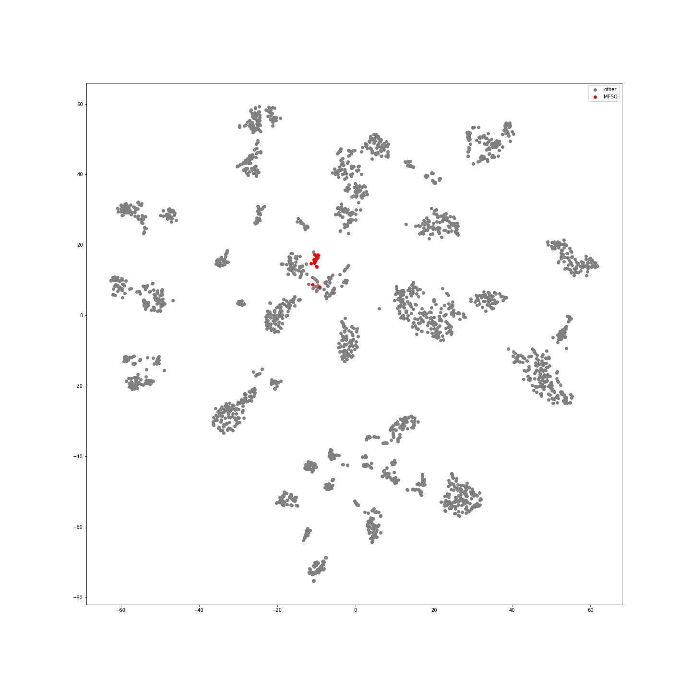
Supplementary Figure 47: MESO Samples in Latent Space
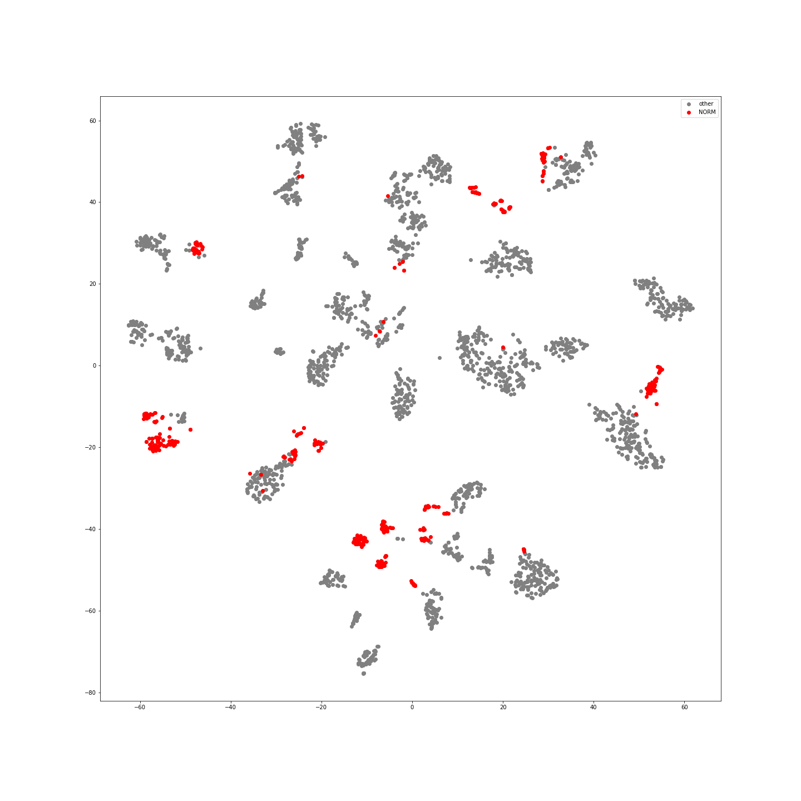
Supplementary Figure 48: NORM Samples in Latent Space
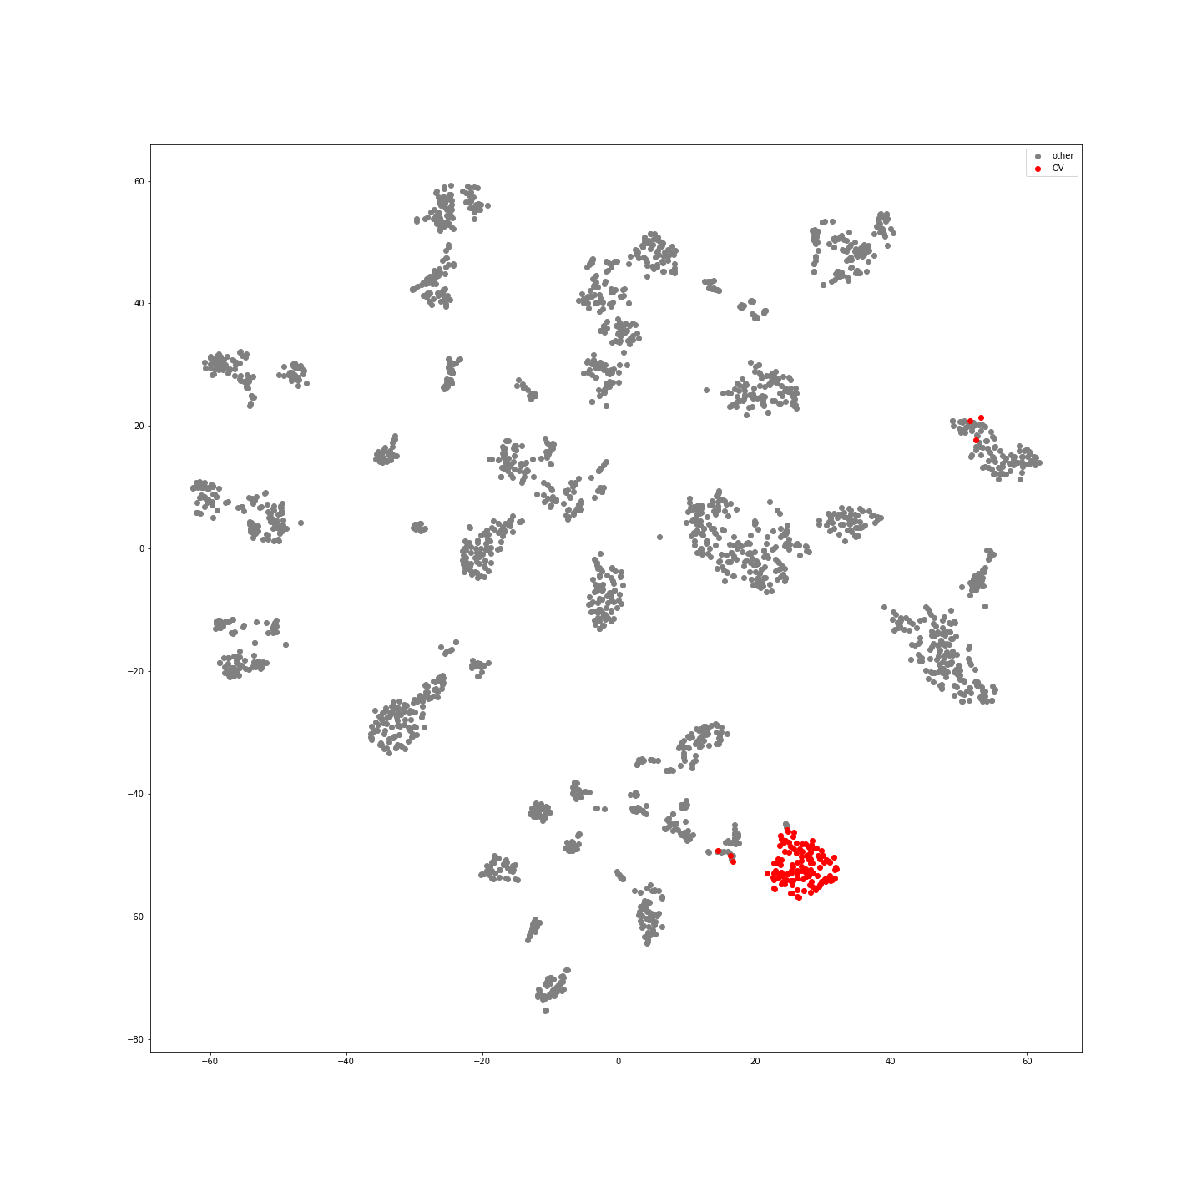
Supplementary Figure 49: OV Samples in Latent Space
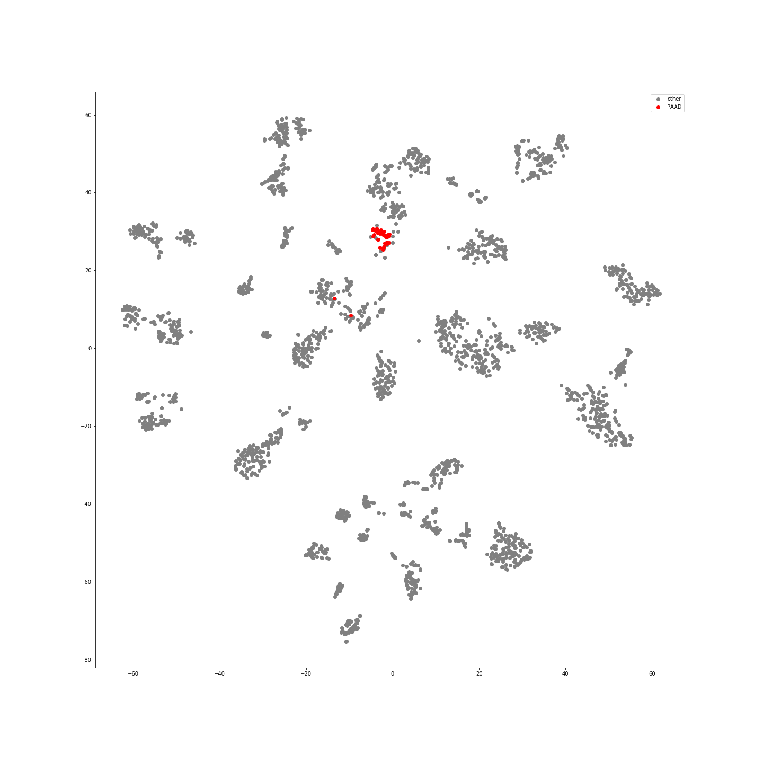
Supplementary Figure 50: PAAD Samples in Latent Space
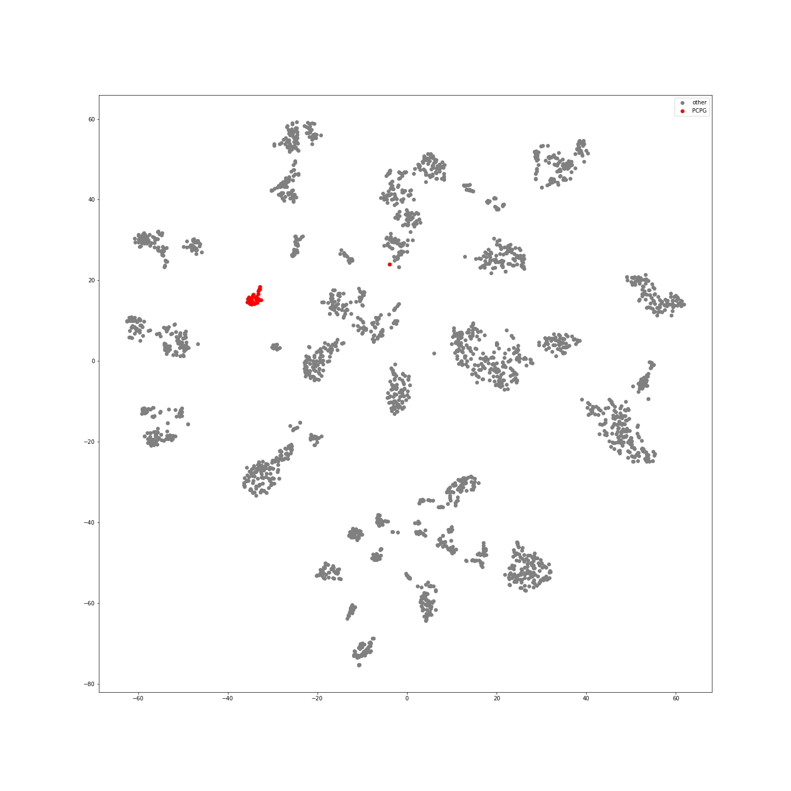
Supplementary Figure 51:PCPG Samples in Latent Space
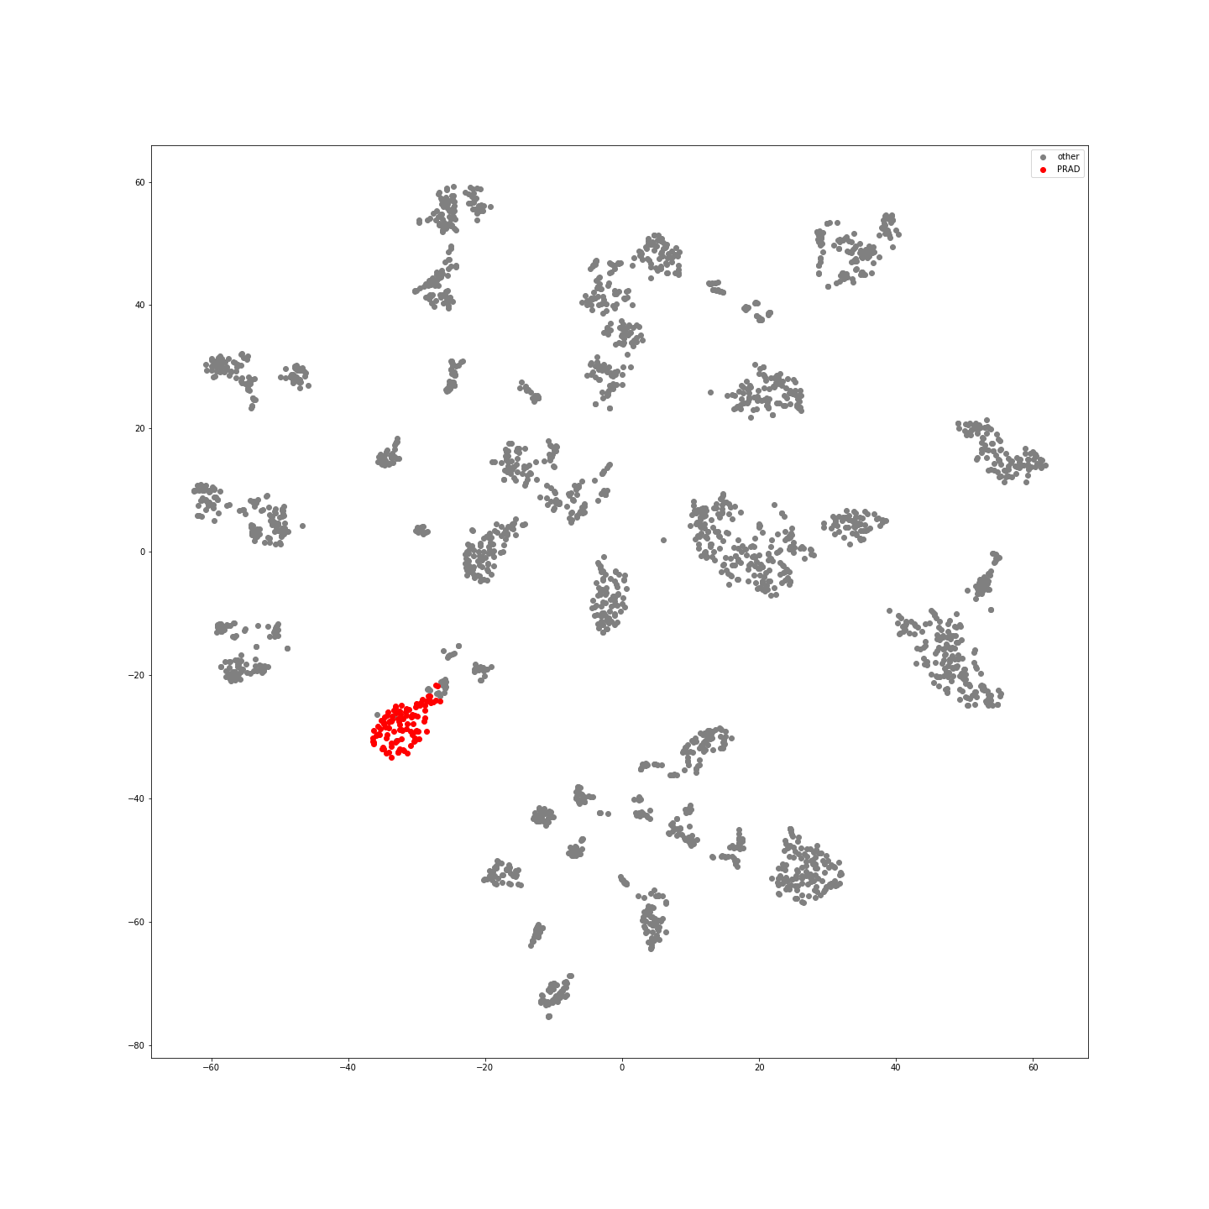
Supplementary Figure 52: PRAD Samples in Latent Space
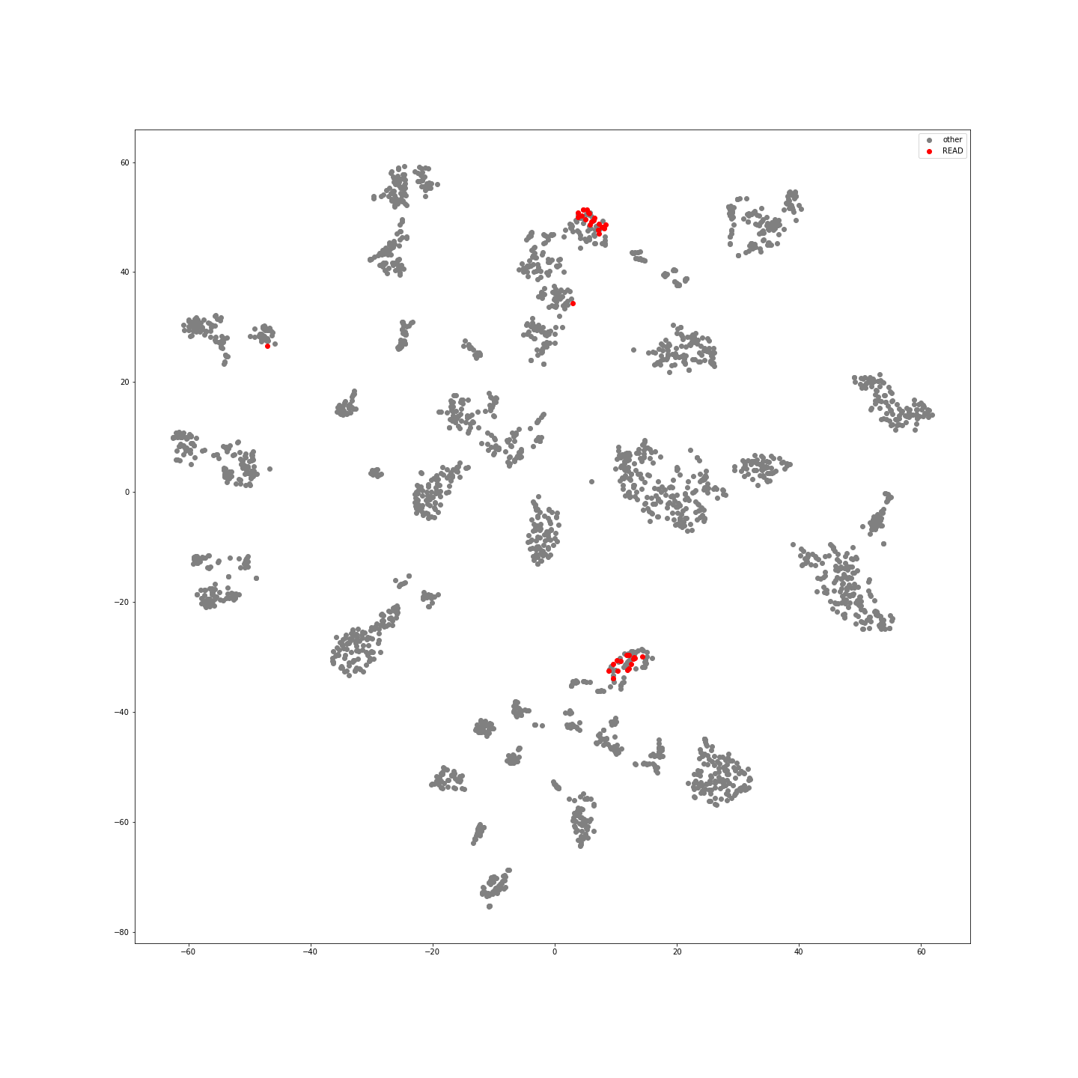
Supplementary Figure 53: READ Samples in Latent Space
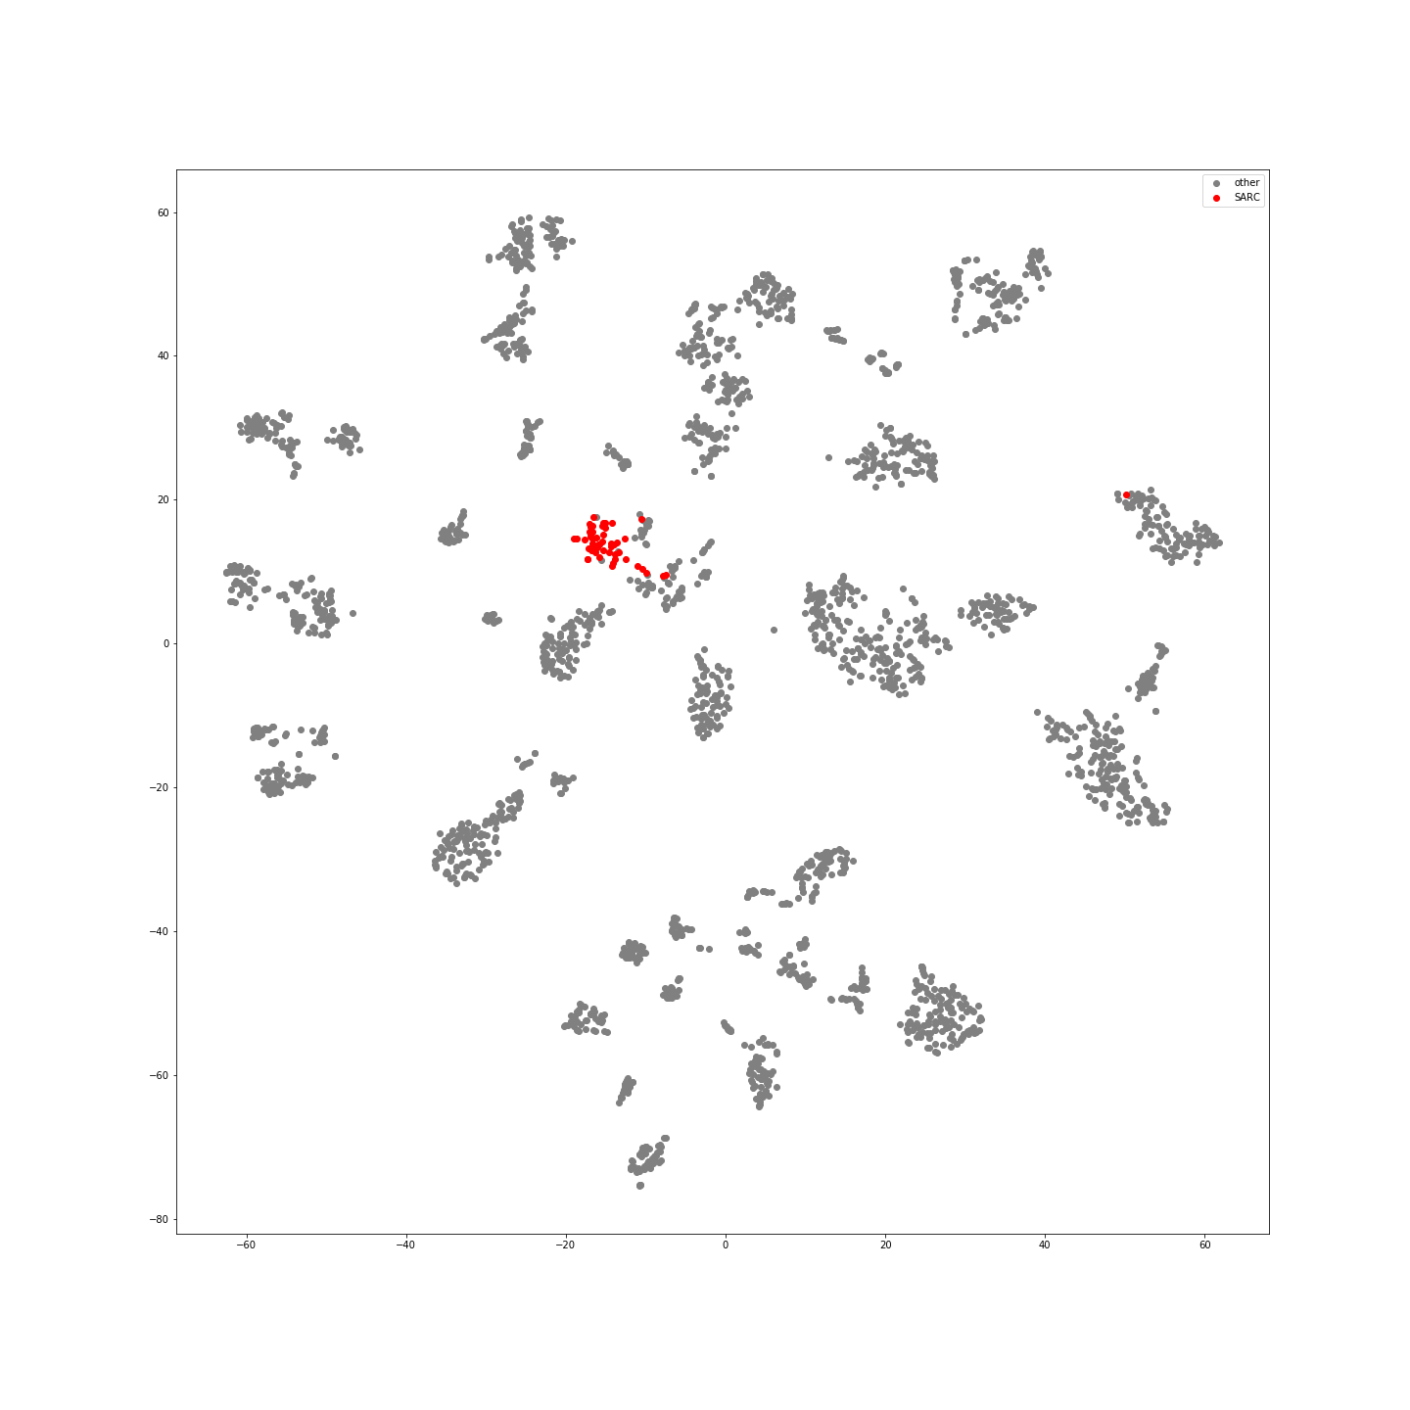
Supplementary Figure 54: SARC Samples in Latent Space
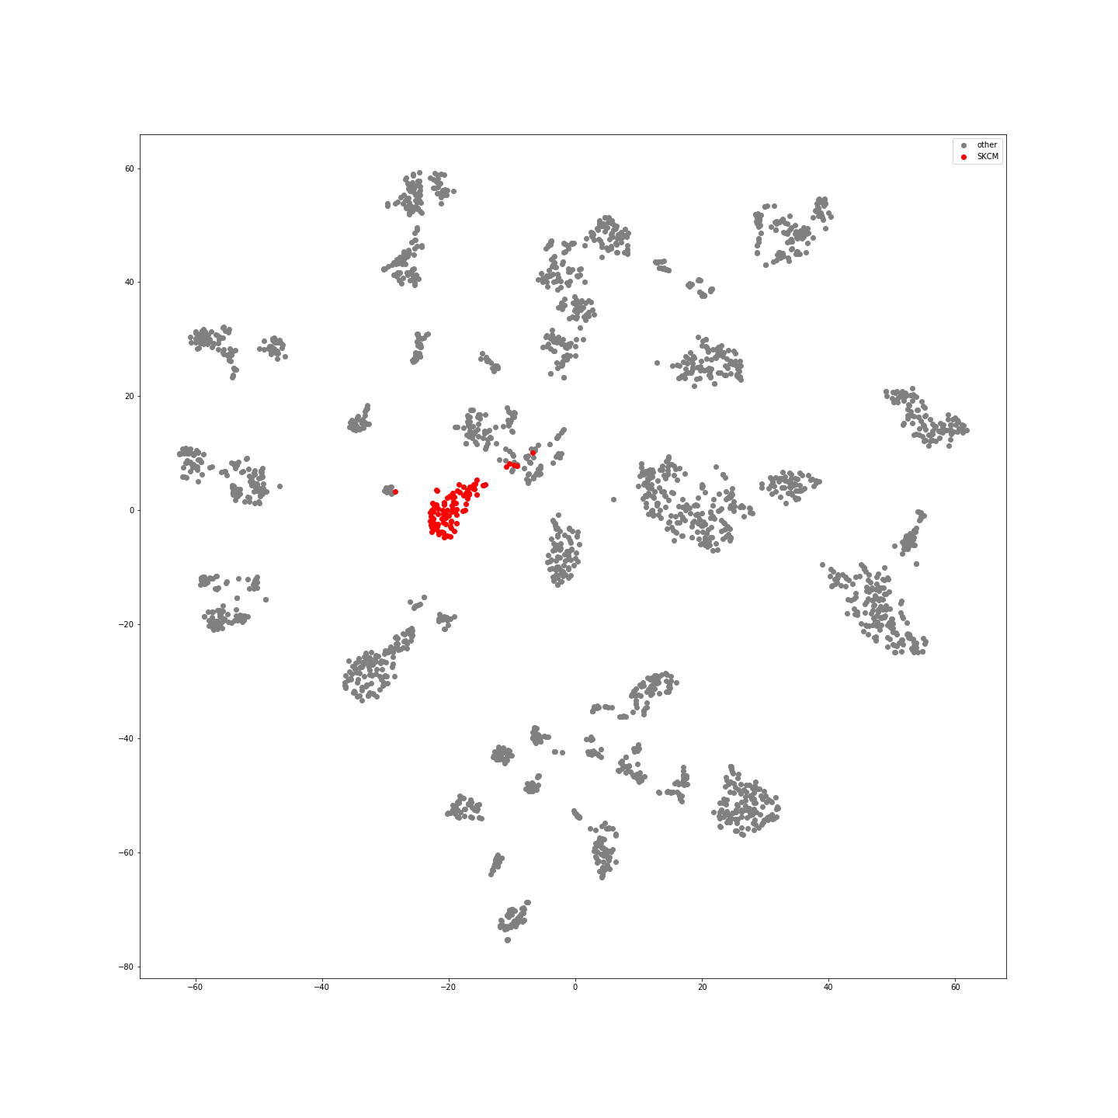
Supplementary Figure 55: SKCM Samples in Latent Space
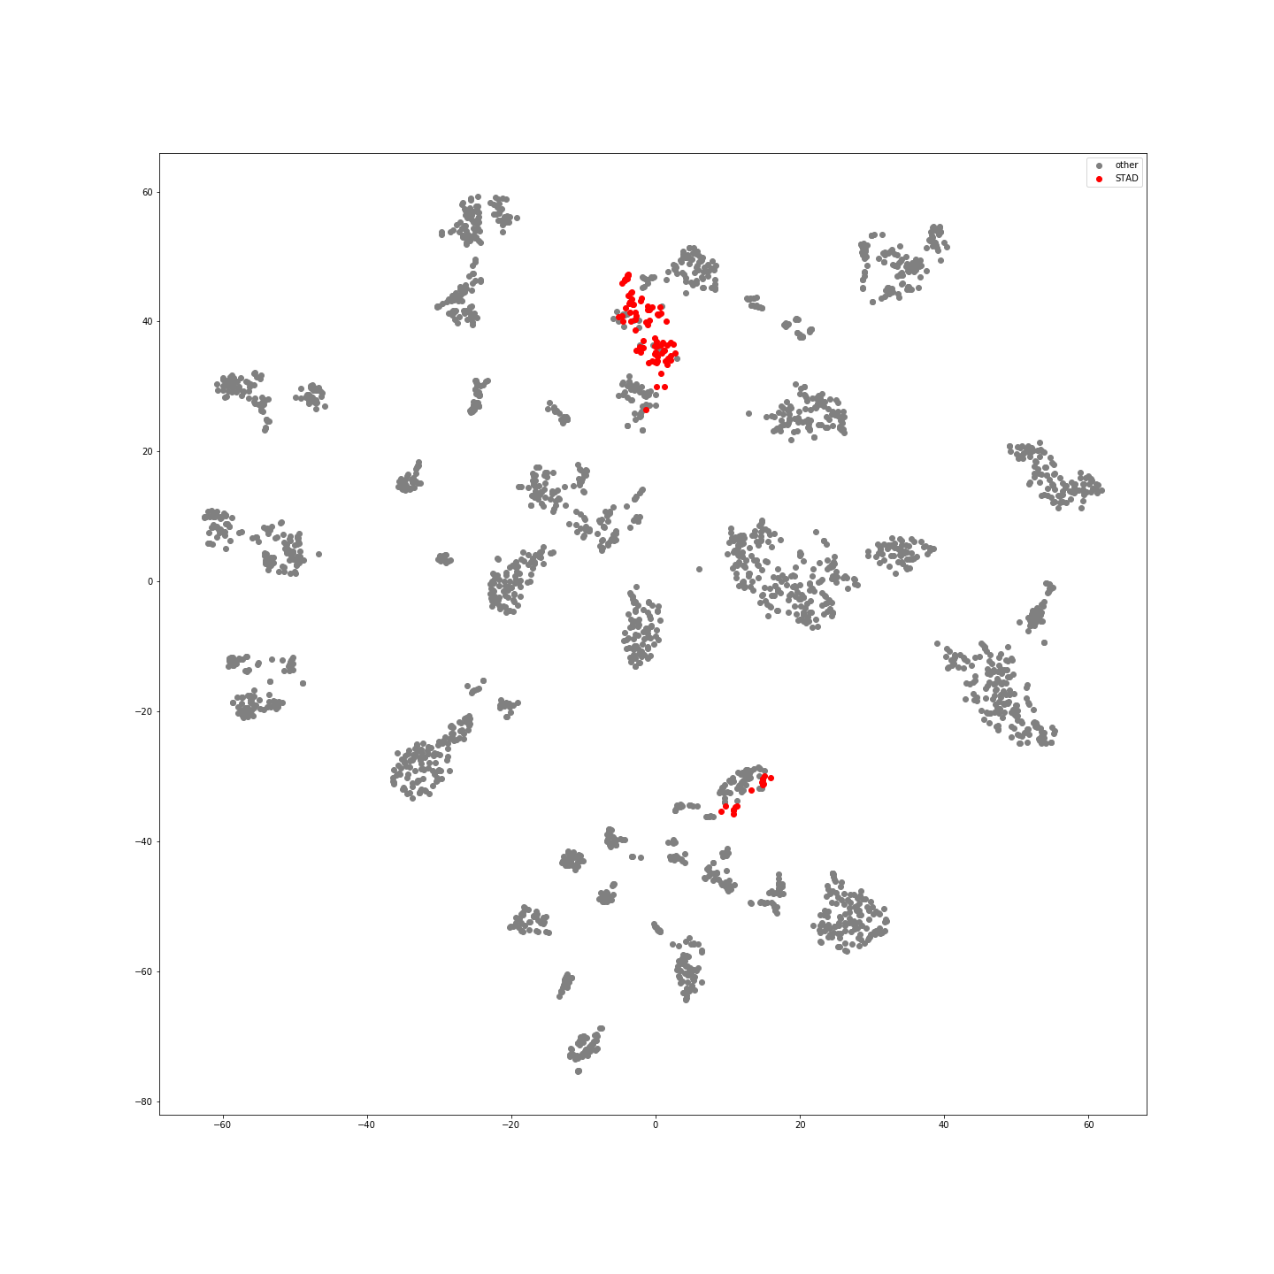
Supplementary Figure 56: STAD Samples in Latent Space
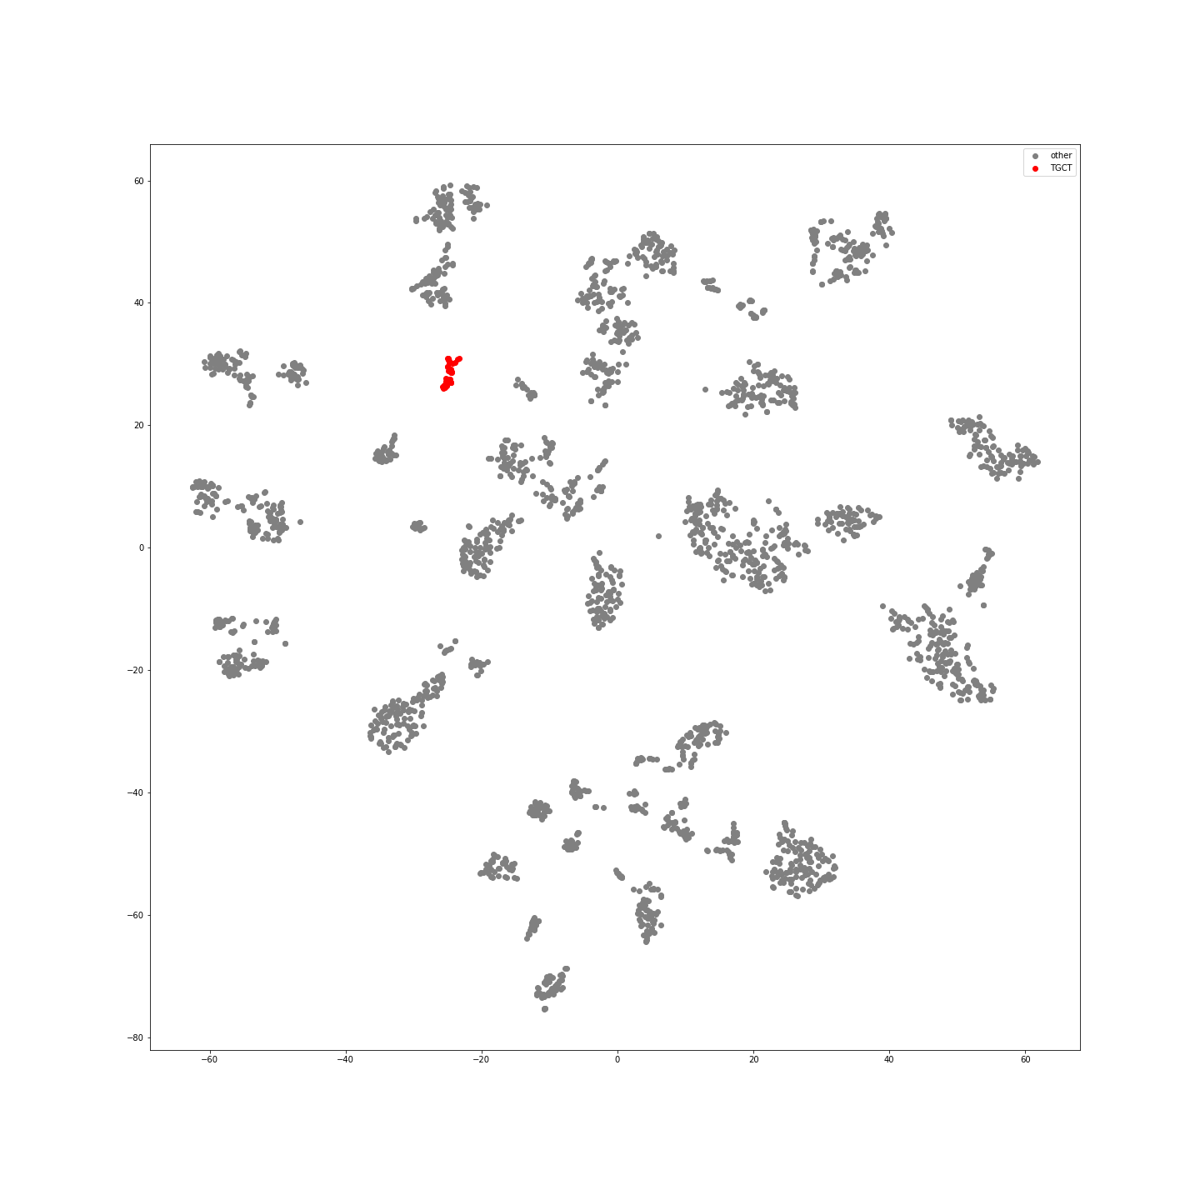
Supplementary Figure 57:TGCT Samples in Latent Space
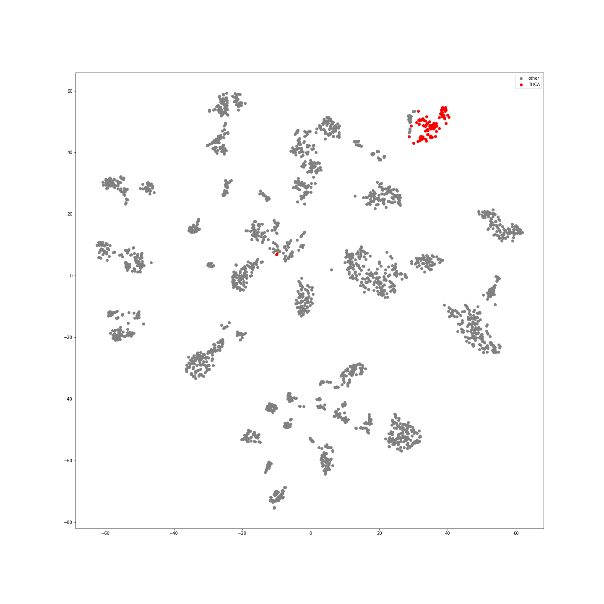
Supplementary Figure 58:THCA Samples in Latent Space
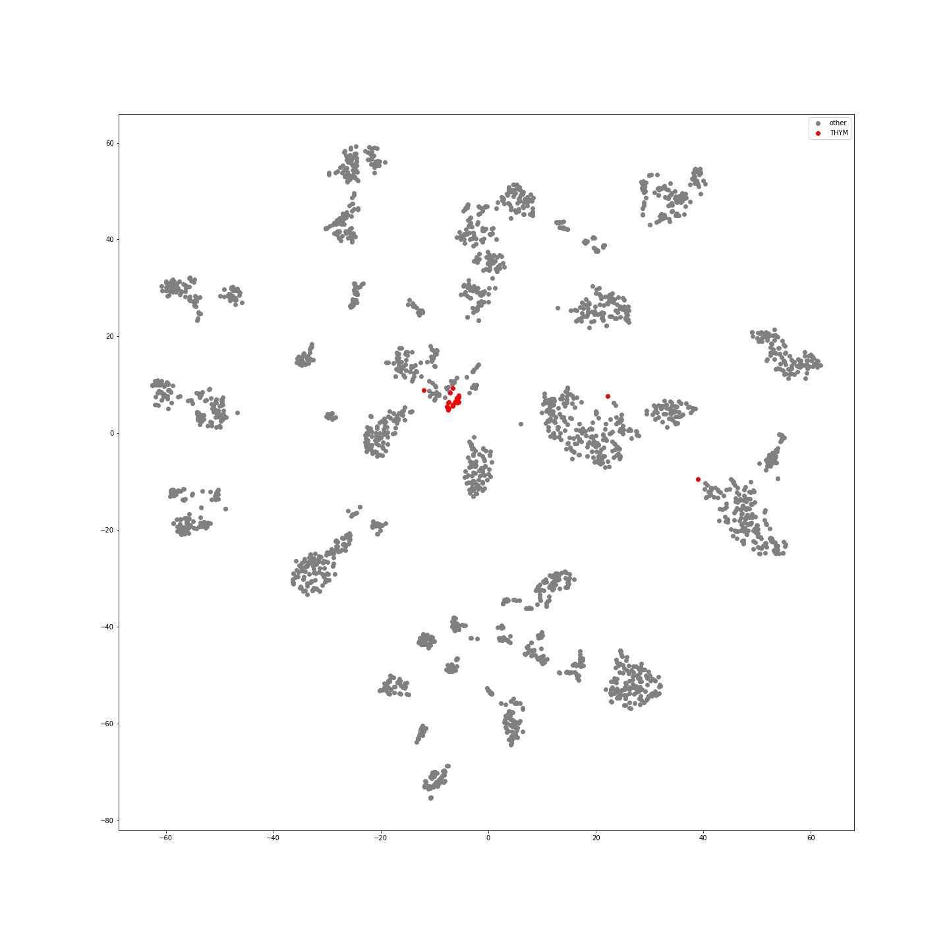
Supplementary Figure 59:THYM Samples in Latent Space
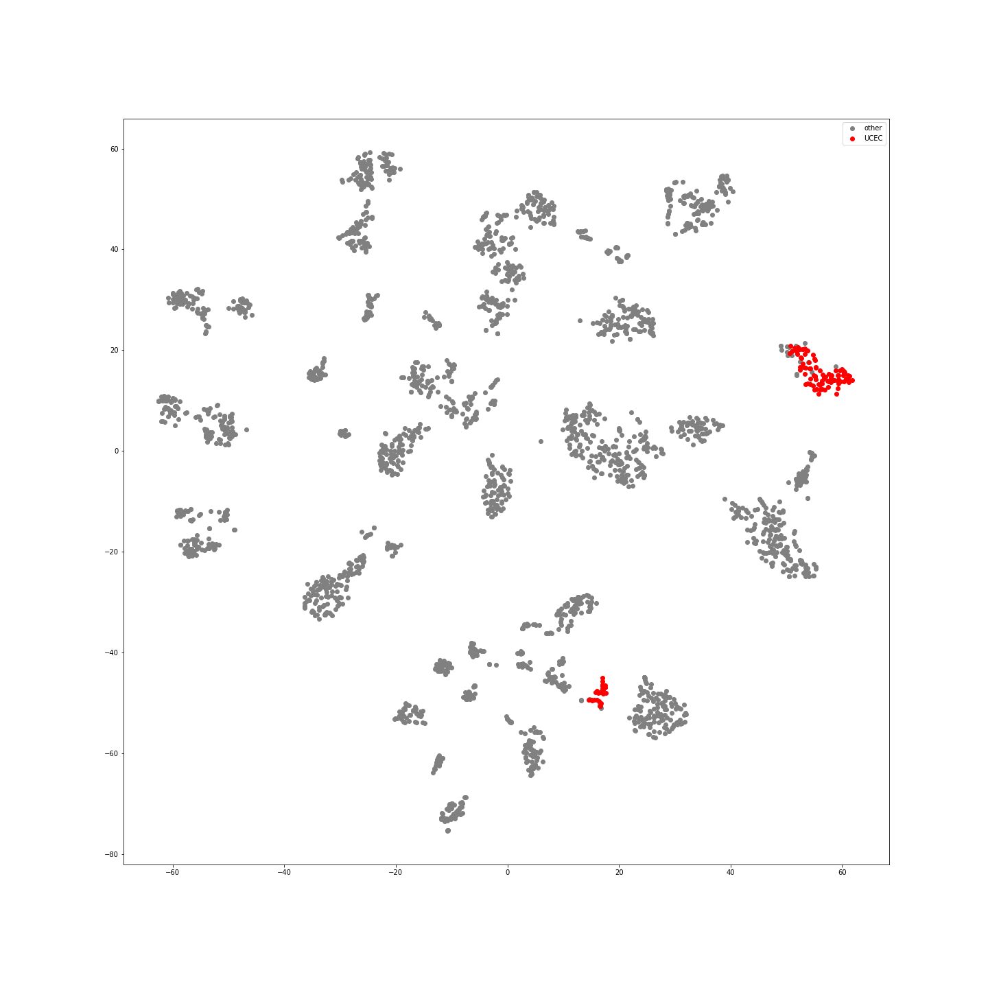
Supplementary Figure 60:UCEC Samples in Latent Space
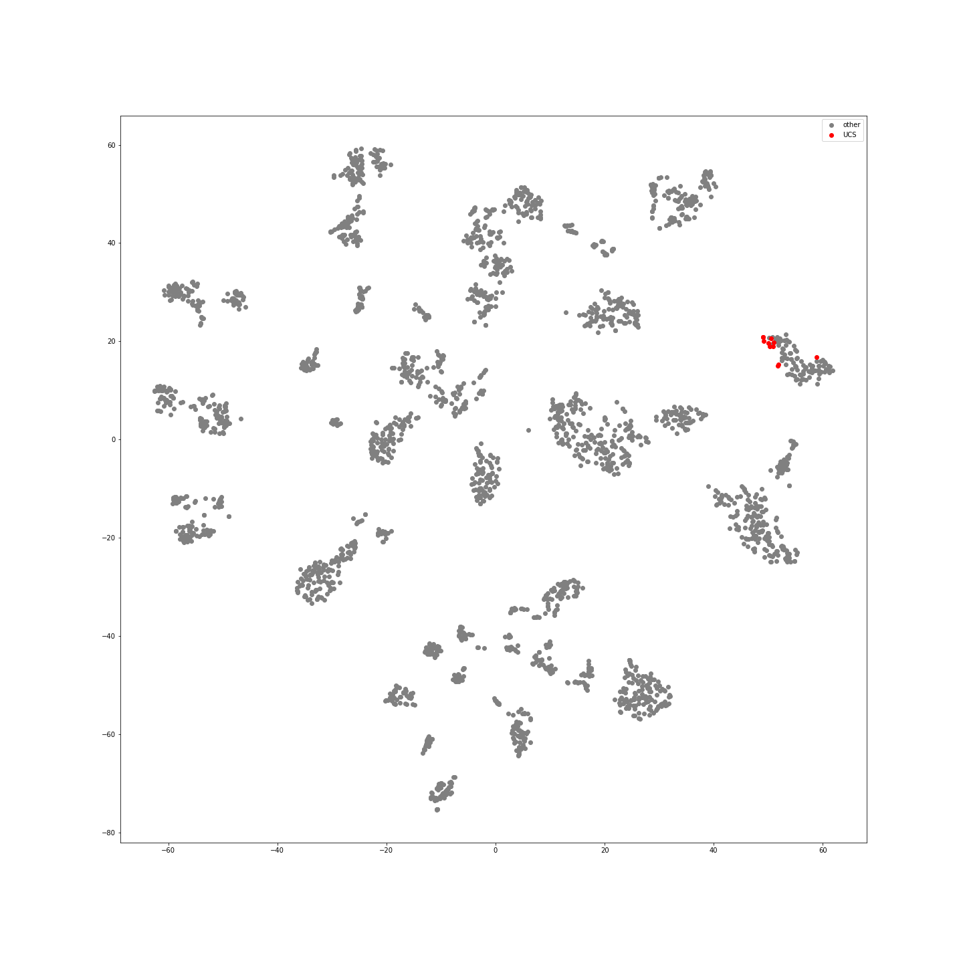
Supplementary Figure 61: UCS Samples in Latent Space
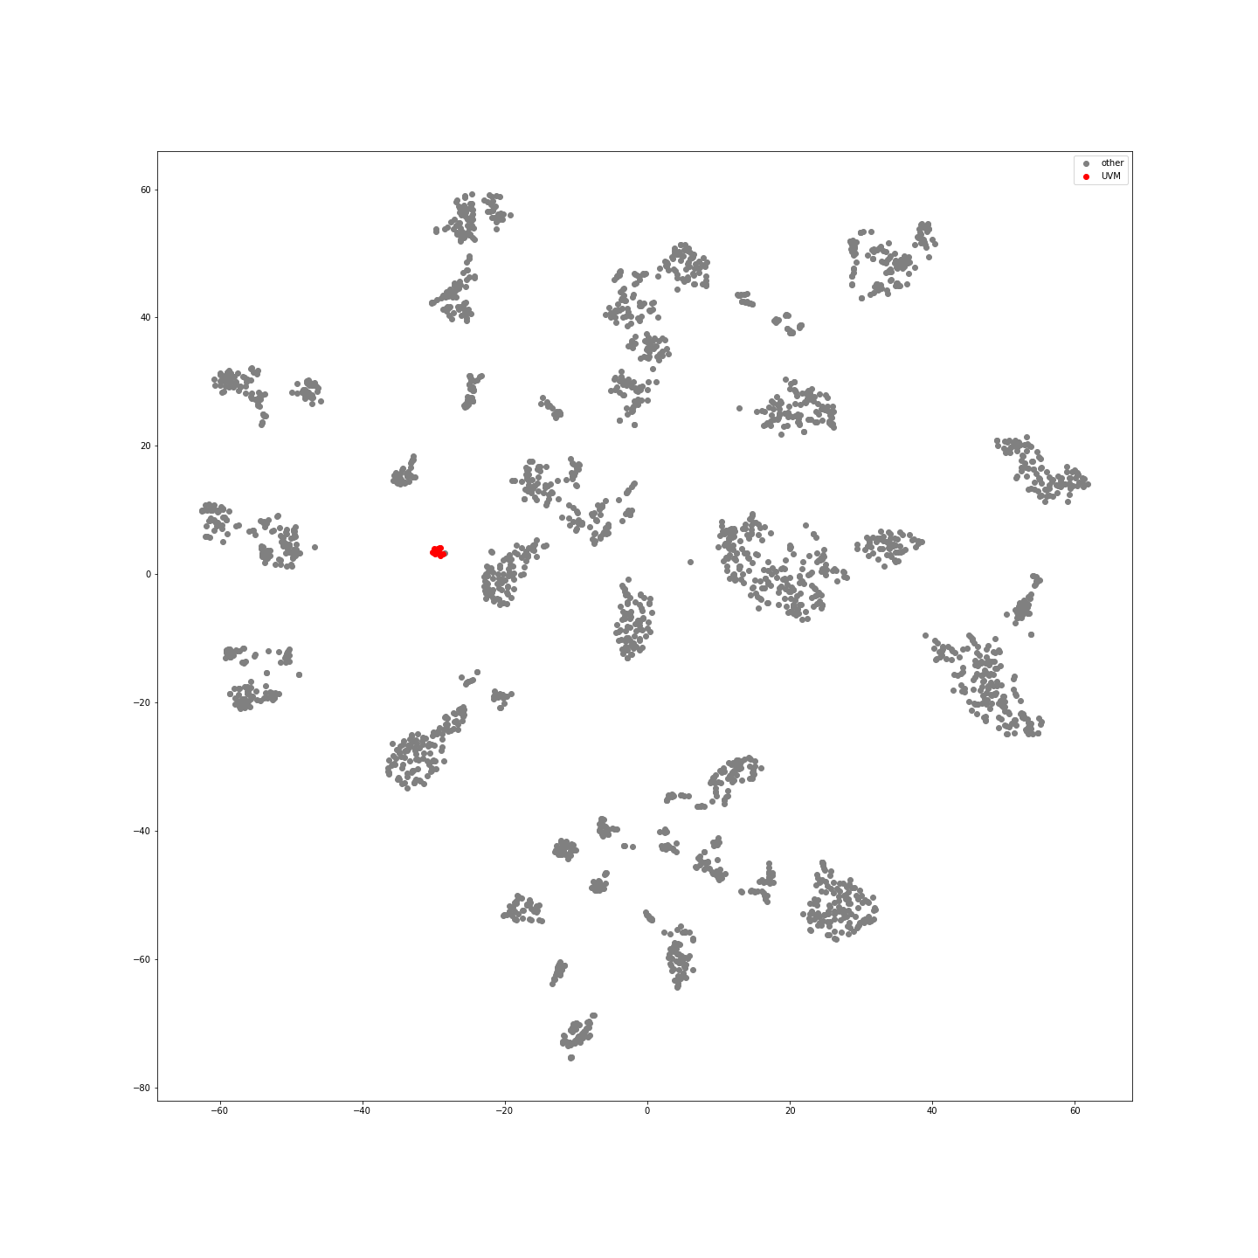
Supplementary Figure 62: UVM Samples in Latent Space

Supplementary Figure 63: Latent space arrangement of samples colored by predicted class
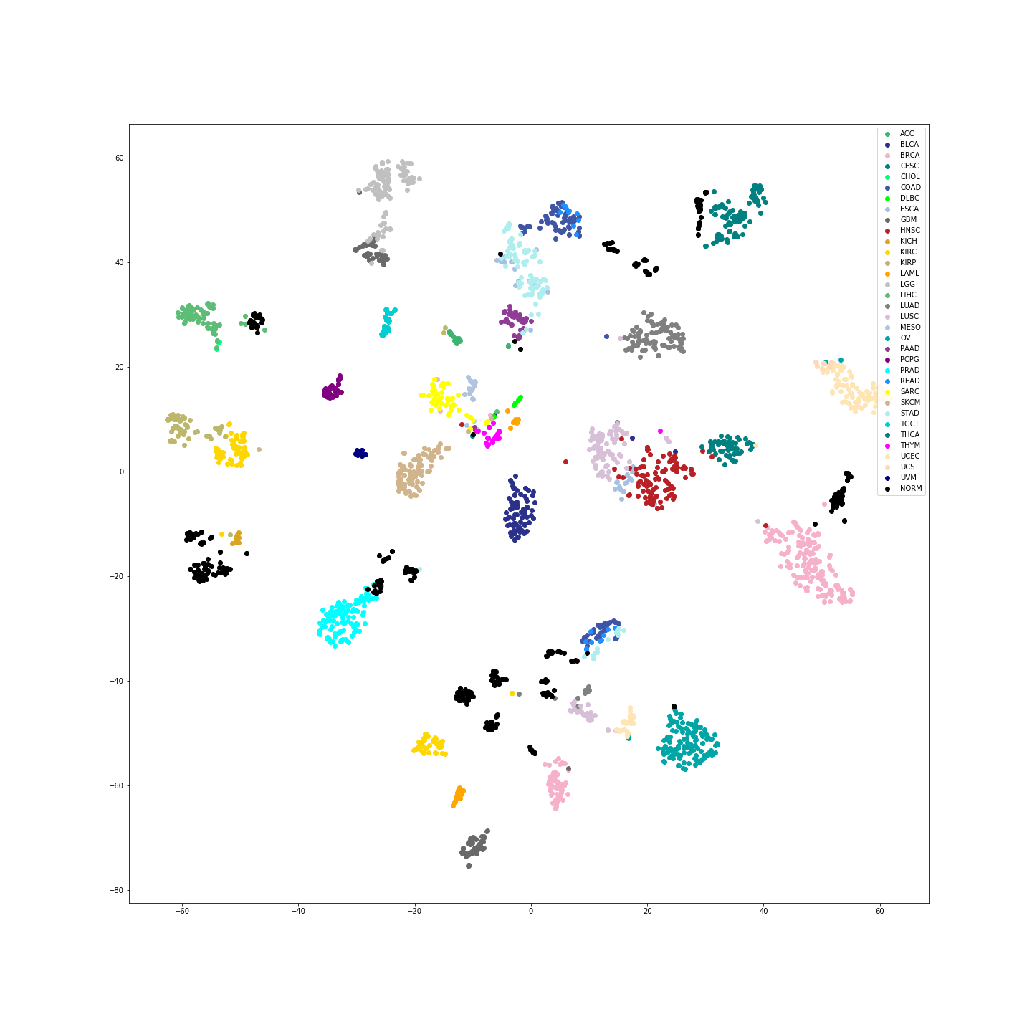
Supplementary Figure 63: All Samples in Latent Space

