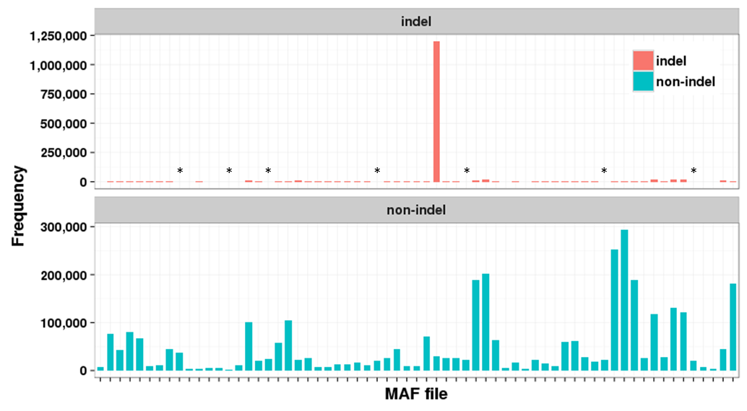
Supplementary Figures

Figure S1. Frequency of indel and non-indel mutations in each MAF file

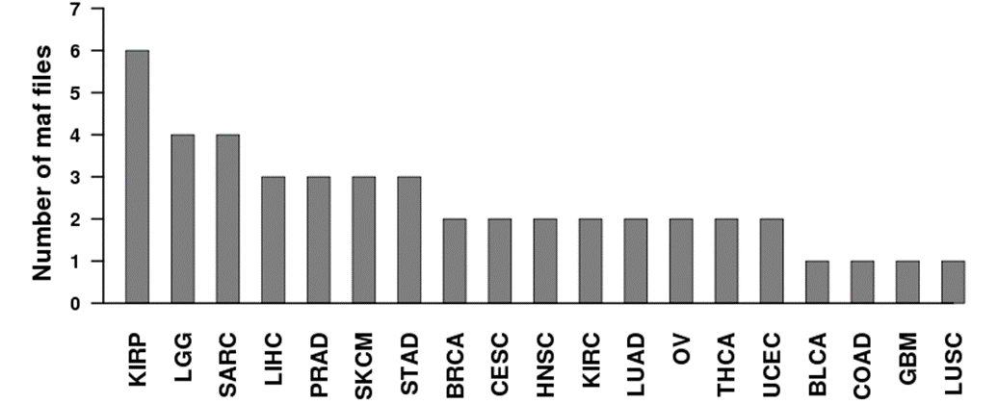
Figure S2. Number of MAF files for each cancer type
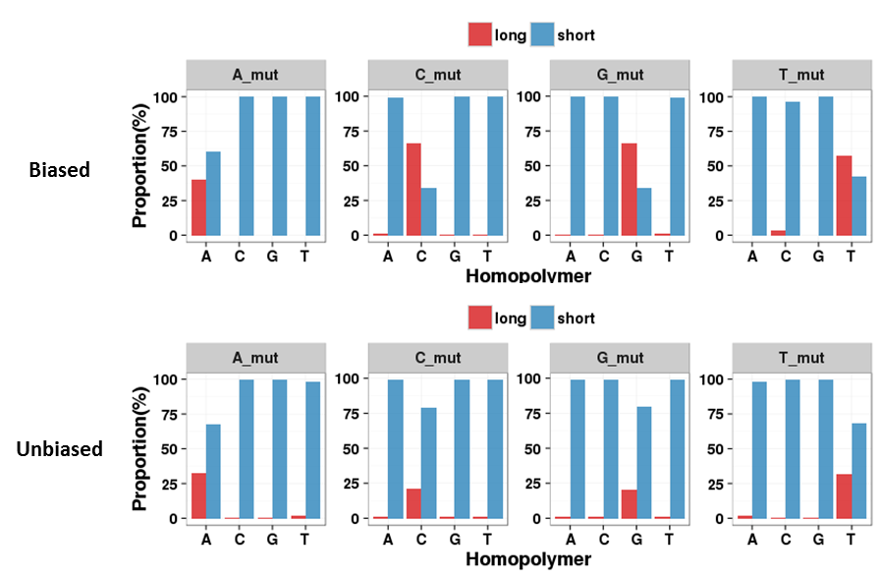
Figure S3. Homopolymer runs in flanking sequences of batch-biased indels

Figure S4. Consensus sequences at flanking sequences of batch-biased indels

