Supporting information
Prognostic and Immunological Landscape of DDX17 in Pan-Cancer Analysis: A Comprehensive Study
Yu Lei^{1a}, Xin He^{1b}, Peng Chen^{1a} , Yiping Qin^{c}, Bin Geª, Yan Liuª, Pu Li^{b*}, Xing Wei^{a*}
ª Department of Clinical Laboratory, Pidu District People's Hospital, Third Affiliated Hospital of Chengdu Medical College, Chengdu , Sichuan, China. 611730, P.R. China
^{b} Department of Clinical Laboratory, Chongqing University Jiangjin Hospital, School of Medicine, Chongqing University, Jiangjin, Chongqing, China. 402260, P.R. China
^{c} Chongqing Key Laboratory of Translational Research for Cancer Metastasis and Individualized Treatment, Chongqing University Cancer Hospital, Chongqing 400030, China

¹ Parallel first author
*Correspondence authors:
Xing Wei, Department of Clinical Laboratory, Pidu District People's Hospital, Third Affiliated Hospital of Chengdu Medical College, Sichuan, China. 611730, P.R. China.
E-mail address: weixing3009@163.com
Pu Li, Department of Clinical Laboratory, Chongqing University Jiangjin Hospital, School of Medicine, Chongqing University, Jiangjin, Chongqing, China. 402260, P.R. China.
E-mail address: lipu.cqu@cqu.edu.cn.
Fax.: 86-23-47521342

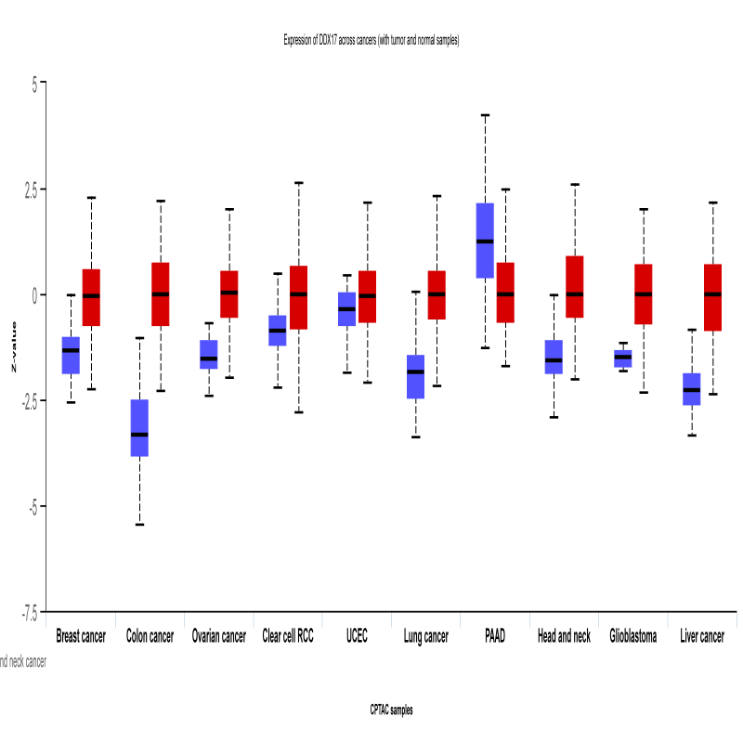

Figure S1: DDX17 total protein levels between cancer tissues and normal tissues were shown by CPTAC and the red module represents the cancer tissue.

Table S1. Abbreviations from the TCGA database for 33 cancers.
Cancer Type | Abbreviation
ACC | Adrenocortical carcinoma
BLCA | Bladder Urothelial Carcinoma
BRCA | Breast invasive carcinoma
CESC | Cervical squamous cell carcinoma and endocervical adenocarcinoma
CHOL | Cholangiocarcinoma
COAD | Colon adenocarcinoma
DLBC | Lymphoid Neoplasm Diffuse Large B-cell Lymphoma
ESCA | Esophageal carcinoma
GBM | Glioblastoma multiforme
HNSC | Head and Neck squamous cell carcinoma
KICH | Kidney Chromophobe
KIRC | Kidney renal clear cell carcinoma
KIRP | Kidney renal papillary cell carcinoma
LAML | Acute Myeloid Leukemia
LGG | Brain Lower Grade Glioma
LIHC | Liver hepatocellular carcinoma
LUAD | Lung adenocarcinoma
LUSC | Lung squamous cell carcinoma
MESO | Mesothelioma
OV | Ovarian serous cystadenocarcinoma
PAAD | Pancreatic adenocarcinoma
PCPG | Pheochromocytoma and Paraganglioma
PRAD | Prostate adenocarcinoma
READ | Rectum adenocarcinoma
SARC | Sarcoma
STAD | Stomach adenocarcinoma
SKCM | Skin Cutaneous Melanoma
TGCT | Testicular Germ Cell Tumors
THCA | Thyroid carcinoma
THYM | Thymoma
UCEC | Uterine Corpus Endometrial Carcinoma
UCS | Uterine Carcinosarcoma
UVM | Uveal Melanoma

Table S2. Mutation Analysis of DDX17 in the TCGA pan-cancer cohort.
Cancer Type | Sample ID | Protein Change | Mutation Type
Glioblastoma | TCGA-06-2565-01 | CSNK1E-DDX17 Fusion | fusion
Non-Small Cell Lung Cancer | TCGA-50-6594-01 | ASPHD2-DDX17 Fusion | fusion
Hepatobiliary Cancer | TCGA-KR-A7K8-01 | DDX17-ENTHD1 Fusion | fusion
Melanoma | TCGA-D3-A1Q3-06 | DDX17-CDH10 Fusion | fusion
Melanoma | TCGA-EE-A2MU-06 | DDX17-CPT1B Fusion | fusion
Thyroid Cancer | TCGA-DJ-A2QB-01 | R480S | Missense_Mutation
Thyroid Cancer | TCGA-FE-A23A-01 | P63Q | Missense_Mutation
Glioma | TCGA-DU-6410-01 | R329G | Missense_Mutation
Ovarian Epithelial Tumor | TCGA-25-1326-01 | R589* | Nonsense_Mutation
Ovarian Epithelial Tumor | TCGA-04-1651-01 | R161S | Missense_Mutation
Glioblastoma | TCGA-19-2629-01 | K428Efs*4 | Frame_Shift_Del
Glioblastoma | TCGA-28-5207-01 | K535R | Missense_Mutation
Glioblastoma | TCGA-06-5416-01 | L226F | Missense_Mutation
Glioblastoma | TCGA-06-5416-01 | S219P | Missense_Mutation
Glioblastoma | TCGA-06-5416-01 | R154Q | Missense_Mutation
Sarcoma | TCGA-DX-A8BK-01 | R209W | Missense_Mutation
Non-Small Cell Lung Cancer | TCGA-22-5478-01 | R684G | Missense_Mutation
Non-Small Cell Lung Cancer | TCGA-85-8350-01 | R586Q | Missense_Mutation
Bladder Cancer | TCGA-2F-A9KT-01 | D332H | Missense_Mutation
Bladder Cancer | TCGA-4Z-AA7Q-01 | D395G | Missense_Mutation
Bladder Cancer | TCGA-G2-AA3D-01 | E126K | Missense_Mutation
Bladder Cancer | TCGA-XF-AAML-01 | L248I | Missense_Mutation
Bladder Cancer | TCGA-XF-AAML-01 | P252S | Missense_Mutation
Bladder Cancer | TCGA-DK-AA75-01 | S400T | Missense_Mutation
Bladder Cancer | TCGA-E5-A4TZ-01 | R684G | Missense_Mutation
Bladder Cancer | TCGA-4Z-AA84-01 | S672L | Missense_Mutation
Bladder Cancer | TCGA-XF-AAML-01 | E583K | Missense_Mutation
Bladder Cancer | TCGA-YC-A89H-01 | G590E | Missense_Mutation
Leukemia | TCGA-AB-2926-03 | X246_splice | Splice_Site
Hepatobiliary Cancer | TCGA-XR-A8TF-01 | A469E | Missense_Mutation
Hepatobiliary Cancer | TCGA-CC-A9FS-01 | R440I | Missense_Mutation
Hepatobiliary Cancer | TCGA-2Y-A9H3-01 | T375S | Missense_Mutation
Hepatobiliary Cancer | TCGA-KR-A7K8-01 | R605P | Missense_Mutation
Prostate Cancer | TCGA-KK-A59X-01 | N541S | Missense_Mutation
Thymic Epithelial Tumor | TCGA-3S-AAYX-01 | P622Q | Missense_Mutation
Endometrial Cancer | TCGA-AX-A2IN-01 | K121Sfs*4 | Frame_Shift_Del
Endometrial Cancer | TCGA-D1-A1NZ-01 | K121Sfs*4 | Frame_Shift_Del
Endometrial Cancer | TCGA-EY-A549-01 | K121Sfs*4 | Frame_Shift_Del
Endometrial Cancer | TCGA-PG-A917-01 | K121Sfs*4 | Frame_Shift_Del
Endometrial Cancer | TCGA-A5-A2K7-01 | G163Efs*20 | Frame_Shift_Del
Endometrial Cancer | TCGA-AX-A2HG-01 | G163Efs*20 | Frame_Shift_Del
Endometrial Cancer | TCGA-D1-A17D-01 | G163Efs*20 | Frame_Shift_Del
Endometrial Cancer | TCGA-EY-A1H0-01 | G163Efs*20 | Frame_Shift_Del
Endometrial Cancer | TCGA-B5-A3FC-01 | P203L | Missense_Mutation
Endometrial Cancer | TCGA-B5-A11N-01 | K341N | Missense_Mutation
Endometrial Cancer | TCGA-BS-A0UJ-01 | P524S | Missense_Mutation
Endometrial Cancer | TCGA-D1-A103-01 | K108N | Missense_Mutation
Endometrial Cancer | TCGA-BK-A6W3-01 | R589* | Nonsense_Mutation
Endometrial Cancer | TCGA-B5-A1MX-01 | R439C | Missense_Mutation
Endometrial Cancer | TCGA-B5-A0JZ-01 | R684Q | Missense_Mutation
Endometrial Cancer | TCGA-A5-A0G2-01 | T659I | Missense_Mutation
Endometrial Cancer | TCGA-AP-A059-01 | P723H | Missense_Mutation
Endometrial Cancer | TCGA-AP-A1DK-01 | W459C | Missense_Mutation
Endometrial Cancer | TCGA-AP-A1DV-01 | L371I | Missense_Mutation
Endometrial Cancer | TCGA-AX-A06F-01 | P283H | Missense_Mutation
Endometrial Cancer | TCGA-AX-A1CE-01 | R116C | Missense_Mutation
Endometrial Cancer | TCGA-AX-A2HC-01 | P59Q | Missense_Mutation
Endometrial Cancer | TCGA-B5-A1MW-01 | N133Kfs*16 | Frame_Shift_Ins
Endometrial Cancer | TCGA-B5-A3FC-01 | D266E | Missense_Mutation
Endometrial Cancer | TCGA-D1-A16X-01 | Y502H | Missense_Mutation
Endometrial Cancer | TCGA-DI-A1BU-01 | A282V | Missense_Mutation
Endometrial Cancer | TCGA-EO-A3AV-01 | R161G | Missense_Mutation
Endometrial Cancer | TCGA-EO-A3AV-01 | F134L | Missense_Mutation
Endometrial Cancer | TCGA-EO-A3KX-01 | I278F | Missense_Mutation
Endometrial Cancer | TCGA-EY-A1GI-01 | L10F | Missense_Mutation
Endometrial Cancer | TCGA-QF-A5YS-01 | F5C | Missense_Mutation
Non-Small Cell Lung Cancer | TCGA-44-6777-01 | S385C | Missense_Mutation
Non-Small Cell Lung Cancer | TCGA-67-3771-01 | D266Y | Missense_Mutation
Non-Small Cell Lung Cancer | TCGA-62-8394-01 | G560D | Missense_Mutation
Non-Small Cell Lung Cancer | TCGA-05-4410-01 | S685Lfs*8 | Frame_Shift_Del
Non-Small Cell Lung Cancer | TCGA-17-Z060-01 | Q365H | Missense_Mutation
Esophagogastric Cancer | TCGA-L5-A4OJ-01 | S219C | Missense_Mutation
Melanoma | TCGA-FW-A3R5-06 | R511C | Missense_Mutation
Melanoma | TCGA-DA-A1I4-06 | H504R | Missense_Mutation
Melanoma | TCGA-ER-A195-06 | H504R | Missense_Mutation
Melanoma | TCGA-ER-A19F-06 | H504R | Missense_Mutation
Melanoma | TCGA-WE-AAA4-06 | H504R | Missense_Mutation
Melanoma | TCGA-FS-A1ZA-06 | R289* | Nonsense_Mutation
Melanoma | TCGA-EE-A2GI-06 | G450E | Missense_Mutation
Melanoma | TCGA-EB-A551-01 | I288M | Missense_Mutation
Melanoma | TCGA-EE-A2A2-06 | P203L | Missense_Mutation
Melanoma | TCGA-D3-A5GR-06 | E485* | Nonsense_Mutation
Melanoma | TCGA-EE-A2MD-06 | P722S | Missense_Mutation
Melanoma | TCGA-EE-A3AB-06 | D582G | Missense_Mutation
Melanoma | TCGA-D3-A2JO-06 | R603L | Missense_Mutation
Melanoma | TCGA-EE-A17Z-06 | S624Y | Missense_Mutation
Melanoma | TCGA-ER-A19P-06 | V6L | Missense_Mutation
Melanoma | TCGA-GN-A266-06 | G114V | Missense_Mutation
Melanoma | TCGA-GN-A26C-01 | G303* | Nonsense_Mutation
Esophagogastric Cancer | TCGA-BR-8372-01 | K121Sfs*4 | Frame_Shift_Del
Esophagogastric Cancer | TCGA-CD-A4MG-01 | K121Sfs*4 | Frame_Shift_Del
Esophagogastric Cancer | TCGA-CG-5726-01 | K121Sfs*4 | Frame_Shift_Del
Esophagogastric Cancer | TCGA-HF-A5NB-01 | K121Sfs*4 | Frame_Shift_Del
Esophagogastric Cancer | TCGA-VQ-A924-01 | K121Sfs*4 | Frame_Shift_Del
Esophagogastric Cancer | TCGA-BR-7851-01 | G163Efs*20 | Frame_Shift_Del
Esophagogastric Cancer | TCGA-CG-4465-01 | G163Efs*20 | Frame_Shift_Del
Esophagogastric Cancer | TCGA-VQ-A8PT-01 | T704A | Missense_Mutation
Esophagogastric Cancer | TCGA-CD-8536-01 | V170M | Missense_Mutation
Esophagogastric Cancer | TCGA-CD-8529-01 | R457T | Missense_Mutation
Esophagogastric Cancer | TCGA-BR-8361-01 | R372H | Missense_Mutation
Esophagogastric Cancer | TCGA-BR-8680-01 | M706I | Missense_Mutation
Esophagogastric Cancer | TCGA-F1-6874-01 | R564H | Missense_Mutation
Esophagogastric Cancer | TCGA-VQ-A8E3-01 | A264V | Missense_Mutation
Esophagogastric Cancer | TCGA-VQ-A8PT-01 | R566H | Missense_Mutation
Breast Cancer | TCGA-BH-A1FC-01 | R272T | Missense_Mutation
Breast Cancer | TCGA-BH-A0H3-01 | T421K | Missense_Mutation
Breast Cancer | TCGA-A2-A0ER-01 | D265Y | Missense_Mutation
Breast Cancer | TCGA-AQ-A7U7-01 | D476G | Missense_Mutation
Breast Cancer | TCGA-D8-A27V-01 | F489Lfs*2 | Frame_Shift_Del
Breast Cancer | TCGA-EW-A1J5-01 | Q653E | Missense_Mutation
Colorectal Cancer | TCGA-AD-6889-01 | K121Sfs*4 | Frame_Shift_Del
Colorectal Cancer | TCGA-AA-3949-01 | G616D | Missense_Mutation
Colorectal Cancer | TCGA-AA-3715-01 | D582V | Missense_Mutation
Colorectal Cancer | TCGA-AA-3852-01 | Q180* | Nonsense_Mutation
Colorectal Cancer | TCGA-AA-3510-01 | X246_splice | Splice_Region
Colorectal Cancer | TCGA-AD-5900-01 | D432G | Missense_Mutation
Colorectal Cancer | TCGA-AM-5821-01 | A518T | Missense_Mutation
Colorectal Cancer | TCGA-CA-6717-01 | E654D | Missense_Mutation
Colorectal Cancer | TCGA-CK-4951-01 | E368K | Missense_Mutation
Colorectal Cancer | TCGA-CM-6674-01 | L434P | Missense_Mutation
Colorectal Cancer | TCGA-WS-AB45-01 | P139L | Missense_Mutation
Renal Non-Clear Cell Carcinoma | TCGA-2Z-A9JK-01 | G104C | Missense_Mutation
Renal Non-Clear Cell Carcinoma | TCGA-B9-5155-01 | S727P | Missense_Mutation
Renal Non-Clear Cell Carcinoma | TCGA-WN-A9G9-01 | P700T | Missense_Mutation
Head and Neck Cancer | TCGA-KU-A66S-01 | G280R | Missense_Mutation
Head and Neck Cancer | TCGA-F7-A50J-01 | R728C | Missense_Mutation
Cervical Cancer | TCGA-2W-A8YY-01 | R439H | Missense_Mutation
Cervical Cancer | TCGA-Q1-A73O-01 | G620E | Missense_Mutation
Cervical Cancer | TCGA-Q1-A73O-01 | E607K | Missense_Mutation
Cervical Cancer | TCGA-VS-A950-01 | R372C | Missense_Mutation
Cervical Cancer | TCGA-2W-A8YY-01 | R684Q | Missense_Mutation
Pleural Mesothelioma | TCGA-TS-A7OZ-01 | G590R | Missense_Mutation
Seminoma | TCGA-ZM-AA0B-01 | E148D | Missense_Mutation

