Supplementary file 7

OCT genes expression in different TCGA data as compared to normal controls.
The analysis was done using Gene_DE module in TIMER2.0.
Statistical significance computed by the Wilcoxon test that is annotated by the number of stars (*: p-value < 0.05; **: p-value < 0.01; ***: p-value < 0.001).

OCT 1

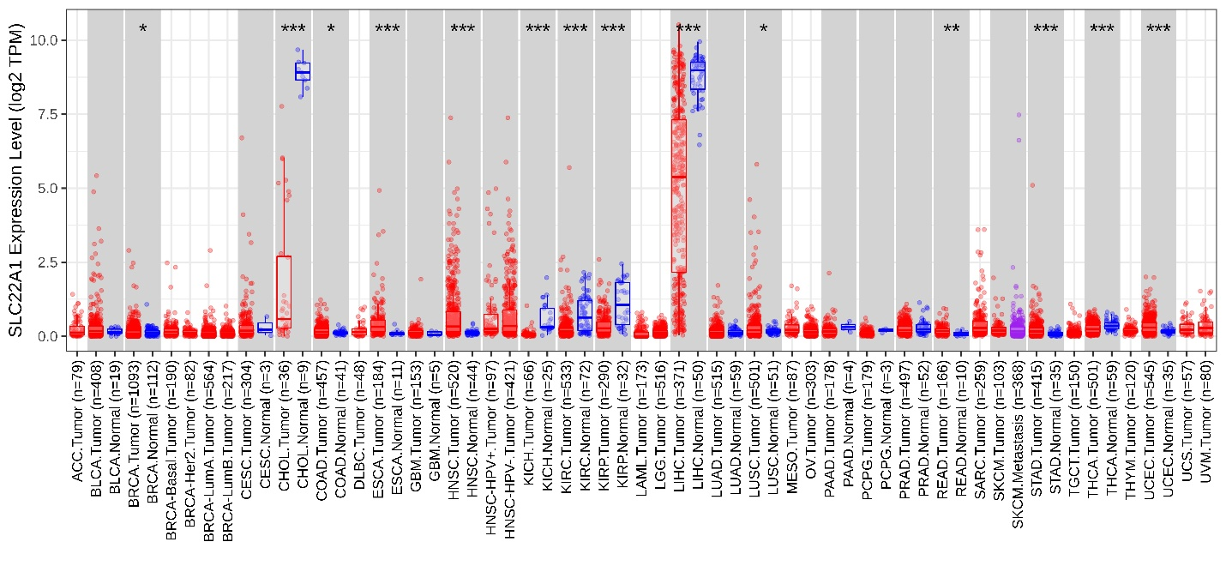
OCT1 = SLC22A1 = Organic Cationic Transporter 1

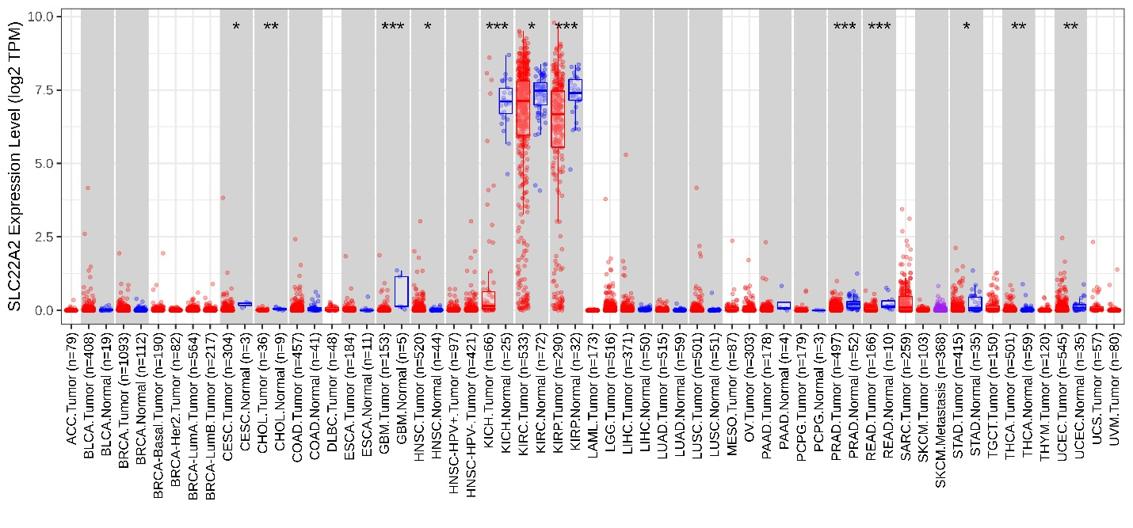
OCT 2
OCT2 = SLC22A2 = Organic Cationic Transporter 2

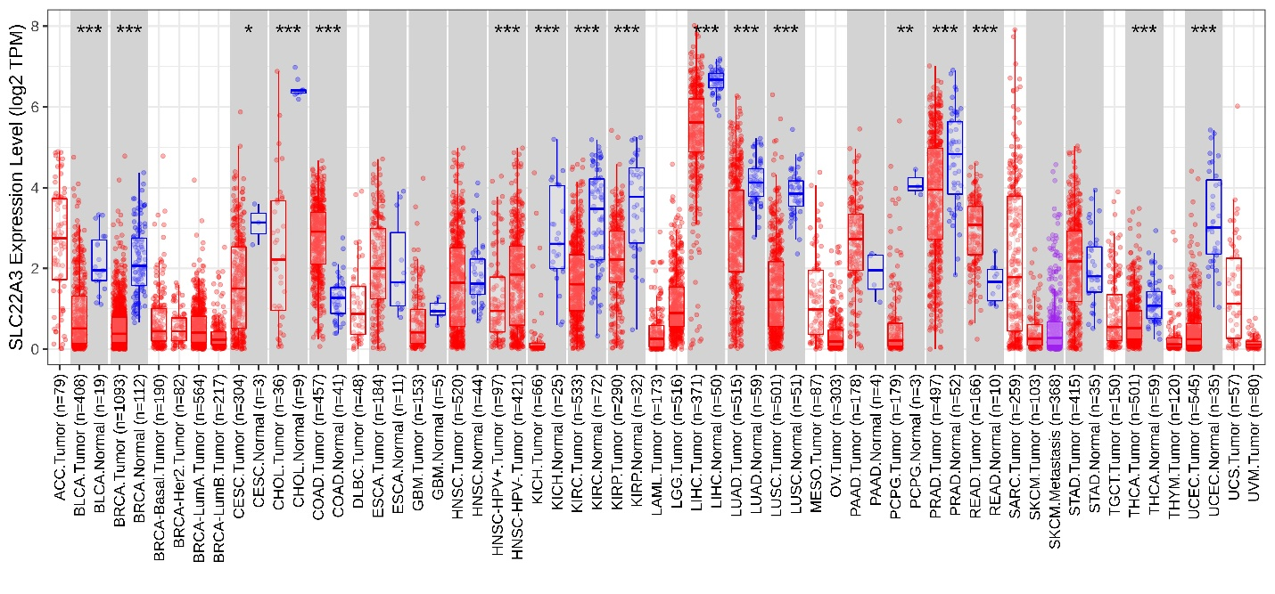
OCT 3
OCT3 = SLC22A3 = Organic Cationic Transporter 3

