Supplementary file 5
Venny Intersection Figures

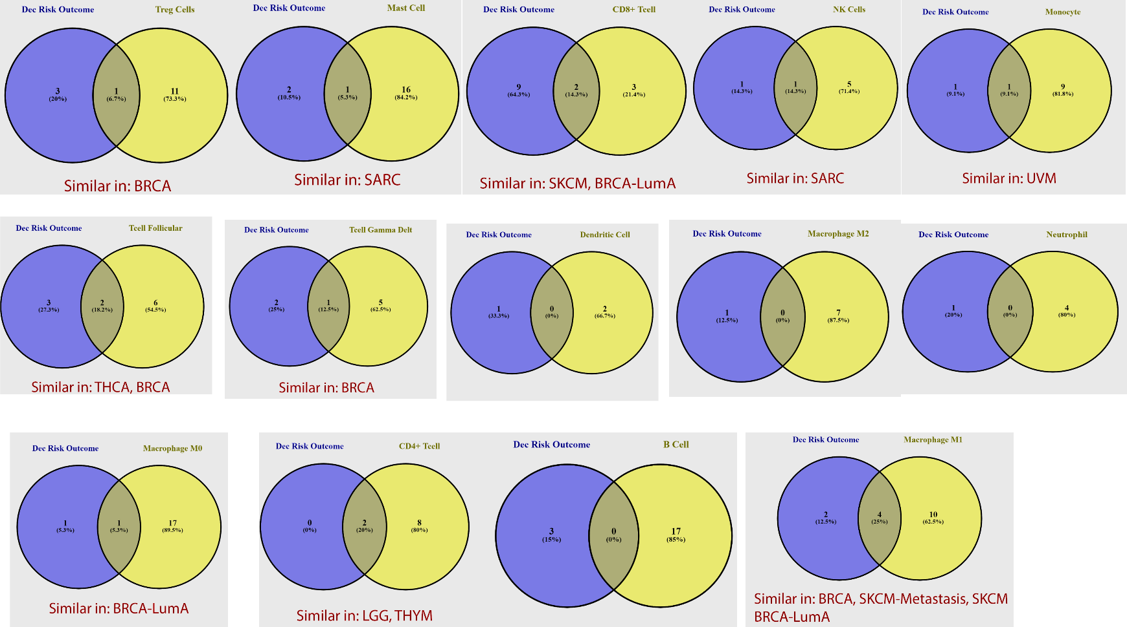
SI. 1 Venny intersection results between Immune infiltrates that show decrease risk clinical outcome and different 32 tumor types that showed positive correlation with OCT genes.
decrease risk immune infiltrates intersected with types of tumors that showed positive correlation with OCT genes.

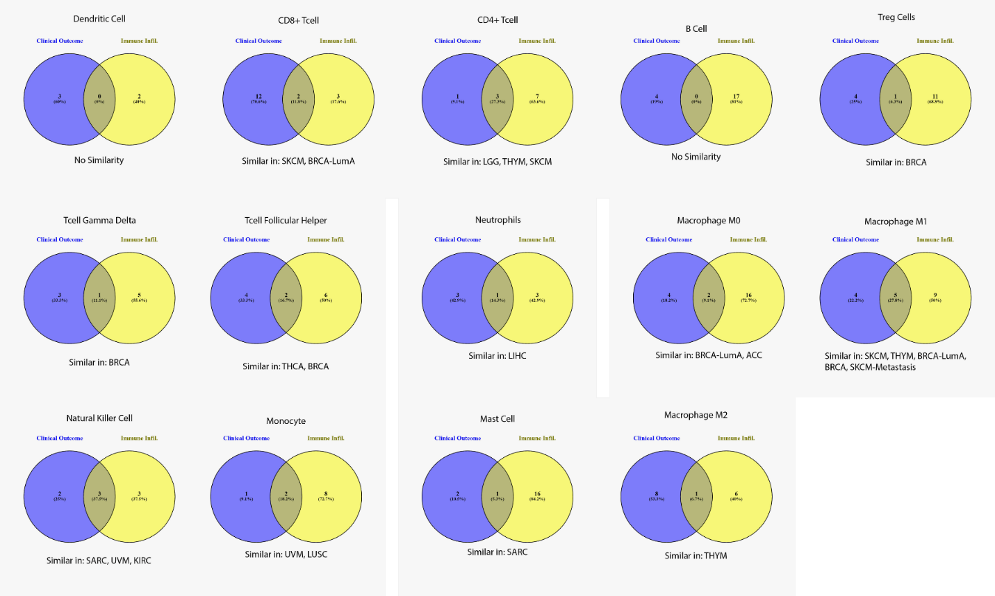

SI. 2 Venny intersection results between Immune infiltrates that show both increase and decrease risk clinical outcome and different 32 tumor types that showed positive correlation with OCT genes.
shows the combined increase and decrease risk immune infiltrates along with the tumor types that had positive correlation with OCT genes.

