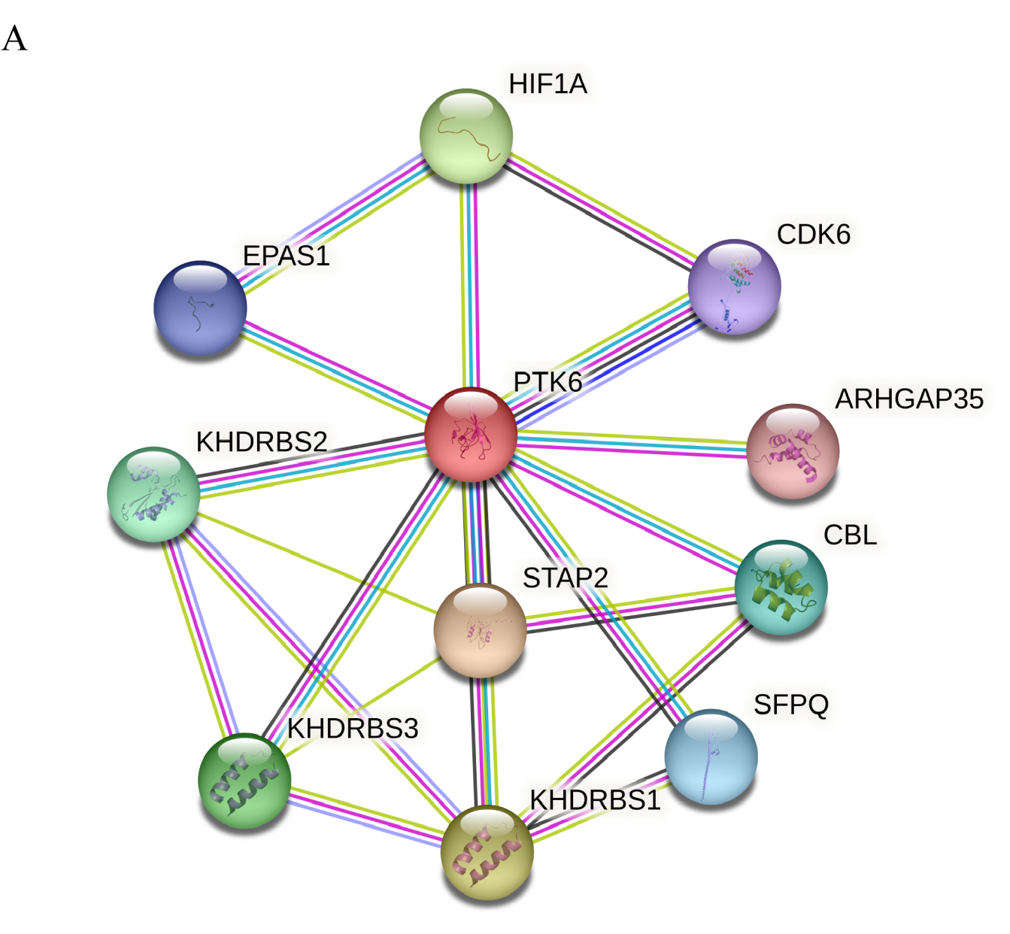
Fig. S1 A PPI network has been established to highlight the relationship between PTK6 and CDK6, HIF1A, EPAS1, KHDRBS1, KHDRBS2, KHDRBS3, STAP2, SFPQ, CBL, ARHGAP35.
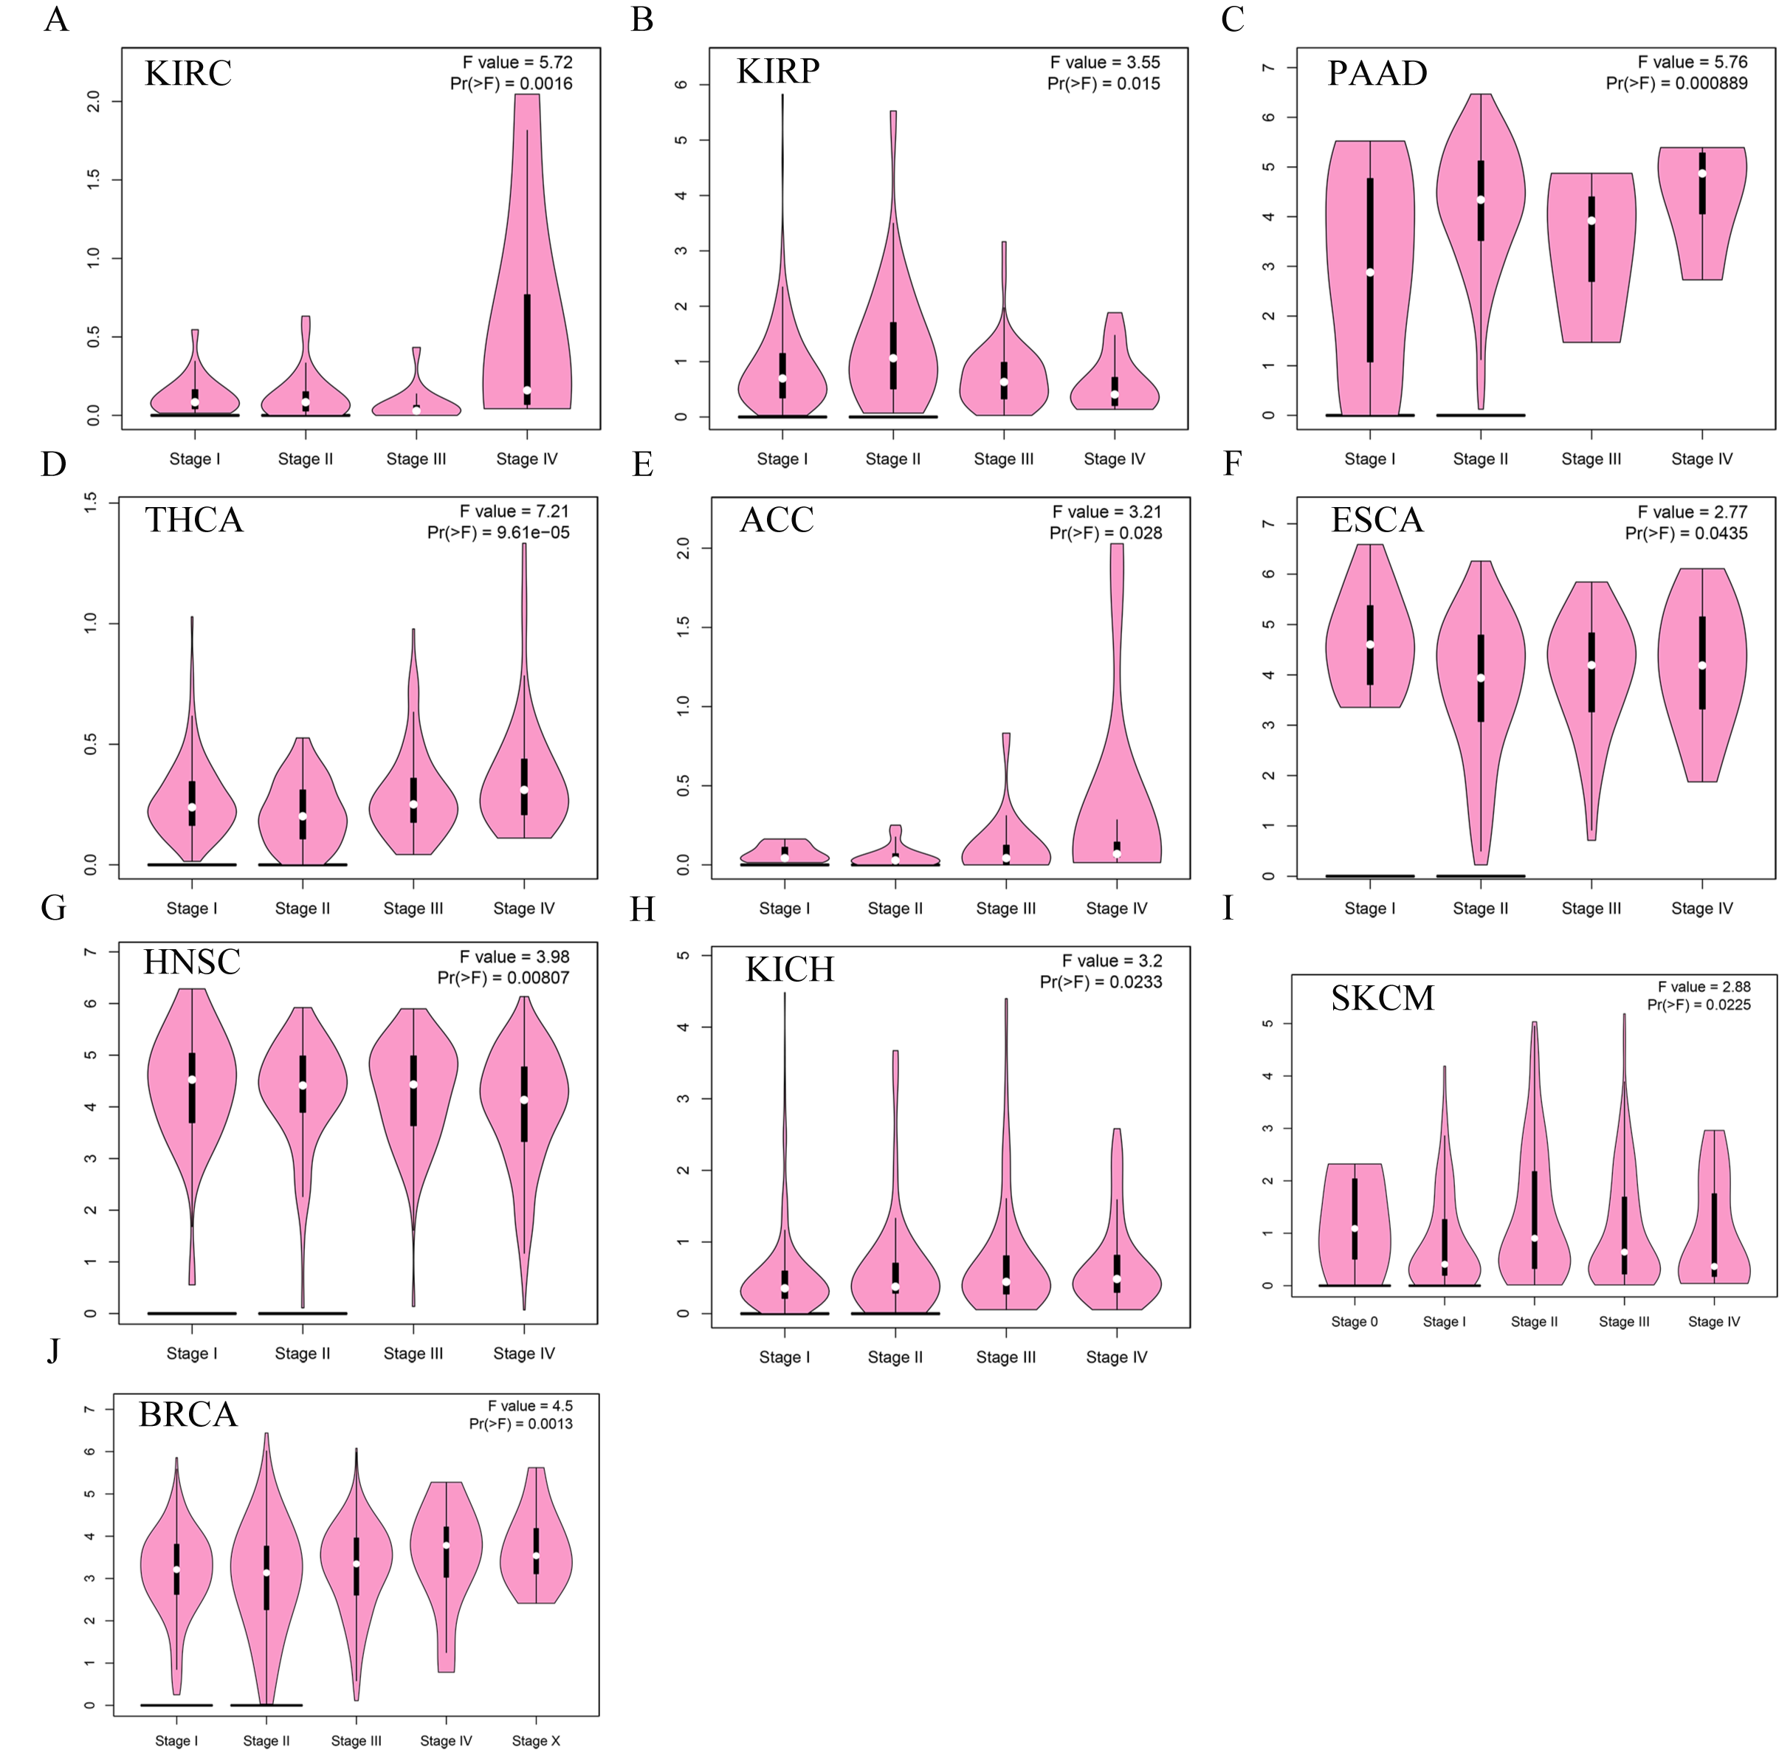

Fig. S2 Stage-dependent expression levels of PTK6 (A–J). Main pathological stages of tumors were assessed and compared using TCGA data. The log2 (TPM + 1) for log-scale was used.
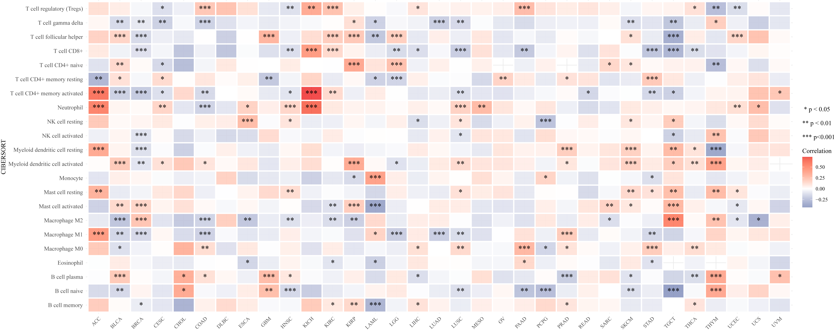

Fig. S3 Association of PTK6 with immune cells in pan-cancer, * p < 0.05, ** p < 0.01, *** p < 0.001.

