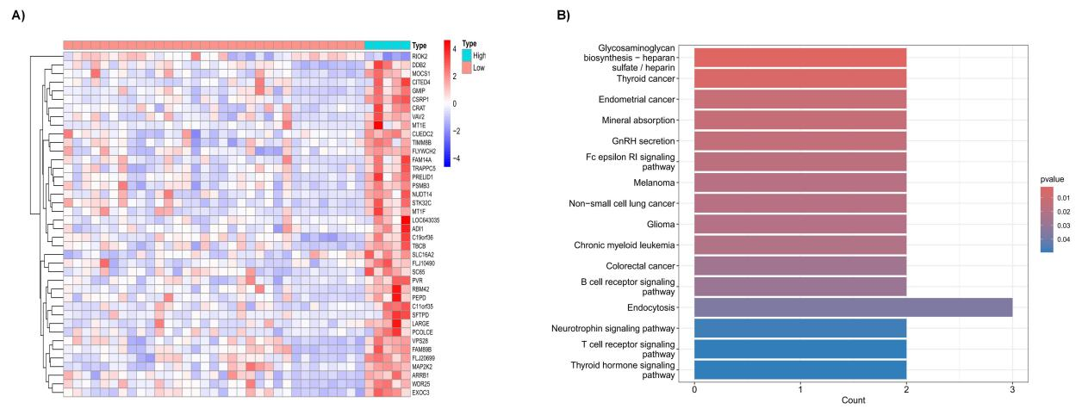
Supplementary Figure 1. Contrasting samples exhibiting high expression of CSRP1 (gene expression > 1000) with those showing lower expression (CSRP1 gene expression ≤ 1000): A) Differential gene expression profile. B) KEGG analysis.

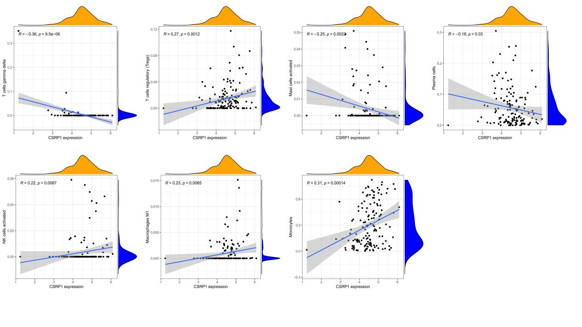
Supplementary Figure 2. The correlation of CSRP1 gene and diverse immune cells.

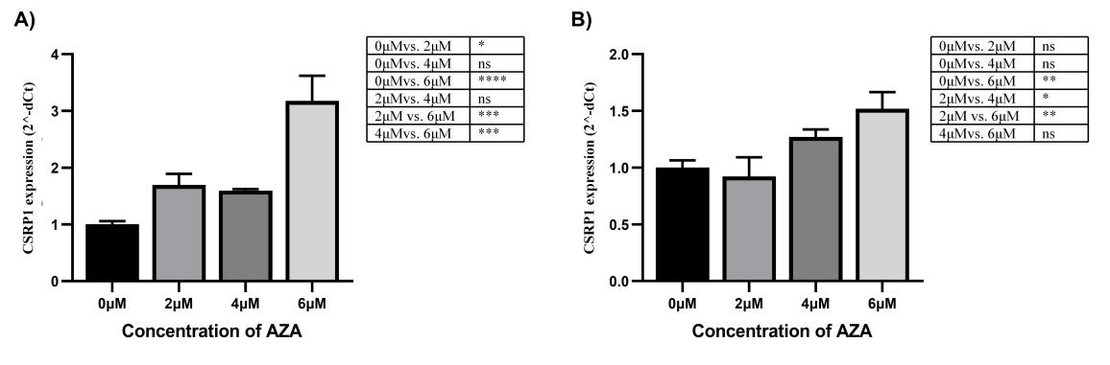
Supplementary Figure 3. THP1 cells treated with varying concentrations of the AZA compound (2uM, 4uM and 6uM), p value were calculated by two-way ANOVA and Tukey’s post-hoc test, the data represent the mean ± SD of triplicates per condition and are from two representative out of three independent experiments.

