Supplementary Table 1. Relation between SLC25A1 expression and patient prognosis of different cancer in PrognoScan database.

Cancer type | Dataset | Endpoint | N | Hazard ratio(95%CI) | Cox P
Brain cancer | GSE4271-GPL96 | Overall Survival | 77 | 0.70 [0.50 - 0.98] | 0.0396255
Brain cancer | MGH-glioma | Overall Survival | 50 | 0.75 [0.60 - 0.92] | 0.00643142
Breast cancer | GSE9195 | Relapse Free Survival | 77 | 2.38 [1.00 – 5.62] | 0.0487464
Breast cancer | GSE9893 | Overall Survival | 155 | 1.40 [1.14 - 1.73] | 0.00141275
Breast cancer | GSE1456-GPL96 | Relapse Free Survival | 159 | 3.12 [1.49 - 6.54] | 0.00250823
Breast cancer | GSE1456-GPL96 | Disease Specific Survival | 159 | 3.32 [1.40 - 7.90] | 0.00653033
Breast cancer | GSE3494-GPL96 | Disease Specific Survival | 236 | 2.31 [1.30 - 4.12] | 0.00454712
Breast cancer | GSE4922-GPL96 | Disease Free Survival | 249 | 2.06 [1.32 - 3.23] | 0.00158794
Breast cancer | GSE2990 | Distant Metastasis Free Survival | 125 | 2.09 [1.09 - 4.02] | 0.0267711
Breast cancer | GSE2990 | Relapse Free Survival | 125 | 1.79 [1.08 - 2.97] | 0.0245571
Breast cancer | GSE7390 | Overall Survival | 198 | 1.86 [1.27 - 2.73] | 0.00151504
Breast cancer | GSE7390 | Relapse Free Survival | 198 | 1.58 [1.15 - 2.16] | 0.00422566
Breast cancer | GSE7390 | Distant Metastasis Free Survival | 198 | 1.81 [1.25 - 2.62] | 0.00163706
Lung cancer  (Adenocarcinoma) | GSE31210 | Relapse Free Survival | 204 | 2.95 [1.21 - 7.17] | 0.0172484
Ovarian cancer | DUKE-OC | Overall Survival | 133 | 0.62 [0.47 - 0.82] | 0.000840631
 | GSE8841 | Overall Survival | 81 | 3.78 [1.55 - 9.20] | 0.00344676
Skin cancer  (Melanoma) | GSE19234 | Overall Survival | 38 | 4.24 [1.27 - 14.13] | 0.0186759

Supplemental figure 1

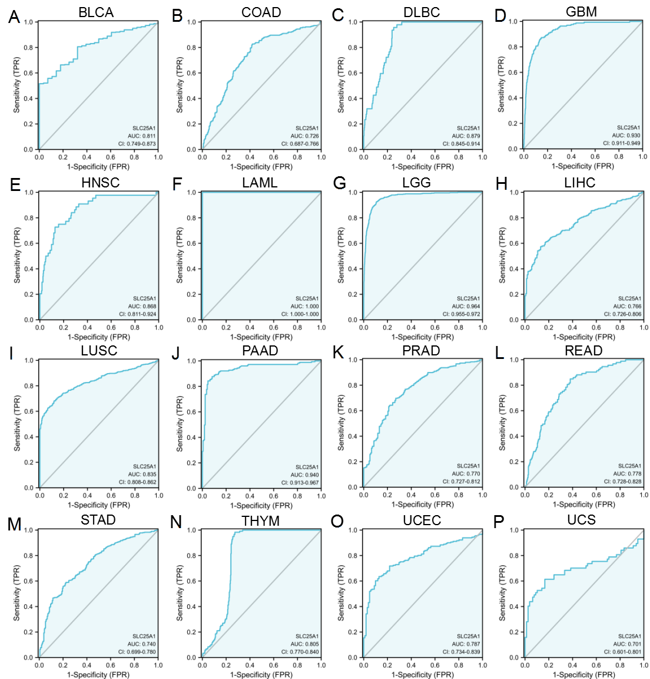

Supplemental figure 1. Receiver operating characteristic (ROC) curve for SLC25A1 expression in pan-cancer. (A) BLCA; (B) COAD; (C) DLBC; (D) GBM; (E) HNSC; (F) LAML; (G) LGG; (H) LIHC; (I) LUSC; (J) PAAD; (K) PRAD; (L) READ; (M) STAD; (N) THYM; (O) UCEC; (P) UCS.

Supplemental figure 2

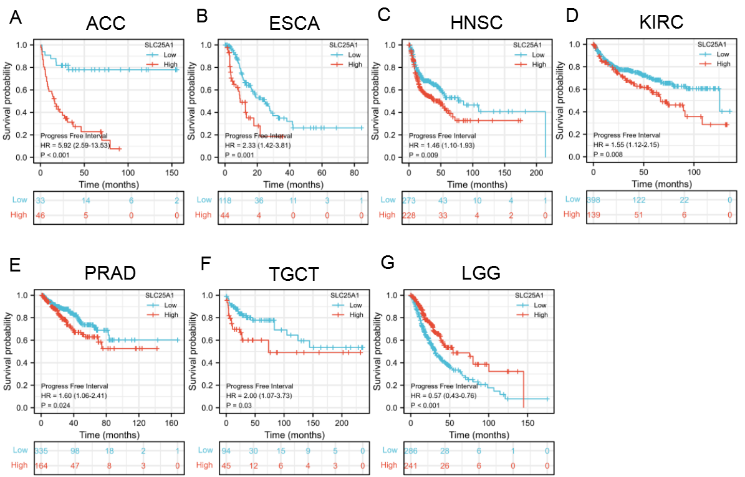

Supplemental figure 2. Correlation between SLC25A1 expression with PFI from TCGA database. The expression of SLC25A1 was related to the PFI of ACC (A), ESCA (B), HNSC (C), KIRC (D), PRAD (E), TGCT (F) and LGG (G). PFI, progression-free interval survial.

Supplemental figure 3

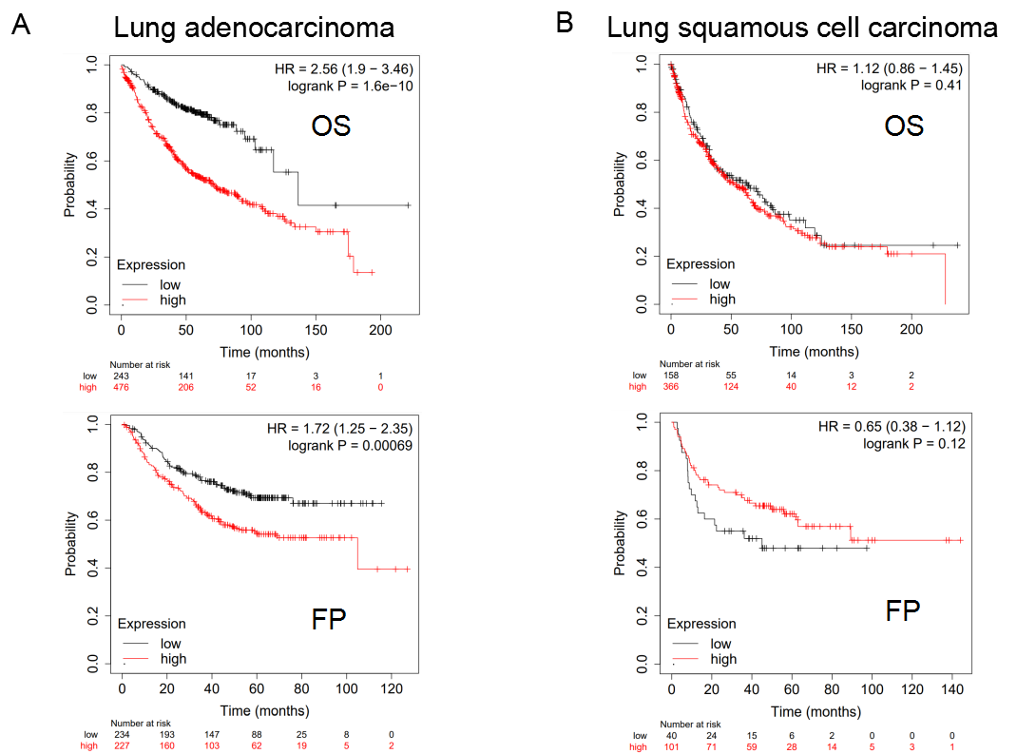

Supplemental figure 3. Prognostic values of SLC25A1 expression in different subtypes of lung cancer in Kaplan-Meier Plotter database. (A-B) Correlation between SLC25A1 expression and the prognosis (OS and FP) of lung adenocarcinoma. (C-D) Correlation between SLC25A1 expression and the prognosis (OS and FP) of lung squamous cell carcinoma.

