Supplementary Figure 1 Identification of magnesium homeostasis-associated genes. Network map of magnesium homeostasis-associated genes.
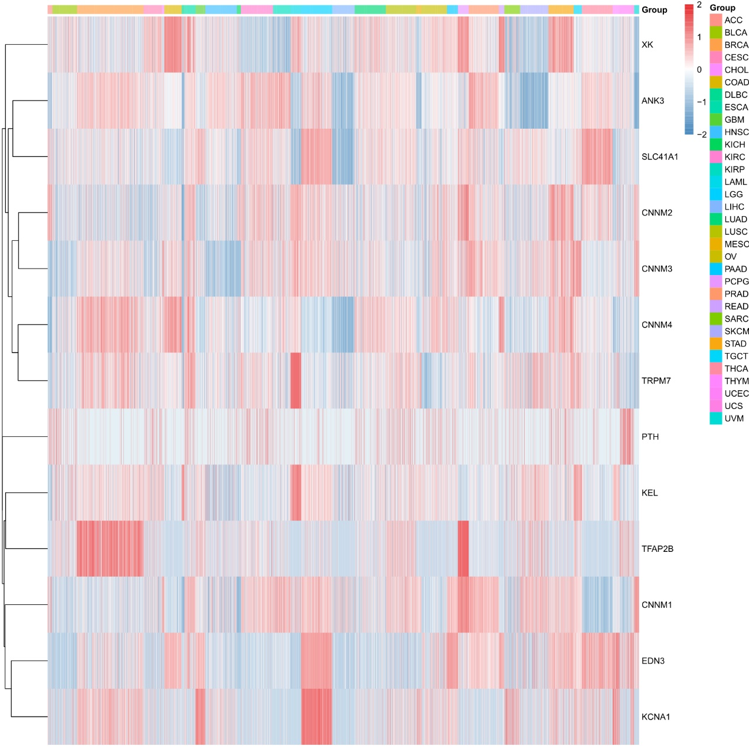
Supplementary Figure 2 Relationship between magnesium homeostasis score and tumor stage based on WHO (World Health Organization).
Supplementary Figure 3 Effect of magnesium homeostasis on disease-specificoverall survival (DSSOS).
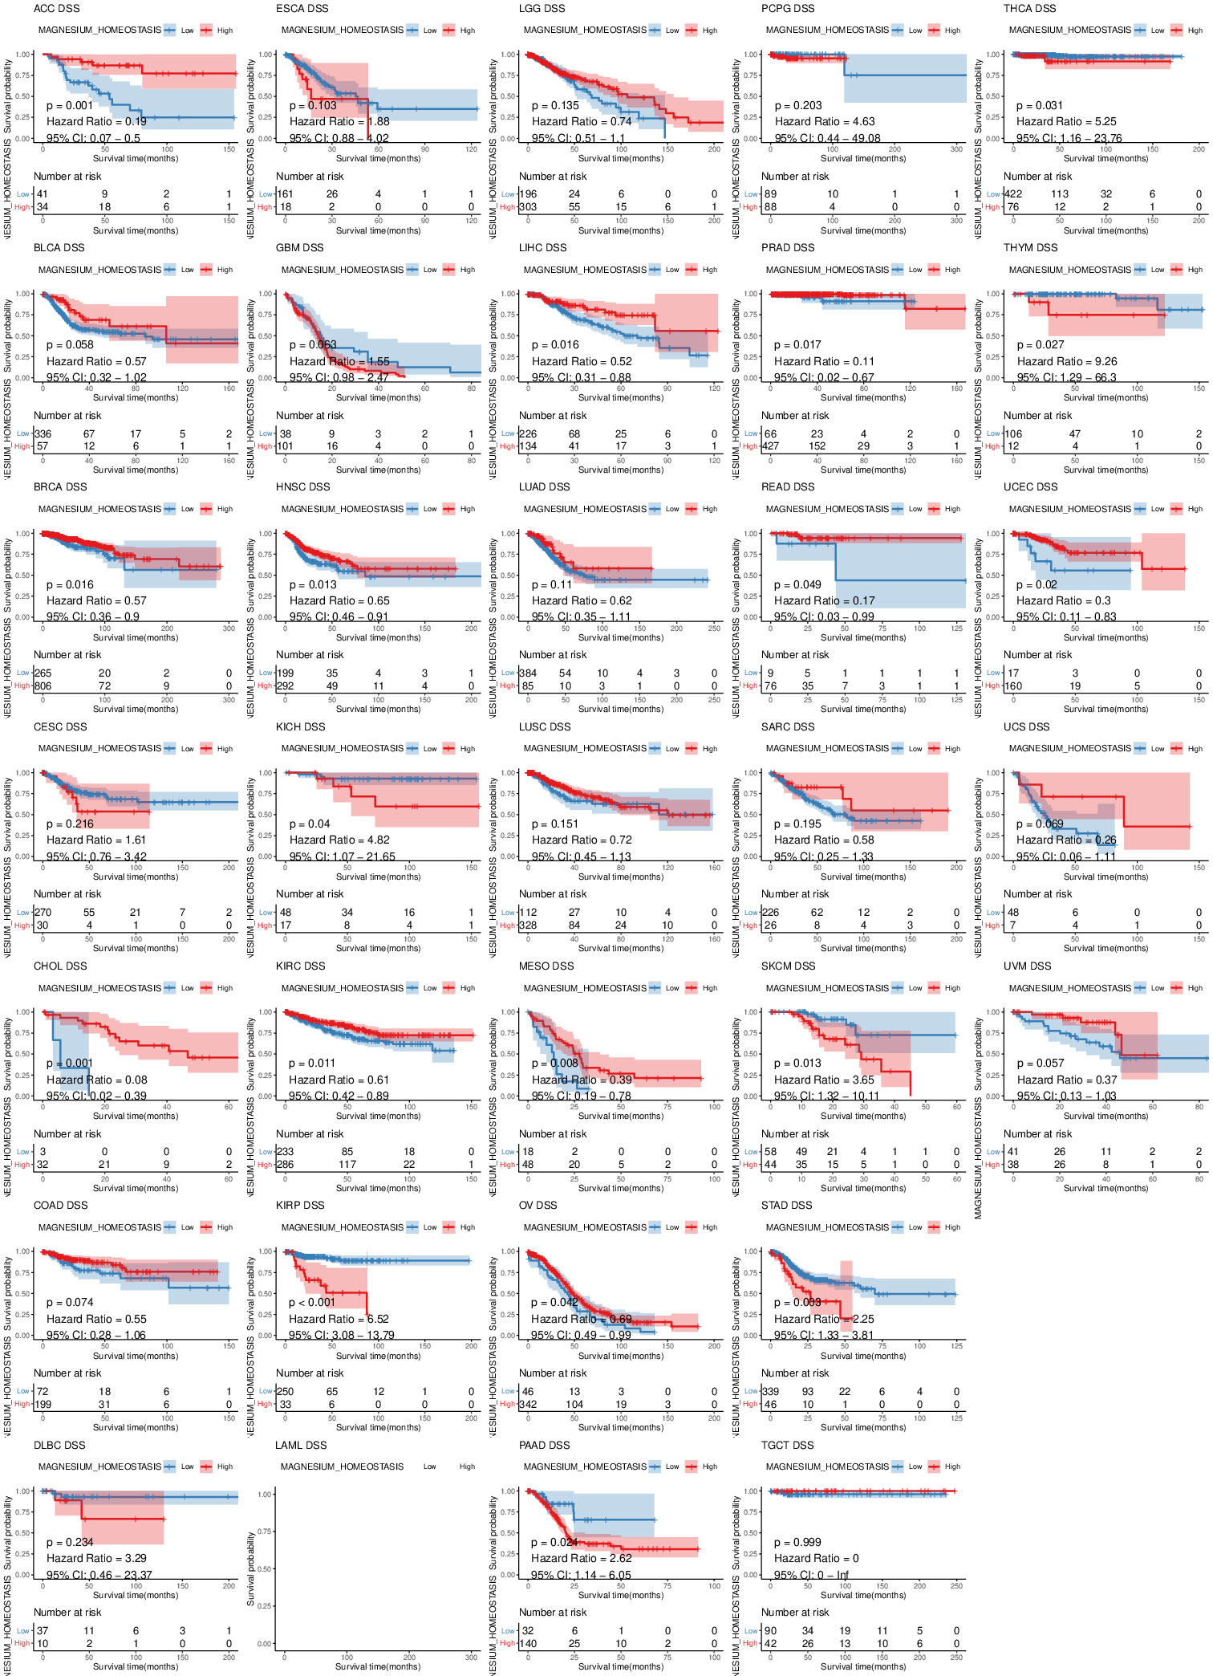
Supplementary Figure 4 Effect of magnesium homeostasis on overalldisease-specific survival (OSDSS).
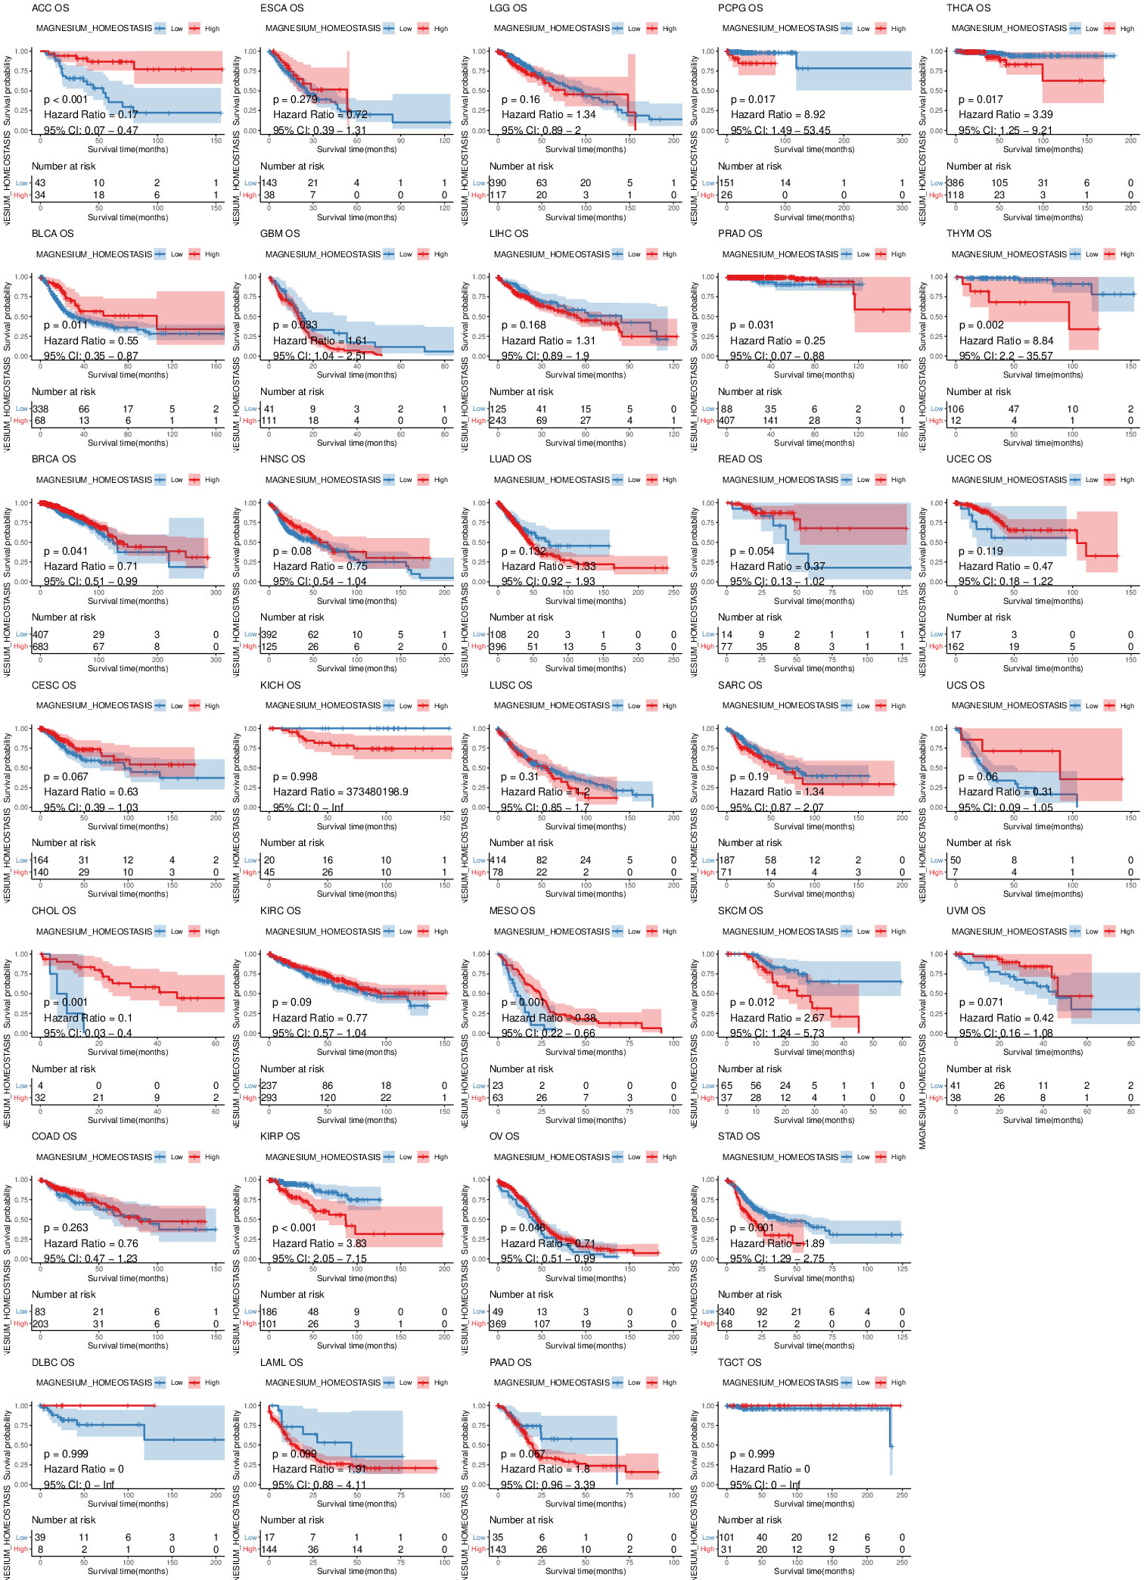
Supplementary Figure 5 Effect of magnesium homeostasis on disease-free interval (DFI).
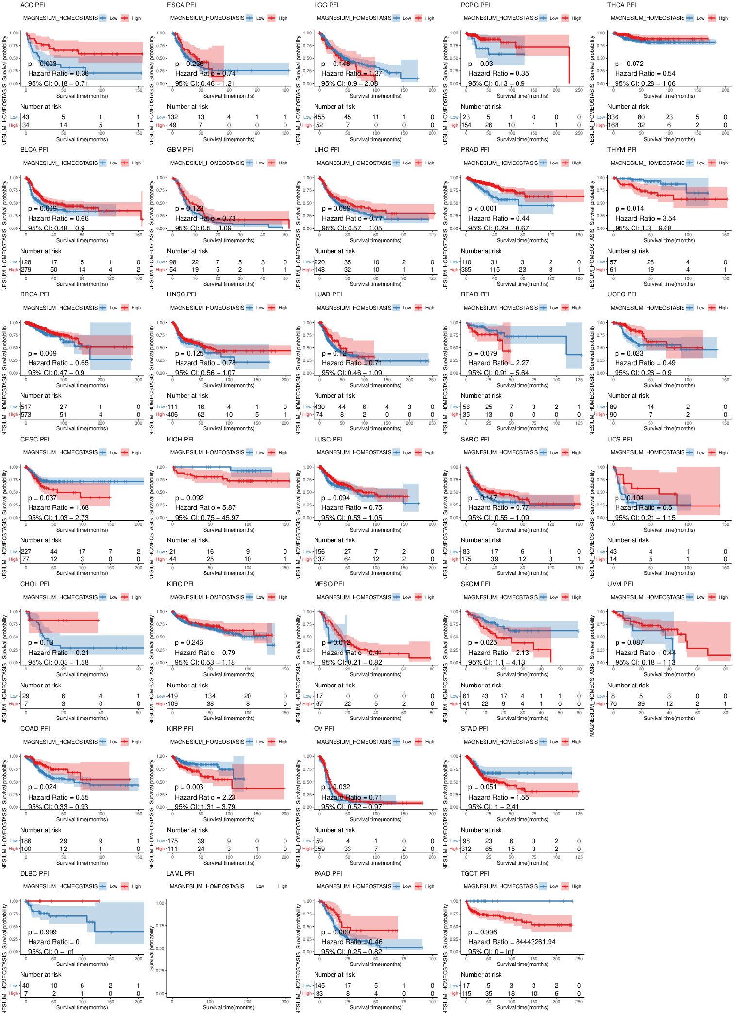
Supplementary Figure 6 The relationship between magnesium homeostasis scoresscore and cancer stromal score.
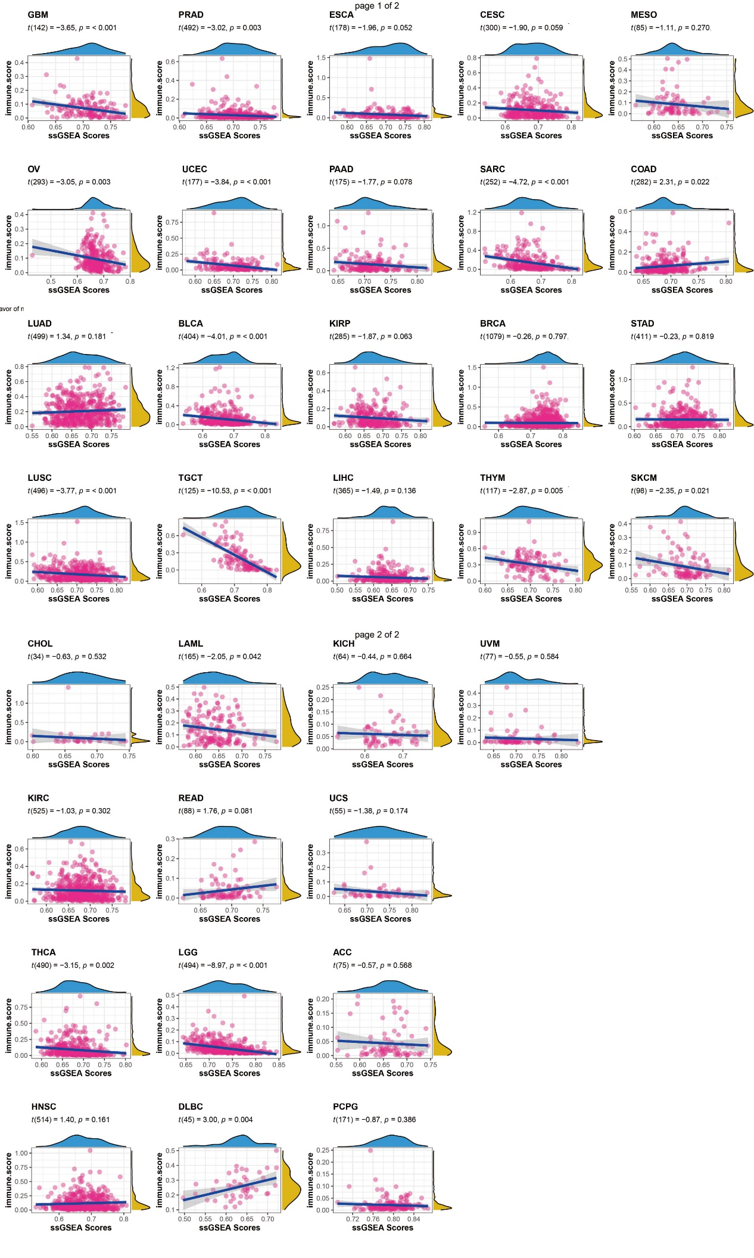
Supplementary Figure 7 The relationship between magnesium homeostasis scoresscore and cancer immune score.
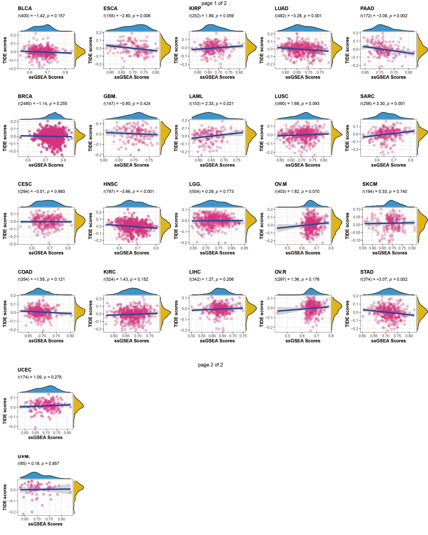
Supplementary Figure 8 The relationship between magnesium homeostasis scoresscore and cancers microenvironment score.
Supplementary Figure 9 Expression level of different markers in different cells.
Supplementary Figure 10 The marker genes expressed in different cell populations.
Supplementary Table 1: Full names and abbreviations of the tumor types involved

