Supporting information

Gastric parietal cell and Intestinal goblet cell secretion: a novel cell-mediated in vivo metal nanoparticle metabolic pathway enhanced with diarrhea via Chinese Herbs
Yanlei Liu¹, Kunlu Liu², Meng Yang¹, Yue Han¹, Qian Zhang¹, João Conde³, Yuming Yang¹, Gabriel Alfranca¹, Yuxia Wang² , Lijun Ma^{4,5}, Yingge Zhang², Jie Song¹, Yunxiang Pan¹, Jian Ni^{1,5}, Daxiang Cui^{1,5}

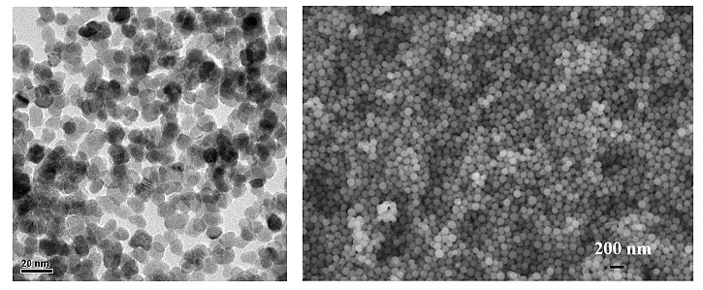Figure S1.Characterization of Fe₃O₄ magnetic nanoparticles by HR-TEM.

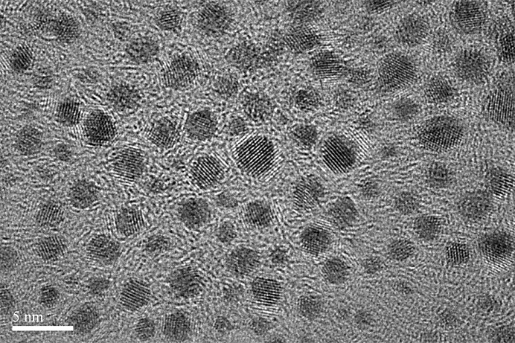
Figure S2. Characterization of Au clusters by HR-TEM. Scale bar, 5 nm.

Figure S3. (A) TEM image of GNRs. Scale bar, 100 nm; (B) absorption spectra of GNRs.

Figure S4. Distribution of Au nanoclusters in intestinal tissues. (A) Control groups; (B) Ligation groups.

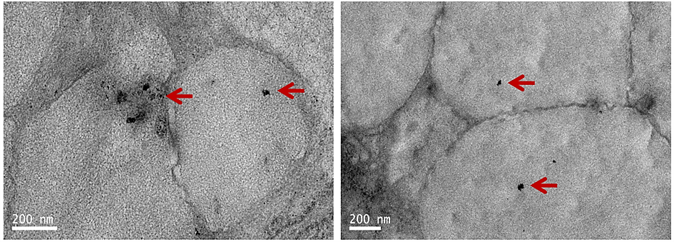
Figure S5. Distribution of magnetic nanoparticles in goblet cells of mice with CBD ligation.
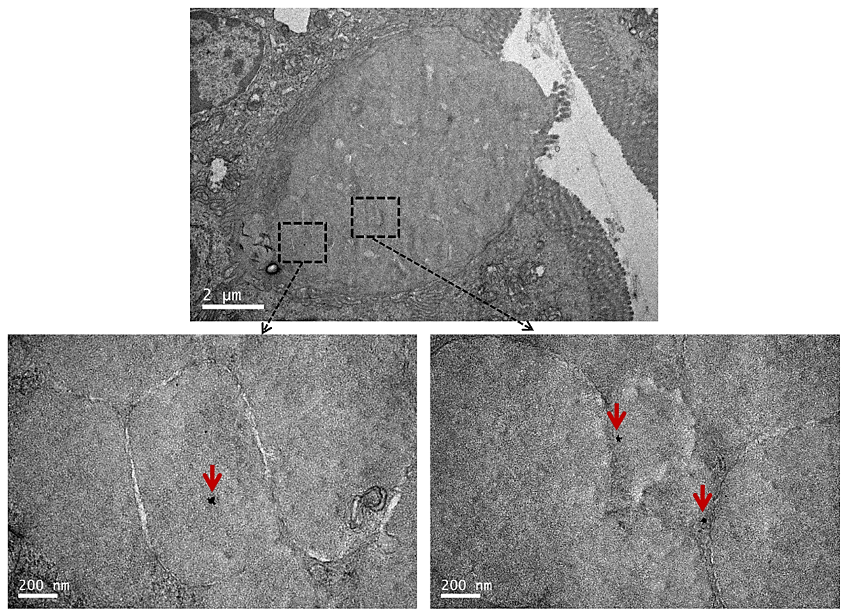
Figure S6. Distribution of gold nanorods in goblet cells of mice with CBD ligation.

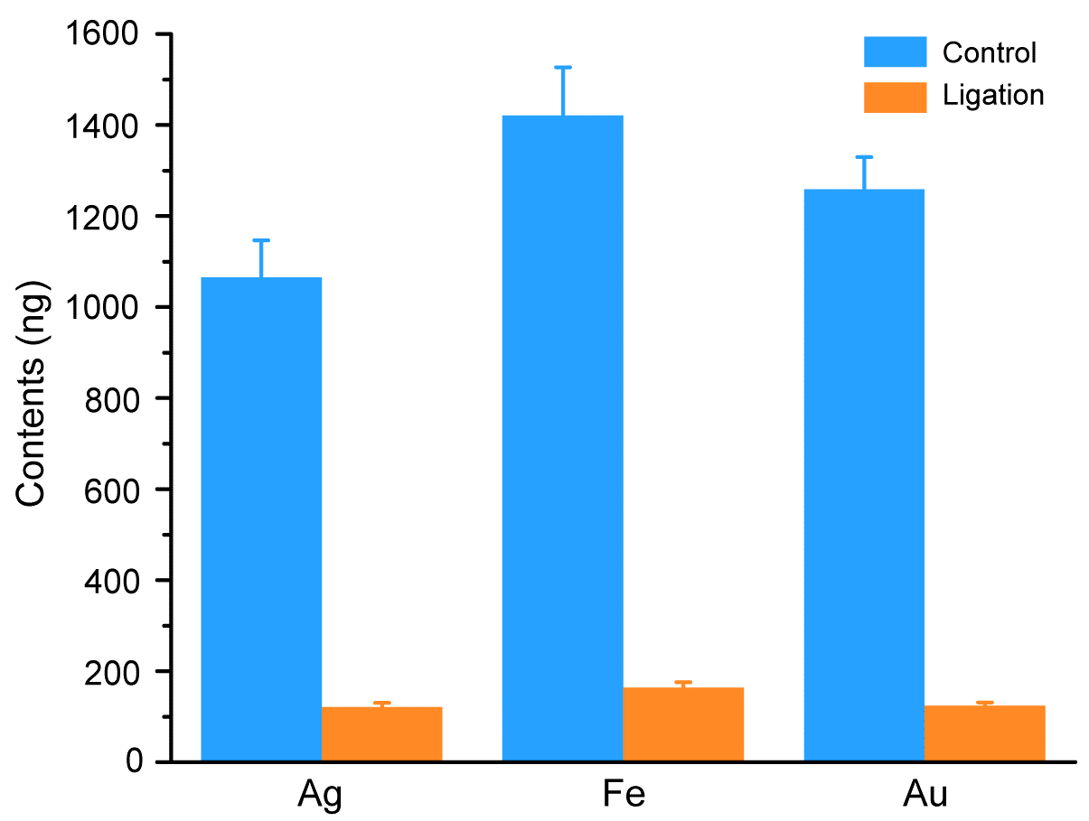
Figure S7. Quantitative analysis of nanoparticles in feces based on ICP-MS.

