Supplement 1. ICD9 and 10 Codes and CPT Codes
Condition | ICD9  Diagnosis codes | ICD10  Diagnosis codes | ICD9  Procedure codes | ICD10 Procedure codes | CPT codes
Coronary Artery Disease | 410.xx, 411.xx, 412.xx, 414.xx, 429.7x | I21.xx, I22.xx, I23.xx, I24.xx, I25.xx | 00.66, 36.10, 36.11, 36.12, 36.13, 36.14, 36.15, 36.16, 36.17, 36.06, 36.07, 36.09, 36.19,  36.2 | 02109x, 02100Ax, 02100Jx, 02100Kx, 02100Zx, 021049x, 02104Ax, 02104Jx, 02104Kx, 02104Zx, 021109x, 02110Ax, 02110Jx, 02110Kx, 02110Zx, 021149x, 02114Ax, 02114Jx, 02114Kx, 02114Zx, 021209x, 02120Ax, 02120Jx, 02120Kx, 02120Zx, 021249x, 02124Ax, 02124Jx, 02124Kx, 02124Zx  021309x, 02130Ax, 02130Jx, 02130Kx, 02130Zx, 021349x, 02134Ax, 02134Jx, 02134Kx, 02134Zx, 027034x, 02703Dx, 02703Tx, 02703Zx, 027044x, 02704Dx, 02704Tx, 02704Zx, 027134x, 02713Dx, 02713T6, 02713ZZ, 02714ZZ, 02723ZZ, 02724ZZ, 02733ZZ, 02734ZZ | 33510, 33511, 33512, 33513, 33514, 33515, 33516, 33517, 33518, 33519, 33521, 33522, 33523, 33533, 33534, 33535, 33536, 33545, 33572, 4110F, 92973, 92974, 92980, 92981, 92982, 92984, 92995, 92996, 93540, 93564, G0290, G0291, S2205, S2206, S2207, S2208, S2209
Acute Myocardial Infarction | 410.xx, 429.7xx | I21.xx, I22.xx, I23.xx
Percutaneous Coronary Intervention |  |  | 0.66, 36.03, 36.04, 36.06, 36.07, 36.09 | 0270xxx, 02C03Zx, 02C04Zx, 02C13Zx, 02C14Zx, 02C23Zx, 02C24Zx, 02C33Zx, 02C34Zx | 92920, 92921, 92924, 92925, 92928, 92929, C9600, C9601, 92933, 92934, C9602, C9603, 92937, 92938, C9604, C9605, 92943, 92944, C9607, C9608
Coronary Artery Bypass Graft |  |  | 36.10, 36.11, 36.12, 36.13, 36.14, 36.15, 36.16, 36.17, 36.19 | 0210xxx, 0211xxx, 0212xxx, 0213xxx | 33510, 33511, 33512, 33513, 33514, 33516, 33517, 33518, 33519, 33521, 33522, 33523, 33533, 33534, 33535, 33536
Stroke | 430.xx, 431.xx, 433.01, 433.11, 433.21, 433.31, 433.81, 433.91, 434.01, 434.11, 434.91, 436.xx | I63.xx
Supplement 2: Terms used to search for evidence of cannabis use in the medical record
Marijuana
Marij
MJX (Not TMJX)
Marj (misspelling)
Cannabis
Cannab
Canab (misspelling)
* each term should include a space before and after while searching.

Supplement 3. Research Assistant Training Process
Training Component | Steps
Medical Chart Abstraction | - Trainee abstracts at least 2 records with full guidance of Trainer  - Trainee abstracts ≥2 additional records with partial guidance; Trainer addresses all questions/concerns of Trainee during abstractions  - Trainee abstracts at least 1 training batch (25 records previously abstracted by Trainer)  - If >1 discrepancy* in first training batch, Trainee abstracts 1 additional batch  - Repeat new training batch(es) until no discrepancies found
Telephone Interviews | - Trainee reviews staff-developed Technology Guide and Interview Guide  - Trainer goes through interview with Trainee and introduces different probing methods  - Trainee does simulation calls with other trained Research Assistants (Ras)  - Trainer provides direct feedback while listening to simulation calls with Trainee in 1-on-1 session  - Continue simulation calls until Trainee’s interview skills are well-developed  - Trainee listens to recorded interviews of trained Ras while Trainer conducts Quality Assurance (QA); Trainer addresses all questions/concerns of Trainee  - Continue until Trainee’s interview skills are well-developed  - Once interview skills well-developed, Trainee does first 10 interviews with participants  - Trainer provides feedback using QA Form (see below)  - If average overall score on first 10 interviews is ≥95%, Trainee is considered certified to interview  - If average score <95%, Trainee conducts another 5 interviews and Trainer provides feedback and score using QA Form  - Repeat until average score ≥95%  - Once certified, Trainee moves into QA phase
Quality Assurance (QA) | - RAs record every call  - Two calls per RA randomly selected and reviewed each week using staff-developed QA Form  - QA Form  - Each section scored for:  - Script compliance and answer coding  - Probing  - Overall survey scored for:  - Problem solving abilities  - Call etiquette  - Script compliance and answer coding  - Total score
*Based upon inclusion/exclusion criteria and reasons for exclusion

Supplement 4. Source Material for Interview Tool
Scale | Source Material | Reference
Overall Health Questions | Short Form Survey (SF-36) | Ware JE Jr, Sherbourne CD. The MOS 36-item short-form health survey (SF-36). I. Conceptual framework and item selection. Med Care. 1992 Jun;30(6):473-83. PMID: 1593914.  https://www.rand.org/health-care/surveys_tools/mos/36-item-short-form.html
Mobility | Health and Retirement Study (HRS) | https://hrs.isr.umich.edu/about
Physical Activity | International Physical Activity Questionnaire (IPAQ) | http://www.ipaq.ki.se/
Alcohol Use | Alcohol Use Disorders Identification Test (AUDIT C) | Bush K, Kivlahan DR, McDonell MB, Fihn SD, Bradley KA, for the Ambulatory Care Quality Improvement Project (ACQUIP). The AUDIT Alcohol Consumption Questions (AUDIT-C): An Effective Brief Screening Test for Problem Drinking. Arch Intern Med. 1998;158(16):1789–1795.  https://www.mdcalc.com/audit-c-alcohol-use
Tobacco Use | Adapted from Psychiatric Research Interview for Substance and Mental Disorders for DSM-V (PRISM-V), National Health Interview Survey (NHIS) | PRISM-V: Hasin DS, Trautman KD, Miele GM, Samet S, Smith M, Endicott J. Psychiatric Research Interview for Substance and Mental Disorders (PRISM): reliability for substance abusers. Am J Psychiatry. 1996 Sep;153(9):1195-201. PMID: 8780425.  NHIS: https://www.cdc.gov/nchs/nhis/index.htm
Marijuana Use | Cannabis Assessment Tool (CAT-1)
Secondhand Smoke Exposure | Adapted from NHIS | https://www.cdc.gov/nchs/nhis/index.htm
Illicit Drug Use | Adapted from Coronary Artery Risk Development in Young Adults (CARDIA) | https://www.cardia.dopm.uab.edu/exam-materials2/data-collection-forms
Mood | Patient Health Questionnaire (PHQ-9) | Kroenke K, Spitzer RL, Williams JB. The PHQ-9: validity of a brief depression severity measure. J Gen Intern Med. 2001;16(9):606-613.  https://www.mdcalc.com/phq-9-patient-health-questionnaire-9
PTSD | PTSD Checklist-5 (PCL-5) | Blevins CA, Weathers FW, Davis MT, Witte TK, Domino JL. The Posttraumatic Stress Disorder Checklist for DSM-5 (PCL-5): Development and Initial Psychometric Evaluation. J Trauma Stress. 2015 Dec;28(6):489-98. Epub 2015 Nov 25. PMID: 26606250.  https://www.ptsd.va.gov/professional/  assessment/documents/using-PCL5.pdf
Aspirin | CAT-1
SES | Adapted from CARDIA and HRS | CARDIA: https://www.cardia.dopm.uab.edu/  HRS: https://hrs.isr.umich.edu/about

Supplement 5. Baseline Characteristics of Individuals who Participated in the Telephone Interview Compared to Individuals who Refused to Participate or Were Not Reached
 |  | non-respondents | respondents
 |  | mean(sd)
Age |  | 67.1 (0.81) | 67.7 (1.11)
 |  | N (%)
Gender
 | Male | 1941 (98.2%) | 4196 (97.9%)
 | Female | 35 (1.8%) | 89 (2%)
Race
 | White | 1481 (75%) | 3405 (79%)
 | Black | 337 (17%) | 714 (17%)
 | Other | 158 (8%) | 166 (4%)
Marital Status
 | Married/ Partner | 932 (47%) | 2092 (49%)
 | Other | 1044 (53%) | 2193 (51%)

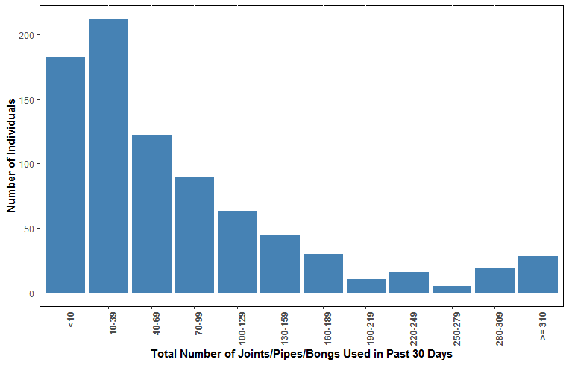

Supplement 6: Frequency of Use Per Month.

