Supplementary Data
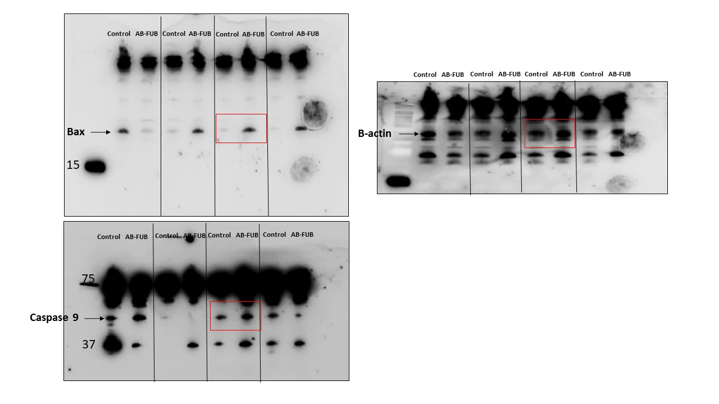

Supplementary figure 1: uncropped blots for BAX, Caspase 9, and B-actin

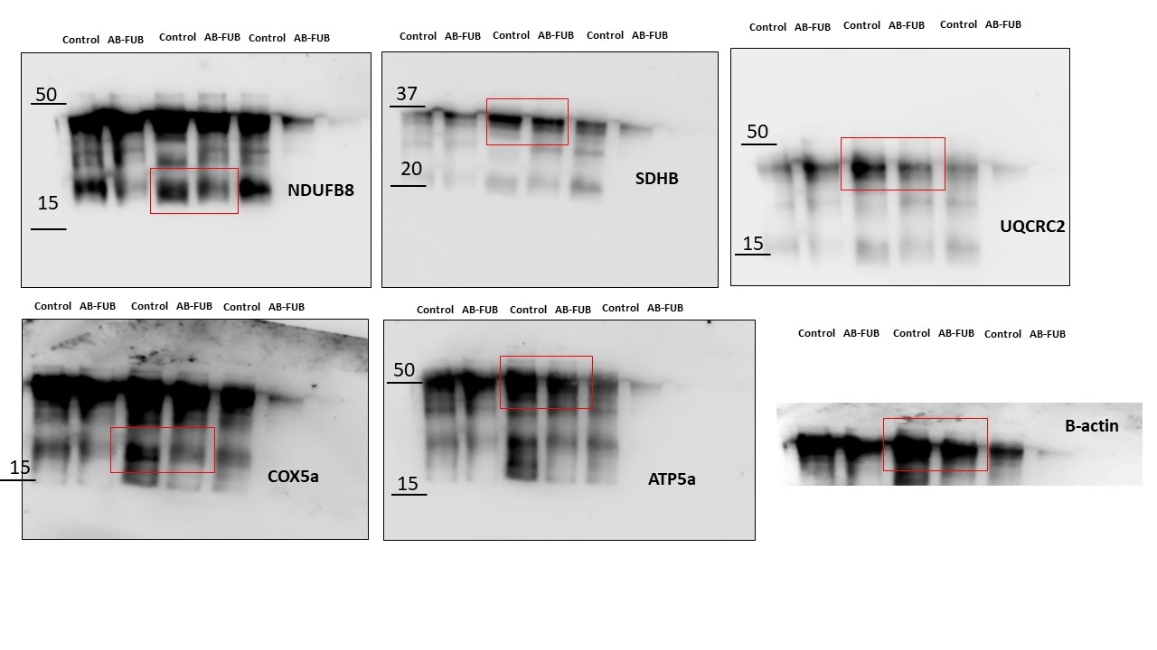
Supplementary figure 2: uncropped blots for mitochondrial complexes

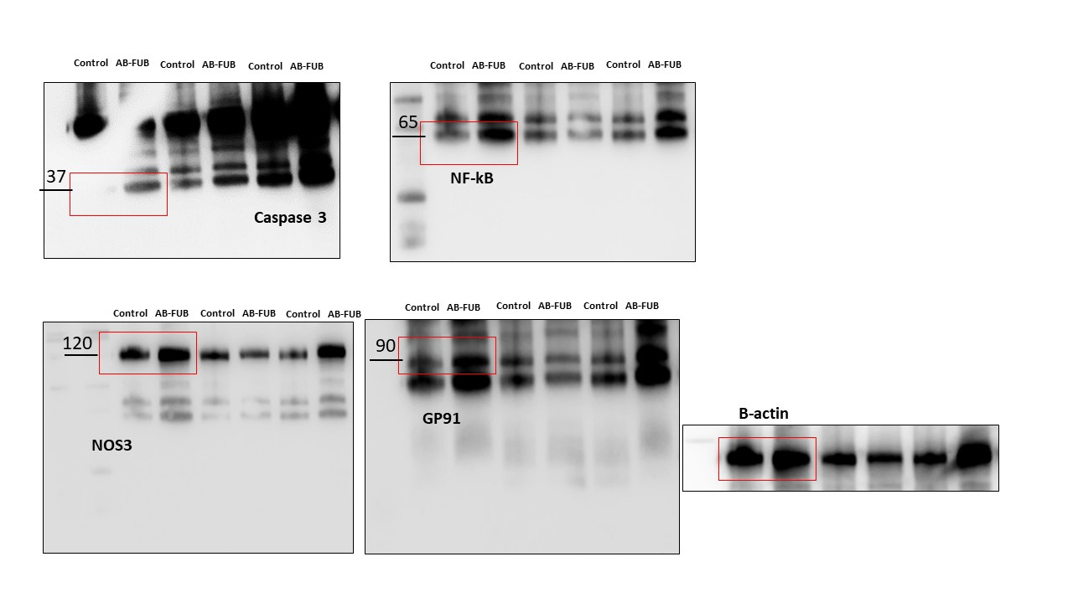

Supplementary figure 3: uncropped blots for Caspase 3, NF-KB, NOS3, GP91, and B-actin

