Online Supplement
Cell Biology and Toxicology

Transcriptomic Changes in Oxidative Stress, Immunity and Cancer Pathways Caused by Cannabis Vapor on Alveolar Epithelial Cells

Emily T. Wilson^{1,2}, Percival Graham³, David H. Eidelman^{2,4}, and Carolyn J. Baglole^{1,2,4*}

¹Department of Pharmacology and Therapeutics, McGill University, Montreal, Quebec Canada
²Research Institute of the McGill University Heath Centre, Montreal Quebec Canada
³SCIREQ - Scientific Respiratory Equipment Inc., Montreal, Canada
⁴Department of Medicine, McGill University, Montreal, Canada

*Author for Correspondence:
Carolyn J. Baglole
Research Institute of the MUHC
Centre for Translational Biology (CTB), Block E
1001 Decarie Blvd.
Montreal QC H4A 3J1 Canada
Tel: (514) 934-1934 Ext 96109
Email: carolyn.baglole@mcgill.ca

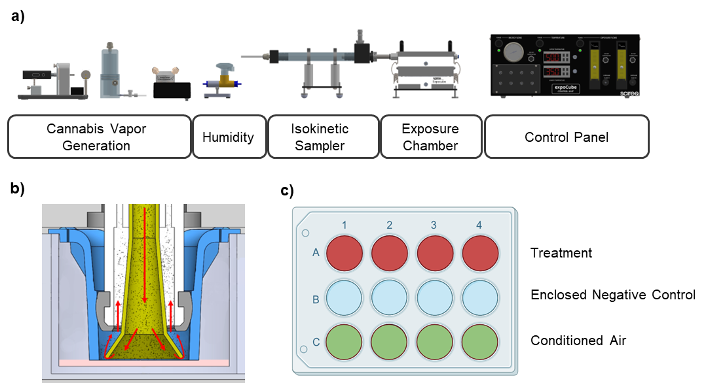
Supplementary Fig. 1. Schematic of expoCube for Cannabis Vapor Exposure of ALI culture. (a) DaVinci MIQRO vaporizer was used to generate cannabis vapor. This sample is humidified and shuttled through the isokinetic sampler and into the exposure site. The control unit allows adjustments to airflow outputs and temperature gradients. (b) Inside the well, trumpets deliver particles to the apical side of ALI cell cultures. (c) The expoCube is compartmentalized into three rows: a test row for cannabis vapor exposure, a vehicle control row of conditioned air, and the enclosed negative control row that remains untouched by any airflow.

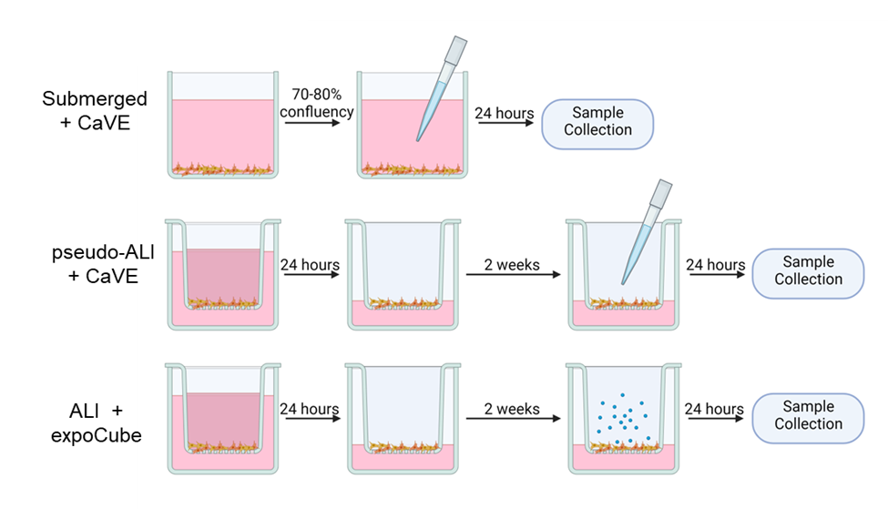
Supplementary Fig. 2. Schematic of cell models and experimental outline Experimental Design: Submerged model: A549 cells were grown in submerged conditions until reaching 70-80% confluency. They were then serum starved for 18 hours before exposure to CaVE. Samples were collected 24 hours post-treatment. Pseudo-ALI model: A549 cells were seeded into transwell inserts. After 24 hours the apical media was removed to create an ALI condition. Cells were kept at ALI for 2 weeks before treatment to allow for differentiation. Cells were serum starved 24 hours in advance of treatment. CaVE was added apically to cells dissolved in media for a total apical volume of 100 ul. Twenty-four hours after treatment samples were collected. ALI model: A549 cells were seeded into Transwell inserts. After 24 hours the apical media was removed to create an ALI condition. Cells were kept at ALI for 2 weeks before treatment to allow for differentiation. Cells were serum starved 24 hours in advance of treatment. Cells were exposed to cannabis vapor using the expoCubeTM for 30 minutes. Twenty-four hours after exposure samples were collected.

