Supplementary Fig. 1 Past-month cannabis use was not associated with event-based prospective memory or time-based prospective memory subscale performance in PWH (N = 307)

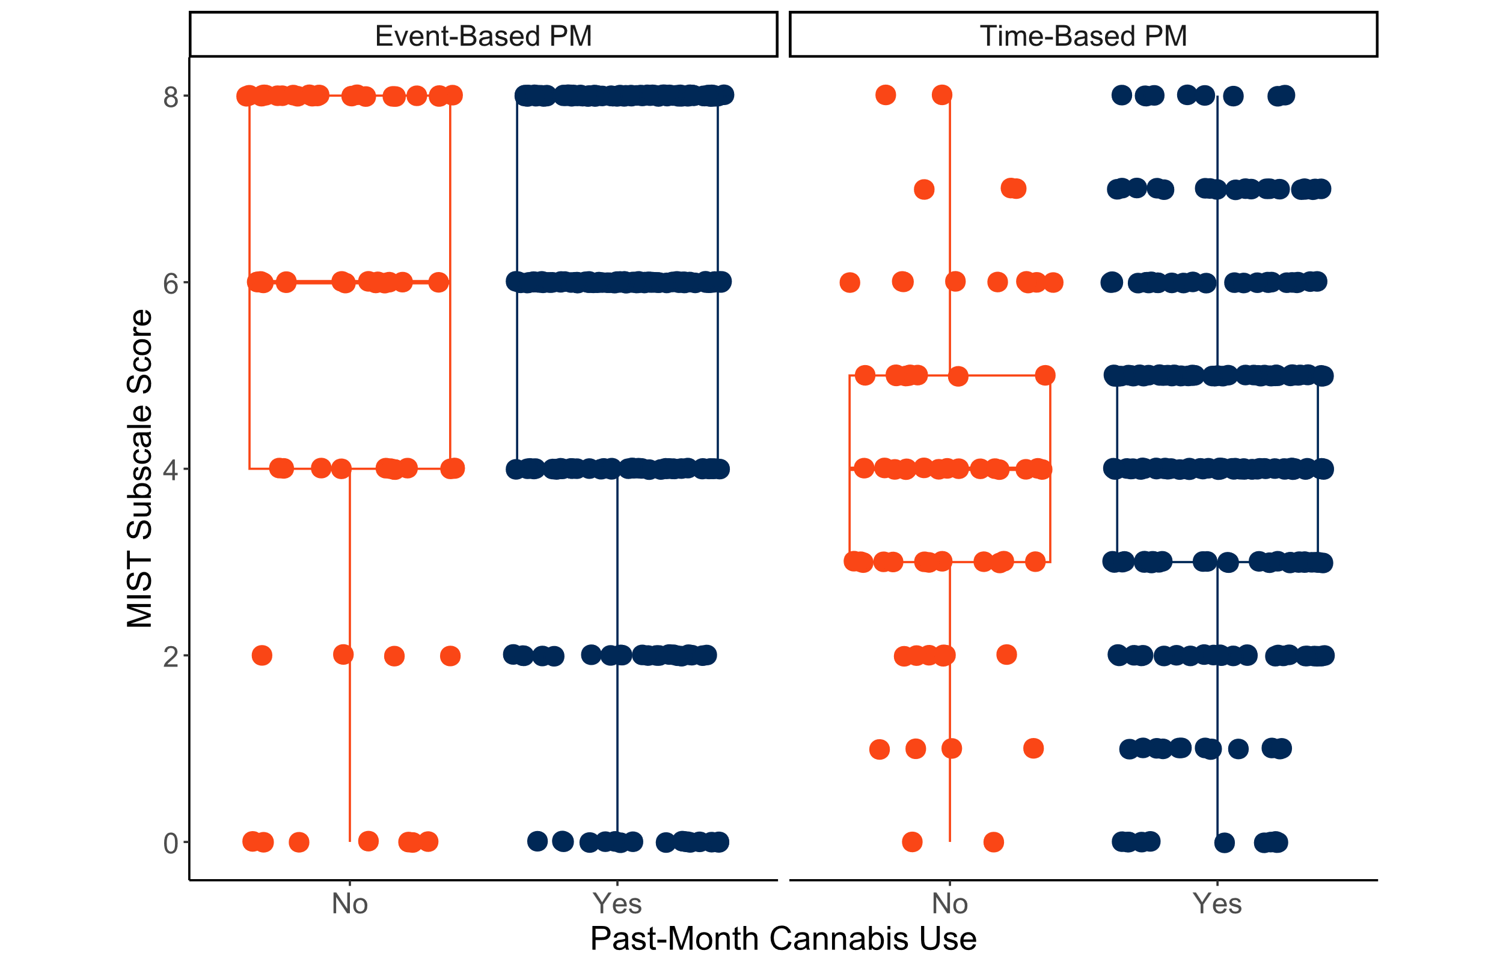

Supplementary Fig. 2 Past-month cannabis use was not associated with retrospective recognition performance in PWH (N = 301)

