Integrated Multi-Omics Analysis of Chromosome 19 miRNA Cluster in Bladder Cancer

Akshay Pramod Ware¹, Kapaettu Satyamoorthy², and Bobby Paul^{1*}

¹Department of Bioinformatics, Manipal School of Life Sciences, Manipal Academy of Higher Education, Manipal – 576104, Karnataka, India.

²Department of Cell and Molecular Biology, Manipal School of Life Sciences, Manipal Academy of Higher Education, Manipal – 576104, Karnataka, India.

*Correspondence to: bobby.paul@manipal.edu

Supplementary Information

All supplementary tables are combined in a single excel file.
Table titles and captions are listed below.

Supplementary Table S1. Differentially expressed miRNAs in BCa compared with Normal.

Supplementary Table S2. Differentially expressed genes in BCa compared with Normal.

Supplementary Table S3. List of 167 (116 amplified, and 51 deleted) significant CNV aberrations detected by GAIA analysis in on chr19 in BCa.

Supplementary Table S4. Details of miRNA clusters residing on recurrent CNV regions on chr19.

Supplementary Table S5. Methylation beta value of 4 probes mapped at CpG island (17.5 kb upstream of C19MC).

Supplementary Table S6. C19MC targeted genes and their expression in BCa.

Supplementary Table S7. Mapping of 42 C19MC target (Tumor suppressors) across 11 types of cancers.
Supplementary Table S8. Details of CNV and DNA promoter methylation information of C19MC targeted genes.

Supplementary Table S9. Details of immune cell infiltration analysis obtained from CIBERSORT algorithm.

Supplementary Figures

Supplementary Fig. 1 Comparative methylation of probes at CpG-island region between normal and BCa using TCGA 450k methylation data.

Supplementary Fig. 2 Identification of regulatory elements in the C19MC region using the UCSC Genome Browser. UCSC Genome Browser tracks displays information about the H3K27Ac markers, enhancers, and promoter regions in the A) pre-C19MC, B) complete C19MC and C) post-C19MC regions.

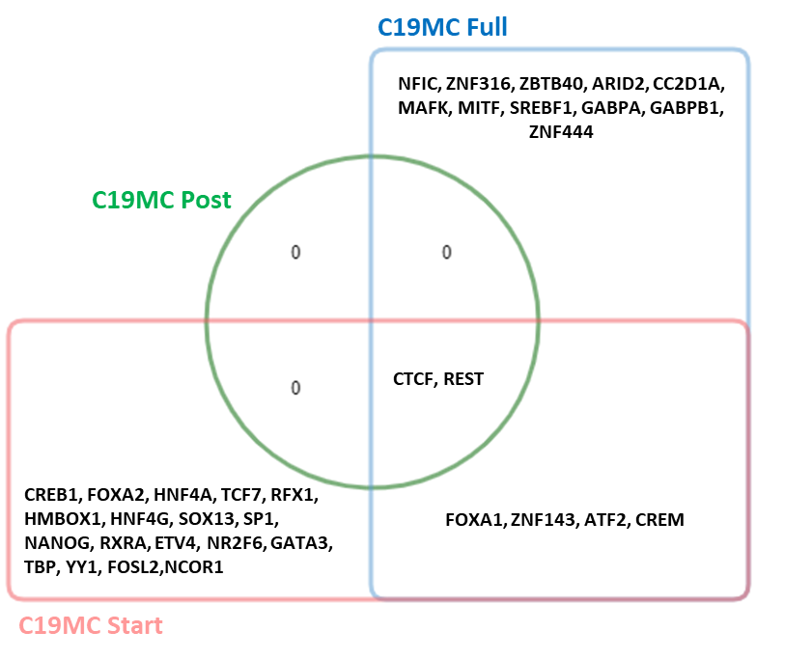

Supplementary Fig. 3 Venn diagram representing the unique and common TFs targeting at three C19MC regions (pre-C19MC, full C19MC and post-C19MC)

Supplementary Fig. 4 Interaction network of C19MC members and their target genes. High confidence miRNA target genes were predicated with the help of multiMiR R/Bioconductor package. Target genes were prioritised according to the number of individual miRNAs from the C19MC that had targeted them. The miRNA-mRNA regulatory networks were visualized by using Circos tool.

Supplementary Fig. 5 Interaction network of C19MC members and their target genes. High confidence miRNA target genes were predicated with the help of multiMiR R/Bioconductor package. The top miRNAs were prioritised according to the highest number target. The miRNA-mRNA regulatory networks were visualized by using Circos tool.

