Supplemental
Tables
Table S1: All analytes listed with their corresponding internal standard and the surrogate analyte used for the calibration.
Analyte | Internal standard | Analyte for calibration
2-AG | D₁₁-AEA | D₅-2-AG
AEA | D₁₁-AEA | D₄-AEA
Androstenedione | D₉-progesterone | ¹³C₃-Androstenedione
Cortisol | D₇-cortisone | ¹³C₃-Cortisol
Cortisone | D₇-cortisone | ¹³C₃-Cortisone
OEA | D₁₁-AEA | D₄-OEA
PEA | D₁₁-AEA | D₄-PEA
Progesterone | D₉-progesterone | ¹³C₃-Progesterone
Testosterone | D₉-progesterone | ¹³C₃-Testosterone

Table S2: Measurement results of authentic samples: N=57 samples, n.d.: not detected
Sample | Age | Amount | 2-AG | AEA | OEA | PEA | Cortisol | Cortisone | Androstenedione | Progesterone | Testosterone
 |  | [mg] | [pg/mg] | [pg/mg] | [pg/mg] | [pg/mg] | [pg/mg] | [pg/mg] | [pg/mg] | [pg/mg] | [pg/mg]
K1_LR | 1 month | 2.6 | 70.4 | 2.7 | 685.8 | 1145.4 | 2.7 | 20.4 | 2.1 | 4.6 | n.d.
K10 | 1 year | 0.9 | 124.6 | 1.9 | 1068.2 | 1259.1 | n.d. | 3.5 | n.d. | 1.8 | n.d.
K2_F1 | 5 years | 20.8 | 35.4 | 1.7 | 525.6 | 798.0 | 0.9 | 4.6 | 0.1 | 0.5 | n.d.
K2_F2 | 5 years | 19.9 | 19.8 | 1.2 | 426.9 | 998.5 | 0.6 | 3.8 | 0.0 | 0.5 | n.d.
K2_F3 | 5 years | 24.6 | 23.4 | 1.0 | 567.0 | 1100.2 | 1.1 | 5.4 | 0.0 | 0.5 | n.d.
K2_H1 | 5 years | 21.0 | 57.0 | 2.5 | 1784.2 | 4446.0 | 2.2 | 8.2 | 0.1 | 1.0 | n.d.
K2_H2 | 5 years | 20.5 | 33.0 | 2.1 | 2162.9 | 6478.9 | 1.6 | 6.5 | 0.0 | 0.8 | n.d.
K2_H3 | 5 years | 16.2 | 23.3 | 1.6 | 1565.6 | 4230.1 | 1.6 | 5.7 | 0.0 | 0.8 | n.d.
K2_L1 | 5 years | 5.4 | 35.7 | 1.9 | 1087.3 | 4146.3 | 0.2 | 4.8 | 0.6 | 5.7 | n.d.
K2_L2 | 5 years | 8.7 | 21.5 | 2.1 | 1132.7 | 3797.6 | 0.5 | 5.4 | 0.4 | 1.0 | n.d.
K2_L3 | 5 years | 6.2 | 25.1 | 1.8 | 1889.6 | 6693.8 | 0.0 | 6.6 | 0.5 | 8.5 | n.d.
K2_R1 | 5 years | 6.0 | 28.8 | 1.9 | 1412.6 | 5715.3 | 0.1 | 5.0 | 0.6 | 2.7 | n.d.
K2_R2 | 5 years | 11.8 | 19.3 | 1.3 | 835.0 | 3075.3 | 1.0 | 6.4 | n.d. | 1.5 | n.d.
K2_R3 | 5 years | 8.6 | 19.9 | 1.3 | 1566.7 | 6511.3 | 2.0 | 7.5 | 0.5 | 3.3 | n.d.
K3_F1 | 8 years | 19.6 | 18.2 | 0.9 | 353.9 | 1083.9 | 1.1 | 3.6 | 0.0 | 0.4 | n.d.
K3_F2 | 8 years | 19.6 | 17.5 | 1.1 | 456.6 | 1224.1 | 1.2 | 3.8 | 0.0 | 0.3 | n.d.
K3_H1 | 8 years | 21.0 | 31.9 | 1.8 | 1264.0 | 4452.2 | 1.5 | 5.9 | 0.0 | 0.6 | n.d.
K3_H2 | 8 years | 20.3 | 49.0 | 1.6 | 1668.8 | 5998.8 | 1.3 | 5.6 | 0.1 | 0.7 | n.d.
K3_L | 5 years | 11.2 | 36.8 | 1.4 | 516.5 | 2158.8 | 0.0 | 2.9 | n.d. | 0.8 | n.d.
K3_R | 5 years | 14.7 | 36.5 | 1.3 | 679.5 | 2890.3 | 0.7 | 4.7 | 0.1 | 0.9 | n.d.
K4 | unknown | 14.0 | 28.7 | 1.9 | 555.1 | 1563.0 | 1.4 | 9.1 | 0.4 | 2.1 | n.d.
K5 A | 6 years | 20.5 | 18.5 | 1.1 | 1013.1 | 4492.0 | 1.2 | 3.6 | 0.2 | 0.5 | n.d.
K5 B | 6 years | 20.3 | 16.9 | 1.1 | 854.4 | 3534.7 | 0.9 | 2.9 | 0.2 | 0.4 | n.d.
K6 T1 | 11 months | 2.8 | 44.2 | 1.1 | 498.7 | 4540.2 | n.d. | 3.4 | n.d. | 2.4 | n.d.
K6 T2 | 11 months | 0.6 | 164.3 | 2.5 | 1569.2 | 2672.5 | n.d. | 6.3 | n.d. | 1.9 | n.d.
K6 T3 | 11 months | 1.8 | n.d. | 0.9 | 523.0 | 728.4 | n.d. | 3.8 | n.d. | 1.5 | n.d.
K7 T1 | 1 year | 3.1 | 35.1 | n.d. | 481.3 | 1535.6 | n.d. | 7.2 | 1.3 | 2.4 | n.d.
K7 T2 | 1 year | 2.0 | 55.1 | n.d. | 601.0 | 1329.5 | n.d. | 9.4 | 1.7 | 3.1 | n.d.
K7 T3 | 1 year | 2.5 | 44.1 | n.d. | 458.9 | 868.5 | n.d. | 5.2 | n.d. | 2.1 | n.d.
K7 T4 | 1 year | 3.1 | 36.7 | n.d. | 397.3 | 864.0 | n.d. | 6.8 | 1.4 | 1.6 | n.d.
K7 T5 | 1 year | 4.4 | 24.9 | n.d. | 345.5 | 762.0 | 0.3 | 9.1 | 0.8 | 1.1 | n.d.
K8 | 2 years | 18.9 | 69.0 | 2.6 | 1142.9 | 2595.7 | 1.7 | 7.6 | 0.0 | 0.4 | n.d.
K9 | 5 months | 7.2 | 28.6 | 4.5 | 575.2 | 2353.6 | 4.2 | 28.5 | 1.2 | 0.9 | n.d.
M1_L | Adult unknown | 20.9 | 41.3 | 1.0 | 1423.3 | 4410.9 | 1.9 | 4.3 | 1.1 | 12.8 | 0.2
M1_R | Adult unknown | 22.6 | 34.4 | 0.8 | 985.7 | 2833.6 | 1.0 | 2.8 | 1.3 | 8.2 | 0.1
M2_F1 | 38 years | 19.8 | 7.7 | 0.6 | 206.0 | 678.9 | 0.2 | 0.8 | 0.6 | 0.9 | 0.0
M2_F2 | 38 years | 23.1 | 9.5 | 0.6 | 388.2 | 1050.8 | 0.4 | 1.5 | 0.7 | 0.9 | 0.1
M2_H1 | 38 years | 21.1 | 32.7 | 0.9 | 1438.8 | 5833.0 | 1.2 | 3.3 | 0.4 | 0.7 | 0.0
M2_H2 | 38 years | 20.0 | 12.5 | 0.7 | 273.2 | 939.3 | 0.7 | 1.9 | 0.5 | 0.8 | n.d.
M2_L1 | 38 years | 24.8 | 29.7 | 0.7 | 926.7 | 4063.8 | 1.1 | 2.6 | 0.7 | 1.1 | 0.1
M2_L2 | 38 years | 19.0 | 18.8 | 0.6 | 581.3 | 2740.3 | 0.6 | 2.6 | 0.7 | 0.9 | 0.1
M2_L3 | 38 years | 23.0 | 35.1 | 0.5 | 747.9 | 3998.6 | 1.0 | 2.5 | 0.6 | 1.3 | 0.0
M2_R1 | 38 years | 22.4 | 29.6 | 0.7 | 953.6 | 3534.7 | 1.3 | 3.3 | 0.9 | 1.3 | 0.1
M2_R2 | 38 years | 18.8 | 17.5 | 0.7 | 803.2 | 4059.8 | 1.1 | 3.6 | 1.0 | 1.6 | 0.1
M2_R3 | 38 years | 23.8 | 33.5 | 0.7 | 895.2 | 4280.7 | 0.9 | 2.7 | 0.6 | 1.0 | 0.0
M3 A | 43 years | 20.6 | 36.2 | 0.7 | 1545.0 | 4372.2 | 1.0 | 3.5 | 0.6 | 1.5 | 0.1
M3 B | 43 years | 20.3 | 30.0 | 0.9 | 1564.7 | 4055.1 | 1.0 | 4.0 | 0.5 | 1.4 | 0.1
P21-607 A | Pool 3/2 years | 20.0 | 43.3 | 3.1 | 816.0 | 1146.2 | 0.5 | 1.7 | 0.1 | 0.6 | 0.0
P21-607 B | Pool 3/2 years | 20.1 | 43.2 | 2.9 | 867.4 | 1244.5 | 0.4 | 1.5 | 0.1 | 0.6 | 0.3
P21-608 A | Pool 1 year | 20.0 | 18.6 | 0.9 | 865.9 | 1620.5 | 2.1 | 141.7 | 0.4 | 1.6 | 0.5
P21-608 B | Pool 1 year | 19.9 | 18.9 | 0.9 | 886.0 | 1582.2 | 2.1 | 143.1 | 0.5 | 1.6 | 0.1
P21-610 A | Adult unknown | 20.2 | 19.6 | 0.7 | 663.9 | 2114.5 | 0.5 | 2.1 | 0.8 | 5.2 | 0.1
P21-610 B | Adult unknown | 20.0 | 24.1 | 0.6 | 874.1 | 2740.7 | 0.8 | 3.4 | 0.9 | 6.0 | 0.2
V1 A | 43 years | 20.8 | 23.1 | 0.6 | 652.9 | 1299.5 | 0.4 | 2.7 | 0.7 | 1.3 | 0.4
V1 B | 43 years | 20.3 | 13.6 | 0.6 | 663.3 | 1030.2 | 0.4 | 1.9 | 0.5 | 1.0 | 0.1
V2 A | 32 years | 19.8 | 25.8 | 1.5 | 1153.9 | 3005.8 | 2.8 | 4.7 | 0.4 | 2.1 | 0.5
V2 B | 32 years | 20.7 | 34.9 | 2.2 | 2317.3 | 5520.2 | 3.8 | 6.9 | 0.8 | 1.8 | 0.8

Table S3: MRM transitions and MS parameters for all analytes and the internal standards. For each substance, the most sensitive transition was used for quantitation (quantifier) and the second sensitive was used for confirmation (qualifier). RT = retention time, DP = declustering potential, EP = entrance potential, CE = collision energy, CXP = cell exit potential.
Compound | Q1 mass  [Da] | Q3 mass  [Da] | RT  [min] | DP  [V] | EP  [V] | CE  [V] | CXP  [V]
2-AG 1 | 379.035 | 287.1 | 10.20 | 21 | 10 | 17 | 14
2-AG 2 | 379.035 | 269.1 | 10.20 | 21 | 10 | 13 | 12
2-AG D₅ 1 | 384.324 | 287.2 | 10.20 | 71 | 10 | 21 | 16
2-AG D₅ 2 | 384.324 | 90.9 | 10.20 | 71 | 10 | 71 | 14
AEA 1 | 348.193 | 287.1 | 9.70 | 26 | 10 | 13 | 10
AEA 2 | 348.193 | 61.9 | 9.70 | 26 | 10 | 13 | 10
AEA D₄ 1 | 352.352 | 66.2 | 9.68 | 56 | 10 | 17 | 10
AEA D₄ 2 | 352.352 | 91.0 | 9.68 | 56 | 10 | 61 | 10
AEA D₁₁ | 359.265 | 61.9 | 9.63 | 1 | 10 | 13 | 8
Androstenedione 1 | 286.984 | 97.0 | 4.77 | 145 | 10 | 46 | 11
Androstenedione 2 | 286.984 | 109.2 | 4.77 | 145 | 10 | 46 | 11
Androstenedione ¹³C₃ 1 | 290.123 | 100.2 | 4.76 | 61 | 10 | 31 | 16
Androstenedione ¹³C₃ 2 | 290.123 | 112.1 | 4.76 | 145 | 10 | 46 | 11
N-OEA 1 | 326.160 | 62.1 | 10.85 | 150 | 10 | 13 | 6
N-OEA 2 | 326.160 | 265.3 | 10.85 | 150 | 10 | 13 | 6
N-OEA D₄ 1 | 330.305 | 313.4 | 10.82 | 46 | 10 | 21 | 22
N-OEA D₄ 2 | 330.305 | 66.1 | 10.82 | 46 | 10 | 21 | 8
N-PEA 1 | 301.115 | 63.1 | 10.12 | 36 | 10 | 13 | 16
N-PEA 2 | 300.115 | 109.2 | 10.12 | 36 | 10 | 13 | 16
N-PEA D₄ 1 | 304.296 | 66.1 | 10.10 | 200 | 10 | 19 | 8
N-PEA D₄ 2 | 304.296 | 287.3 | 10.10 | 16 | 10 | 21 | 42
Cortisol 1 | 363.049 | 121.0 | 3.16 | 145 | 10 | 46 | 11
Cortisol 2 | 363.049 | 90.9 | 3.16 | 6 | 10 | 31 | 10
Cortisol ¹³C₃ 1 | 366.049 | 124.0 | 3.15 | 56 | 10 | 29 | 18
Cortisol ¹³C₃ 2 | 366.049 | 330.1 | 3.15 | 56 | 10 | 29 | 18
Cortisone 1 | 361.030 | 163.0 | 2.81 | 145 | 10 | 46 | 11
Cortisone 2 | 361.030 | 121.1 | 2.81 | 145 | 10 | 46 | 11
Cortisone ¹³C₃ 1 | 364.030 | 166.0 | 3.08 | 76 | 10 | 31 | 8
Cortisone ¹³C₃ 2 | 364.030 | 124.1 | 3.08 | 76 | 10 | 37 | 6
Cortisone D₇ | 368.030 | 169.0 | 2.75 | 145 | 10 | 46 | 11
Progesterone 1 | 315.075 | 97.0 | 6.30 | 145 | 10 | 46 | 11
Progesterone 2 | 315.075 | 108.9 | 6.30 | 145 | 10 | 46 | 11
Progesterone ¹³C₃ 1 | 318.952 | 100.0 | 6.30 | 26 | 10 | 29 | 16
Progesterone ¹³C₃ 2 | 318.952 | 112.1 | 6.30 | 26 | 10 | 31 | 12
Progesterone D₉ | 324.075 | 100.0 | 6.26 | 145 | 10 | 46 | 11
Testosterone 1 | 288.874 | 97.0 | 5.15 | 145 | 10 | 46 | 11
Testosterone 2 | 288.874 | 109.0 | 5.15 | 145 | 10 | 46 | 11
Testosterone ¹³C₃ 1 | 292.111 | 100.0 | 5.14 | 91 | 10 | 27 | 14
Testosterone ¹³C₃ 2 | 292.111 | 111.9 | 5.14 | 91 | 10 | 31 | 16

Table S4: The ratio of response of the surrogate and authentic analyte = RF.
Compound | RF
D₅-2-AG/ 2-AG | 1.91
D₄-AEA/ AEA | 1.13
D₄-OEA/ OEA | 5.83
D₄-PEA/ PEA | 2.24
¹³C₃-cortisol/ Cortisol | 1.88
¹³C₃-Cortisone/ Cortisone | 1.76
¹³C₃-Androstenedione/ Androstenedione | 3.33
¹³C₃-Progesterone/ Progesterone | 0.41
¹³C₃-Testosterone/ Testosterone | 1.32

Table S5: Linearity and quantification limits for endocannabinoids and steroid hormones in nail. LOQ: Limit of Quantification, Linearity of the calibration was determined over the range pg/mg.
Compound | Calibration range  [pg/mg] |  |  | R² |  | LOQ  [pg/mg]
D₅-2-AG | 5 | to | 200 | 0.99629 |  | 5
D₄₋AEA | 0.1 | to | 10 | 0.99056 |  | 0.3
D₄₋OEA | 20 | to | 10000 | 0.99740 |  | 5.0
D₄₋PEA | 500 | to | 10000 | 0.99510 |  | 3.0
¹³C₃₋Cortisol | 0.3 | to | 50 | 0.99653 |  | 0.4
¹³C₃₋Cortisone | 1 | to | 500 | 0.99685 |  | 0.3
¹³C₃₋Androstenedione | 0.1 | to | 500 | 0.99944 |  | 0.3
¹³C₃₋Progesterone | 0.3 | to | 500 | 0.99819 |  | 0.5
¹³C₃₋Testosterone | 0.1 | to | 10 | 0.98973 |  | 0.3

Table S6: Validation parameters, accuracy (bias), precision, matrix effect and recovery for low, medium and high levels of endocannabinoids and steroid hormones. CV [%]:coefficient of variation percentage. Matrix effect of 100 % indicates no reduction or enhancement of signal. Over 100 % suggests enhancement of signal and below 100 % suggests suppression of signal.
Compound | Validation Conc.  [pg/mg] | Bias  [%] | Intra-day CV [%] | Inter-day CV [%] | Matrix Effect ± SD [%] | Recovery ± SD [%]
D₅-2-AG | 10 | 5 | 7 | 7 | 167 ± 16 | 100 ± 24
 | 50 | 5 | 4 | 11
 | 150 | -5 | 4 | 6 | 165 ± 13 | 087 ± 70
D₄-AEA | 0.1 | -1 | 3 | 6 | 085 ± 12 | 095 ± 10
 | 1 | 0 | 2 | 2
 | 8 | 0 | 5 | 6 | 085 ± 70 | 085 ± 60
D₄-OEA | 600 | 19 | 2 | 17 | 122 ± 15 | 101 ± 12
 | 2000 | 19 | 7 | 10
 | 8000 | 10 | 3 | 3 | 104 ± 60 | 094 ± 60
D₄-PEA | 600 |  | 3 | 20 | 123 ± 17 | 088 ± 12
 | 2000 | 12 | 5 | 14
 | 8000 | 0 | 3 | 4 | 106 ± 16 | 086 ± 90
¹³C₃-Cortisol | 0.6 | 7 | 3 | 3 | 076 ± 23 | 087 ± 15
 | 5 | 7 | 3 | 4
 | 40 | 6 | 3 | 4 | 80 ± 70 | 084 ± 20
¹³C₃-Cortisone | 1.2 | 5 | 4 | 4 | 82 ± 50 | 081 ± 40
 | 50 | 6 | 2 | 3
 | 400 | 5 | 1 | 2 | 087 ± 80 | 084 ± 30
¹³C₃-Androstenedione | 1.2 | 7 | 1 | 5 | 100 ± 50 | 087 ± 40
 | 50 | 14 | 2 | 7
 | 400 | 6 | 4 | 6 | 101 ± 50 | 092 ± 80
¹³C₃-Progesterone | 1.2 | -6 | 5 | 7 | 087 ± 19 | 093 ± 11
 | 50 | 10 | 3 | 2
 | 400 | 11 | 1 | 2 | 078 ± 10 | 085 ± 50
¹³C₃-Testosterone | 0.1 | 1 | 6 | 9 | 092 ± 10 | 083 ± 12
 | 1 | 3 | 4 | 5
 | 8 | 10 | 5 | 5 | 098 ± 50 | 088 ± 10

Tablele S7: Mean concentrations and relative standard deviation of six replicates of authentic nail pool
Compound | Mean [pg/mg] | RSD [%]
2-AG | 64.6 | 12.1
AEA | 1.9 | 2.4
OEA | 3044.4 | 12.8
PEA | 6218.2 | 20.2
Cortisol | 210.4 | 4.4
Cortisone | 5.2 | 2.4
Androstenedione | 1.7 | 4.8
Progesterone | 1.8 | 0.5
Testosterone | 0.7 | 9.8

Table S8: Robustness Pool P17-602
N = 2 | 2-AG |  | AEA |  | OEA |  | PEA |  | Cortisol |  | Cortisone |  | Androstenedione |  | Progesterone |  |  | Testosterone
Weight [mg] | Mean [pg/mg] |  | Mean [pg/mg] |  | Mean [pg/mg] |  | Mean [pg/mg] |  | Mean [pg/mg] |  | Mean [pg/mg] |  | Mean [pg/mg] |  | Mean [pg/mg] |  |  | Mean [pg/mg]
0.5 | 204.7 |  | 5.6 |  | 9778.8 |  | 12702.1 |  | 325.3 |  | 31.5 |  | - |  | 2.8 |  |  | -
1 | 118.9 |  | 3.0 |  | 5503.0 |  | 10764.7 |  | 256.5 |  | 19.2 |  | 10.5 |  | 2.8 |  |  | 0.1
3 | 87.8 |  | 1.9 |  | 3209.9 |  | 10524.3 |  | 247.9 |  | 11.5 |  | 4.2 |  | 1.7 |  |  | 0.5
5 | 76.8 |  | 1.7 |  | 3064.3 |  | 10490.0 |  | 238.8 |  | 11.0 |  | 2.8 |  | 1.6 |  |  | 0.6
10 | 59.8 |  | 2.1 |  | 2656.3 |  | 8081.0 |  | 248.1 |  | 10.2 |  | 1.9 |  | 2.0 |  |  | 0.7
20 | 56.0 |  | 1.5 |  | 2712.8 |  | 8942.5 |  | 187.2 |  | 9.0 |  | 2.2 |  | 2.2 |  |  | 0.8
Mean | 100.6 |  | 2.6 |  | 4487.5 |  | 10250.8 |  | 250.6 |  | 15.4 |  | 4.3 |  | 2.2 |  |  | 0.5
RSD [%] | ± 53.12 |  | ± 55.8 |  | ± 59.6 |  | ± 15.8 |  | ± 18.2 |  | ± 53.8 |  | ± 78.0 |  | ± 26.9 |  |  | ± 45.8

Table S9: Robustness Pool P21-602
N = 2 | 2-AG |  | AEA |  | OEA |  | PEA |  | Cortisol |  | Cortisone |  | Androstenedione |  | Progesterone |  | Testosterone
Weight [mg] | Mean [pg/mg] |  | Mean [pg/mg] |  | Mean [pg/mg] |  | Mean [pg/mg] |  | Mean [pg/mg] |  | Mean [pg/mg] |  | Mean [pg/mg] |  | Mean [pg/mg] |  | Mean [pg/mg]
0.5 | 267.9 |  | 5.8 |  | 2387.9 |  | 3364.9 |  | 299.3 |  | 3.9 |  | - |  | 1.4 |  | -
1 | 153.6 |  | 3.1 |  | 1767.6 |  | 5020.5 |  | 242.5 |  | 2.4 |  | 4.1 |  | 2.6 |  | -
3 | 101.2 |  | 2.0 |  | 1791.7 |  | 6606.5 |  | 243.3 |  | 6.9 |  | 2.1 |  | 2.2 |  | 0.5
5 | 84.3 |  | 1.9 |  | 2072.2 |  | 6731.3 |  | 236.1 |  | 8.4 |  | 1.7 |  | 1.9 |  | 0.7
10 | 68.3 |  | 1.8 |  | 2014.5 |  | 5223.4 |  | 246.8 |  | 9.1 |  | 1.5 |  | 1.9 |  | 1.0
20 | 58.1 |  | 1.5 |  | 2217.8 |  | 5825.5 |  | 186.6 |  | 8.8 |  | 1.7 |  | 2.2 |  | 1.1
Mean | 122.2 |  | 2.7 |  | 2042.0 |  | 5462.0 |  | 242.4 |  | 6.6 |  | 2.2 |  | 2.0 |  | 0.8
RSD [%] | ± 61.60 |  | ± 57.72 |  | ± 13.44 |  | ± 23.67 |  | ± 15.32 |  | ± 42.84 |  | ± 45.88 |  | ± 20.11 |  | ± 29.90

Table S10: Robustness Pool P21-605
N = 2 | 2-AG |  | AEA |  | OEA |  | PEA |  | Cortisol |  | Cortisone |  | Androstenedione |  | Progesterone |  | Testosterone
Weight [mg] | Mean [pg/mg] |  | Mean [pg/mg] |  | Mean [pg/mg] |  | Mean [pg/mg] |  | Mean [pg/mg] |  | Mean [pg/mg] |  | Mean [pg/mg] |  | Mean [pg/mg] |  | Mean [pg/mg]
0.5 | 252.8 |  | 5.5 |  | 1626.6 |  | 822.1 |  | - |  | 3.0 |  | - |  | 0.6 |  | -
1 | 146.5 |  | 3.5 |  | 1436.7 |  | 3103.5 |  | - |  | 8.6 |  | - |  | 0.9 |  | 0.6
3 | 68.9 |  | 6.72.3 |  | 1491.0 |  | 6431.7 |  | 0.4 |  | 11.8 |  | 1.6 |  | 0.8 |  | 2.4
5 | 57.8 |  | 2.5.67 |  | 1531.8 |  | 6967.2 |  | 0.6 |  | 12.0 |  | 1.2 |  | 0.7 |  | 2.2
10 | 83.0 |  | 2.66.1 |  | 2259.1 |  | 12055.8 |  | 1.8 |  | 12.7 |  | 1.4 |  | 0.8 |  | 2.7
20 | 116.0 |  | 2.610.3 |  | 3124.7 |  | 13148.6 |  | 2.9 |  | 12.3 |  | 1.2 |  | 0.8 |  | 3.1
Mean | 120.8 |  | 3.2 |  | 1911.6 |  | 7088.1 |  | 1.4 |  | 10.1 |  | 1.4 |  | 0.8 |  | 2.2
RSD [%] | ± 57.40 |  | ± 36.21 |  | ± 33.54 |  | ± 65.32 |  | ± 76.96 |  | ± 35.88 |  | ± 12.78 |  | ± 26.99 |  | ± 41.99

Table S11: Robustness Pool P21-607
N = 1 | 2-AG | AEA | OEA | PEA | Cortisol | Cortisone | Androstenedione | Progesterone | Testosterone
Weight  [mg] | [pg/mg] | [pg/mg] | [pg/mg] | [pg/mg] | [pg/mg] | [pg/mg] | [pg/mg] | [pg/mg] | [pg/mg]
3 | 60.2 | 3.6 | 604.9 | 1933.6 | - | 0.8 | - | 0.52 | -
5 | 45.3 | 2.6 | 593.5 | 2145.4 | - | 1.7 | - | 0.41 | -
10 | 43.3 | 3.0 | 597.0 | 2202.0 | - | 2.2 | 0.4 | 0.54 | -
15 | 34.9 | 2.4 | 561.4 | 2223.2 | - | 2.1 | 0.3 | 0.53 | -
20 | 35.4 | 2.5 | 611.1 | 2524.5 | 0.39 | 2.3 | 0.2 | 0.46 | -
25 | 32.2 | 2.4 | 561.9 | 2273.7 | 0.37 | 2.6 | 0.3 | 0.51 | 0.03
Mean | 41.9 | 2.8 | 588.3 | 2217.1 | 0.38 | 2.0 | 0.3 | 0.49 | -
RSD [%] | ± 24.66 | ± 16.23 | ± 3.66 | ± 8.64 | ± 3.66 | ± 22.27 | ± 25.33 | ± 10.15 | -

Table S12: Robustness Pool P21-609
N = 1 | 2-AG | AEA | OEA | PEA | Cortisol | Cortisone | Androstenedione | Progesterone | Testosterone
Weight  [mg] | [pg/mg] | [pg/mg] | [pg/mg] | [pg/mg] | [pg/mg] | [pg/mg] | [pg/mg] | [pg/mg] | [pg/mg]
3 | 49.0 | 1.7 | 915.5 | 2867.1 | 0.1 | 16.8 | 1.3 | 1.0 | 0.3
5 | 36.5 | 1.1 | 859.7 | 2745.7 | 1.2 | 17.9 | 1.4 | 1.1 | 0.4
10 | 27.6 | 1.1 | 802.1 | 2729.6 | 2.2 | 16.7 | 1.1 | 1.0 | 0.4
15 | 26.4 | 0.9 | 847.1 | 3263.3 | 2.5 | 18.0 | 0.8 | 1.1 | 0.5
20 | 25.1 | 0.9 | 809.5 | 2468.2 | 2.5 | 17.3 | 0.7 | 1.1 | 0.5
25 | 23.6 | 0.8 | 828.7 | 3356.4 | 3.0 | 17.9 | 0.7 | 1.1 | 0.5
Mean | 31.4 | 1.1 | 843.8 | 9071.7 | 1.9 | 17.4 | 1.0 | 1.1 | 0.4
RSD [%] | ± 31.13 | ± 30.09 | ± 4.90 | ± 10.70 | ± 54.45 | ± 3.35 | ± 29.51 | ± 4.63 | ± 21.81

Table S13: Stability data: 6 aliquots of a QC low, medium and high, as well as an authentic pool were injected over the time of a batch series (24h). The variation of the measurements was calculated. 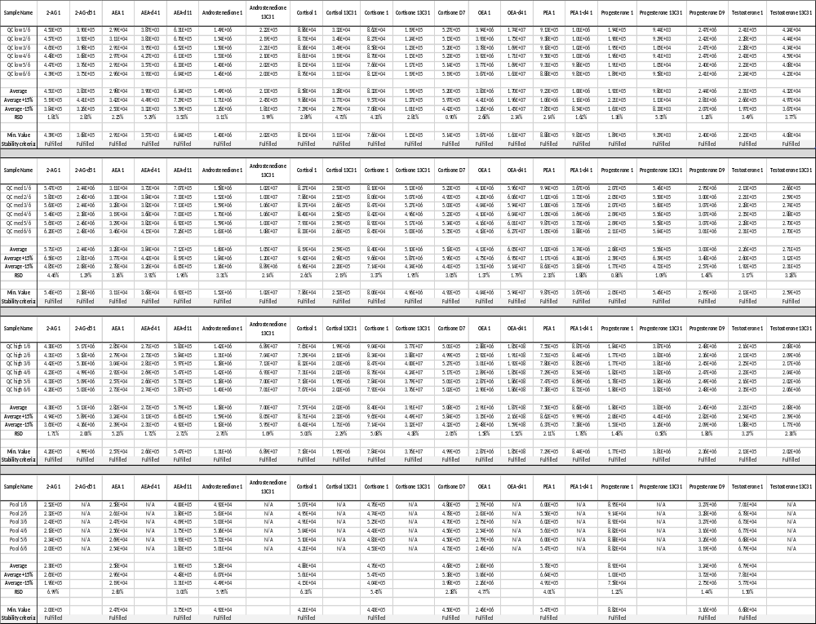

Figures

B
A

Figure S1: Graphic chromatogram as an example for the selectivity experiment (RT: 9.63 – transition 1 = blue and transition 2 = red) of AEA transitions. Peak A are transitions of AEA in a true positive sample of an AEA neat solution. Peak B are transitions of D4-AEA in a true positive sample of an AEA neat solution.

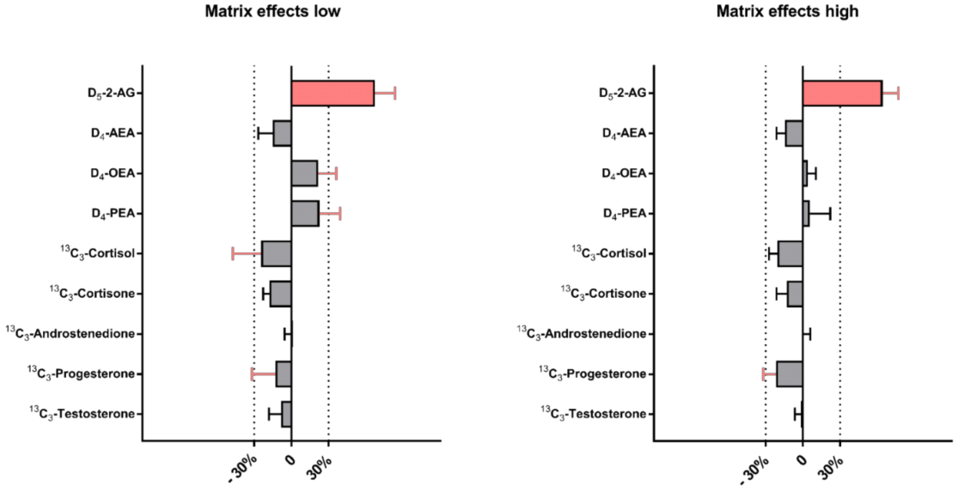
Figure S2: The graph illustrates the matrix effect of the endogenous analytes for QC low and QC high. The bars present the deviation of the matrix effects from 100 %. The dotted indicator lines on the x-axis at ± 30 % reflect the acceptance criteria for the matrix effects. The red marked bars (D₅-2-AG) exceed the mentioned acceptance criteria. The error bars at the end of the bars represent the standard deviation of the evaluated matrix effects (n = 6).

