Supplementary Materials
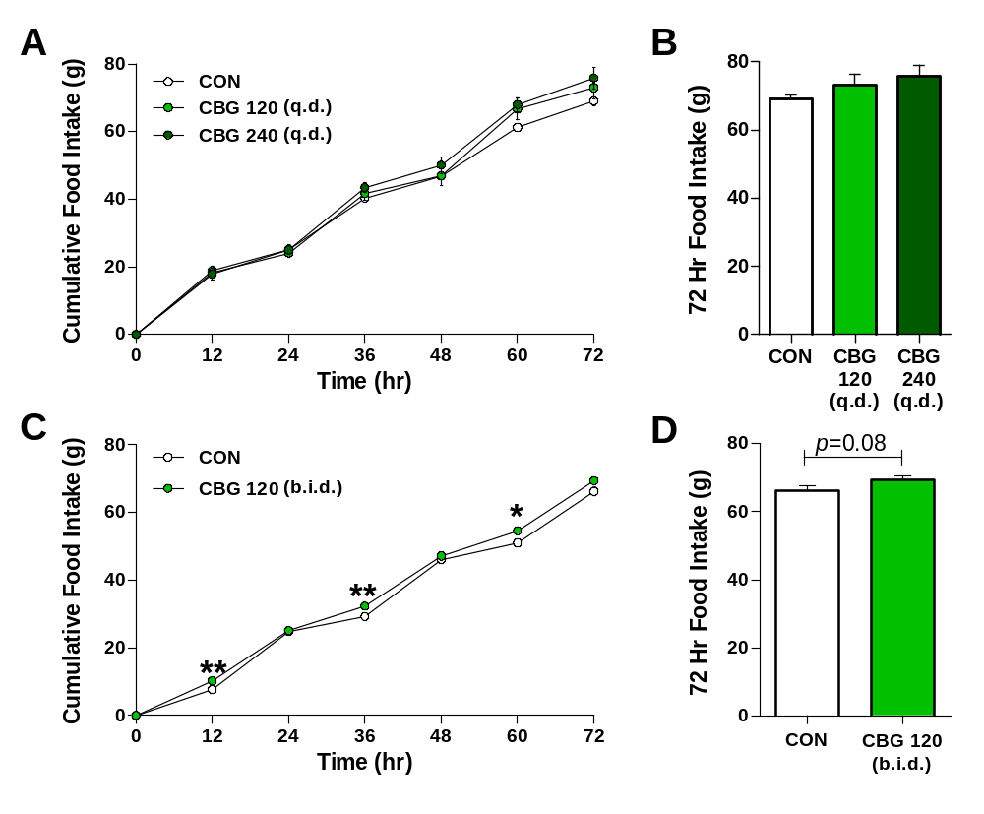
Supplementary figure S1. Semi-chronic cannabigerol administration has limited effects on food intake in cisplatin-naive free-feeding rats. Cumulative food intake in rats administered CBG once daily at 120 or 240 mg/kg (A-B; n = 5-6) was not significantly increased at any time point. Twice daily administration at 120 mg/kg (C-D; n = 10-12) elicited a modest hyperphagic effect during daily light photoperiods only. Data presented as mean ± SEM and analysed by 2-way mixed model ANOVA (drug x time), with a significant interaction followed by unpaired Student’s t-tests at each time point. * p < 0.05 vs CON, ** p < 0.01 vs CON.

 | CON | CIS | CIS+CBG60 | CIS+CBG120
Bodyweight (g) | 253.1  (± 2.6) | 257.5  (± 3.4) | 254.9  (± 3.0) | 257.2  (± 3.6)
24hr Food Intake (g) | 22.8  (± 0.6) | 21.15  (± 0.9) | 21.3  (± 0.9) | 21.4  (± 1.0)
Ambulatory Locomotor Activity (Horizontal Beam Breaks) | 20140  (± 1056) | 20150  (± 655) | 19430  (± 471) | 19190  (± 1314)

Supplementary table S1. Baseline intake, bodyweight and activity did not differ between groups post-randomization. 48 hours prior to the start of testing, drug-naïve animals underwent a 24hr acclimation and baseline session. Following confirmation that animals had acclimated to test chambers, they were randomized to experimental groups. Randomization was successful as no significant differences were observed between groups for 24hr food intake (F_{3, 54} = 0.690, p = 0.562), bodyweight (F_{3, 54} = 0.376, p = 0.771) or 24hr ambulatory locomotor activity (F_{3, 54} = 0.297, p = 0.827). Data presented as mean ± SEM and analysed by one-way between-subjects ANOVA, n = 11-16.

Supplementary figure S2. Asymptomatic animals which do not exhibit a cachectic response to cisplatin were excluded from analyses. A total of 9 animals (2 CIS, 5 CIS+CBG60 and 2 CIS+CBG120) were excluded as asymptomatic, based on a priori criteria from cisplatin model pilot data. Animals were excluded if they failed to show a minimum cachectic response of either <9g food intake during the first dark period (12-24 hours) or a loss of >3% bodyweight at 36 hours.

 |  | CON | CIS | CIS+CBG120
Food Intake (g) | d1 | 16.9  (± 0.4) | 6.7 ###  (± 0.6) | 6.6  (± 0.9)
 | d2 | 16.7  (± 0.7) | 8.1 ###  (± 0.7) | 10.4  (± 1.2)
 | d3 | 15.2  (± 0.6) | 7.2 ###  (± 0.9) | 9.6  (± 1.2)
Number of Meals | d1 | 10.5  (± 0.5) | 5.6 ###  (± 0.8) | 5.2  (± 0.4)
 | d2 | 10.5  (± 0.9) | 7.3 ##  (± 0.6) | 7.8  (± 0.6)
 | d3 | 11.0  (± 0.7) | 7.1 ###  (± 0.6) | 7.0  (± 0.7)
Meal Size (g) | d1 | 1.7  (± 0.1) | 1.2  (± 0.1) | 1.3  (± 0.2)
 | d2 | 1.7  (± 0.1) | 1.1 ##  (± 0.1) | 1.3  (± 0.1)
 | d3 | 1.4  (± 0.1) | 1.1 #  (± 0.1) | 1.4 *  (± 0.1)

Supplementary table S2. Cisplatin-induced anorexia is driven by reductions in both feeding frequency and meal size. Dark photoperiod meal pattern analysis revealed that the anorectic effect of a single dose of cisplatin is apparent from the first dark photoperiod, with persistent reductions in both the number and size of meals. Consistent with the relatively modest effects of CBG on cumulative food intake, dark photoperiod intake was increased non-significantly by this dose, and feeding frequency was essentially unaffected. The size of individual meals, however, was significantly rescued by CBG treatment by day 3. Data presented as mean ± SEM and analysed by 2-way mixed model ANOVA (drug x day), with significant interactions followed by one-way between-subjects ANOVA and planned comparisons at each time point, n = 11-16. # p < 0.05 vs CON, ## p < 0.01 vs CON, ### p < 0.0005 vs CON, * p < 0.05 vs CIS.
 |  |  | CON |  | CIS | CIS+CBG60 | CIS+CBG120
Ambulatory Activity  (Horizontal Beam Breaks) |  | d1 |  | 9869  (± 508) | 7331 ##  (± 533) | 6107  (± 444) | 5834  (± 436)
 |  | d2 |  | 10565  (± 537) | 8182 #  (± 587) | 6344  (± 629) | 7899  (± 517)
 |  | d3 |  | 10734  (± 525) | 8400 #  (± 485) | 7356  (± 593) | 8497  (± 569)
Rearing Activity  (Vertical Beam Breaks) |  | d1 |  | 750  (± 94) | 380 ##  (± 70) | 239  (± 70) | 207  (± 49)
 |  | d2 |  | 767  (± 80) | 574  (± 101) | 341##  (± 60) | 545  (± 82)
 |  | d3 |  | 830  (± 80) | 582  (± 57) | 345 ##  (± 52) | 536  (± 124)

Supplementary table S3. Cisplatin supresses dark photoperiod ambulatory locomotor and rearing activity. Cisplatin reduced ambulatory locomotor activity during the dark photoperiod on all 3 days, and rearing activity on day one. CBG did not attenuate this suppressive effect at either dose, and at 60 mg/kg appeared to have a potentiating effect on rearing behaviour. Data presented as mean ± SEM and analysed by 2-way mixed model ANOVA (drug x day) followed by one-way between-subjects ANOVA and Tukey’s post-hoc comparisons at each time point, n = 11-16. # p < 0.05 vs CON, ## p < 0.01 vs CON.

Supplementary figure S3. Primary Western blots for protein synthesis and autophagy markers in EDL muscle samples. Representative data from one animal each in CON, CIS and CIS+CBG120 groups.
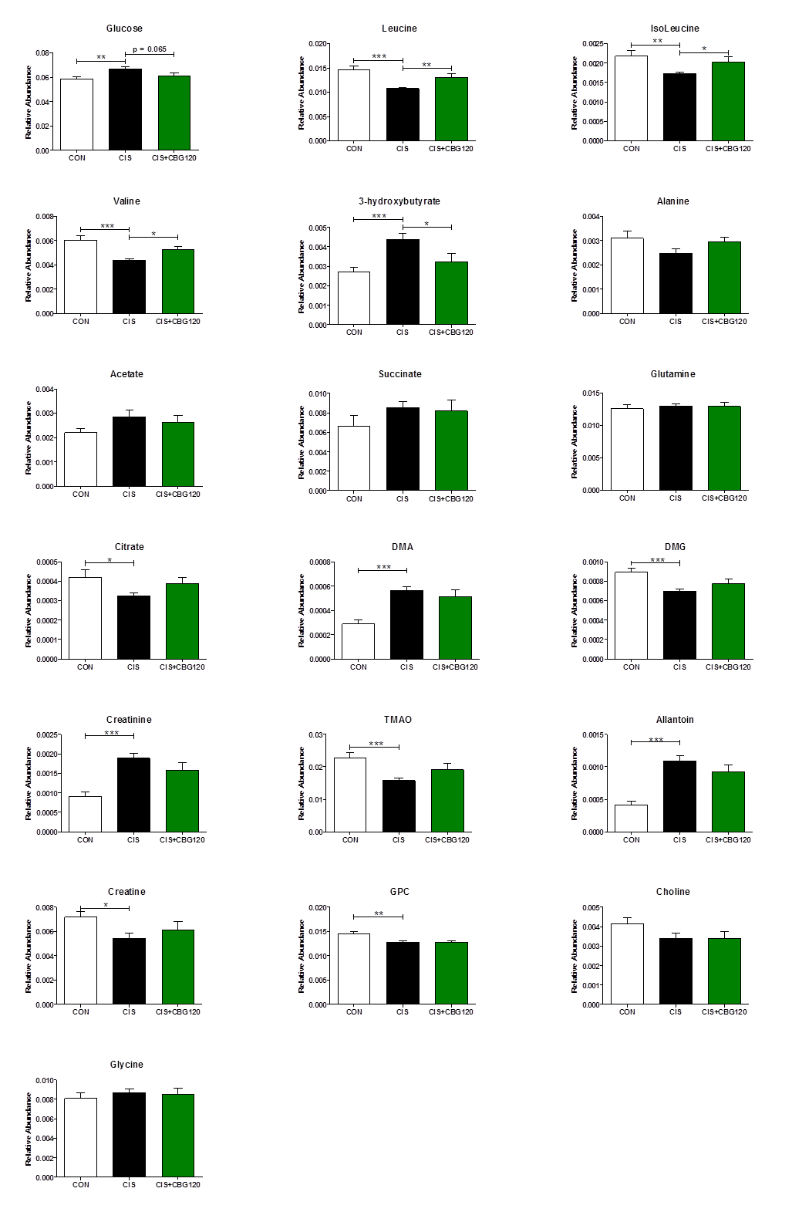
Supplementary figure S4. Relative abundance of individual plasma metabolites from 1[H]-NMR metabonomics. The selected metabolites were identified as varying between groups from OPLS-DA models. Relative integrals of metabolite peak intensity data presented as mean ± SEM and analyzed by one-way between-subjects ANOVA and planned comparisons. * p < 0.05, ** p < 0.01, *** p < 0.0005; n = 11-16.

N-acyl alanine | [M – H]⁻ | Fragment |  | N-acyl proline | [M – H]⁻ | Fragment
N-palmitoyl alanine | 326.5 | 88.09 |  | N-palmitoyl proline | 352.53 | 114.12
N-stearoyl alanine | 354.55 | 88.09 |  | N-stearoyl proline | 380.59 | 114.12
N-oleoyl alanine | 352.53 | 88.09 |  | N-oleoyl proline | 378.31 | 114.12
N-linoleoyl alanine | 350.52 | 88.09 |  | N-linoleoyl proline | 376.56 | 114.12
N-arachidonoyl alanine | 374.5 | 88.09 |  | N-arachidonoyl proline | 400.58 | 114.12
N-docosahexaenoyl alanine | 398.56 | 88.09 |  | N-docosahexaenoyl proline | 424.6 | 114.12
N-acyl ethanolamine | [M + H]⁺ | Fragment |  | N-acyl serine | [M – H]⁻ | Fragment
N-palmitoyl ethanolamine | 300.29 | 62.1 |  | N-palmitoyl serine | 342.3 | 74
N-stearoyl ethanolamine | 328.3 | 62.1 |  | N-stearoyl serine | 370.3 | 74
N-oleoyl ethanolamine | 326.3 | 62.1 |  | N-oleoyl serine | 368.3 | 74
N-linoleoyl ethanolamine | 324.3 | 62.1 |  | N-linoleoyl serine | 366.27 | 74
N-arachidonoyl ethanolamine | 348.29 | 62.1 |  | N-arachidonoyl serine | 390.3 | 74
N-docosahexaenoyl ethanolamine | 372.6 | 62.1 |  | N-docosahexaenoyl serine | 414.3 | 74
N-acyl GABA | [M – H]⁻ | Fragment |  | N-acyl taurine | [M – H]⁻ | Fragment
N-palmitoyl GABA | 340.54 | 102.1 |  | N-arachidonoyl taurine | 410.6 | 124
N-stearoyl GABA | 368.58 | 102.1 |  | N-acyl tryptophan | [M – H]⁻ | Fragment
N-oleoyl GABA | 366.57 | 102.1 |  | N-palmitoyl tryptophan | 441.63 | 203.1
N-linoleoyl GABA | 364.54 | 102.1 |  | N-stearoyl tryptophan | 469.68 | 203.1
N-arachidonoyl GABA | 388.57 | 102.1 |  | N-oleoyl tryptophan | 467.67 | 203.1
N-docosahexaenoyl GABA | 412.59 | 102.1 |  | N-linoleoyl tryptophan | 465.65 | 203.1
N-acyl glycine | [M – H]⁻ | Fragment |  | N-arachidonoyl tryptophan | 489.67 | 203.1
N-palmitoyl glycine | 312.26 | 74.2 |  | N-docosahexaenoyl tryptophan | 513.69 | 203.1
N-stearoyl glycine | 340.3 | 74.2 |  | N-acyl tyrosine | [M – H]⁻ | Fragment
N-oleoyl glycine | 338.3 | 74.2 |  | N-palmitoyl tyrosine | 418.59 | 180.18
N-linoleoyl glycine | 336.3 | 74.2 |  | N-stearoyl tyrosine | 446.65 | 180.18
N-arachidonoyl glycine | 360.3 | 74.2 |  | N-oleoyl tyrosine | 444.63 | 180.18
N-docosahexaenoyl glycine | 384.3 | 74.2 |  | N-linoleoyl tyrosine | 442.61 | 180.18
N-acyl leucine | [M – H]⁻ | Fragment |  | N-arachidonoyl tyrosine | 466 | 180.18
N-palmitoyl leucine | 368.58 | 130.1 |  | N-docosahexaenoyl tyrosine | 490.66 | 180.18
N-stearoyl leucine | 396.63 | 130.1 |  | N-acyl valine | [M – H]⁻ | Fragment
N-oleoyl leucine | 394.61 | 130.1 |  | N-palmitoyl valine | 354.31 | 116.31
N-linoleoyl leucine | 392.6 | 130.1 |  | N-stearoyl valine | 382.6 | 116.14
N-docosahexaenoyl leucine | 440.64 | 130.1 |  | N-oleoyl valine | 380.59 | 116.14
N-acyl methionine | [M – H]⁻ | Fragment |  | N-linoleoyl valine | 378.58 | 116.14
N-palmitoyl methionine | 386.62 | 148.2 |  | N-docosahexaenoyl valine | 426.62 | 116.14
N-stearoyl methionine | 414.64 | 148.2 |  | Free Fatty Acids | [M – H]⁻ | Fragment
N-oleoyl methionine | 412.65 | 148.2 |  | Linoleic Acid | 279.5 | 261
N-linoleoyl methionine | 410.64 | 148.2 |  | Arachidonic Acid | 303.5 | 285
N-arachidonoyl methionine | 434.66 | 148.2 |  | 2-acyl-sn-glycerol | [M + H]⁺ | Fragment
N-docosahexaenoyl methionine | 458.68 | 148.2 |  | 2-arachidonoyl-sn-glycerol | 379.3 | 287.5
N-acyl phenylalanine | [M – H]⁻ | Fragment |  | 2-linoleoyl-sn-glycerol | 355.5 | 245
N-palmitoyl phenylalanine | 402.59 | 164.1 |  | 2-oleoyl-sn-glycerol | 357.5 | 265.2
N-stearoyl phenylalanine | 430.65 | 164.1 |  | 2-palmitoyl-sn-glycerol | 331.5 | 239.5
N-oleoyl phenylalanine | 428.63 | 164.1 |  | Prostaglandins | [M – H]⁻ | Fragment
N-linoleoyl phenylalanine | 426.61 | 164.1 |  | PGE₂ | 351.2 | 315
N-arachidonoyl phenylalanine | 450.64 | 164.1 |  | PGF_{2α} | 353.3 | 309.2
N-docosahexaenoyl phenylalanine | 474.66 | 164.1

Supplementary table S4. Lipids in HPLC/MS/MS screening library with parent ion and fragment ion masses. Lipids are grouped by amide family and all members of that lipid family are screened in a multiple reactions monitoring (MRM) method. The parent ion mass is also listed: negative ionization mode, resulting in a [M – H]⁻ parent ion, is used for all methods except the N-acyl ethanolamine and 2-acyl glycerol methods, which uses positive ionization and generates a parent ion with a mass of [M + H]⁺. Hypothalamus samples were screened for all lipids in the library, whereas only a selected screen was performed on plasma samples (shaded in light gray).
 |  |  | Plasma  (nmol/L) |  |  | Hypothalamus  (pmol/g)
 |  |  | CON | CIS | CIS+CBG 120 | CON | CIS | CIS+CBG 120
N-acyl alanine
 | N-palmitoyl alanine |  | NS | NS | NS | 4.21  (±1.06) | 3.95  (±0.66) | 4.2  (±1.21)
 | N-stearoyl alanine |  | NS | NS | NS | 3.35  (±0.62) | 2.55  (±0.52) | 2.79  (±0.53)
 | N-oleoyl alanine |  | NS | NS | NS | 0.82  (±0.26) | 0.73  (±0.24) | 0.75  (±0.15)
 | N-linoleoyl alanine |  | NS | NS | NS | PISSR | PISSR | PISSR
 | N-arachidonoyl alanine |  | NS | NS | NS | PISSR | PISSR | PISSR
 | N-docosahexaenoyl alanine |  | NS | NS | NS | PISSR | PISSR | PISSR
N-acyl ethanolamine
 | N-palmitoyl ethanolamine |  | 21.70  (±9.60) | 15.22  (±2.49) | 12.82  (±2.05) | 246.08  (±96.4) | 161.44  (±30.1) | 132.55  (±18.8)
 | N-stearoyl ethanolamine |  | 5.85  (±4.40) | 2.46  (±0.70) | 1.70  (±0.51) | 119.39  (±101) | 46.61  (±10.6) | 33.98  (±10)
 | N-oleoyl ethanolamine |  | 11.06  (±5.23) | 7.06  (±1.38) | 5.79  (±1.07) | 81.78  (±40.4) | 50.12  (±10.1) | 43.95  (±7.22)
 | N-linoleoyl ethanolamine |  | 3.86  (±0.74) | 3.43  (±0.85) | 3.05  (±0.58) | 3.20  (±1.04) | 2.53  (±0.69) | 2.40  (±0.55)
 | N-arachidonoyl ethanolamine |  | 1.25  (±0.39) | 1.12  (±0.35) | 0.92  (±0.20) | 5.88  (±2.15) | 4.45  (±1.14) | 4.18  (±0.80)
 | N-docosahexaenoyl ethanolamine |  | 5.89  (±2.17) | 4.03  (±0.88) | 3.84  (±1.46) | 34.77  (±9.2) | 26.60  (±5.96) | 25.25  (±4.63)
N-acyl GABA
 | N-palmitoyl GABA |  | BLD | BLD | BLD | 9.72  (±1.48) | 8.17  (±1.91) | 7.77  (±1.22)
 | N-stearoyl GABA |  | BLD | BLD | BLD | 10.74  (±3.40) | 7.30  (±1.40) | 7.80  (±1.02)
 | N-oleoyl GABA |  | BLD | BLD | BLD | 1.90  (±0.40) | 1.63  (±0.36) | 1.68  (±0.33)
 | N-linoleoyl GABA |  | BLD | BLD | BLD | 0.40  (±0.19) | 0.43  (±0.26) | 0.49  (±0.28)
 | N-arachidonoyl GABA |  | BLD | BLD | BLD | 11.13  (±1.84) | 9.07  (±1.29) | 9.22  (±1.79)
 | N-docosahexaenoyl GABA |  | BLD | BLD | BLD | 1.69  (±0.29) | 1.47  (±0.18) | 1.36  (±0.28)
N-acyl glycine
 | N-palmitoyl glycine |  | 39.60  (±7.83) | 64.67  (±12.90) | 53.28  (±14.20) | 25.36  (±4.79) | 25.18  (±4.57) | 24.14  (±3.24)
 | N-stearoyl glycine |  | 15.42  (±2.14) | 19.78  (±3.05) | 16.27  (±3.80) | 9.43  (±1.87) | 8.20  (±1.34) | 6.86  (±0.85)
 | N-oleoyl glycine |  | 12.25  (±2.52) | 22.17  (±6.72) | 17.34  (±5.69) | 4.82  (±0.42) | 5.10  (±0.84) | 4.68  (±0.74)
 | N-linoleoyl glycine |  | 22.92  (±5.21) | 45.42  (±12.90) | 36.23  (±17.20) | 0.56  (±0.29) | 0.69  (±0.39) | 0.67  (±0.37)
 | N-arachidonoyl glycine |  | 2.95  (±1.19) | 4.29  (±1.73) | 3.31  (±1.06) | 8.25  (±2.00) | 7.49  (±1.29) | 7.80  (±2.17)
 | N-docosahexaenoyl glycine |  | 1.06  (±0.65) | 1.55  (±0.86) | 1.61  (±0.75) | 1.47  (±0.37) | 1.49  (±0.35) | 1.38  (±0.38)
N-acyl leucine
 | N-palmitoyl leucine |  | NS | NS | NS | 2.25  (±0.29) | 2.15  (±0.29) | 2.26  (±0.39)
 | N-stearoyl leucine |  | NS | NS | NS | 4.02  (±0.77) | 3.52  (±0.48) | 3.28  (±0.60)
 | N-oleoyl leucine |  | NS | NS | NS | 2.18  (±0.44) | 2.09  (±0.35) | 1.99  (±0.34)
 | N-linoleoyl leucine |  | NS | NS | NS | 0.55  (±0.28) | 0.51  (±0.18) | 0.53  (±0.16)
 | N-docosahexaenoyl leucine |  | NS | NS | NS | 1.87  (±0.42) | 1.76  (±0.32) | 1.78  (±0.28)
Table continued below
N-acyl methionine
 | N-palmitoyl methionine |  | NS | NS | NS | 2.16  (±1.63) | 2.21  (±1.13) | 2.53  (±1.28)
 | N-stearoyl methionine |  | NS | NS | NS | 2.25  (±0.65) | 2.07  (±0.69) | 1.81  (±0.69)
 | N-oleoyl methionine |  | NS | NS | NS | 1.25  (±0.71) | 1.43  (±0.72) | 1.26  (±0.35)
 | N-linoleoyl methionine |  | NS | NS | NS | BLD | BLD | BLD
 | N-arachidonoyl methionine |  | NS | NS | NS | PISSR | PISSR | PISSR
 | N-docosahexaenoyl methionine |  | NS | NS | NS | PISSR | PISSR | PISSR
N-acyl phenylalanine
 | N-palmitoyl phenylalanine |  | NS | NS | NS | 2.16  (±0.98) | 2.95  (±0.94) | 2.73  (±0.63)
 | N-stearoyl phenylalanine |  | NS | NS | NS | 2.76  (±0.55) | 3.32  (±0.62) | 3.30  (±0.55)
 | N-oleoyl phenylalanine |  | NS | NS | NS | 0.85  (±0.20) | 1.04  (±0.23) | 1.10  (±0.22)
 | N-linoleoyl phenylalanine |  | NS | NS | NS | PISSR | PISSR | PISSR
 | N-arachidonoyl phenylalanine |  | NS | NS | NS | 0.34  (±0.20) | 0.46  (±0.21) | 0.43  (±0.30)
 | N-docosahexaenoyl phenylalanine |  | NS | NS | NS | 0.49  (±0.35) | 0.51  (±0.30) | 0.59  (±0.34)
N-acyl proline
 | N-palmitoyl proline |  | NS | NS | NS | 1.14  (±0.34) | 0.89  (±0.26) | 1.12  (±0.29)
 | N-stearoyl proline |  | NS | NS | NS | 0.32  (±0.09) | 0.21  (±0.06) | 0.30  (±0.07)
 | N-oleoyl proline |  | NS | NS | NS | 0.29  (±0.16) | 0.23  (±0.11) | 0.25  (±0.08)
 | N-linoleoyl proline |  | NS | NS | NS | PISSR | PISSR | PISSR
 | N-arachidonoyl proline |  | NS | NS | NS | PISSR | PISSR | PISSR
 | N-docosahexaenoyl proline |  | NS | NS | NS | BLD | BLD | BLD
N-acyl serine
 | N-palmitoyl serine |  | NS | NS | NS | 69.0  (±8.91) | 61.5  (±6.75) | 58.0  (±6.85)
 | N-stearoyl serine |  | NS | NS | NS | 39.2  (±7.27) | 33.8  (±2.57) | 31.9  (±2.96)
 | N-oleoyl serine |  | NS | NS | NS | 108.0  (±39.8) | 91.6  (±16.6) | 96.5  (±18.5)
 | N-linoleoyl serine |  | NS | NS | NS | 19.6  (±7.71) | 16.7  (±3.79) | 17.3  (±4.52)
 | N-arachidonoyl serine |  | NS | NS | NS | 1.05  (±0.27) | 0.83  (±0.23) | 0.90  (±0.28)
 | N-docosahexaenoyl serine |  | NS | NS | NS | 16.0  (±2.47) | 15.1  (±2.94) | 16.6  (±3.48)
N-acyl taurine
 | N-arachidonoyl taurine |  | NS | NS | NS | 29.7  (±5.41) | 26.4  (±3.93) | 26.9  (±4.96)
N-acyl tryptophan
 | N-palmitoyl tryptophan |  | NS | NS | NS | 1.85  (±0.88) | 2.06  (±0.50) | 1.99  (±0.77)
 | N-stearoyl tryptophan |  | NS | NS | NS | 3.09  (±1.03) | 3.05  (±0.76) | 3.25  (±0.98)
 | N-oleoyl tryptophan |  | NS | NS | NS | PISSR | PISSR | PISSR
 | N-linoleoyl tryptophan |  | NS | NS | NS | BLD | BLD | BLD
 | N-arachidonoyl tryptophan |  | NS | NS | NS | PISSR | PISSR | PISSR
 | N-docosahexaenoyl tryptophan |  | NS | NS | NS | PISSR | PISSR | PISSR
Table continued below

N-acyl tyrosine
 | N-palmitoyl tyrosine |  | NS | NS | NS | 1.91  (±0.71) | 2.55  (±0.85) | 2.60  (±0.65)
 | N-stearoyl tyrosine |  | NS | NS | NS | 1.53  (±0.54) | 1.90  (±0.40) | 1.48  (±0.47)
 | N-oleoyl tyrosine |  | NS | NS | NS | 0.85  (±0.35) | 1.33  (±0.35) | 1.17  (±0.38)
 | N-linoleoyl tyrosine |  | NS | NS | NS | PISSR | PISSR | PISSR
 | N-arachidonoyl tyrosine |  | NS | NS | NS | 0.23  (±0.13) | 0.35  (±0.14) | 0.39  (±0.18)
 | N-docosahexaenoyl tyrosine |  | NS | NS | NS | PISSR | PISSR | PISSR
N-acyl valine
 | N-palmitoyl valine |  | NS | NS | NS | 1.53  (±0.46) | 1.21  (±0.34) | 1.22  (±0.34)
 | N-stearoyl valine |  | NS | NS | NS | 0.35  (±0.23) | 0.25  (±0.09) | 0.24  (±0.12)
 | N-oleoyl valine |  | NS | NS | NS | 0.71  (±0.27) | 0.57  (±1.60) | 0.52  (±0.29)
 | N-linoleoyl valine |  | NS | NS | NS | PISSR | PISSR | PISSR
 | N-docosahexaenoyl valine |  | NS | NS | NS | PISSR | PISSR | PISSR
2-acyl-sn-glycerol
 | 2-palmitoyl-sn-glycerol |  | 30.76  (±26.60) | 35.01  (±20.8) | 30.20  (±25.50) | 962.9  (±713.0) | 623.1  (±496.0) | 510.7  (±377.0)
 | 2-oleoyl-sn-glycerol |  | 88.15  (±48.40) | 80.06  (±33.90) | 111.19  (±93.70) | 9575  (±7110) | 6501  (±4150) | 5270  (±3860)
 | 2-linoleoyl-sn-glycerol |  | 371.11  (±140.0) | 346.53  (±110.0) | 412.54  (±189.0) | 335.2  (±177.0) | 275.7  (±182.0) | 224.4  (±138.0)
 | 2-arachidonoyl-sn-glycerol |  | 60.69  (±41.70) | 56.69  (±24.80) | 48.03  (±23.80) | 3320  (±1020) | 3170  (±1040) | 2680  (±925)
Prostaglandins
 | PGE₂ |  | 5.50  (±1.40) | 5.00  (±2.17) | 5.96  (±1.36) | 51.83  (±19.0) | 46.59  (±15.7) | 38.86  (±18.1)
 | PGF_{2α} |  | 24.71  (±10.5) | 25.74  (±12.2) | 27.54  (±11.2) | 29.74  (±8.38) | 28.29  (±7.89) | 25.65  (±6.56)
Free Fatty Acids
 | Arachidonic acid |  | 11210  (±2450) | 15400  (±3220) | 15060  (±4770) | 28020  (±6440) | 27370  (±5200) | 25380  (±3580)
 | Linoleic acid |  | 17440  (±3900) | 24970  (±5630) | 23820  (±4920) | 768.4  (±491.0) | 694.0  (±197.0) | 642  (±173.0)

Supplementary table S5. Concentrations of N-acyl amide and lipids in hypothalamus and plasma, arranged by amide family. NS: not screened; BLD: below limit of detection; PISSR: present in some samples at random. Data presented as mean ± SD, n = 11-16.

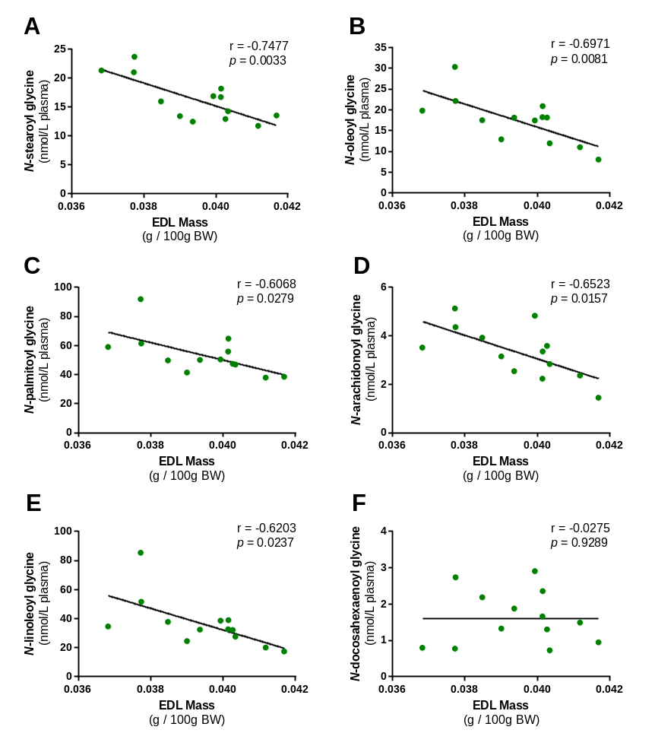
Supplementary figure S5. Plasma concentrations of N-acyl glycine subfamily lipoamines negatively correlate with muscle mass in cannabigerol-treated cachectic animals. Data analysed by Pearson Product Moment correlation, n = 13.

Supplementary Methods
Muscle Tissue Immunohistochemistry
10μm cryosections were obtained from the mid-belly of the EDL muscle, which were incubated in permeability buffer for 15 minutes before being blocked with wash buffer (5% FBS and 0.05% Triton X100 in PBS). Myosin heavy chain (MHC) isoforms I, IIa and IIb were detected using the mouse monoclonal antibodies A4.840 IgM, A4.74 IgG and BFF3 IgM (Developmental studies hybridoma bank, USA, diluated 1:1). p62 was detected using rabbit anti p62 IgG antibody (Gifted by Dr. Sartori from the Venetian Institute of Molecular Medicine), SGK1 using anti pSGK1 (Thr 256) polyclonal IgG) both at 1:500 dilution (Santa Cruz Biotechnology, sc-16744). Primary antibodies were detected using Alexa fluor 488 Goat anti-Mouse IgG (Invitrogen A11029), Alexa fluor 633 Goat anti-Mouse IgM (Invitrogen A21046), Alexa fluor 488 Goat anti-Rabbit IgG (Invitrogen, A11034), and Alexa fluor 488 Donkey anti-Goat IgG (Invitrogen, A11055) secondary antibodies, diluted 1:200.
The cross sectional area (CSA) of muscle fibers were determined using Axiovision 4.9 software and puncta counts were quantified using ImageJ using the Cell Counter plugin..

Western blot analysis of molecular atrophy markers
Muscle proteins were solubilised in lysis buffer (40 mmol Tris pH 7.5, 1 mmol EDTA, 5 mmol EGTA, 0.5% Triton X100 and protease inhibitors (Calbiochem 539131)) and resolved on 4–12% SDS PAGE before transferring to a PVDF membrane. Membranes were probed for total and phosphorylated Akt (at ser473, Cell signalling Technology #4060 and thr308 Cell signalling Technology #9275), total and phosphorylated S6 (Cell signalling Technology #2215 and #4857 respectively) , LC3 (Cell signalling Technology #2775), p62 (Cell signalling Technology #5114) and β-actin (Cell signalling Technology #4970) all used at 1:1000, followed by incubation with horseradish peroxidase-conjugated secondary antibodies (R&D Systems). Visualisation of the proteins were carried out by using enhanced chemiluminescence (ECL, GE Healthcare RPN3000OL1) and bands quantified by laser densitometry using Gel-Pro Analyzer 6.0 software. Densitometric data were normalised to loading controls and expressed as ratios of phosphorylated to total protein (Akt and S6), total protein (p62) or lipidated form of LC3.

¹H-NMR metabonomics sample preparation and data processing
100 μl of plasma was combined with 450 μl of 90% saline (H₂O:D₂O, 1:9). Samples were vortexed and spun at 13,000rpm for 10 min prior to transferring 500 μl to a 5mm NMR tube. Spectroscopic analysis of all samples was performed on a 700 MHz Bruker NMR spectrometer equipped with CryoProbe. For each sample, one-dimensional, water-suppressed Carr-Purcell-Meiboom-Gill (CPMG) spin-echo spectra were acquired. For each spectrum, 8 dummy scans were followed by 256 scans collected in 64K data points using 4s relaxation delay, 2.32s acquisition time and 0.3 Hz line broadening. ¹H NMR spectra were manually corrected for phase and baseline distortions and referenced to the lactate doublet at δ 1.33. Spectra were digitized using an in-house MATLAB (version R2012a, The Mathworks, Inc.; Natwick, MA) script. To minimize baseline distortions arising from imperfect water saturation the region containing the water resonance was excised from the spectra.

Lipidomic analysis of endocannabinoids and lipoamines
Hypothalamic blocks were obtained from coronal blocking cuts at the levels of optic chiasm and mammillary bodies, lateral blocking cuts medial to the pyriform lobe, and finally removal of remaining tissue dorsal to the anterior commissure.
To begin the lipid extraction for the hypothalamus, samples were shock frozen in liquid nitrogen, and weighed before being transferred to a centrifuge tube. The mass of the largest sample was multiplied by 50 to determine how many milliliters of HPLC-grade methanol (Avantor Performance Materials, Inc., Center Valley PA) to be added to the centrifuge tube. For the plasma samples, the sample was allowed to thaw and was transferred to a centrifuge tube containing 1 mL HPLC methanol. Then, hypothalamus samples were spiked with 500 pmols deuterium-labeled N-arachidonoyl glycine (d₈NAGly; Cayman Chemical, Ann Arbor, MI, USA) as an internal standard to determine extraction efficiency. Plasma samples were instead spiked with 500 pmols deuterium-labeled AEA (d₈AEA; Cayman Chemical). Hypothalamus samples were placed on ice in darkness for 2 hours then individually homogenized. Plasma samples also sat on ice in darkness for 2 hours but were vortexed instead of homogenized. Then, the homogenized or vortexed samples were centrifuged at 19,000g for 20 minutes at 20°C. Supernatants were decanted and diluted with HPLC water (purified in house) to make a 75:25 water to supernatant solution. Partial purification was achieved using C-18 solid phase extraction columns (Agilent, Palo Alto, CA, USA). A series of 5 elutions with 1.5 mL of 40%, 60%, 75%, 85%, and 100% methanol were collected for analysis. Vials of eluants were stored at -80°C until they were ready for analysis.

Samples were analyzed using an Applied Biosystems API 3000 triple quadrupole mass spectrometer with electrospray ionization (Foster City, CA, USA. 20µL from each elution were chromatographed using XDB-C18 reversed phase HPLC analytical column (Agilent) and optimized mobile phase gradients. Mobile phase A: 20% methanol, 80% water (v/v) and 1 mM ammonium acetate (Sigma, St. Louis, MO, USA). Mobile phase B: 100% methanol, 1 mM ammonium acetate. Two Shimadzu 10ADvp pumps (Columbia, MD, USA) provided the pressure for gradient elution. Every method run began with 0% mobile phase B, reached a state of 100% mobile phase B flowing at 0.2 mL per minute, and gradually returned to 0% mobile phase B.

Levels of each compound were determined by running each sample using a multiple reactions monitoring (MRM) method tailored for each amide family of compounds (Supplementary table S4). Analysis of the HPLC/MS/MS data was performed using Analyst software (Applied Biosystems). Chromatograms were generated by determining the retention time of analytes with a [M-1] or [M+1] parent peak and a fragmentation peak corresponding to the programmed values. The retention time was then compared to the retention time of a standard for the suspected compound. If the retention times matched, then the concentration of the compound was determined by calculating the area under the curve for the unknown and comparing it to the calibration curve obtained from the standards. Therefore, unknown lipids are matched to known standards according to retention time from the analytical column and according to their mass fingerprint.
Extraction efficiency was calculated with the d₈NAGly or d₈AEA spiked recovery vial as a standard. For each individual lipid in the hypothalamus or plasma, the hypothesis that there was a main effect of treatment group was tested using a one-way ANOVA. A post-hoc Fisher’s Least Significant Differences test was then carried out to determine if lipid levels in one treatment group were statistically different relative to another treatment group. All statistical tests were carried out using SPSS Statistics (IBM, Armonk, NY, USA). Statistical significance was defined as p < .05 and p < .10.

