Electronic Supplementary Information

Unveiling the enzymatic degradation process of bio-based thiophene polyesters

Federico A. Bertoliniª, Michelina Soccio^{b}, Simone Weinbergerª, Giulia Guidotti^{b} Massimo Gazzano^{c}, Georg M. Guebitz^{a,d}, Nadia Lotti^{b,*}, and Alessandro Pellis^{a,d,e*}

ªUniversity of Natural Resources and Life Sciences, Vienna, Department of Agrobiotechnology, Institute of Environmental Biotechnology, Konrad Lorenz Strasse 20, 3430, Tulln an der Donau, Austria
^{b}University of Bologna, Department of Civil, Chemical, Environmental and Materials Engineering, Via Terracini 28, 40131 Bologna, Italy
^{c}Organic Synthesis and Photoreactivity Institute, CNR, Via Gobetti 101, 40129, Bologna, Italy
^{d}Austrian Centre of Industrial Biotechnology, Konrad Lorenz Strasse 20, 3430, Tulln an der Donau, Austria
^{e}University of Natural Resources and Life Sciences, Vienna, Core Facility Bioactive Molecules Screening and Analysis, Konrad Lorenz Strasse 20, 3430, Tulln an der Donau, Austria
*Correspondence to: Dr. Alessandro Pellis alessandro.pellis@boku.ac.at and Prof. Nadia Lotti nadia.lotti@unibo.it

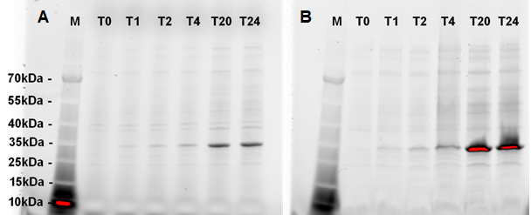Figure S1. Expression analysis of Thc_cut1 (A) and Thc_cut2 (B). SDS-PAGE was carried out on crude extracts of E. coli cells withdrawn at different times after induction (T0-T24).

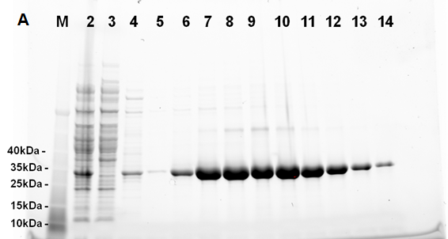
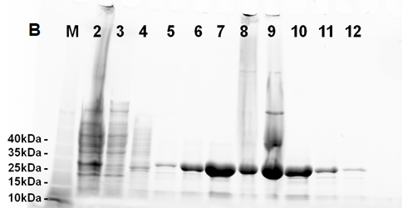
Figure S2. SDS-PAGE analysis of IMAC purifications. (A) Thc_cut1: 1, protein marker; 2, crude extract; 3-4, flow through; 5-14, elution fractions. (B) Thc_cut2: 1, protein marker; 2, crude extract; 3, flow through 4-12, elution fractions.

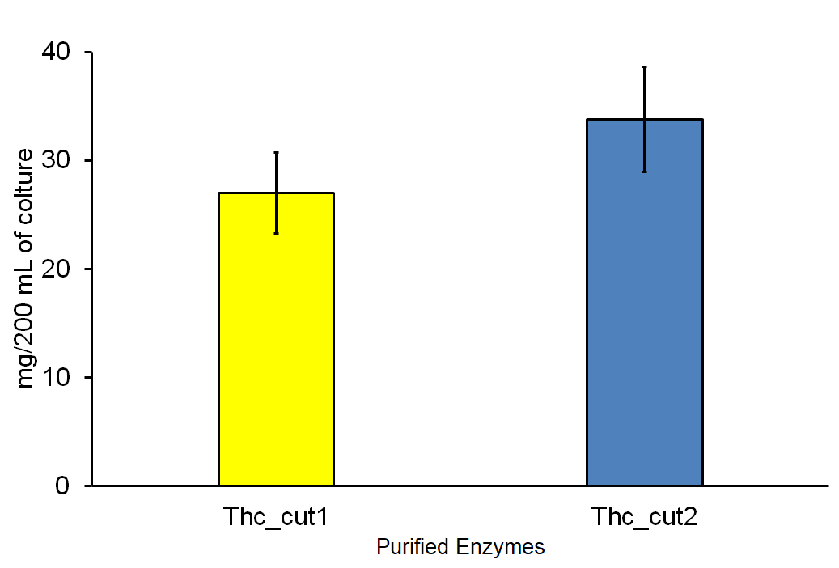
Figure S3. Purification yield for Thc_cut1 (yellow, left) and Thc_cut2 (blue, right). The experiments were performed in triplicate and the average values ± standard deviations are shown.

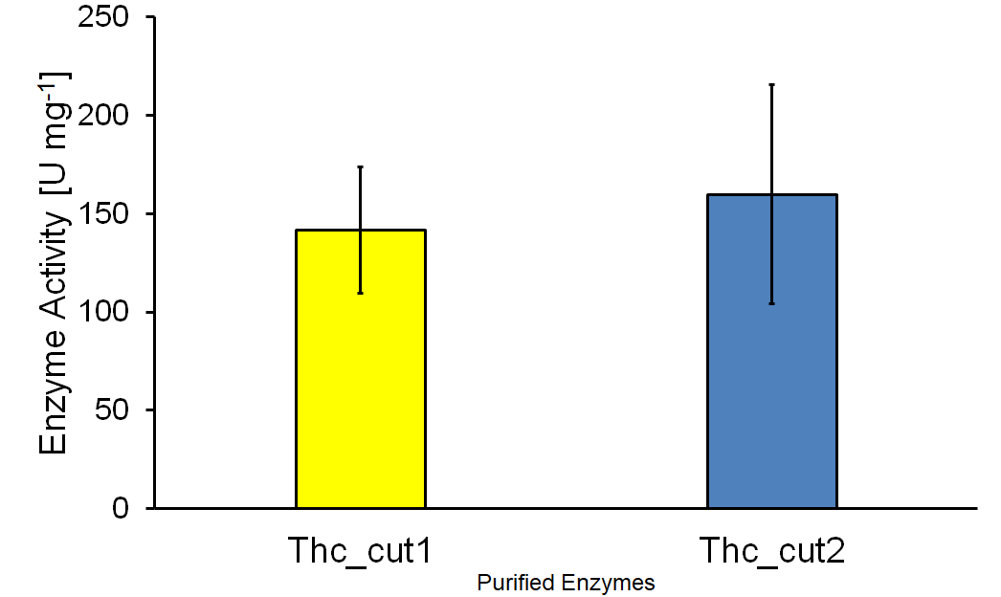
Figure S4. Hydrolytic activity of Thc_cut1 (yellow bar) and Thc_cut2 (blue bar) on pNPB. The experiments were performed in triplicate and the average values ± standard deviations are shown.

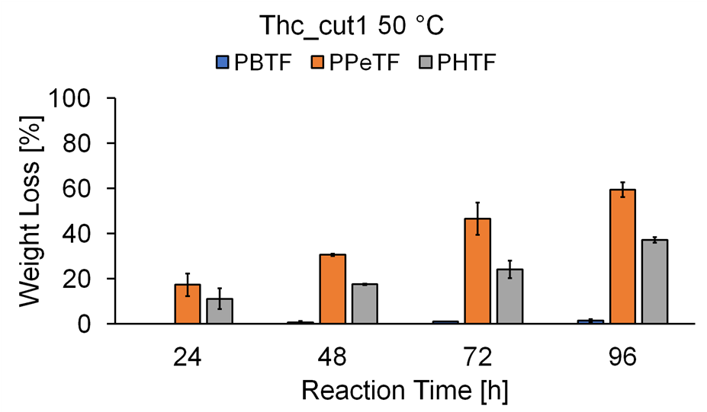
Figure S5. HPLC analysis from the enzymatic hydrolysis of TPCA-based polyesters using Thc_cut1 at 50 °C. All experiments were performed in quadruplicate and the average values ± the standard deviations are shown.

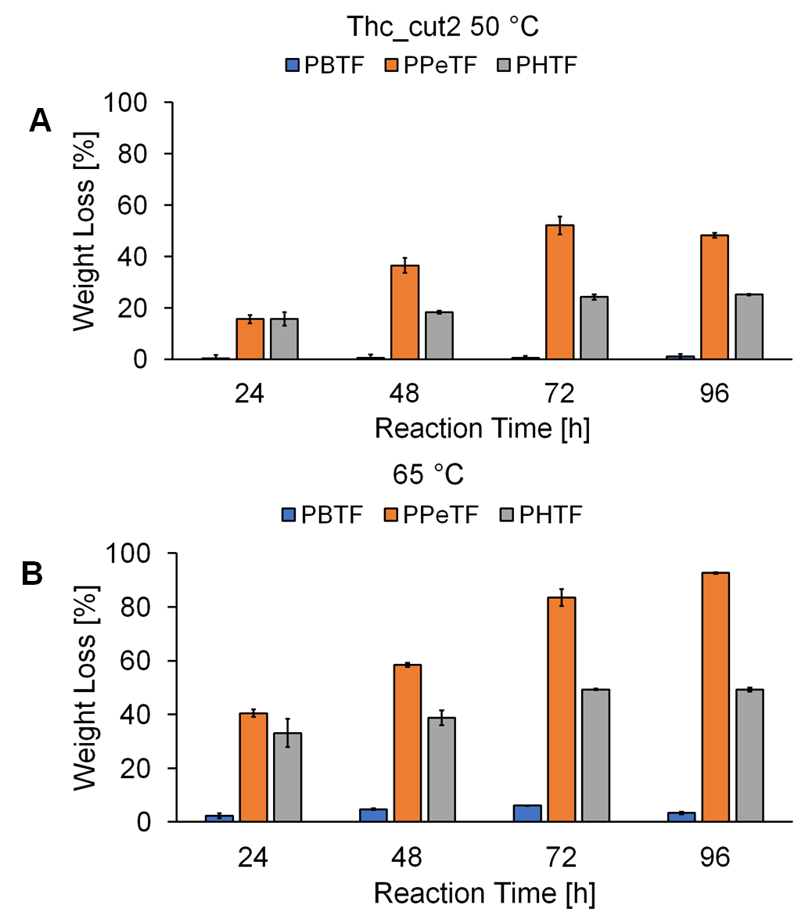
Figure S6. HPLC analysis from the enzymatic hydrolysis of TPCA-based polyesters using Thc_cut2 at 50 °C. All experiments were performed in quadruplicate and the average values ± the standard deviations are shown.
Figure S7. HPLC analysis from the enzymatic hydrolysis of TPCA-based polyesters using Thc_cut1 at 50 °C. All experiments were performed in quadruplicate and the average values ± the standard deviations are shown.

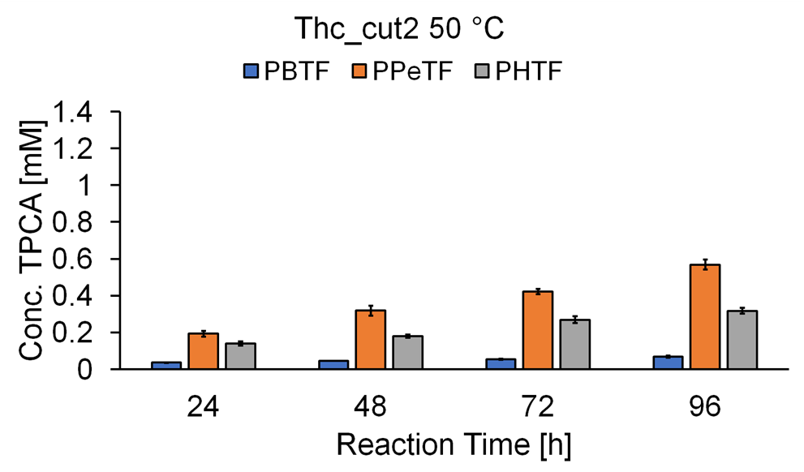
Figure S8. HPLC analysis from the enzymatic hydrolysis of TPCA-based polyesters using Thc_cut2 at 50 °C. All experiments were performed in quadruplicate and the average values ± the standard deviations are shown.

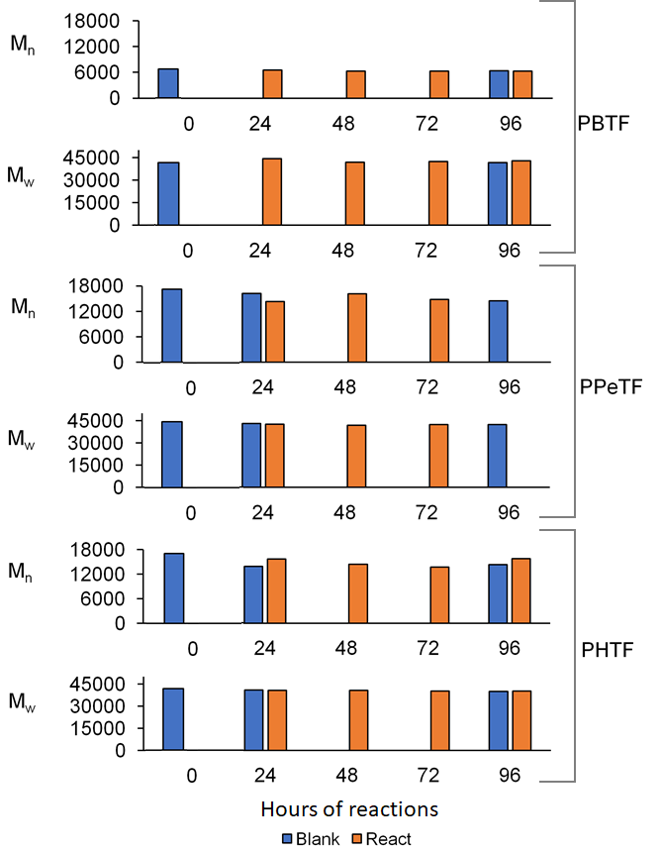
Figure S9. Gel permeation chromatography carried out on TPCA-based polyester films treated over time with Thc_cut1 at 65°C. Blue bars represent the untreated controls (incubated in the saline buffer without enzyme), orange bars represent the samples subjected to hydrolysis. The data are presented in terms of M_{w} and M_{n}.

Figure S10. Released oligomers determined via HPLC-TOF/MS of PHTF polymer. Time course reaction showing the released dimers AB, ABA and BAB for the enzymatic hydrolysis performed at 50°C (panels A and B) and 65°C (panels C and D) with Thc_cut1 and Thc_cut2. The reactions were performed in 1 M KH2PO4/K2HPO4 buffer pH 8.0. No released products were detected in the control reactions.

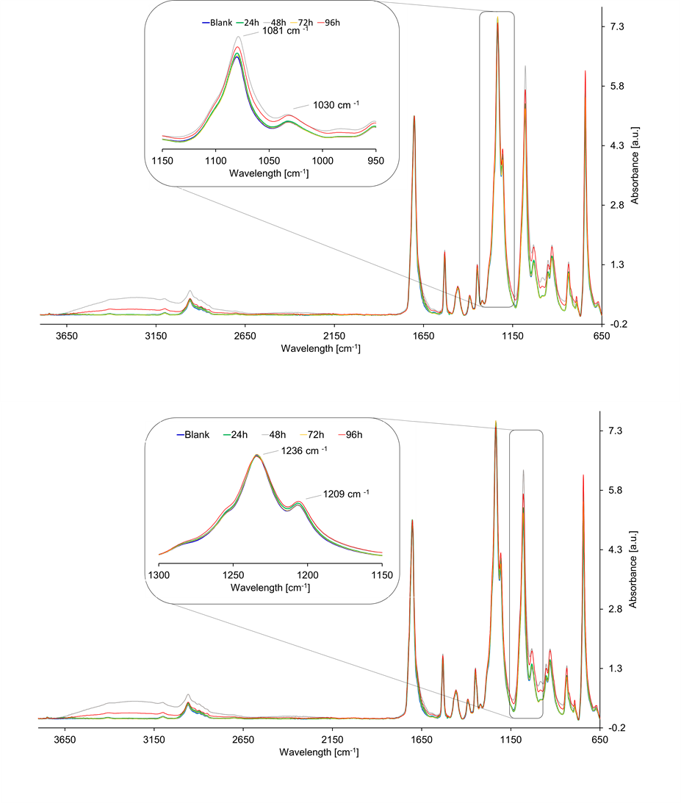
Figure S11. FT-IR spectra of partially hydrolyzed PBTF films. Analyzed samples were treated with Thc_cut1 at 65°C, for 96 h. The spectra were normalized with respect to the intensity of the 1703 cm⁻¹ peak.

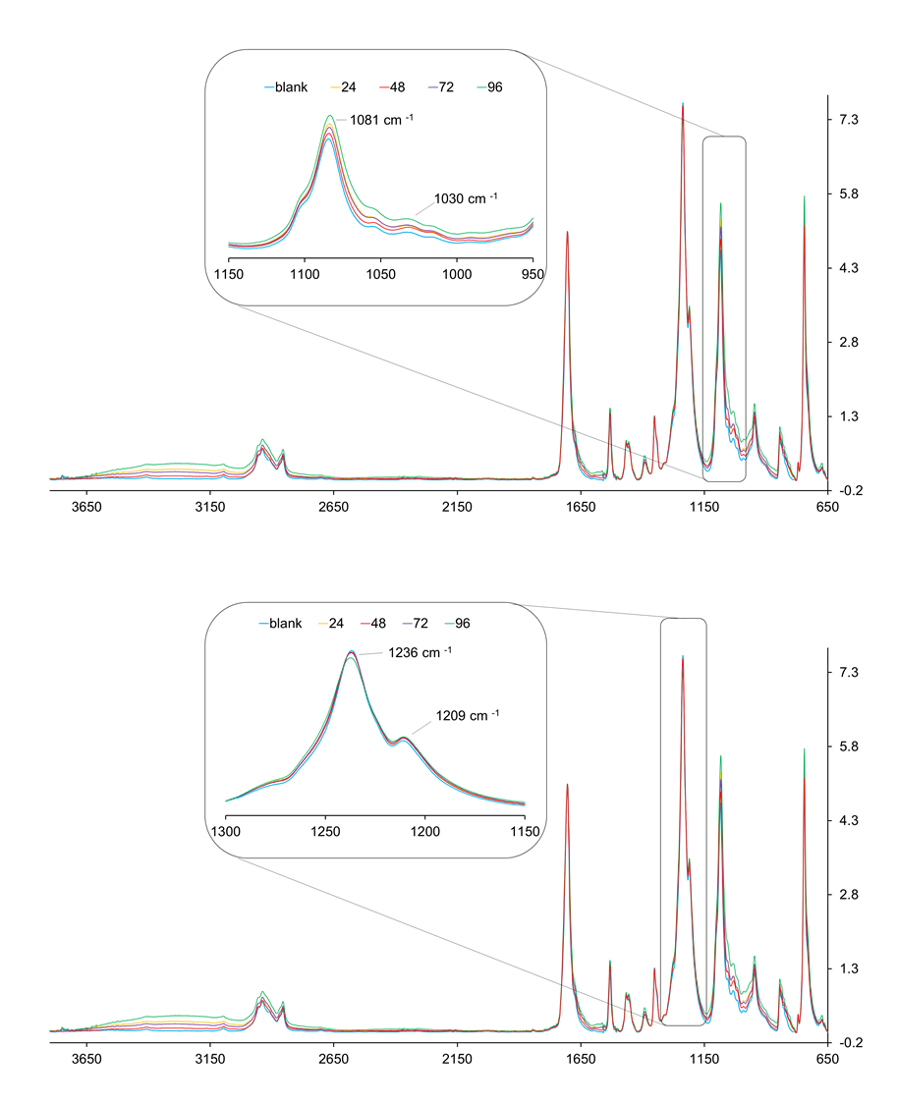
Figure S12. FT-IR spectra of partially hydrolyzed PHTF films. Analyzed samples were treated with Thc_cut1, at 65°C for 96 h. The spectra were normalized with respect to the intensity of the 1703 cm⁻¹ peak.

Table S1. HPLC method used for TPCA detection and quantification.
Time  [min] | A [MeOH]  [%] | B [HCOOH]  [%]
0 | 30 | 70
2 | 50 | 50
9 | 100 | 0
18 | 100 | 0
19 | 30 | 70
20 | 30 | 70

Table S2. LC-TOF/MS method used for TPCA soluble oligomers detection.
Time  [min] | A  [20 mM NH₄COOH] [%] | B  [AcN] [%]
0 | 100 | 0
1 | 100 | 0
11 | 0 | 100
12 | 0 | 100
14 | 100 | 0
15 | 100 | 0

Table S3. Thermal characterization data (T_{m} and ΔH_{m}) of the partially degraded samples and their blanks.
PPeTF |  | 50 °C |  |  |  |  |  |  |  | 65 °C
PPeTF | Enzyme | Thc_cut1 |  |  |  | Thc_cut2 |  |  |  | Thc_cut1 |  |  |  | Thc_cut2
PPeTF | Time (h) | 24 | 48 | 72 | 96 | 24 | 48 | 72 | 96 | 24 | 48 | 72 | 96 | 24 |  | 48 |  | 72 | 96
blank | T_{m} (°C) | 65 | 66 | 66 | 66 | 65 | 66 | 66 | 66 | 72 | 72 | - | - |  | 72 |  | 72 | 73 | -
blank | ΔH_{m} (J/g) | 25 | 26 | 28 | 27 | 26 | 26 | 26 | 27 | 29 | 29 | - | - |  | 27 |  | 29 | 28 | -
degraded | T_{m} (°C) | 65 | 66 | 66 | 67 | 65 | 66 | 67 | 66 | 72 | 73 | - | - |  | 73 |  | 73 | 72 | -
degraded | ΔH_{m} (J/g) | 26 | 26 | 29 | 28 | 25 | 26 | 26 | 26 | 29 | 27 | - | - |  | 28 |  | 27 | 29 | -

PHTF |  | 50 °C |  |  |  |  |  |  |  | 65 °C
PHTF | Enzyme | Thc_cut1 |  |  |  | Thc_cut2 |  |  |  | Thc_cut1 |  |  |  | Thc_cut2
PHTF | Time (h) | 24 | 48 | 72 | 96 | 24 | 48 | 72 | 96 | 24 | 48 | 72 | 96 | 24 | 48 | 72 | 96
blank | T_{m}^{I} (°C) | 63 | 64 | 65 | 64 | 63 | 64 | 63 | 64 | 72 | 73 | 73 | 73 | 72 | 72 | 73 | 73
blank | ΔH_{m}^{I} (J/g) | 10 | 10 | 11 | 11 | 9 | 10 | 10 | 12 | 16 | 18 | 16 | 16 | 15 | 16 | 16 | 16
blank | T_{m}^{II} (°C) | 95 | 95 | 95 | 95 | 95 | 95 | 95 | 95 | 96 | 95 | 95 | 95 | 95 | 95 | 95 | 95
blank | ΔH_{m}^{II} (J/g) | 25 | 24 | 24 | 27 | 23 | 22 | 27 | 26 | 21 | 24 | 21 | 19 | 21 | 22 | 19 | 21
degraded | T_{m}^{I} (°C) | 63 | 64 | 64 | 64 | 64 | 64 | 65 | 65 | 72 | 73 | 73 | 73 | 72 | 72 | 73 | 73
degraded | ΔH_{m}^{I} (J/g) | 10 | 10 | 11 | 11 | 9 | 10 | 10 | 12 | 15 | 17 | 16 | 16 | 15 | 17 | 16 | 17
degraded | T_{m}^{II} (°C) | 95 | 95 | 95 | 95 | 95 | 95 | 95 | 95 | 96 | 95 | 95 | 95 | 95 | 95 | 95 | 95
degraded | ΔH_{m}^{II} (J/g) | 26 | 24 | 25 | 25 | 24 | 21 | 26 | 26 | 20 | 23 | 21 | 19 | 21 | 23 | 19 | 21

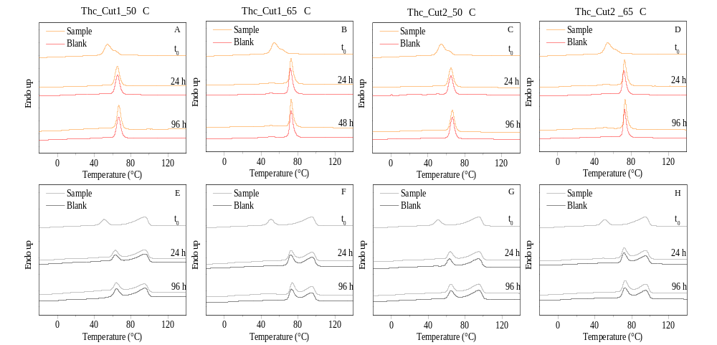
Figure S13. DSC curves of the samples at different degradation times and their relative blanks: A-D) PPeTF; E-H) PHTF.

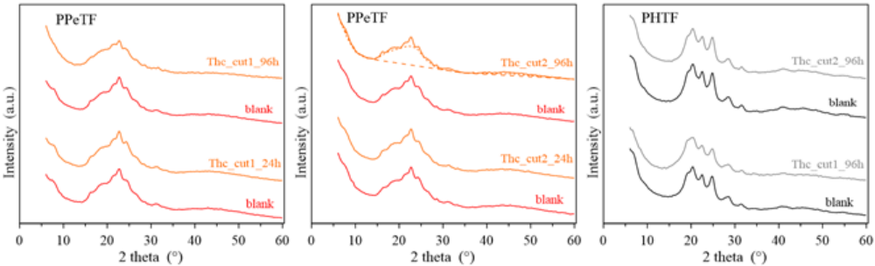
Figure S14. XRD patterns of the samples after enzymatic degradation at 50°C. Peak intensity of patterns of samples after 96 h of enzyme digestion are multiplied by two. Dotted and dashed line are reported to highline crystalline and amorphous components for sample Thc_cut2_96h, as an example.

