Supplementary Information
I. TRPV1 and CB1R are upregulated in nociceptors following SCI
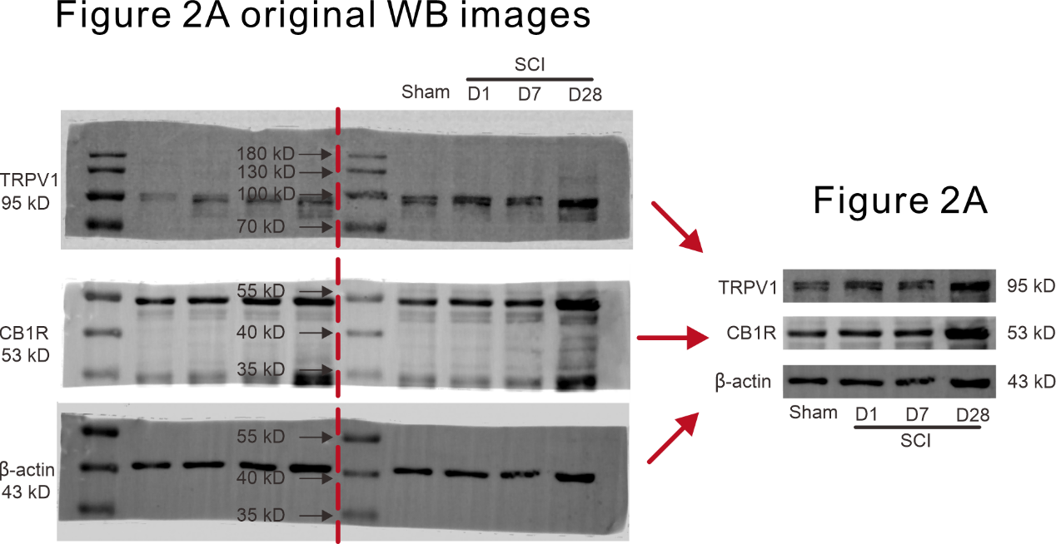
Figure S1. Original uncropped blot images of Figure 2A showing of TRPV1 and CB1R protein levels in DRGs from the sham group and at different time points after SCI.

