Supplementary Data S3
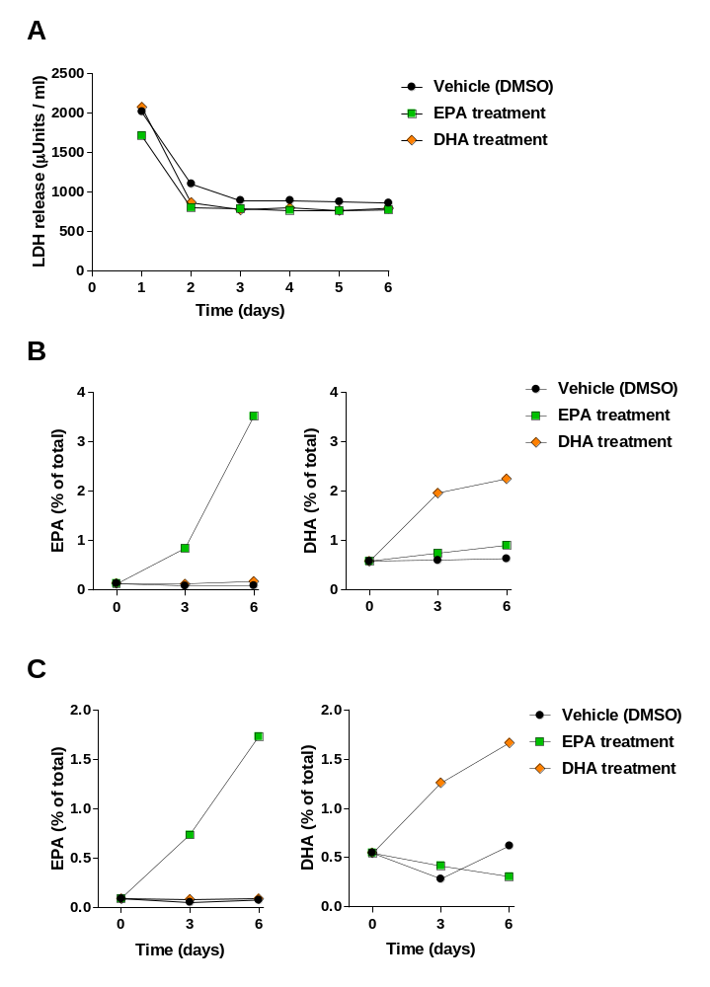
Supplementary Figure S3. Representative data showing the viability and metabolic competence of skin from an individual donor in ex vivo culture. Following an initial release of lactate dehydrogenase (LDH) into the culture medium following the trauma experienced by peripheral skin cells during biopsy sampling, LDH release settles within a day and remains low during culture (data are expressed as µUnits of LDH activity per ml culture medium). Neither EPA nor DHA affected viability and therefore LDH release (A). Skin biopsies cultured for 3 and 6 days with 50 µM EPA (green squares) or DHA (orange diamonds) show uptake of the fatty acids and alterations in the EPA and DHA content of the epidermis (B) and dermis (C), compared with vehicle (DMSO) treatment. EPA and DHA content are shown as % of total fatty acids in the epidermis (B) or dermis (C).

