Supporting Information
Comprehensive Analysis of Chemical and Enantiomeric Stability of Terpenes in Cannabis sativa L. flowers

Justine Raeber¹, Bryan Bajor¹, Michael Poetzsch², Christian Steuer¹*
¹ETH Zurich, Institute of Pharmaceutical Sciences, Vladimir-Prelog-Weg 1-5/10, CH-8093 Zurich, Switzerland
Tel.:+41 44 633 74 19; Fax: +41 44 633 13 79
²Swiss Drug Testing GmbH, Technoparkstrasse 2, CH-8406 Winterthur, Switzerland
Tel.:+41 628385315; Fax: +41 628385399
*Corresponding author

ORCID:
Justine Raeber: 0000-0003-4732-7484
Christian Steuer: 0000-0002-6102-3367

Table S1: Elution order of analytes studied on a BGB-wax column with their corresponding retention time (RT), resolution (R_{s}), retention index (RI) and validation results. RSD_{R} and RSD_{T} are relative standard deviations for the intra- and inter-day imprecision, respectively.
# | Analyte | RT [min] | R_{s} | RI | Equation | R² | Range [μg/mL] | LoD/LoQ [ng] | QC_{high} |  |  | QC_{med} |  |  | QC_{low}
 |  |  |  |  |  |  |  |  | Bias [%] | RSD_{R} [%] | RSD_{T}  [%] | Bias [%] | RSD_{R} [%] | RSD_{T}  [%] | Bias [%] | RSD_{R} [%] |  | RSD_{T}  [%]
1 | α-pinene | 3.98 ± 0.01 | 13.84 | 1013 | Y = 132.5*X - 0.8395 | 0.9993 | 30-875 | 0.87/2.64 | -2.3 | 1.67 | 1.54 | -2.0 | 1.74 | 1.80 | 7.2 |  | 1.50 |  | 4.60
2 | camphene | 4.96 ± 0.01 | 15.73 | 1048 | Y = 145.4*X - 0.8251 | 0.9993 | 25-760 | 0.90/2.72 | -2.1 | 1.29 | 1.26 | -1.9 | 1.67 | 1.72 | 7.9 |  | 1.58 |  | 3.52
3 | β-pinene | 6.27 ± 0.00 | 7.10 | 1095 | Y = 143.3*X - 1.403 | 0.9992 | 40-1260 | 0.91/2.76 | -1.7 | 1.50 | 1.21 | -1.5 | 1.71 | 1.71 | 7.4 |  | 1.32 |  | 3.71
4 | sabinene | 6.91 ± 0.01 | 25.68 | 1108 | Y = 135.7*X - 0.3343 | 0.9991 | 10-300 | 0.97/2.93 | -2.1 | 1.43 | 1.35 | -1.8 | 2.26 | 2.18 | 9.0 |  | 1.39 |  | 2.83
5 | myrcene | 9.51 ± 0.02 | 3.39 | 1150 | Y = 124.5*X - 1.165 | 0.9989 | 25-780 | 1.09/3.29 | -1.7 | 1.30 | 1.38 | -1.4 | 2.28 | 2.08 | 10.5 |  | 1.94 |  | 4.74
6 | α-terpinene | 9.96 ± 0.02 | 8.75 | 1157 | Y = 102.5*X - 0.8582 | 0.9991 | 30-990 | 0.99/3.01 | -2.0 | 1.74 | 1.30 | -2.1 | 2.01 | 2.29 | 9.0 |  | 1.85 |  | 4.41
7 | limonene | 11.23 ± 0.03 | 23.77 | 1177 | Y = 138.4*X - 1.155 | 0.9989 | 30-860 | 1.08/3.27 | -1.7 | 0.89 | 0.91 | -1.4 | 1.81 | 1.54 | 9.3 |  | 1.03 |  | 3.59
8 | γ-terpinene | 15.48 ± 0.05 | 13.10 | 1237 | Y = 116.2*X - 0.8975 | 0.9990 | 30-840 | 1.06/3.20 | -0.5 | 0.53 | 0.87 | -1.3 | 2.31 | 2.14 | 10.1 |  | 1.07 |  | 3.41
9 | p-cymene | 17.48 ± 0.03 | 5.60 | 1263 | Y = 183.8*X - 1.396 | 0.9990 | 30-830 | 1.06/3.21 | -1.4 | 0.44 | 1.08 | -1.5 | 1.30 | 1.53 | 7.2 |  | 1.02 |  | 4.67
10 | α-terpinolene | 18.23 ± 0.02 | 33.77 | 1272 | Y = 117.8*X - 1.100 | 0.9990 | 30-1000 | 1.06/3.23 | -0.9 | 0.22 | 0.68 | -1.4 | 1.72 | 1.52 | 9.4 |  | 0.84 |  | 2.50
11 | cis-rose oxide | 21.93 ± 0.03 | 5.56 | 1338 | Y = -0.1098 + 84.77*X + 23.40*X^2 | 1.000 | 30-830 | 0.04/0.11 | 0.7 | 0.21 | 0.65 | 2.7 | 0.92 | 1.14 | -7.0 |  | 2.40 |  | 3.69
12 | trans-rose-oxide | 22.45 ± 0.03 | 12.71 | 1350 | Y = 0.09979 + 72.77*X + 241.7*X^2 | 1.000 | 3-85 | 0.25/0.74 | 1.7 | 1.97 | 1.62 | 3.5 | 1.85 | 1.36 | -7.1 |  | 4.58 |  | 5.09
13 | cis-3-hexen-1-ol | 23.56 ± 0.01 | 23.71 | 1377 | NA | NA | NA | n.a. | n.a. | n.a. | n.a. | n.a. | n.a. | n.a. | n.a. |  | n.a. |  | n.a.
14 | trans-menthone | 25.66 ± 0.02 | 9.98 | 1437 | Y = -0.1208 + 70.69*X + 28.08*X^2 | 1.000 | 20-630 | 0.15/0.45 | 1.0 | 0.40 | 0.89 | 2.4 | 0.96 | 1.04 | -6.3 |  | 2.73 |  | 3.65
15 | cis-menthone | 26.53 ± 0.02 | 25.53 | 1464 | Y = -0.2583 + 80.84 *X + 9.686 *X^2 | 0.9991 | 10-260 | 0.15/0.45 | 1.9 | 1.10 | 1.81 | 2.1 | 1.23 | 1.31 | -3.1 |  | 3.12 |  | 6.91
16 | linalool | 28.78 ± 0.01 | 6.58 | 1542 | Y = 0.1644 + 104.6*X + 26.78*X^2 | 1.000 | 25-770 | 0.43/1.30 | 0.9 | 0.69 | 0.73 | 2.0 | 1.11 | 1.10 | -8.1 |  | 0.91 |  | 2.50
17 | isobornyl acetate | 29.37 ± 0.01 | 1.70 | 1564 | Y = 108.6*X - 1.437 | 0.9983 | 30-930 | 1.34/4.07 | 0.2 | 1.53 | 1.81 | -1.5 | 1.66 | 1.71 | 8.2 |  | 0.84 |  | 3.29
18 | β-caryophyllene | 29.54 ± 0.02 | 20.99 | 1571 | Y = 0.2940 + 96.90*X + 20.16*X^2 | 1.000 | 30-940 | 0.37/1.12 | 0.4 | 1.97 | 2.61 | 1.5 | 1.59 | 1.39 | -8.2 |  | 0.29 |  | 2.15
19 | α-humulene | 31.38 ± 0.02 | 2.50 | 1643 | Y = 0.4305 + 135.4*X + 45.80*X^2 | 1.000 | 25-800 | 0.28/0.84 | 0.6 | 1.70 | 2.38 | 2.2 | 2.33 | 2.56 | -10.0 |  | 0.83 |  | 5.20
20 | citronellyl acetate | 31.59 ± 0.01 | 3.52 | 1652 | Y = -0.04279 + 80.54*X + 21.35*X^2 | 1.000 | 30-980 | 0.19/0.58 | 1.1 | 1.35 | 2.21 | 1.5 | 1.58 | 1.23 | -6.7 |  | 1.71 |  | 3.25
21 | cis-citral | 31.89 ± 0.02 | 13.73 | 1664 | Y = 0.1592 + 80.23*X + 120.7*X^2 | 1.000 | 10-370 | 0.45/1.36 | -0.1 | 3.85 | 5.36 | 0.4 | 3.38 | 6.10 | 0.6 |  | 1.03 |  | 6.05
22 | neryl acetate | 33.10 ± 0.01 | 6.63 | 1716 | NA | NA | NA | n.a. | n.a. | n.a. | n.a. | n.a. | n.a. | n.a. | n.a. |  | n.a. |  | n.a.
23 | trans-citral | 33.10 ± 0.01 | 6.63 | 1716 | NA | NA | NA | n.a. | n.a. | n.a. | n.a. | n.a. | n.a. | n.a. | n.a. |  | n.a. |  | n.a.
24 | geranyl acetate | 33.80 ± 0.01 | 3.33 | 1747 | Y = 0.2051 + 87.10*X + 20.53*X^2 | 1.000 | 30-950 | 0.42/1.28 | 0.9 | 1.59 | 2.44 | 1.3 | 2.01 | 1.68 | -7.6 |  | 0.66 |  | 2.34
25 | citronellol | 34.01 ± 0.01 | 16.34 | 1756 | Y = -0.1001 + 68.59*X + 21.43*X^2 | 1.000 | 30-920 | 0.23/0.69 | 1.6 | 1.17 | 1.83 | 1.7 | 1.55 | 1.40 | -6.0 |  | 1.73 |  | 3.02
26 | nerol | 34.73 ± 0.01 | 5.67 | 1788 | Y = 0.2810 + 100.3*X + 22.66*X^2 | 1.000 | 35-1000 | 0.43/1.31 | 0.9 | 1.32 | 1.88 | 1.5 | 1.68 | 1.39 | -7.6 |  | 0.67 |  | 2.37
27 | phenylethanol | 34.97 ± 0.01 | 17.93 | 1799 | Y = 0.1957 + 103.3*X + 33.86*X^2 | 1.000 | 20-580 | 0.51/1.54 | 0.5 | 1.24 | 1.34 | 1.8 | 1.20 | 1.14 | -8.7 |  | 0.39 |  | 2.22
28 | geraniol | 35.76 ± 0.01 | 40.98 | 1837 | Y = 0.2671 + 84.59*X + 20.54*X^2 | 1.000 | 35-990 | 0.24/0.73 | 1.1 | 1.42 | 2.12 | 1.3 | 1.87 | 1.53 | -7.0 |  | 1.38 |  | 2.07
29 | cis-nerolidol | 38.93 ± 0.01 | 2.50 | 1992 | Y = -0.06779 + 81.74*X + 94.08*X^2 | 1.000 | 10-310 | 0.58/1.75 | 1.5 | 2.76 | 4.10 | 0.8 | 2.58 | 2.33 | -4.6 |  | 1.62 |  | 3.25
30 | methyleugenol | 39.15 ± 0.01 | 7.13 | 2003 | Y = -0.05093 + 71.12*X + 17.69*X^2 | 1.000 | 2-1065 | 0.54/1.64 | 1.0 | 1.72 | 2.69 | 1.4 | 2.20 | 1.89 | -7.3 |  | 1.37 |  | 2.15
31 | trans-nerolidol | 39.70 ± 0.01 | 29.82 | 2031 | Y = -0.1165 + 81.59*X + 68.44*X^2 | 1.000 | 15-450 | 0.76/2.30 | 1.4 | 3.04 | 4.09 | -0.6 | 2.93 | 4.41 | -5.1 |  | 1.98 |  | 4.42
32 | eugenol | 41.99 ± 0.01 | 14.44 | 2152 | Y = -0.5610 + 63.24*X + 26.30*X^2 | 1.000 | 35-1000 | 1.24/3.75 | 1.4 | 1.53 | 2.65 | 1.3 | 2.25 | 2.24 | -3.2 |  | 1.99 |  | 3.45
33 | carvacrol | 42.91 ± 0.01 | 21.61 | 2202 | Y = -0.9395 + 88.25*X + 31.59*X^2 | 0.9999 | 30-970 | 1.09/3.29 | 1.3 | 2.05 | 3.20 | 1.5 | 2.27 | 2.22 | -2.8 |  | 2.04 |  | 2.74
34 | farnesol 1 | 44.66 ± 0.01 | 3.11 | 2301 | Y = -0.004047 + 76.99*X + 248.1*X^2 | 1.000 | 4-120 | 0.73/2.22 | 1.0 | 6.53 | 7.07 | -1.1 | 4.11 | 7.17 | -0.3 |  | 8.95 |  | 7.81
35 | farnesol 2 | 44.91 ± 0.01 | 6.99 | 2316 | Y = -0.08291 + 78.77*X + 93.47*X^2 | 1.000 | 11-330 | 1.84/5.58 | 0.6 | 5.86 | 6.34 | 0.0 | 4.29 | 4.66 | 1.0 |  | 10.57 |  | 8.75
36 | farnesol 3 | 45.37 ± 0.01 | n.a. | 2343 | Y = -0.2010 + 81.00*X + 55.65*X^2 | 1.000 | 20-520 | 1.76/5.34 | 0.5 | 6.14 | 6.61 | -0.1 | 4.80 | 4.95 | 0.6 |  | 10.62 |  | 8.62

Table S2: Elution order of analytes studied on a DB-5 MS column with their corresponding retention time (RT), resolution (R_{s}), retention index (RI) and validation results. RSD_{R} and RSD_{T} are relative standard deviations for the intra- and inter-day imprecision, respectively.
# | Analyte | RT [min] | R_{s} | RI | Equation | R² | Range [μg/mL] | LoD/LoQ [ng] | QC_{high} |  |  |  |  | QC_{med} |  |  |  |  | QC_{low}
 |  |  |  |  |  |  |  |  | Bias [%] | RSD_{R} [%] |  | RSD_{T}  [%] |  | Bias [%] | RSD_{R} [%] |  | RSD_{T}  [%] |  | Bias [%] | RSD_{R} [%] |  | RSD_{T}  [%]
1 | cis-hexen-1-ol | 3.50 ± 0.02 | 21.14 | 856 | NA | NA | NA | n.a. | n.a. |  | n.a. |  | n.a. | n.a. |  | n.a. |  | n.a. | n.a. |  | n.a. |  | n.a.
2 | α-pinene | 5.10 ± 0.01 | 4.14 | 935 | Y = 2.826 + 0.0618*X + 0.0001*X^2 | 0.9979 | 15-875 | 2.49/7.54 | -3.2 |  | 3.94 |  | 11.96 | -2.3 |  | 8.85 |  | 9.36 | -12.1 |  | 6.93 |  | 17.16
3 | camphene | 5.51 ± 0.00 | 6.35 | 951 | Y = 2.081 + 0.0835*X + 0.0001*X^2 | 0.9982 | 15-755 | 4.65/14.09 | -2.6 |  | 4.99 |  | 11.41 | 2.1 |  | 12.57 |  | 10.10 | -5.8 |  | 6.96 |  | 19.11
4 | sabinene | 6.13 ± 0.07 | 1.59 | 976 | Y = 2.139 + 0.3737*X + 0.0016*X^2 | 0.9997 | 5-300 | 0.73/2.21 | -6.7 |  | 7.62 |  | 11.76 | -0.3 |  | 8.49 |  | 8.24 | -2.4 |  | 10.48 |  | 10.03
5 | β-pinene | 6.22 ± 0.01 | 3.50 | 980 | Y = 3.295 + 0.0708*X + 0.0001*X^2 | 0.9984 | 20-1260 | 2.87/8.68 | -0.7 |  | 4.21 |  | 10.49 | 0.9 |  | 10.39 |  | 10.32 | -11.7 |  | 12.98 |  | 16.37
6 | myrcene | 6.49 ± 0.09 | 13.80 | 990 | Y = 1.743 + 0.0665*X + 0.0001*X^2 | 0.9989 | 15-780 | 1.11/3.36 | -1.2 |  | 5.40 |  | 9.24 | 2.6 |  | 8.58 |  | 7.59 | -13.2 |  | 7.81 |  | 8.07
7 | α-terpinene | 7.29 ± 0.01 | 4.65 | 1020 | Y = 2.108 + 0.1647*X + 0.0002*X^2 | 0.9997 | 15-790 | 4.04/12.24 | -2.3 |  | 5.70 |  | 11.14 | 2.4 |  | 11.99 |  | 11.00 | -5.4 |  | 13.87 |  | 11.02
8 | p-cymene | 7.48 ± 0.05 | 1.97 | 1026 | Y = 2.096 + 0.1573*X + 0.0002*X^2 | 0.9997 | 15-830 | 4.08/12.36 | -1.2 |  | 7.32 |  | 8.31 | 0.2 |  | 12.26 |  | 9.55 | -11.2 |  | 13.60 |  | 11.30
9 | limonene | 7.57 ± 0.05 | 14.89 | 1029 | Y = 2.014 + 0.1530*X + 0.0002*X^2 | 0.9997 | 115-860 | 3.05/9.24 | -1.1 |  | 6.10 |  | 7.92 | 1.0 |  | 12.26 |  | 9.88 | -15.4 |  | 11.23 |  | 10.17
10 | γ-terpinene | 8.41 ± 0.01 | 1.53 | 1059 | Y = 1.881 + 0.0730*X + 0.0001*X^2 | 0.9972 | 15-840 | 6.64/20.14 | -1.2 |  | 4.35 |  | 8.77 | 0.4 |  | 13.48 |  | 10.06 | -7.2 |  | 10.99 |  | 11.60
11 | phenylethanol | 8.47 ± 0.01 | 15.08 | 1061 | Y = 0.4674 + 0.0638*X + 0.00004*X^2 | 0.9993 | 10-580 | 8.97/27.18 | 5.2 |  | 11.71 |  | 10.27 | 0.3 |  | 11.60 |  | 9.17 | -6.7 |  | 12.02 |  | 13.32
12 | α-terpinolene | 9.19 ± 0.01 | 7.87 | 1086 | Y = 1.002 + 0.0830*X + 0.00007*X^2 | 0.9997 | 20-1000 | 1.62/4.90 | 1.1 |  | 8.24 |  | 9.10 | 0.5 |  | 16.05 |  | 12.74 | -13.9 |  | 10.85 |  | 9.41
13 | linalool | 9.67 ± 0.11 | 5.62 | 1103 | Y = 0.2186 + 0.0964*X + 0.00009*X^2 | 0.9998 | 15-770 | 1.11/3.36 | -1.5 |  | 8.19 |  | 8.12 | -4.4 |  | 13.90 |  | 12.37 | -3.2 |  | 9.67 |  | 13.19
14 | cis-rose oxide | 9.90 ± 0.01 | 7.70 | 1110 | Y = 0.2252 + 0.0904*X + 0.00007*X^2 | 0.9998 | 15-835 | 0.98/2.97 | -0.9 |  | 6.34 |  | 5.84 | -2.3 |  | 15.16 |  | 13.45 | -9.1 |  | 12.36 |  | 13.70
15 | trans-rose oxide | 10.35 ± 0.01 | 14.26 | 1126 | Y = 0.0631 + 0.0920*X + 0.0004*X^2 | 0.9998 | 1-80 | 1.60/4.85 | 0.1 |  | 6.79 |  | 9.33 | -4.4 |  | 13.28 |  | 9.99 | -5.4 |  | 9.08 |  | 13.03
16 | trans-menthone | 11.23 ± 0.00 | 4.10 | 1157 | Y = 0.0657 + 0.0811*X + 0.0004*X^2 | 0.9998 | 10-640 | 1.30/3.94 | -2.2 |  | 8.44 |  | 8.02 | -1.1 |  | 14.09 |  | 13.52 | -3.9 |  | 11.05 |  | 13.19
17 | cis-menthone | 11.48 ± 0.01 | 33.24 | 1165 | Y = 0.1423 + 0.0816*X + 0.00008*X^2 | 0.9999 | 4-255 | 2.96/8.98 | -4.1 |  | 5.71 |  | 10.76 | -3.6 |  | 14.24 |  | 12.75 | -5.7 |  | 11.04 |  | 12.67
18 | nerol | 13.21 ± 0.01 | 1.18 | 1226 | Y = 0.0090 + 0.0812*X + 0.00007*X^2 | 0.9994 | 20-1005 | 6.97/21.13 | -0.6 |  | 10.78 |  | 8.30 | -1.9 |  | 12.58 |  | 10.57 | -0.1 |  | 12.84 |  | 15.11
19 | citronellol | 13.26 ± 0.01 | 0.66 | 1227 | Y = 0.0783*X + 0.3081 | 0.9997 | 30-920 | 1.35/4.08 | -4.0 |  | 11.28 |  | 11.74 | -1.3 |  | 11.89 |  | 10.46 | -1.3 |  | 7.59 |  | 10.10
20 | cis-citral | 13.56 ± 0.00 | 3.17 | 1238 | Y = -0.1870 + 0.0896*X + 0.00001*X^2 | 0.9990 | 7-400 | 6.70/20.30 | -4.9 |  | 8.61 |  | 7.80 | -3.2 |  | 11.00 |  | 11.66 | -7.4 |  | 12.81 |  | 12.97
21 | geraniol | 13.93 ± 0.01 | 9.83 | 1251 | Y = -0.7550 + 0.0821*X + 0.00003*X^2 | 0.9988 | 16-985 | 3.22/9.76 | -3.9 |  | 7.57 |  | 7.01 | -1.4 |  | 14.47 |  | 12.94 | -3.4 |  | 9.23 |  | 10.58
22 | trans-citral | 14.38 ± 0.01 | 6.93 | 1267 | Y = -0.8626 + 0.1108*X – 0.00002*X^2 | 0.9947 | 7-410 | 2.07/6.28 | -2.2 |  | 6.51 |  | 8.58 | -2.4 |  | 9.04 |  | 13.33 | -2.6 |  | 5.57 |  | 11.86
23 | isobornyl acetate | 14.94 ± 0.01 | 4.25 | 1287 | Y = 0.0272 + 0.1118*X + 0.00006*X^2 | 0.9987 | 30-930 | 8.12/24.60 | -2.3 |  | 9.16 |  | 9.51 | -0.9 |  | 9.48 |  | 13.33 | -7.1 |  | 16.80 |  | 14.14
24 | carvacrol | 15.25 ± 0.01 | 18.21 | 1298 | Y = -1.309 + 0.1216*X + 0.00003*X^2 | 0.9983 | 30-970 | 5.76/17.45 | -2.5 |  | 7.57 |  | 7.63 | -1.2 |  | 12.78 |  | 13.36 | -4.8 |  | 14.85 |  | 13.14
25 | citronellyl acetate | 16.65 ± 0.01 | 2.62 | 1350 | Y = 1.340 + 0.1034*X + 0.0002*X^2 | 0.9998 | 35-985 | 2.88/8.72 | -2.2 |  | 11.26 |  | 9.43 | -0.5 |  | 11.66 |  | 12.10 | -1.5 |  | 13.43 |  | 11.57
26 | eugenol | 16.70 ± 0.02 | 0.78 | 1352 | Y = 0.0754*X – 1.910 | 0.9956 | 20-1000 | 5.48/16.60 | -2.5 |  | 6.19 |  | 7.65 | 6.3 |  | 4.71 |  | 3.94 | 10.8 |  | 6.24 |  | 10.16
27 | neryl acetate | 16.88 ± 0.01 | 2.04 | 1360 | Y = -0.9481 + 0.1104*X + 0.00006*X^2 | 0.9980 | 15-890 | 3.53/10.69 | -3.3 |  | 4.24 |  | 6.46 | 0.4 |  | 10.31 |  | 12.31 | -5.3 |  | 9.95 |  | 9.12
28 | geranyl acetate | 17.41 ± 0.01 | 8.06 | 1379 | Y = -1.182 + 0.1141*X + 0.00003*X^2 | 0.9969 | 15-955 | 1.24/3.77 | -3.4 |  | 4.91 |  | 6.52 | -2.0 |  | 12.91 |  | 13.58 | -4.9 |  | 9.78 |  | 8.80
29 | methyleugenol | 17.97 ± 0.02 | 7.05 | 1397 | Y = -1.199 + 0.1107*X + 0.00003*X^2 | 0.9980 | 20-1065 | 2.838.59 | -3.3 |  | 5.43 |  | 6.79 | -1.5 |  | 12.06 |  | 12.54 | -4.0 |  | 13.12 |  | 12.05
30 | β-caryophyllene | 18.51 ± 0.01 | 19.18 | 1421 | Y = -0.6273 + 0.1178*X + 0.00004*X^2 | 0.9995 | 20-990 | 1.80/5.47 | -4.6 |  | 6.08 |  | 7.53 | -2.3 |  | 12.96 |  | 14.17 | -4.5 |  | 16.62 |  | 12.38
31 | α-humulene | 19.42 ± 0.01 | 27.11 | 1457 | Y = -1.578 + 0.1607*X + 0.00004*X^2 | 0.9973 | 15-940 | 7.57/22.95 | -1.7 |  | 6.36 |  | 7.16 | 1.2 |  | 11.97 |  | 12.21 | -8.8 |  | 19.45 |  | 17.53
32 | cis-nerolidol | 21.24 ± 0.01 | 9.03 | 1530 | Y = -0.1256 + 0.1036*X + 0.0001*X^2 | 0.9995 | 5-305 | 6.91/20.94 | -1.2 |  | 8.25 |  | 7.33 | 0.6 |  | 10.20 |  | 11.21 | -3.1 |  | 13.51 |  | 13.44
33 | trans-nerolidol | 21.99 ± 0.01 | 28.38 | 1561 | Y = -0.3046 + 0.1085*X + 0.00009*X^2 | 0.9994 | 8-460 | 7.40/22.43 | -1.9 |  | 4.33 |  | 5.75 | -2.3 |  | 6.46 |  | 11.97 | -7.2 |  | 16.39 |  | 15.28
34 | farnesol 1 | 25.01 ± 0.01 | 3.65 | 1687 | Y = -0.7394 + 0.0888*X + 0.0001*X^2 | 0.9998 | 8-460 | 3.68/11.16 | -3.7 |  | 5.40 |  | 6.67 | -0.1 |  | 15.42 |  | 14.88 | 1.0 |  | 9.50 |  | 12.50
35 | farnesol 2 | 25.53 ± 0.00 | n.a. | 1710 | Y = -1.130 + 0.1033*X + 0.00001*X^2 | 0.9997 | 8-500 | 2.74/8.32 | -2.8 |  | 5.75 |  | 6.87 | -1.2 |  | 13.89 |  | 13.25 | -4.3 |  | 8.60 |  | 6.69

Table S3: Elution order of analytes studied on a BGB 178 30% CD column with their corresponding retention time (RT), resolution (Rs), retention index (RI) and validation results. RSDR and RSDT are relative standard deviations for the intra- and inter-day imprecision, respectively. Failed QC samples are marked bold.
# | Analyte | RT [min] | R_{s} | RI | Equation | R² | Range [μg/mL] | LoD/LoQ [ng] | QC_{high} |  |  |  |  | QC_{med} |  |  |  |  | QC_{low}
 |  |  |  |  |  |  |  |  | Bias [%] | RSD_{R} [%] |  | RSD_{T}  [%] |  | Bias [%] | RSD_{R} [%] |  | RSD_{T}  [%] |  | Bias [%] | RSD_{R} [%] |  | RSD_{T}  [%]
1 | (±)-α-pinene | 9.24 ± 0.09 | 1.27 | 932 | Y = 0.7825 + 135.4*X + 25.95*X^2 | 0.9995 | 15-875 | 0.27/0.82 | -0.4 |  | 2.46 |  | 2.55 | 1.4 |  | 2.15 |  | 3.14 | -9.5 |  | 2.17 |  | 3.21
2 | (±)-camphene 1 | 9.50 ± 0.07 | 3.25 | 938 | Y = 0.3554 + 146.9*X + 65.79*X^2 | 0.9996 | 7-395 | 0.24/0.72 | -0.5 |  | 2.36 |  | 2.35 | 1.7 |  | 2.20 |  | 3.09 | -9.4 |  | 2.63 |  | 3.82
3 | (±)-camphene 2 | 9.94 ± 0.08 | 7.53 | 947 | Y = 0.3159 + 145.4*X + 68.57*X^2 | 0.9996 | 6-360 | 0.24/0.72 | -0.6 |  | 2.25 |  | 2.25 | 1.4 |  | 2.05 |  | 2.97 | -9.6 |  | 1.23 |  | 2.95
4 | (+)-β-pinene | 10.86 ± 0.08 | 3.14 | 967 | Y = 0.03157 + 147.8*X + 509.1*X^2 | 0.9998 | 1-35 | 0.67/2.03 | -0.2 |  | 2.65 |  | 2.29 | 1.6 |  | 1.33 |  | 3.63 | -20.5 |  | 12.31 |  | 18.02
5 | (-)-β-pinene | 11.15 ± 0.09 | 5.71 | 973 | Y = 0.6740 + 144.2*X + 14.06*X^2 | 0.9999 | 20-1230 | 0.19/0.57 | 0.4 |  | 3.37 |  | 2.58 | 1.8 |  | 2.34 |  | 3.14 | -8.0 |  | 1.58 |  | 4.12
6 | sabinene | 11.74 ± 0.10 | 8.18 | 986 | Y = 0.2709 + 132.6*X + 78.20*X^2 | 0.9996 | 5-300 | 0.06/0.17 | 0.0 |  | 2.10 |  | 2.31 | 1.6 |  | 2.17 |  | 2.86 | -9.3 |  | 1.90 |  | 3.01
7 | myrcene | 12.58 ± 0.11 | 20.65 | 1003 | Y = 0.4370 + 119.9*X + 28.42*X^2 | 0.9997 | 13-770 | 0.28/0.86 | 0.2 |  | 2.10 |  | 2.21 | 2.5 |  | 1.70 |  | 2.59 | -9.9 |  | 1.31 |  | 2.89
8 | cis-3-hexen-1-ol | 14.53 ± 0.18 | 10.28 | 1038 | NA | NA | NA | n.a. | n.a. |  | n.a. |  | n.a. | n.a. |  | n.a. |  | n.a. | n.a. |  | n.a. |  | n.a.
9 | α-terpinene | 15.75 ± 0.15 | 7.14 | 1059 | Y = 0.6571 + 118.6*X + 24.53*X^2 | 0.9997 | NA | n.a. | n.a. |  | n.a. |  | n.a. | n.a. |  | n.a. |  | n.a. | n.a. |  | n.a. |  | n.a.
10 | (S)-limonene | 15.75 ± 0.15 | 7.14 | 1059 | NA | NA | NA | n.a. | n.a. |  | n.a. |  | n.a. | n.a. |  | n.a. |  | n.a. | n.a. |  | n.a. |  | n.a.
11 | (R)-limonene | 16.47 ± 0.14 | 0.62 | 1072 | Y = 0.5530 + 130.0*X – 22.87*X^2 | 0.9997 | 30-860 | 1.21/3.67 | 0.3 |  | 1.95 |  | 3.37 | 2.7 |  | 1.43 |  | 2.89 | -12.1 |  | 1.65 |  | 4.28
12 | p-cymene | 16.59 ± 0.14 | 12.92 | 1074 | Y = 0.2506 + 192.3*X + 57.74*X^2 | 1.000 | 30-830 | 0.57/1.73 | 0.6 |  | 1.73 |  | 1.97 | 1.5 |  | 1.56 |  | 2.72 | -9.3 |  | 1.57 |  | 2.70
13 | α-terpinolene | 19.17 ± 0.13 | 1.33 | 1118 | Y = 0.6541 + 111.1*X + 16.80*X^2 | 0.9999 | 35-1000 | 0.16/0.49 | 0.1 |  | 1.59 |  | 2.22 | 2.2 |  | 1.14 |  | 2.34 | -10.3 |  | 2.02 |  | 2.12
14 | γ-terpinene | 19.38 ± 0.16 | 2.40 | 1122 | Y = 0.6025 + 112.9*X + 20.08*X^2 | 0.9998 | 30-840 | 0.14/0.44 | -0.3 |  | 1.88 |  | 2.58 | 2.1 |  | 1.30 |  | 2.50 | -10.8 |  | 2.25 |  | 2.57
15 | (±)-cis-rose oxide 1 | 19.94 ± 0.11 | 0.56 | 1131 | Y = -0.09524 + 84.60*X + 31.31*X^2 | 0.9999 | 15-400 | 0.39/1.18 | 1.3 |  | 1.76 |  | 2.03 | 3.0 |  | 1.03 |  | 1.94 | -5.3 |  | 1.64 |  | 3.18
16 | (±)-cis-rose oxide 2 | 20.08 ± 0.11 | 4.64 | 1133 | Y = 0.00322 + 82.77*X + 46.28*X^2 | 0.9999 | 15-435 | 0.46/1.39 | 1.0 |  | 1.72 |  | 1.43 | 2.8 |  | 1.42 |  | 2.24 | -6.5 |  | 2.81 |  | 3.21
17 | (±)-trans-rose oxide 1 | 21.05 ± 0.11 | 0.61 | 1149 | Y = -0.00027 + 80.80*X + 357.2*X^2 | 0.9996 | 1-40 | 2.69/8.16 | 1.0 |  | 1.69 |  | 1.74 | 3.9 |  | 2.48 |  | 2.16 | 5.1 |  | 17.81 |  | 14.98
18 | (±)-trans-rose oxide 2 | 21.20 ± 0.11 | 7.30 | 1152 | Y = -0.0031 + 83.92*X + 331.5*X^2 | 0.9996 | 1-40 | 2.90/8.78 | 0.9 |  | 1.78 |  | 2.02 | 3.3 |  | 2.30 |  | 2.88 | 6.9 |  | 28.98 |  | 26.45
19 | (-)-linalool | 22.71 ± 0.13 | 1.36 | 1177 | Y =-0.0047 +113.8*X + 24.84*X^2 | 0.9998 | 13-390 | 0.95/2.89 | 0.6 |  | 1.54 |  | 1.98 | 1.9 |  | 0.93 |  | 1.61 | -10.2 |  | 1.89 |  | 2.90
20 | (±)-cis-menthone 1 | 23.04 ± 0.08 | 2.38 | 1182 | Y = -0.0460 + 51.87*X + 72.89*X^2 | 0.9996 | 5-140 | 1.91/5.80 | 3.3 |  | 2.75 |  | 6.15 | 1.0 |  | 7.33 |  | 8.32 | -0.9 |  | 4.07 |  | 17.09
21 | (±)-cis-menthone 2 | 23.37 ± 0.14 | 1.29 | 1188 | NA | NA | NA | n.a. | n.a. |  | n.a. |  | n.a. | n.a. |  | n.a. |  | n.a. | n.a. |  | n.a. |  | n.a.
22 | (+)-linalool | 23.37 ± 0.14 | 1.29 | 1188 | NA | NA | NA | n.a. | n.a. |  | n.a. |  | n.a. | n.a. |  | n.a. |  | n.a. | n.a. |  | n.a. |  | n.a.
23 | (±)-trans-menthone 1 | 23.61 ± 0.11 | 0.81 | 1192 | Y = -0.6049 + 86.27*X + 35.26*X^2 | 0.9997 | 1-320 | 2.40/7.28 | -2.3 |  | 6.48 |  | 13.08 | 0.6 |  | 1.94 |  | 9.56 | -11.3 |  | 10.10 |  | 21.65
24 | (±)-trans-menthone 2 | 23.77 ± 0.09 | 25.38 | 1194 | Y = 0.00490 + 29.66*X + 19.80*X^2 | 0.9993 | 4-120 | 1.36/4.11 | 5.8 |  | 7.49 |  | 9.49 | -1.6 |  | 2.22 |  | 10.21 | -24.6 |  | 3.94 |  | 46.18
25 | isobornyl acetate | 28.86 ± 0.02 | 7.09 | 1278 | Y = 0.2646 + 96.67*X + 4.814*X^2 | 0.9998 | 30-930 | 0.26/0.79 | 1.0 |  | 1.87 |  | 1.89 | 2.2 |  | 0.71 |  | 1.82 | -10.3 |  | 1.83 |  | 3.44
26 | phenylethanol | 29.81 ± 0.15 | 3.17 | 1293 | Y = 0.1396 + 110.4*X + 12.68*X^2 | 0.9999 | 20-580 | 0.97/2.94 | 0.7 |  | 1.40 |  | 1.83 | 2.2 |  | 0.76 |  | 1.89 | -9.7 |  | 1.11 |  | 2.24
27 | trans-citral | 30.34 ± 0.10 | 8.55 | 1301 | Y = 0.1328 + 84.20*X + 15.86*X^2 | 0.9999 | 12-370 | 1.33/4.04 | -0.2 |  | 6.29 |  | 9.61 | 1.0 |  | 5.12 |  | 8.27 | -50.5 |  | 2.68 |  | 93.09
28 | (±)-citronellol 1 | 31.64 ± 0.10 | 0.61 | 1323 | Y = -0.1495 + 69.45*X + 23.46*X^2 | 0.9995 | 13-390 | 0.69/2.10 | 2.2 |  | 2.88 |  | 2.58 | 2.0 |  | 2.69 |  | 2.32 | -4.0 |  | 4.63 |  | 5.75
29 | (±)-citronellol 2 | 31.74 ± 0.10 | 1.76 | 1324 | Y = -0.2119 + 62.38*X + 8.864*X^2 | 0.9990 | 20-530 | 0.86/2.61 | 1.7 |  | 2.56 |  | 2.83 | 3.0 |  | 2.51 |  | 2.36 | -6.5 |  | 2.81 |  | 6.38
30 | nerol | 31.98 ± 0.10 | 6.31 | 1328 | Y = 0.1430 + 107.8*X + 5.424*X^2 | 0.9998 | 35-1000 | 1.22/3.69 | 1.3 |  | 2.24 |  | 1.99 | 2.1 |  | 2.04 |  | 2.42 | -8.5 |  | 1.38 |  | 1.87
31 | cis-citral | 32.93 ± 0.09 | 7.32 | 1344 | Y = 0.1284 + 81.80*X + 2.31*X^2 | 0.9998 | 15-440 | 1.30/3.95 | 1.2 |  | 7.42 |  | 14.20 | 8.7 |  | 5.70 |  | 18.84 | -53.0 |  | 4.78 |  | 95.20
32 | geraniol | 33.99 ± 0.10 | 6.65 | 1361 | Y = -0.0217 + 85.13*X + 7.404*X^2 | 0.9997 | 35-985 | 0.88/2.66 | 1.2 |  | 3.04 |  | 2.57 | 2.3 |  | 1.57 |  | 2.49 | -7.6 |  | 2.22 |  | 4.15
33 | (±)-citronellyl acetate 1 | 35.07 ± 0.06 | 0.61 | 1379 | Y = -0.0383 + 75.04*X + 32.04*X^2 | 0.9996 | 15-440 | 0.62/1.88 | 1.6 |  | 2.95 |  | 6.02 | 1.0 |  | 6.89 |  | 6.26 | -1.8 |  | 3.09 |  | 9.47
34 | (±)-citronellyl acetate 2 | 35.15 ± 0.05 | 4.48 | 1381 | Y = -0.2604 + 77.40*X + 4.660*X^2 | 0.9995 | 20-545 | 0.99/3.01 | 1.8 |  | 6.00 |  | 5.42 | 0.8 |  | 6.45 |  | 5.36 | -11.8 |  | 5.36 |  | 14.66
35 | neryl acetate | 35.84 ± 0.05 | 12.82 | 1392 | Y = 98.69*X – 0.3525 | 0.9996 | 30-890 | 0.56/1.71 | 1.0 |  | 2.29 |  | 2.20 | -0.2 |  | 1.56 |  | 2.63 | 2.7 |  | 1.78 |  | 7.84
36 | geranyl acetate | 37.71 ± 0.06 | 0.87 | 1423 | Y = 94.17*X – 0.5369 | 0.9991 | 30-955 | 0.81/2.46 | 2.8 |  | 1.88 |  | 2.68 | 0.3 |  | 0.94 |  | 2.89 | 10.3 |  | 1.50 |  | 6.14
37 | β-caryophyllene | 37.88 ± 0.05 | 9.82 | 1426 | Y = 107.7*X – 0.7075 | 0.9995 | 30-990 | 0.63/1.91 | 1.1 |  | 2.50 |  | 1.84 | 0.3 |  | 1.27 |  | 1.48 | 2.2 |  | 1.72 |  | 7.37
38 | eugenol | 39.51 ± 0.07 | 1.05 | 1454 | Y=0.5412 + 32.19*X + 70.99*X^2 – 37.12*X^3 | 0.9998 | 35-1000 | 0.35/1.05 | 1.6 |  | 3.75 |  | 3.64 | 1.9 |  | 2.64 |  | 3.59 | -3.7 |  | 0.73 |  | 4.92
39 | α-humulene | 39.78 ± 0.03 | 8.02 | 1458 | Y = 129.1*X – 1.059 | 0.9992 | 30-940 | 0.80/2.41 | 0.9 |  | 2.82 |  | 2.55 | -0.3 |  | 1.49 |  | 2.08 | 6.2 |  | 1.66 |  | 8.71
40 | methyleugenol | 41.12 ± 0.05 | 12.68 | 1481 | Y = -0.2062 + 70.23*X + 5.484*X^2 | 0.9996 | 35-1060 | 1.07/3.24 | 1.4 |  | 2.73 |  | 2.11 | 2.4 |  | 1.96 |  | 2.77 | -7.6 |  | 2.26 |  | 5.32
41 | carvacrol | 42.91 ± 0.08 | 19.12 | 1511 | Y = -0.5830 + 77.68*X + 15.96*X^2 | 0.9991 | 2-970 | 0.58/1.77 | 2.3 |  | 3.18 |  | 2.52 | 3.1 |  | 2.68 |  | 3.08 | -10.2 |  | 3.95 |  | 5.40
42 | (±)-cis-nerolidol 1 | 46.80 ± 0.03 | 1.02 | 1578 | Y = 0.0244 + 79.33*X + 28.88*X^2 | 0.9990 | 5-155 | 2.14/6.49 | 2.0 |  | 3.19 |  | 2.37 | 1.8 |  | 2.68 |  | 2.96 | -20.3 |  | 34.24 |  | 36.22
43 | (±)-cis-nerolidol 2 | 47.05 ± 0.03 | 6.78 | 1583 | Y = 0.0168 + 73.41*X + 42.65*X^2 | 0.9992 | 6-170 | 2.64/8.00 | 1.9 |  | 3.46 |  | 2.70 | 1.6 |  | 2.38 |  | 2.98 | -13.0 |  | 8.32 |  | 10.97
44 | (±)-trans-nerolidol 1 | 48.81 ± 0.03 | 1.06 | 1614 | Y = -0.0780 + 77.79*X + 38.88*X^2 | 0.9979 | 7-220 | 2.06/6.26 | 2.0 |  | 3.37 |  | 2.50 | 1.1 |  | 3.05 |  | 2.88 | -8.9 |  | 5.92 |  | 9.03
45 | (±)-trans-nerolidol 2 | 49.06 ± 0.03 | 23.66 | 1618 | Y = -0.3098 + 75.21*X + 97.86*X^2 | 0.9938 | 7-220 | 1.73/5.25 | 2.7 |  | 3.51 |  | 2.99 | 1.0 |  | 8.16 |  | 5.92 | 1.7 |  | 5.24 |  | 11.23
46 | farnesol 1 | 57.40 ± 0.01 | 0.54 | 1770 | Y = -0.1919 + 86.54*X – 14.82*X^2 | 0.9982 | 4-115 | 3.20/9.70 | 1.9 |  | 4.20 |  | 3.29 | 1.1 |  | 3.45 |  | 4.74 | -9.3 |  | 25.77 |  | 36.95
47 | farnesol 2 | 57.60 ± 0.02 | 5.08 | 1773 | Y = -0.3887 + 83.48*X + 12.75*X^2 | 0.9983 | 10-320 | 1.93/5.85 | -1.4 |  | 8.54 |  | 9.87 | 1.0 |  | 3.65 |  | 4.21 | -3.8 |  | 7.74 |  | 12.70
48 | farnesol 3 | 59.03 ± 0.02 | n.a. | 1800 | Y = -0.1247+ 75.27*X + 17.18*X^2 | 0.9990 | 20-520 | 1.68/5.09 | 2.1 |  | 4.40 |  | 3.29 | 2.1 |  | 3.50 |  | 4.28 | -5.3 |  | 4.61 |  | 8.23

Table S4: Elution order of analytes studied on a BGB 176 SE column with their corresponding retention time (RT), resolution (Rs), retention index (RI) and validation results. RSDR and RSDT are relative standard deviations for the intra- and inter-day imprecision, respectively. Failed QC samples are marked bold.
# | Analyte | RT [min] | R_{s} | RI | Equation | R² | Range [μg/mL] | LoD/LoQ [ng] | QC_{high} |  |  |  |  | QC_{med} |  |  |  |  | QC_{low}
 |  |  |  |  |  |  |  |  | Bias [%] | RSD_{R} [%] |  | RSD_{T}  [%] |  | Bias [%] | RSD_{R} [%] |  | RSD_{T}  [%] |  | Bias [%] | RSD_{R} [%] |  | RSD_{T}  [%]
1 | (-)-α-pinene | 17.18 ± 0.0 | 3.02 | 977 | NA | NA | NA | n.a. | n.a. |  | n.a. |  | n.a. | n.a. |  | n.a. |  | n.a. | n.a. |  | n.a. |  | n.a.
2 | (+)-α-pinene | 17.56 ± 0.01 | 5.61 | 983 | Y = 0.0092 + 1.202*X + 0.1978*X^2 | 0.9997 | 30-875 | 5.17/15.17 | -2.6 |  | 1.71 |  | 2.30 | 2.7 |  | 2.09 |  | 1.98 | -12.7 |  | 1.60 |  | 3.51
3 | myrcene | 18.32 ± 0.00 | 1.18 | 996 | Y = 0.0030 + 1.163*X + 0.1382*X^2 | 1.000 | 25-780 | 0.49/1.47 | -1.6 |  | 1.74 |  | 3.47 | 2.9 |  | 2.17 |  | 1.97 | -10.6 |  | 1.94 |  | 5.03
4 | camphene | 18.48 ± 0.01 | 0.96 | 999 | Y = 0.0037 + 1.309*X + 0.5136*X^2 | 0.9999 | 15-400 | 1.10/3.32 | -2.7 |  | 2.29 |  | 2.25 | 2.8 |  | 2.37 |  | 3.15 | -10.4 |  | 2.38 |  | 2.47
5 | sabinene | 18.63 ± 0.00 | 1.84 | 1001 | Y = 0.0060 + 1.044*X + 1.227*X^2 | 0.9993 | 10-300 | 1.62/4.91 | -1.4 |  | 2.88 |  | 3.87 | 7.6 |  | 10.48 |  | 13.61 | -12.6 |  | 2.22 |  | 10.09
6 | camphene | 18.87 ± 0.00 | 5.46 | 1004 | Y = 0.0051 + 1.265*X + 0.6325*X^2 | 0.9995 | 10-360 | 0.44/1.34 | -1.8 |  | 1.65 |  | 2.47 | 3.4 |  | 3.16 |  | 5.00 | -12.4 |  | 2.32 |  | 5.51
7 | (+)-β-pinene | 19.69 ± 0.01 | 4.13 | 1016 | NA | NA | NA | n.a. | n.a. |  | n.a. |  | n.a. | n.a. |  | n.a. |  | n.a. | n.a. |  | n.a. |  | n.a.
8 | cis-hexen-1-ol | 19.69 ± 0.01 | 4.13 | 1016 | NA | NA | NA | n.a. | n.a. |  | n.a. |  | n.a. | n.a. |  | n.a. |  | n.a. | n.a. |  | n.a. |  | n.a.
9 | (-)-β-pinene | 20.09 ± 0.01 | 10.18 | 1022 | Y = 0.0231 + 1.217*X + 0.2105*X^2 | 0.9999 | 40-1230 | 1.47/4.47 | -2.1 |  | 2.22 |  | 2.41 | 3.4 |  | 1.77 |  | 2.42 | -12.5 |  | 2.82 |  | 3.83
10 | α-terpinene | 21.54 ± 0.01 | 4.43 | 1042 | Y = 0.0068 + 1.078*X + 0.1934*X^2 | 0.9996 | 25-800 | 0.59/1.79 | -1.8 |  | 2.24 |  | 2.37 | 2.5 |  | 1.98 |  | 2.09 | -9.2 |  | 2.34 |  | 3.31
11 | p-cymene | 22.14 ± 0.01 | 6.42 | 1051 | NA | NA | NA | n.a. | n.a. |  | n.a. |  | n.a. | n.a. |  | n.a. |  | n.a. | n.a. |  | n.a. |  | n.a.
12 | (S)-limonene | 22.14 ± 0.01 | 6.42 | 1051 | NA | NA | NA | n.a. | n.a. |  | n.a. |  | n.a. | n.a. |  | n.a. |  | n.a. | n.a. |  | n.a. |  | n.a.
13 | (R)-limonene | 23.01 ± 0.01 | 16.67 | 1063 | Y = 0.0071 + 1.231*X + 0.1732*X^2 | 0.9998 | 30-860 | 0.44/1.33 | -2.1 |  | 1.78 |  | 2.18 | 2.4 |  | 1.94 |  | 2.12 | -11.7 |  | 2.88 |  | 3.70
14 | γ-terpinene | 25.26 ± 0.01 | 1.03 | 1095 | Y = 0.0058 + 1.013*X + 0.1228*X^2 | 0.9998 | 30-840 | 0.55/1.66 | -3.5 |  | 2.58 |  | 3.65 | 2.8 |  | 3.05 |  | 3.58 | -9.9 |  | 2.29 |  | 7.26
15 | α-terpinolene | 25.40 ± 0.01 | 9.28 | 1097 | Y = 0.0036 + 1.091*X + 0.1081*X^2 | 0.9999 | 35-1000 | 0.54/1.62 | -0.5 |  | 1.12 |  | 1.76 | 2.9 |  | 2.30 |  | 2.85 | -13.2 |  | 6.02 |  | 8.03
16 | (+/-)-cis-rose oxide 1 | 26.70 ± 0.00 | 5.27 | 1116 | Y = -0.0003+ 0.9987*X + 0.2129*X^2 | 0.9999 | 10-415 | 0.43/1.30 | -1.1 |  | 2.20 |  | 2.08 | 2.4 |  | 1.75 |  | 2.48 | -9.7 |  | 4.84 |  | 5.26
17 | (+/-)-cis-rose oxide 2 | 27.37 ± 0.00 | 14.07 | 1126 | Y = -0.0014+ 1.005*X + 0.1141*X^2 | 0.9999 | 15-420 | 0.25/0.76 | -1.1 |  | 1.94 |  | 2.54 | 1.9 |  | 2.60 |  | 2.09 | -10.0 |  | 4.53 |  | 5.25
18 | (+/-)-trans-rose oxide 1 | 28.99 ± 0.00 | 0.69 | 1150 | Y = -0.0002+ 0.7599*X + 9.119*X^2 | 0.9986 | 3-40 | 4.71/14.28 | 2.7 |  | 4.75 |  | 9.60 | 3.6 |  | 11.38 |  | 11.32 | -8.6 |  | 24.98 |  | 56.37
19 | (+/-)-trans-rose oxide 1 | 29.07 ± 0.00 | 9.68 | 1151 | Y = -0.0017+ 1.271*X – 6.579*X^2 | 0.9983 | 3-40 | 2.07/6.27 | -0.3 |  | 5.93 |  | 13.18 | 0.9 |  | 8.11 |  | 8.22 | -15.6 |  | 39.98 |  | 62.80
20 | (+/-)-cis-menthone 1 | 30.30 ± 0.00 | 3.79 | 1170 | Y = -0.0011+ 0.8567*X + 0.0028*X^2 | 0.9987 | 5-140 | 1.52/4.60 | -0.4 |  | 2.11 |  | 2.65 | 2.3 |  | 3.48 |  | 3.45 | -10.4 |  | 11.60 |  | 18.35
21 | (+/-)-cis-menthone 2 | 30.82 ± 0.00 | 2.05 | 1177 | Y = -0.0023+ 0.8346*X + 0.0873*X^2 | 0.9998 | 10-320 | 0.57/1.74 | -1.6 |  | 3.29 |  | 2.69 | 3.4 |  | 1.32 |  | 1.87 | -8.5 |  | 7.03 |  | 10.33
22 | (+/-)-trans-menthone 1 | 31.07 ± 0.00 | 3.15 | 1181 | Y = -0.0029+ 0.8588*X – 0.0258*X^2 | 0.9998 | 10-320 | 0.34/1.02 | -1.2 |  | 2.53 |  | 2.63 | 2.7 |  | 0.59 |  | 1.69 | -5.4 |  | 6.96 |  | 11.06
23 | (-)-linalool | 31.46 ± 0.00 | 2.28 | 1186 | Y = -0.0062+ 1.196*X – 0.0709*X^2 | 0.9996 | 15-390 | 0.41/1.24 | -0.9 |  | 3.22 |  | 3.13 | 2.6 |  | 1.66 |  | 1.71 | -6.0 |  | 7.46 |  | 10.60
24 | (+/-)-trans-menthone 2 | 31.77 ± 0.00 | 1.64 | 1191 | Y = -0.0013+ 0.8118*X + 0.3995*X^2 | 0.9998 | 4-120 | 0.98/1.05 | -0.9 |  | 4.93 |  | 7.00 | 3.2 |  | 3.75 |  | 3.92 | -3.1 |  | 8.00 |  | 23.85
25 | (+)-linalool | 31.98 ± 0.00 | 28.56 | 1195 | Y = -0.0045+ 1.177*X -0.0681*X^2 | 0.9995 | 15-390 | 0.41/1.23 | -1.2 |  | 2.20 |  | 2.55 | 2.5 |  | 1.83 |  | 1.95 | -8.0 |  | 6.87 |  | 8.79
26 | isobornyl acetate | 35.63 ± 0.00 | 12.04 | 1252 | Y = -0.0076+ 1.057*X – 0.0831*X^2 | 0.9995 | 30-940 | 0.35/1.05 | -1.1 |  | 3.53 |  | 3.09 | 1.4 |  | 1.61 |  | 1.81 | -8.5 |  | 2.37 |  | 8.35
27 | phenylethanol | 37.12 ± 0.01 | 19.28 | 1275 | NA | NA | NA | n.a. | n.a. |  | n.a. |  | n.a. | n.a. |  | n.a. |  | n.a. | n.a. |  | n.a. |  | n.a.
28 | trans-citral | 37.12 ± 0.01 | 19.28 | 1275 | NA | NA | NA | n.a. | n.a. |  | n.a. |  | n.a. | n.a. |  | n.a. |  | n.a. | n.a. |  | n.a. |  | n.a.
29 | cis-citral | 39.64 ± 0.01 | 1.96 | 1316 | Y = 0.0005+ 1.018*X – 0.4312*X^2 | 0.9997 | 15-440 | 0.40/1.22 | 0.7 |  | 6.69 |  | 15.72 | 11.9 |  | 9.70 |  | 21.72 | -52.2 |  | 9.12 |  | 92.75
30 | nerol | 39.91 ± 0.01 | 0.95 | 1320 | NA | NA | NA | n.a. | n.a. |  | n.a. |  | n.a. | n.a. |  | n.a. |  | n.a. | n.a. |  | n.a. |  | n.a.
31 | (+/-)-citronellol 1 | 39.91 ± 0.01 | 0.95 | 1320 | NA | NA | NA | n.a. | n.a. |  | n.a. |  | n.a. | n.a. |  | n.a. |  | n.a. | n.a. |  | n.a. |  | n.a.
32 | (+/-)-citronellol 2 | 40.09 ± 0.01 | 10.18 | 1323 | Y = -0.0026 + 0.862*X – 0.1112*X^2 | 0.9999 | 15-530 | 1.40/4.23 | -2.6 |  | 3.81 |  | 4.47 | 1.4 |  | 3.07 |  | 5.07 | -7.8 |  | 10.79 |  | 18.72
33 | geraniol | 41.40 ± 0.01 | 2.55 | 1345 | Y = -0.0093 + 1.060*X – 0.1148*X^2 | 0.9998 | 35-985 | 0.46/1.39 | -0.5 |  | 5.16 |  | 5.30 | 2.2 |  | 3.08 |  | 3.65 | -9.3 |  | 2.78 |  | 9.03
34 | citronellyl acetate | 41.83 ± 0.01 | 1.28 | 1352 | Y = -0.0041 + 0.9796*X – 0.0738*X^2 | 1.000 | 35-980 | 0.21/0.65 | -0.6 |  | 2.97 |  | 3.41 | 1.5 |  | 2.20 |  | 2.20 | -9.3 |  | 1.88 |  | 5.67
35 | neryl acetate | 42.10 ± 0.00 | 15.50 | 1357 | Y = -0.0083 + 1.097*X – 0.1433*X^2 | 0.9999 | 30-890 | 0.56/1.71 | -0.2 |  | 3.62 |  | 3.05 | -0.2 |  | 3.55 |  | 3.96 | -8.5 |  | 5.08 |  | 7.26
36 | geranyl acetate | 44.11 ± 0.00 | 7.80 | 1390 | Y = -0.0080 + 1.092*X – 0.1516*X^2 | 0.9997 | 30-955 | 0.50/1.53 | -0.7 |  | 4.32 |  | 3.79 | 1.9 |  | 1.59 |  | 1.86 | 0.6 |  | 1.82 |  | 17.86
37 | eugenol | 45.20 ± 0.01 | 2.18 | 1409 | Y = -0.0152 + 0.9727*X – 0.1171*X^2 | 0.9997 | 35-1000 | 0.86/2.59 | -1.7 |  | 4.17 |  | 3.64 | 0.9 |  | 2.04 |  | 4.32 | -5.0 |  | 4.87 |  | 12.01
38 | methyleugenol | 45.53 ± 0.01 | 10.68 | 1415 | NA | NA | NA | n.a. | n.a. |  | n.a. |  | n.a. | n.a. |  | n.a. |  | n.a. | n.a. |  | n.a. |  | n.a.
39 | β-caryophyllene | 45.53 ± 0.01 | 10.68 | 1415 | NA | NA | NA | n.a. | n.a. |  | n.a. |  | n.a. | n.a. |  | n.a. |  | n.a. | n.a. |  | n.a. |  | n.a.
40 | α-humulene | 47.06 ± 0.00 | 37.51 | 1442 | Y = -0.0061 + 1.465*X – 0.1811*X^2 | 0.9998 | 30-940 | 0.76/2.30 | -1.4 |  | 4.26 |  | 3.53 | 0.1 |  | 1.70 |  | 4.78 | -7.8 |  | 1.47 |  | 5.69
41 | carvacrol | 52.35 ± 0.01 | 13.25 | 1538 | Y = -0.0066 + 1.253*X – 0.1969*X^2 | 0.9998 | 30-970 | 0.69/2.10 | -0.9 |  | 5.23 |  | 4.αα22 | 0.4 |  | 1.24 |  | 2.98 | -8.0 |  | 1.23 |  | 5.55
42 | (+/-)-cis-nerolidol 1 | 54.01 ± 0.01 | 2.00 | 1569 | Y = -0.0017 + 1.336*X – 2.177*X^2 | 0.9991 | 5-140 | 1.38/4.19 | 2.3 |  | 7.20 |  | 7.04 | 0.2 |  | 4.89 |  | 7.51 | -5.9 |  | 4.96 |  | 8.81
43 | (+/-)-cis-nerolidol 2 | 54.30 ± 0.01 | 10.97 | 1575 | Y = -0.0017 + 1.286*X – 1.795*X^2 | 0.9998 | 5-150 | 1.25/3.80 | -0.7 |  | 7.07 |  | 6.13 | -0.6 |  | 4.37 |  | 5.52 | -6.0 |  | 3.10 |  | 8.62
44 | (+/-)-trans-nerolidol 1 | 55.89 ± 0.01 | 2.42 | 1605 | Y = -0.0019 + 1.238*X – 0.8563*X^2 | 1.000 | 10-245 | 0.34/1.03 | 0.2 |  | 6.72 |  | 5.40 | 1.0 |  | 2.61 |  | 4.32 | -7.4 |  | 4.94 |  | 10.08
45 | (+/-)-trans-nerolidol 2 | 56.24 ± 0.01 | 45.68 | 1612 | Y = -0.0012 + 1.244*X – 0.9862*X^2 | 1.000 | 10-230 | 0.90/2.74 | -1.3 |  | 7.27 |  | 7.08 | -0.6 |  | 2.11 |  | 5.11 | -6.4 |  | 5.20 |  | 6.52
46 | farnesol 1 | 62.86 ± 0.01 | 10.42 | 1744 | Y = -0.0014 + 1.136*X – 0.3948*X^2 | 0.9995 | 15-450 | 0.65/1.97 | -0.1 |  | 7.37 |  | 6.57 | 1.6 |  | 2.98 |  | 8.16 | -6.7 |  | 5.44 |  | 11.80
47 | farnesol 2 | 64.37 ± 0.01 | n.a. | 1775 | Y = -0.0016 + 1.121*X – 0.2924*X^2 | 0.9995 | 20-515 | 0.47/1.41 | 0.1 |  | 8.26 |  | 6.91 | 1.5 |  | 2.84 |  | 5.47 | -2.6 |  | 4.23 |  | 6.06

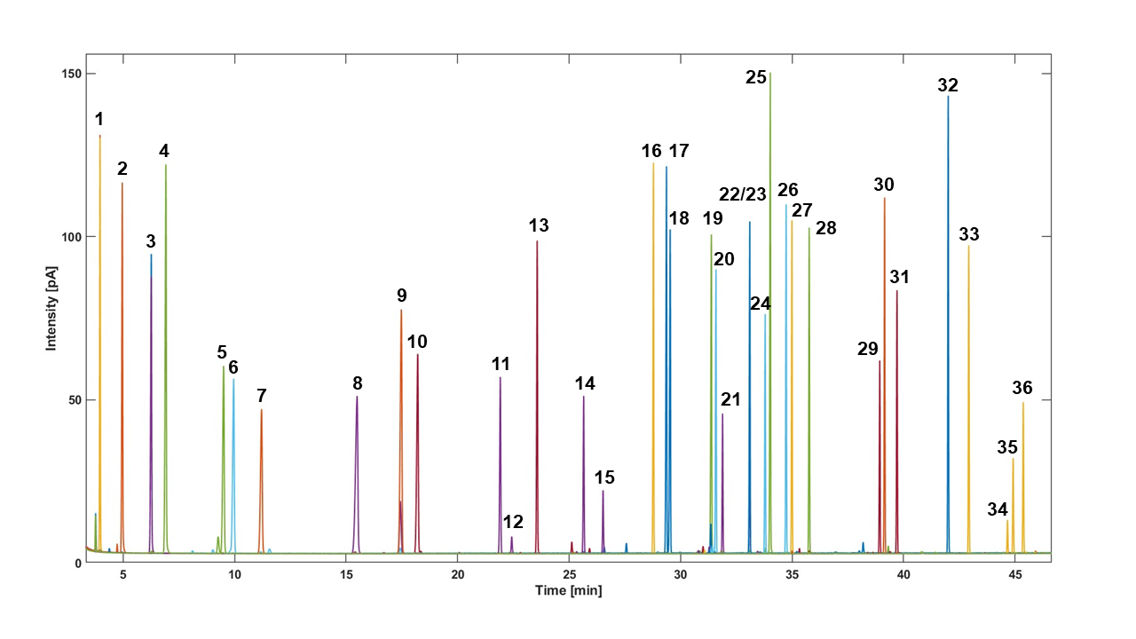
Figure S1: Chromatogram of terpene multi mix analysed on a BGB-wax column with GC-FID Analytes are colour coded to see different elution orders across chromatographic platforms. A complete list of analytes can be found in table S4.

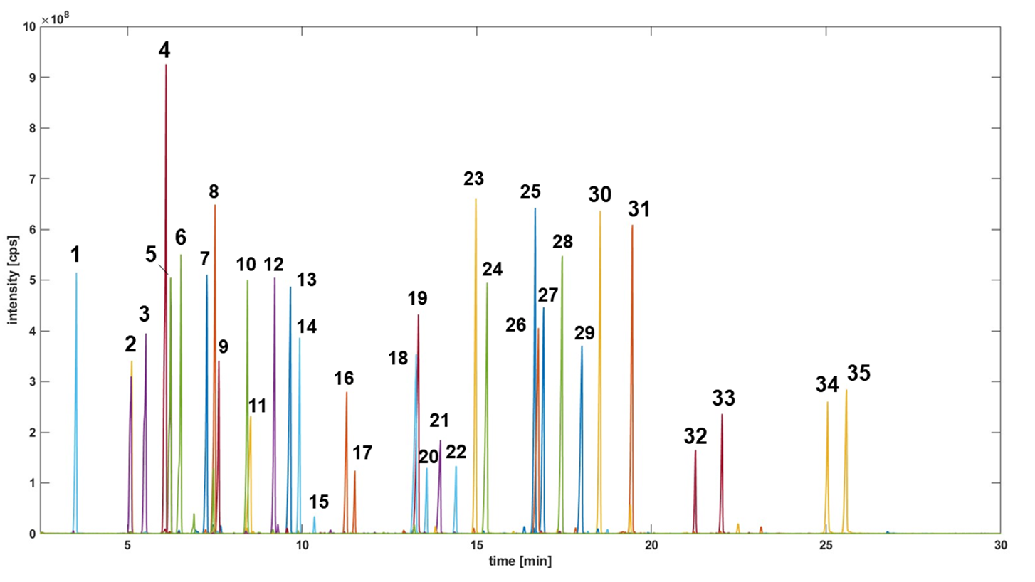
Figure S2: Chromatogram of terpenes multi mix analysed on a DB-5 MS column with GC-MS. Analytes are colour coded to see different elution orders across chromatographic platforms. A complete list of analytes can be found in table S4.
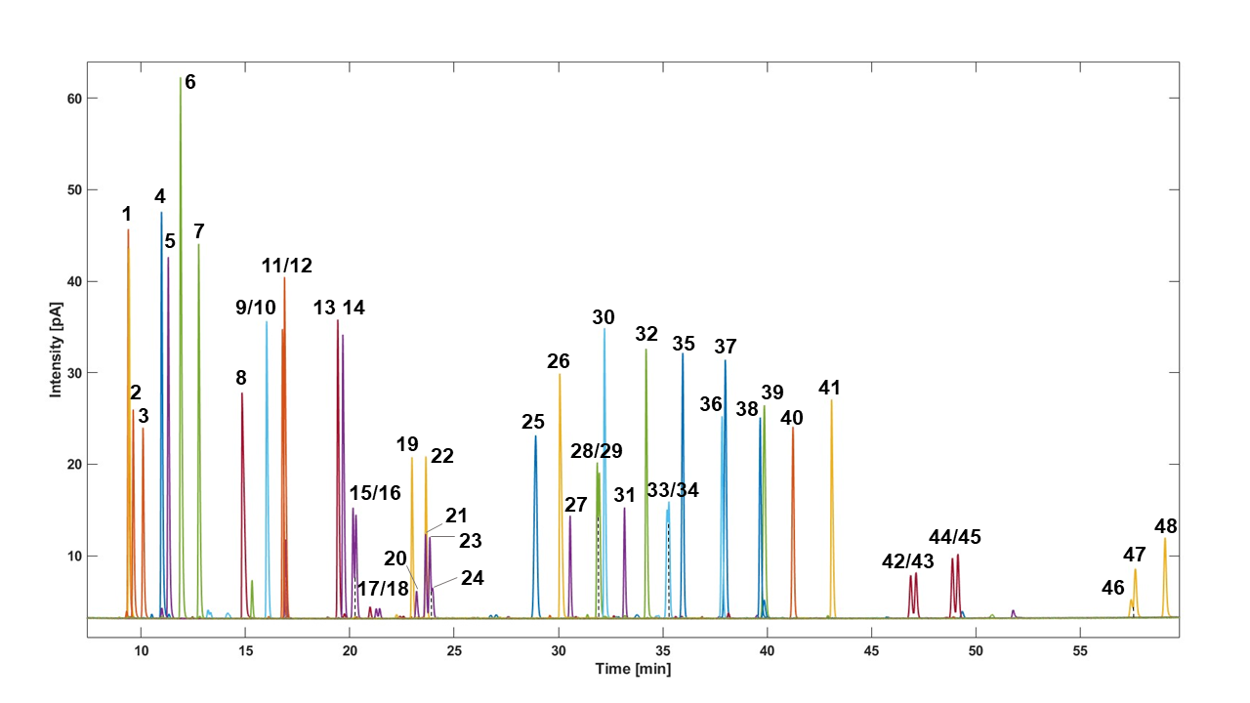
Figure S3: Chromatogram of terpenes analysed on a BGB 178 30% CD column with GC-FID. Analytes are colour coded to see different elution orders across chromatographic platforms. A complete list of analytes can be found in table S4.

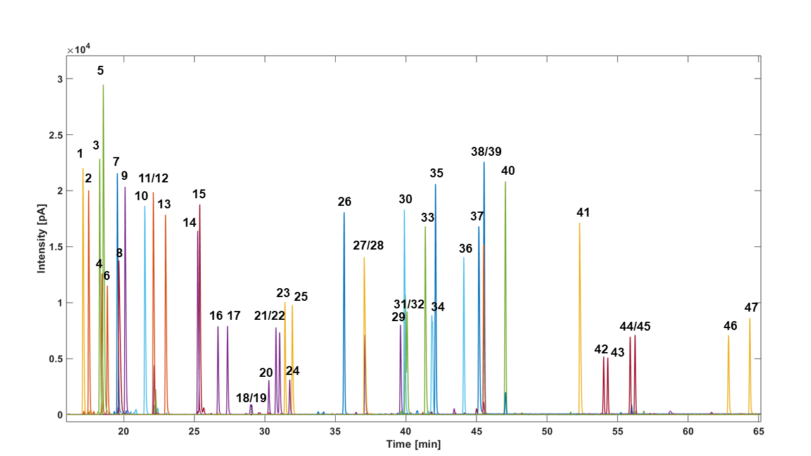

Figure S4: Chromatogram for terpenes analysed on a BGB 176 SE column with GC-FID. Analytes are colour coded to see different elution orders across chromatographic platforms. A complete list of analytes can be found in table S4.
Table S5: results for the mixed effects model on the BGB-wax column. Significance levels were set at ns for P > 0.05, * for ≤ 0.5, ** for P ≤ 0.01, *** for P ≤ 0.001 and **** for P ≤ 0.0001.
Analyte | P-value time | P-value Treatment | P-value Time x Treatment
α-pinene | 0,0003, *** | 0,4442, ns. | 0,0371, *
camphene | 0,0002, *** | 0,0180, * | 0,0319, *
β-pinene | <0,0001, **** | <0,0001, **** | <0,0001, ****
sabinene | <0,0001, **** | <0,0001, **** | <0,0001, ****
myrcene | <0,0001, **** | <0,0001, **** | <0,0001, ****
α-terpinene | <0,0001, **** | 0,0451, * | 0,1461, ns
limonene | <0,0001, **** | <0,0001, **** | 0,0004, ***
γ-terpinene | <0,0001, **** | 0,0038, ** | <0,0001, ****
p-cymene | <0,0001, **** | 0,0102, * | 0,0001, ***
α-terpinolene | <0,0001, **** | 0,0384, * | 0,0050, **
cis-rose oxide | <0,0001, **** | 0,0424, * | 0,0282, *
trans-rose-oxide | <0,0001, **** | 0,1297, ns | 0,1273, ns
cis-3-hexen-1-ol | n.a. | n.a. | n.a.
trans-menthone | <0,0001, **** | <0,0001, **** | <0,0001, ****
cis-menthone | <0,0001, **** | <0,0001, **** | <0,0001, ****
linalool | <0,0001, **** | 0,0025, ** | <0,0001, ****
isobornyl acetate | <0,0001, **** | 0,7592, n.s. | 0,0178, *
β-caryophyllene | <0,0001, **** | 0,0006, *** | <0,0001, ****
α-humulene | <0,0001, **** | 0,0012, ** | <0,0001, ****
citronellyl acetate | <0,0001, **** | 0,8992, ns | 0,4992, ns
cis-citral | <0,0001, **** | 0,0037, ** | <0,0001, ****
neryl acetate | n.a. | n.a. | n.a.
trans-citral | n.a. | n.a. | n.a.
geranyl acetate | <0,0001, **** | 0,4131, ns | 0,0116, *
citronellol | <0,0001, **** | 0,0205, * | <0,0001, ****
nerol | <0,0001, **** | 0,2029, ns | 0,0004, ***
phenylethanol | <0,0001, **** | 0.3339, ns | 0.0191, *
geraniol | <0,0001, **** | 0.0064, ** | <0,0001, ****
cis-nerolidol | <0,0001, **** | 0.4601, ns | <0,0001, ****
methyleugenol | <0,0001, **** | 0.4672, ns | 0.0104, *
trans-nerolidol | <0,0001, **** | 0.1072, ns | 0.0012, **
eugenol | <0,0001, **** | 0.0025, ** | <0,0001, ****
carvacrol | <0,0001, **** | 0.4357, ns | 0.0008, ***
farnesol 1 | <0,0001, **** | 0.5578, ns | 0.0173, *
farnesol 2 | <0,0001, **** | 0.6077, ns | 0.0010, ***
farnesol 3 | <0,0001, **** | 0.2118, ns | 0.0377 *

Table S6: results for the mixed effects model on the BGB 178 30% CD column. Significance levels were set at ns for P > 0.05, * for ≤ 0.5, ** for P ≤ 0.01, *** for P ≤ 0.001 and **** for P ≤ 0.0001.
Analyte | P-value time | P-value Treatment | P-value Time x Treatment
(±)-α-pinene | <0,0001, **** | 0,0004, *** | 0,0062, **
(±)-camphene 1 | <0,0001, **** | 0,1100, ns | 0,0918, ns
(±)-camphene 2 | <0,0001, **** | 0,1809, ns | 0,1809, ns
(-)-β-pinene | <0,0001, **** | <0,0001, **** | <0,0001, ****
sabinene | <0,0001, **** | <0,0001, **** | <0,0001, ****
myrcene | <0,0001, **** | <0,0001, **** | <0,0001, ****
α-terpinene | <0,0001, **** | 0,0798, ns | 0,4357, ns
(R)-limonene | <0,0001, **** | 0,0993, ns | 0,0195, *
p-cymene | <0,0001, **** | 0,0174, * | 0,0001, ***
α-terpinolene | <0,0001, **** | 0,0526, ns | 0,0078, **
γ-terpinene | <0,0001, **** | 0,0044, ** | <0,0001, ****
(±)-cis-rose oxide 1 | <0,0001, **** | 0,9266, ns | 0,3539, ns
(±)-cis-rose oxide 2 | <0,0001, **** | 0,9706, ns | 0,4862, ns
(±)-cis-menthone 1 | <0,0001, **** | <0,0001, **** | <0,0001, ****
(±)-cis-menthone 2 | <0,0001, **** | <0,0001, **** | 0,0043, **
(+)-linalool | <0,0001, **** | <0,0001, **** | <0,0001 , ****
(±)-trans-menthone 1 | <0,0001, **** | <0,0001, **** | <0,0001, ****
(±)-trans-menthone 2 | <0,0001, **** | <0,0001, **** | <0,0001, ****
isobornyl acetate | <0,0001, **** | 0,7286, ns | 0,3912, ns
phenylethanol | <0,0001, **** | 0,5227, ns | 0,6731, ns
trans-citral | <0,0001, **** | <0,0001, **** | 0,0849, ns
(±)-citronellol 1 | <0,0001, **** | 0,0059, ** | <0,0001, ****
(±)-citronellol 2 | <0,0001, **** | 0,0527, ns | 0,0003, ***
nerol | <0,0001, **** | 0,0408, * | 0,0619, ns
cis-citral | <0,0001, **** | <0,0001, **** | 0,2699, ns
geraniol | <0,0001, **** | 0,0446, * | 0,0252, *
(±)-citronellyl acetate 1 | <0,0001, **** | 0,2532, ns | 0,2818, ns
(±)-citronellyl acetate 2 | <0,0001, **** | 0,6076, ns | 0,2387, ns
neryl acetate | <0,0001, **** | 0,6205, ns | 0,3278, ns
geranyl acetate | <0,0001, **** | 0,1040, ns | 0,6843, ns
β-caryophyllene | <0,0001, **** | 0,0004, *** | <0,0001, ****
eugenol | <0,0001, **** | 0,0031, ** | <0,0001, ****
α-humulene | <0,0001, **** | 0,0010, ** | <0,0001, ****
methyleugenol | <0,0001, **** | 0,0670, ns | 0,1874, ns
carvacrol | <0,0001, **** | 0,5948, ns | 0,1619, ns
(±)-cis-nerolidol 1 | <0,0001, **** | 0,3648, ns | 0,7494, ns
(±)-cis-nerolidol 2 | <0,0001, **** | 0,2957, ns | 0,9502, ns
(±)-trans-nerolidol 1 | <0,0001, **** | 0,1627, ns | 0,3244, ns
(±)-trans-nerolidol 2 | <0,0001, **** | 0,0009, *** | 0,4956, ns
farnesol 1 | <0,0001, **** | 0,7331, ns | 0,7122, ns
farnesol 2 | <0,0001, **** | 0,5571, ns | 0,6959, ns
farnesol 3 | <0,0001, **** | 0,9073, ns | 0,9972, ns

Table S7: results for the mixed effects model on the BGB 176 SE column. Significance levels were set at ns for P > 0.05, * for ≤ 0.5, ** for P ≤ 0.01, *** for P ≤ 0.001 and **** for P ≤ 0.0001.
Analyte | P-value time | P-value Treatment | P-value Time x Treatment
(+)-α-pinene | <0,0001, **** | 0,0267, * | 0,0226, *
myrcene | <0,0001, **** | <0,0001, **** | <0,0001, ****
camphene | <0,0001, **** | 0,425ns | 0,0056, **
sabinene | <0,0001, **** | <0,0001, **** | <0,0001, ****
camphene | <0,0001, **** | <0,0001, **** | 0,0151, *
(-)-β-pinene | <0,0001, **** | 0,1429, ns | 0,5976, ns
α-terpinene | <0,0001, **** | 0,0471, * | 0,1925, ns
(R)-limonene | <0,0001, **** | 0,005, ** | 0,0052, **
γ-terpinene | <0,0001, **** | 0,0211, * | <0,0001, ****
α-terpinolene | <0,0001, **** | 0,0067, ** | <0,0001, ****
(+/-)-cis-rose oxide 1 | <0,0001, **** | 0,0126, * | 0,0158, *
(+/-)-cis-rose oxide 2 | <0,0001, **** | 0,2284, ns | 0,9036, ns
(+/-)-cis-menthone 1 | <0,0001, **** | <0,0001, **** | <0,0001, ****
(+/-)-cis-menthone 2 | <0,0001, **** | <0,0001, **** | <0,0001, ****
(+/-)-trans-menthone 1 | <0,0001, **** | <0,0001, **** | <0,0001, ****
(-)-linalool | <0,0001, **** | <0,0001, **** | 0,0005, ***
(+/-)-trans-menthone 2 | <0,0001, **** | <0,0001, **** | 0,0134, *
isobornyl acetate | <0,0001, **** | 0,3052, ns | 0,0099, **
nerol | <0,0001, **** | <0,0001, **** | 0,3256, ns
(+/-)-citronellol 2 | 0,0142, * | 0,2469, ns | 0,1478, ns
geraniol | <0,0001, **** | 0,5879, ns | 0,0012, **
citronellyl acetate | <0,0001, **** | 0,3559, ns | 0,2182, ns
neryl acetate | <0,0001, **** | 0,4745, ns | 0,0099, **
geranyl acetate | <0,0001, **** | 0,4005, ns | 0,0186, *
eugenol | <0,0001, **** | 0,0005, *** | <0,0001, ****
α-humulene | <0,0001, **** | 0,0003, *** | <0,0001, ****
carvacrol | <0,0001, **** | 0,5379, ns | 0,026, *
(+/-)-cis-nerolidol 1 | <0,0001, **** | 0,0301, * | 0,1557, ns
(+/-)-cis-nerolidol 2 | <0,0001, **** | 0,0187, * | 0,1651, ns
(+/-)-trans-nerolidol 1 | <0,0001, **** | 0,217, ns | 0,0824, ns
(+/-)-trans-nerolidol 2 | <0,0001, **** | 0,0664, ns | 0,7051, ns
farnesol 1 | <0,0001, **** | 0,0491, * | 0,2899, ns
farnesol 2 | <0,0001, **** | 0,0175, * | 0,219, ns

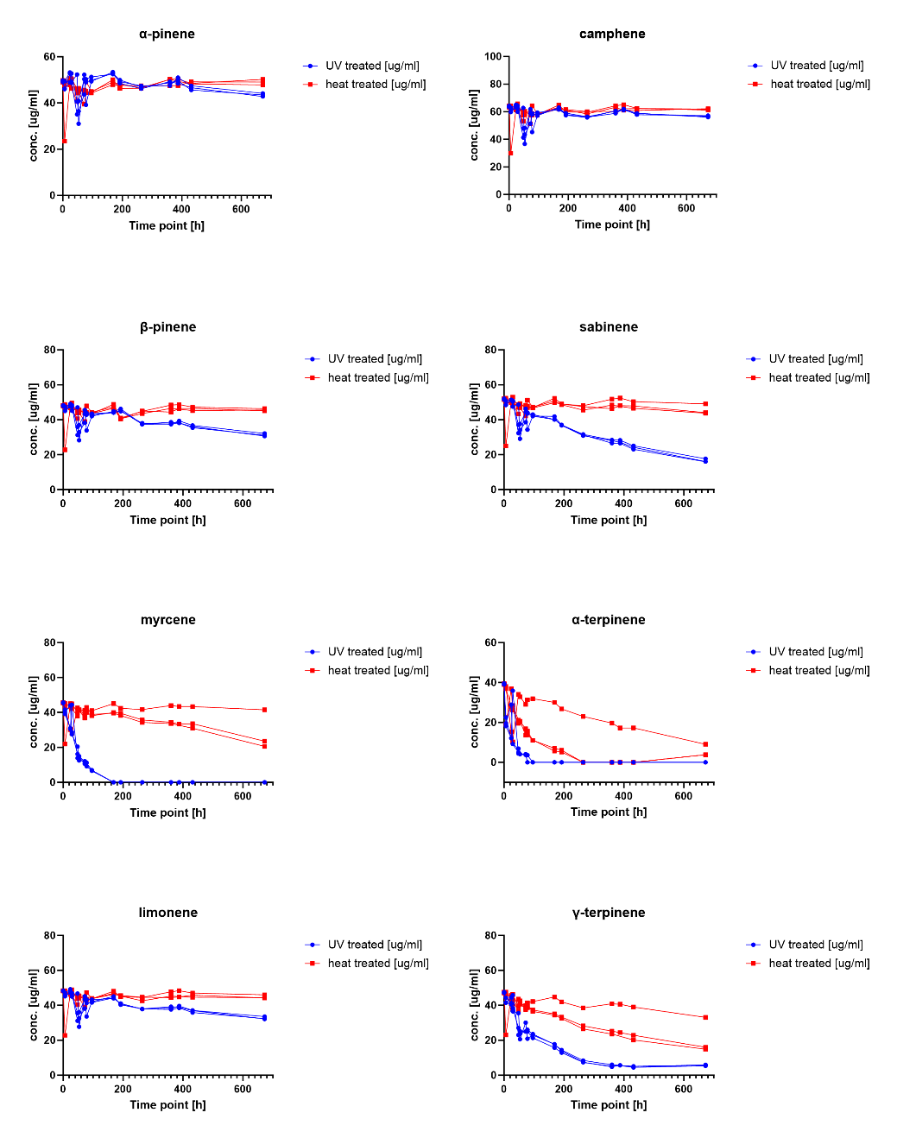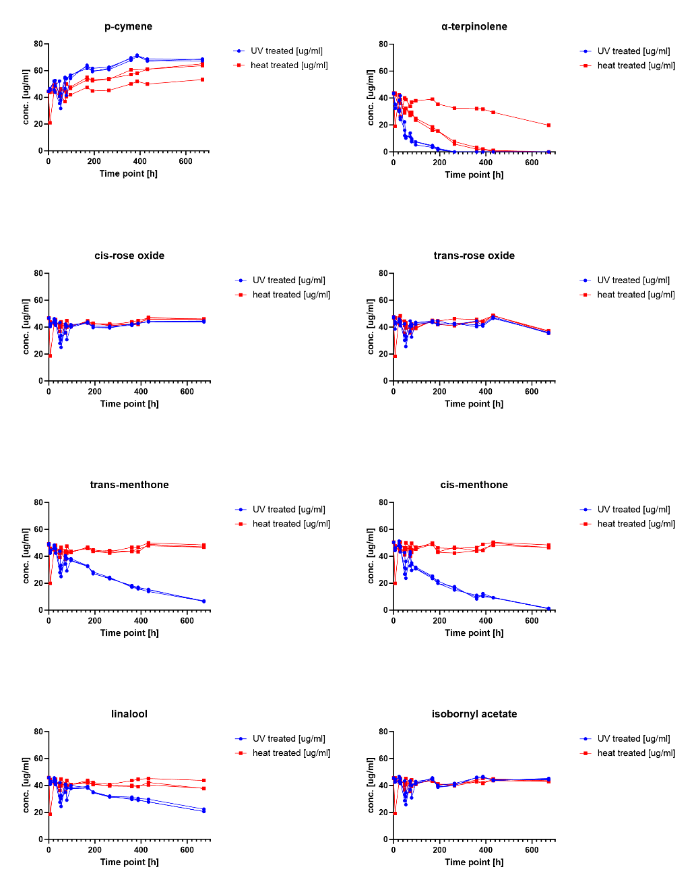
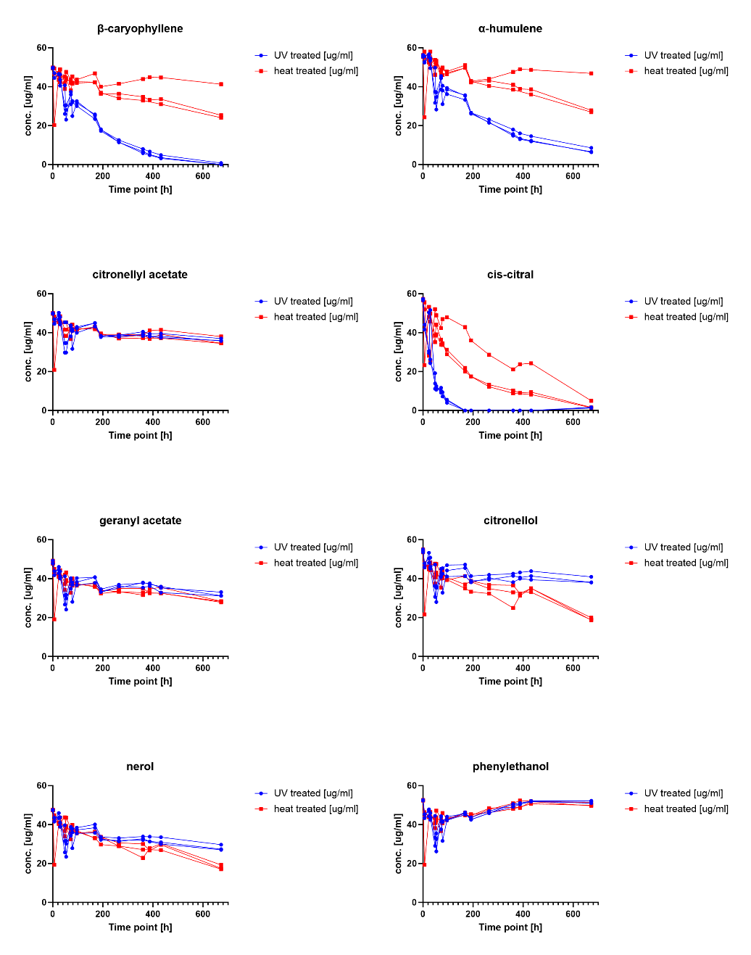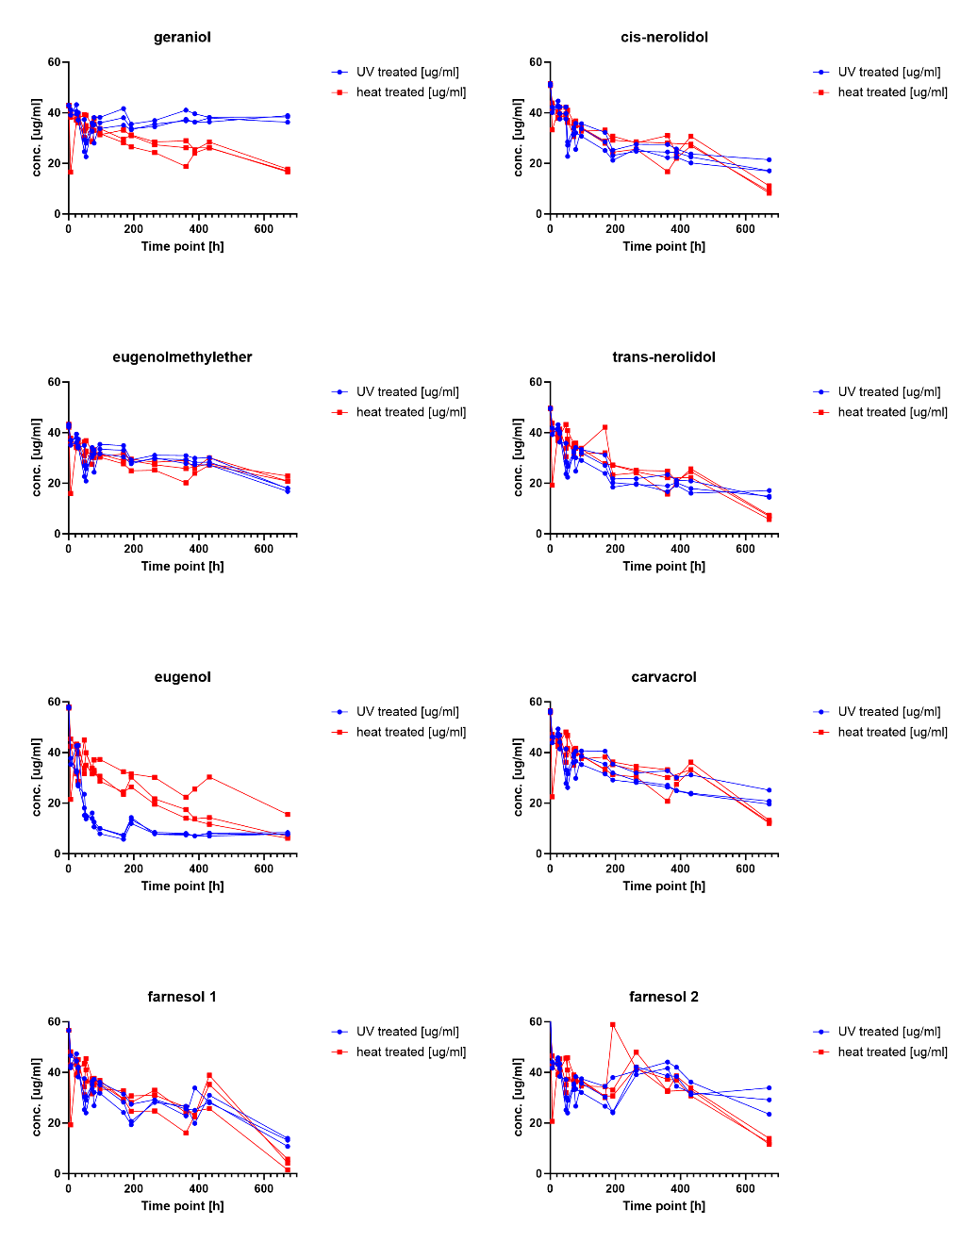
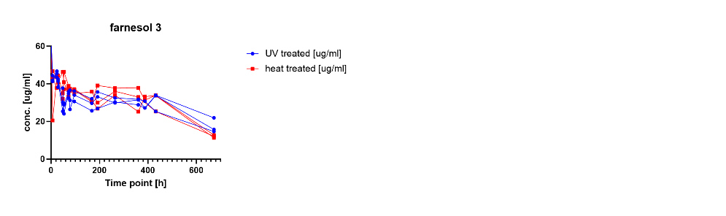
Figure S5: Concentration changes of terpenes after UV light treatment (blue) and heat treatment (red). Profiles were acquired using GC-FID equipped with a BGB wax column. Experiments were carried out in triplicates (n=3).

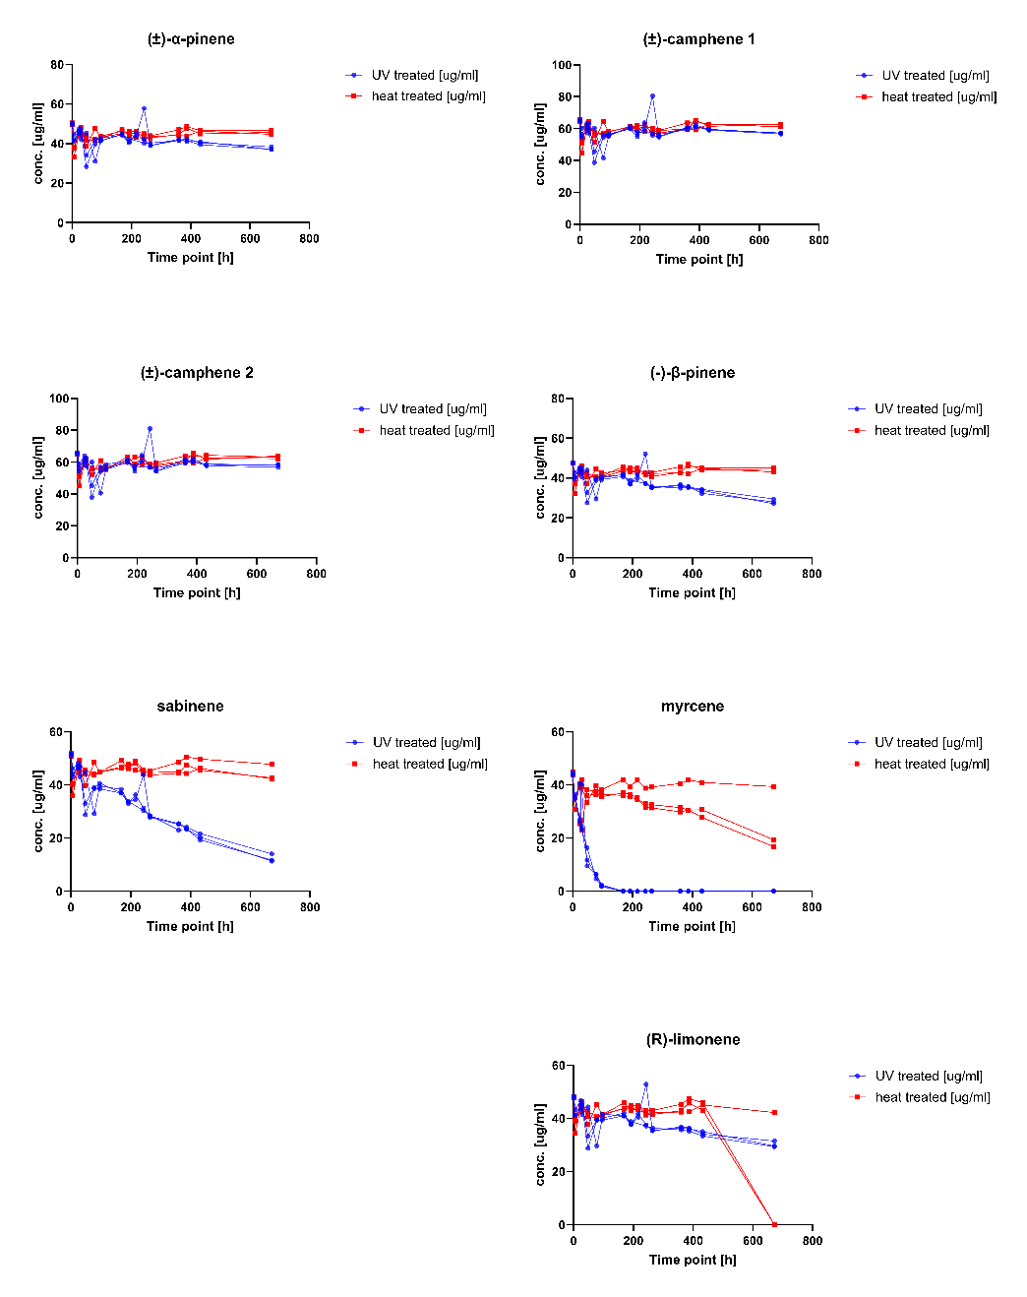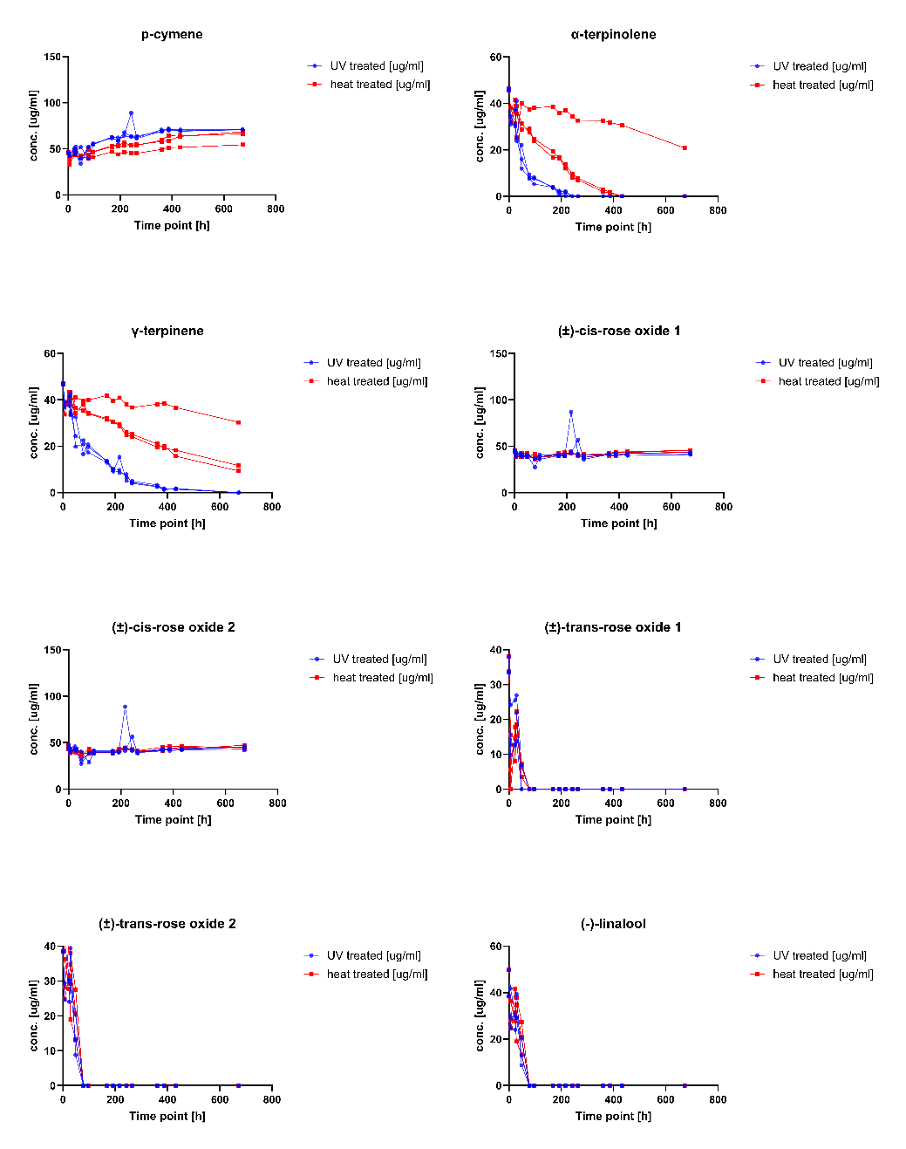
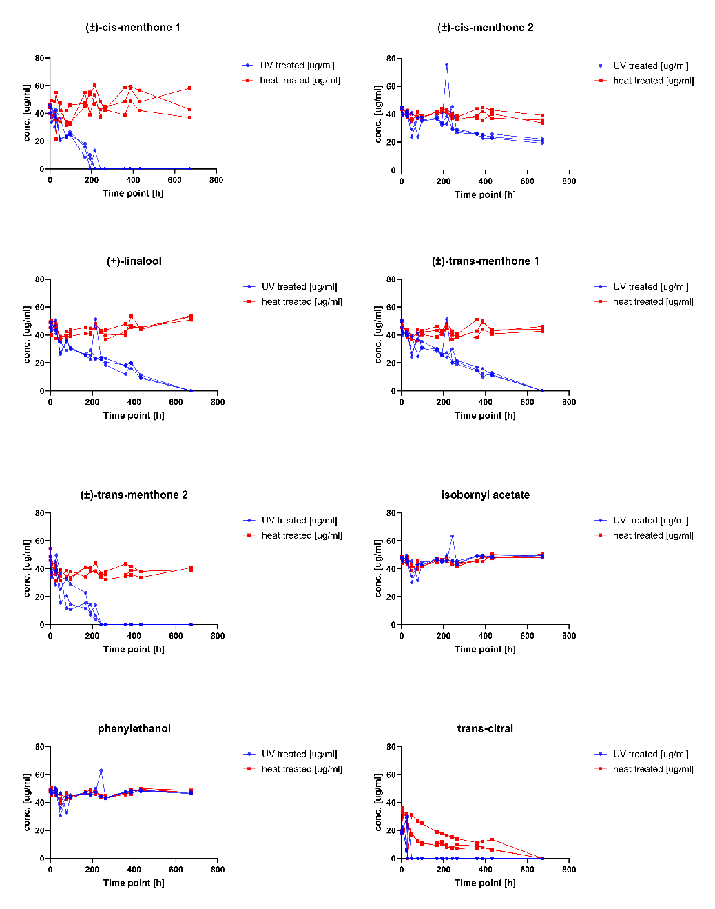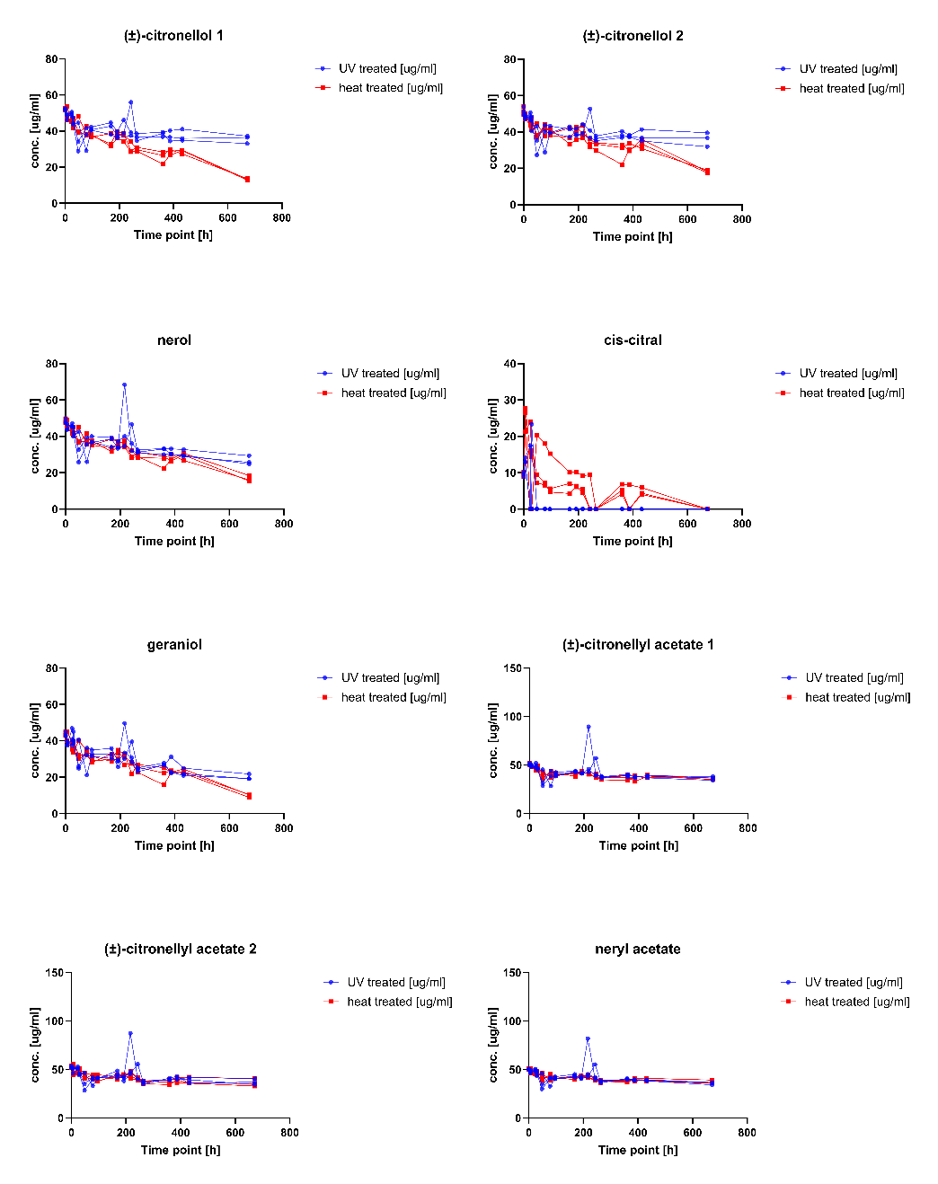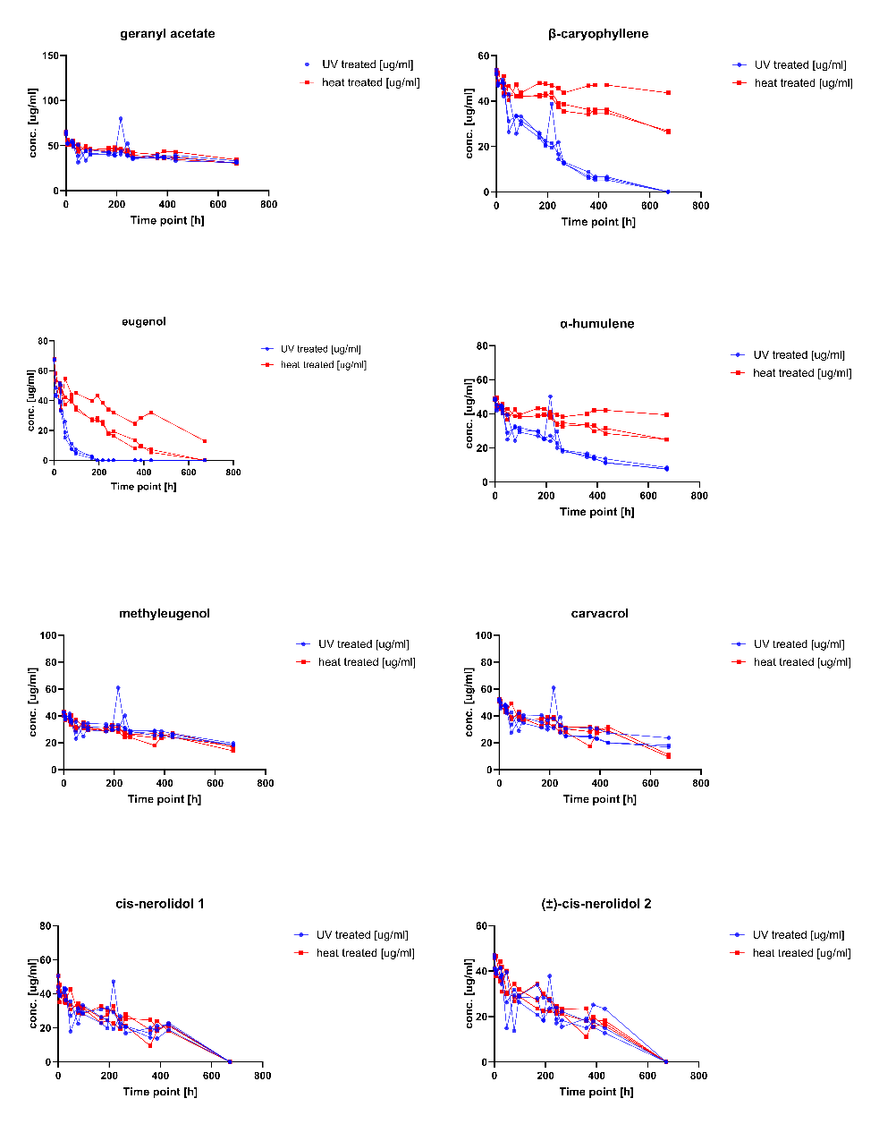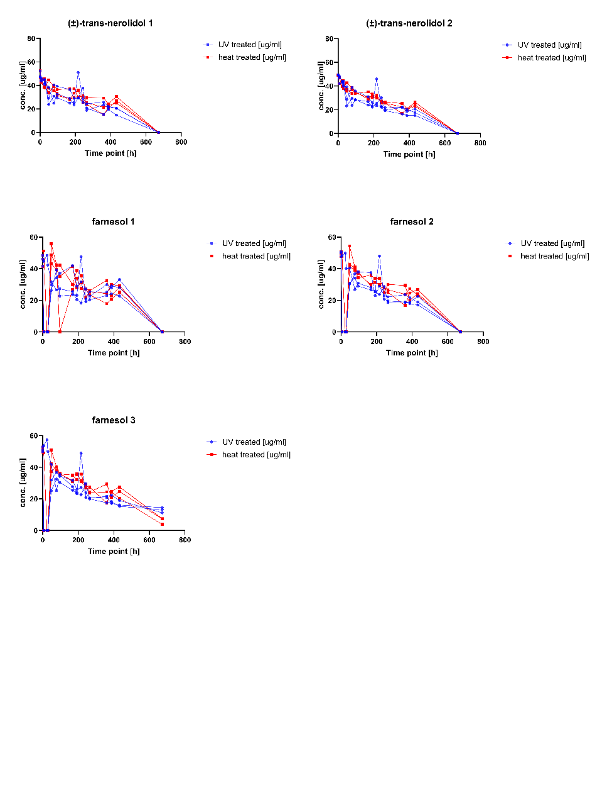
Figure S6: Concentration changes of terpenes after UV light treatment (blue) and heat treatment (red). Profiles were acquired using GC-FID equipped with a BGB 178 30% CD chiral column. Experiments were carried out in triplicates (n=3).
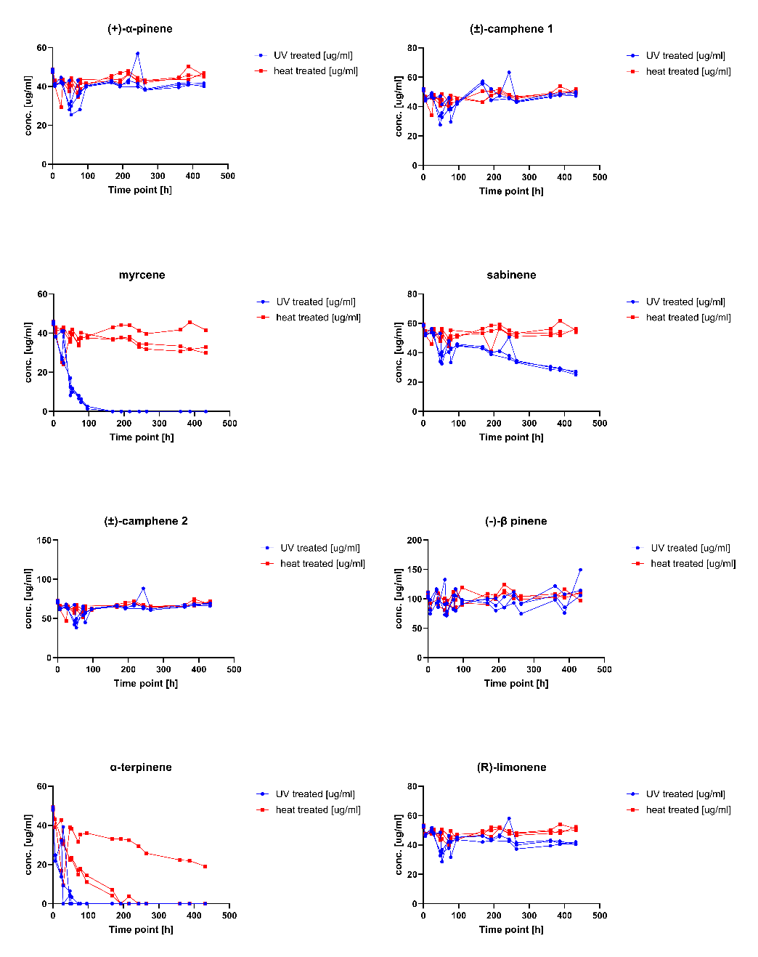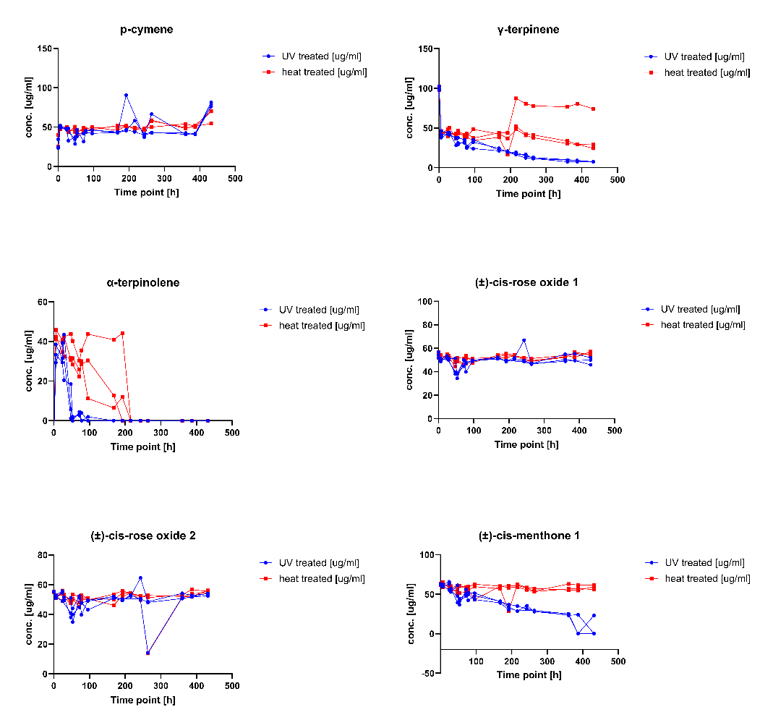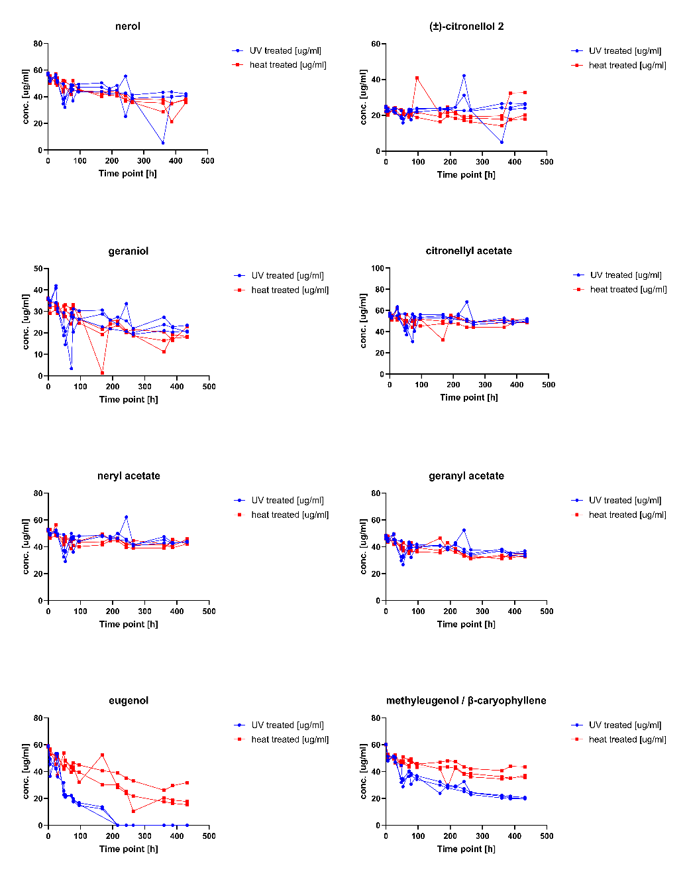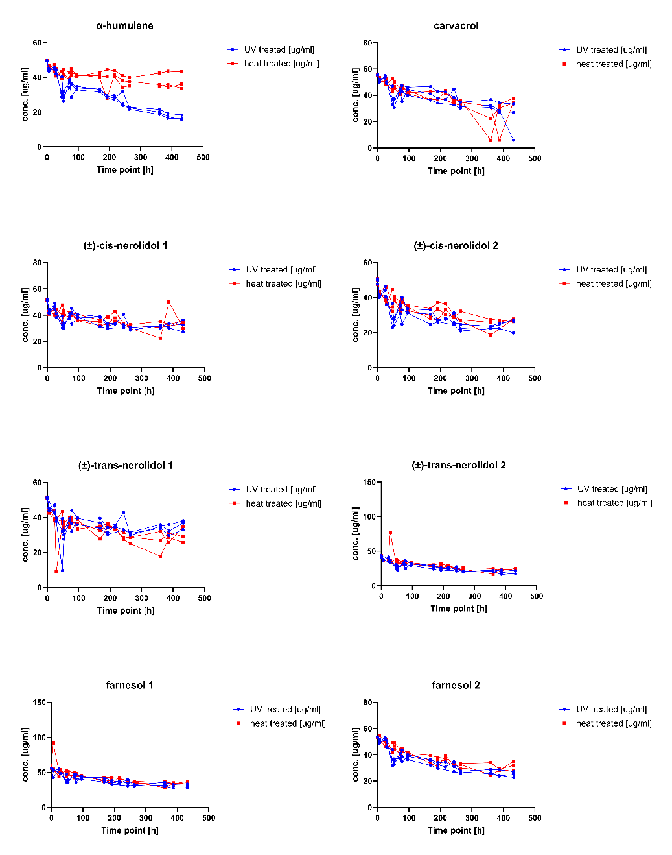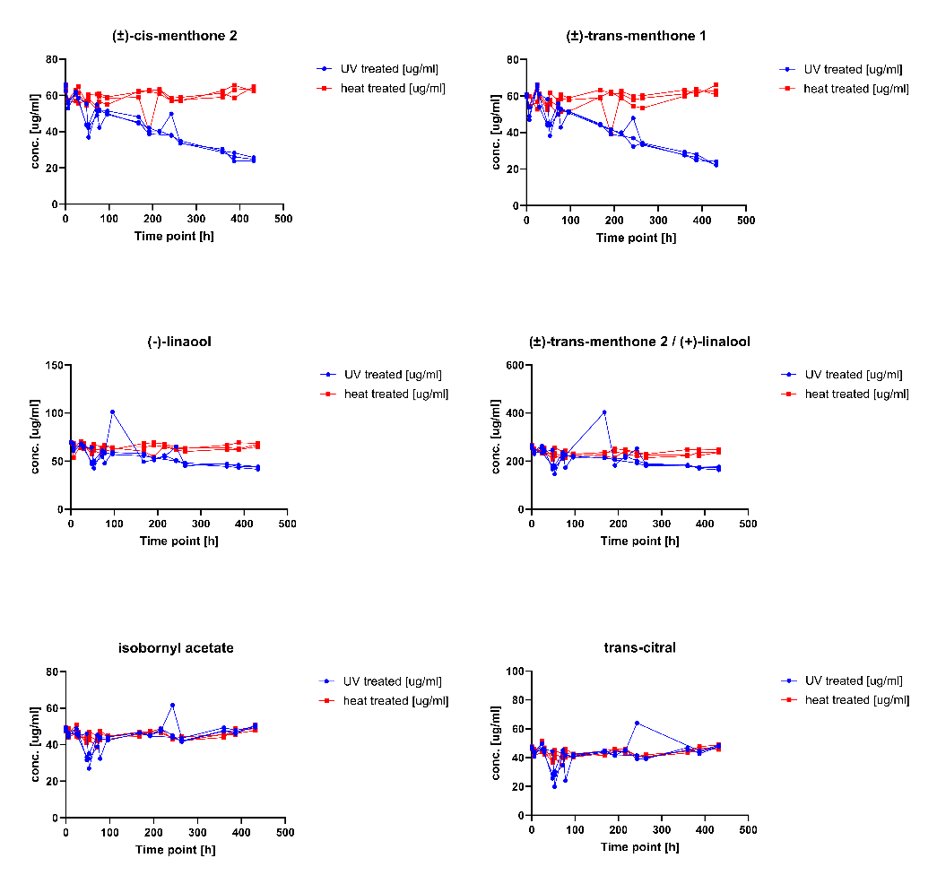
Figure S7: Concentration changes of terpenes after UV light treatment (blue) and heat treatment (red). Profiles were acquired using GC-FID equipped with a BGB 176 SE chiral column. Experiments were carried out in triplicates (n=3).

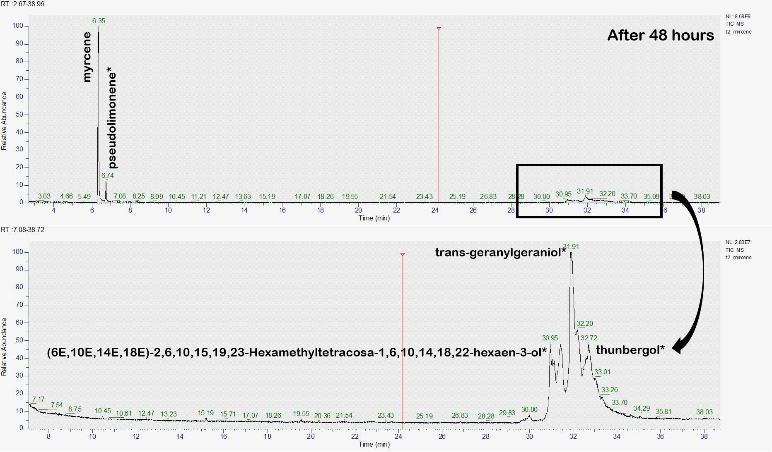
Figure S8: GC-MS profile of a stressed 1 mg/ml myrcene solution for 48 hours. Asterisk (*) marks putatively identified compounds.

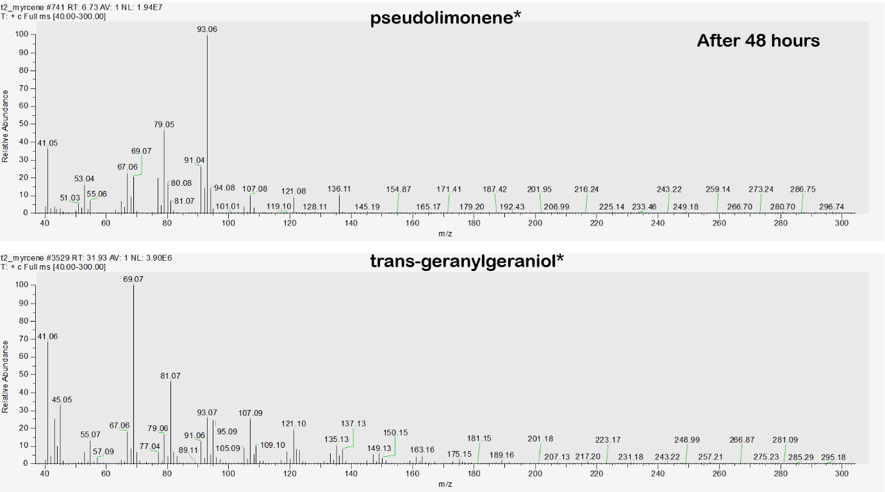
Figure S9: MS spectrum of pseudolimonene and trans-geranylgeraniol.

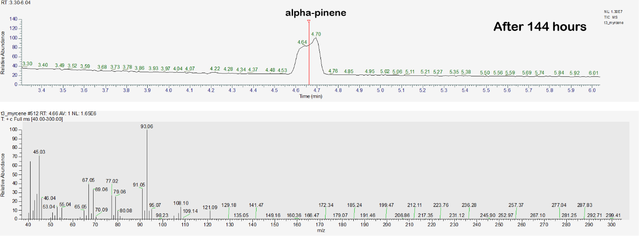
Figure S10: GC-MS chromatogram and MS spectrum of α-pinene identified in a 144 h UV-stressed myrcene sample.

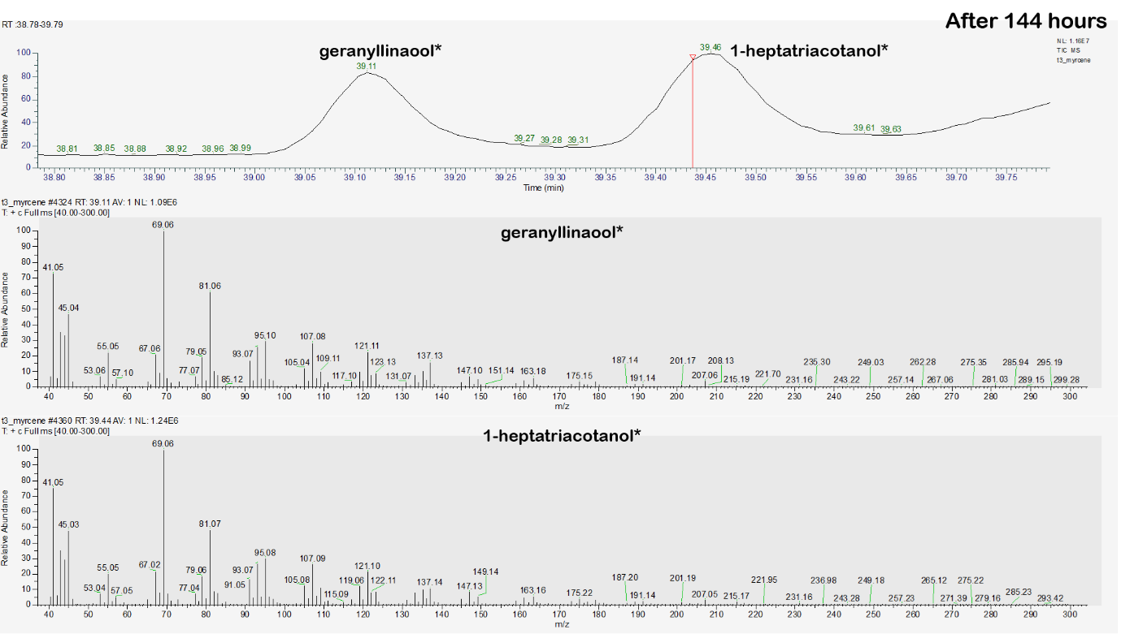
Figure S11: GC-MS chromatogram and MS spectrum of geranyllinalool and 1-heptatriacotanol identified in a 144 h UV-stressed myrcene sample.

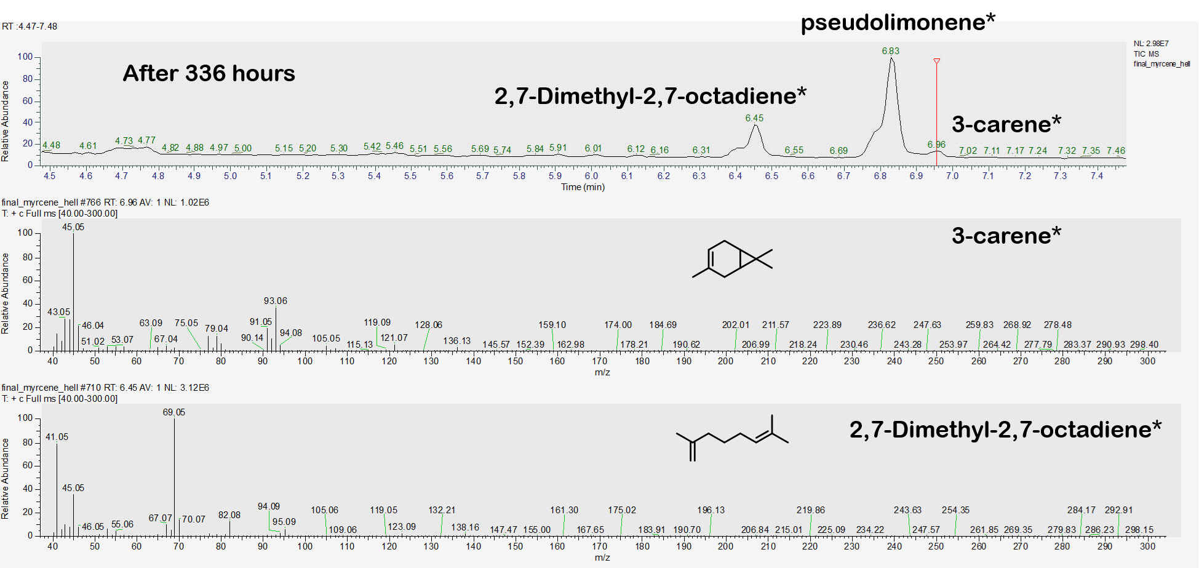
Figure S12: GC-MS chromatogram and MS spectrum of 2,7-dimethyl-2,7-octadiene and 3-carene identified in a 336 h UV-stressed myrcene sample.

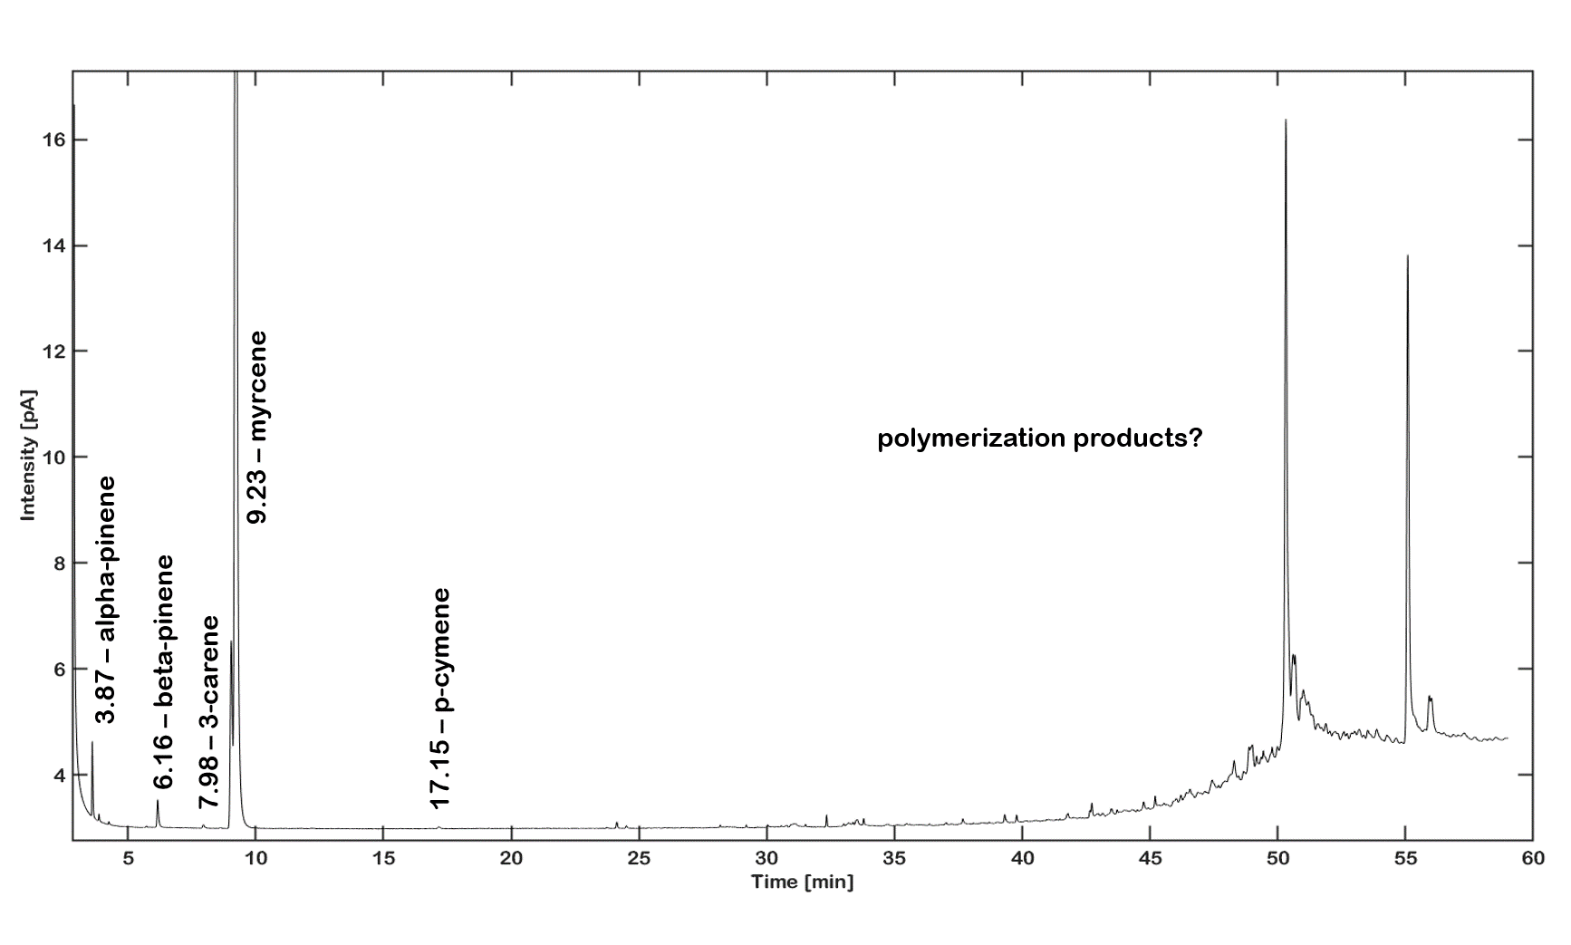
Figure S13: Chromatogram acquired using GC-FID equipped with a BGB-wax column of a 1 mg/ml myrcene samples, which was stressed for 48 hours.

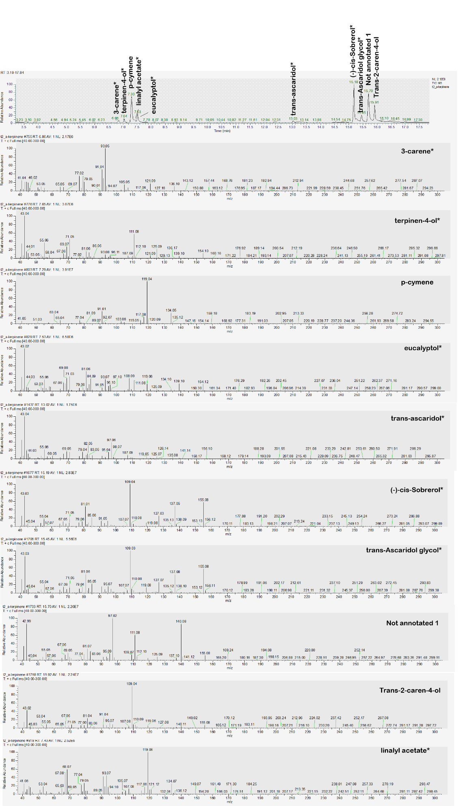
Figure S14: GC-MS profile with corresponding MS spectra for a 1 mg/ml α-terpinene solution. The solution was stressed for 48 hours with UV-light.

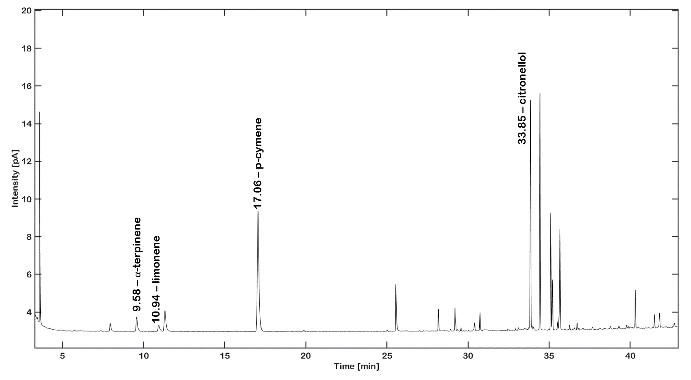Figure S15: Chromatogram acquired using GC-FID equipped with a BGB-wax column of a 1 mg/ml α-terpinene sample, which was stressed for 48 hours.

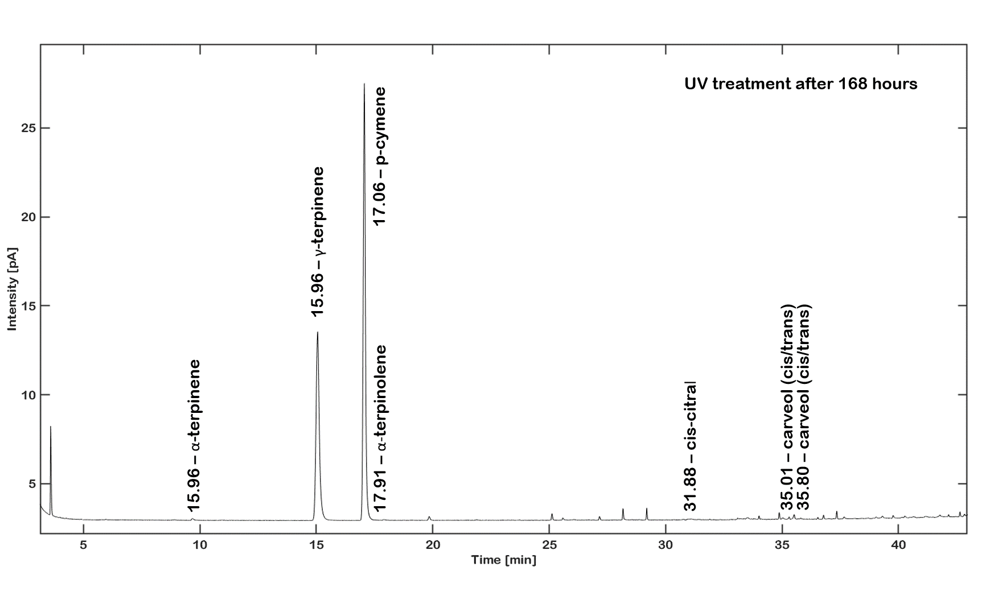
Figure S16: Chromatogram acquired using GC-FID equipped with a BGB-wax column of a 1 mg/ml γ-terpinene sample, which was stressed for 168 hours.

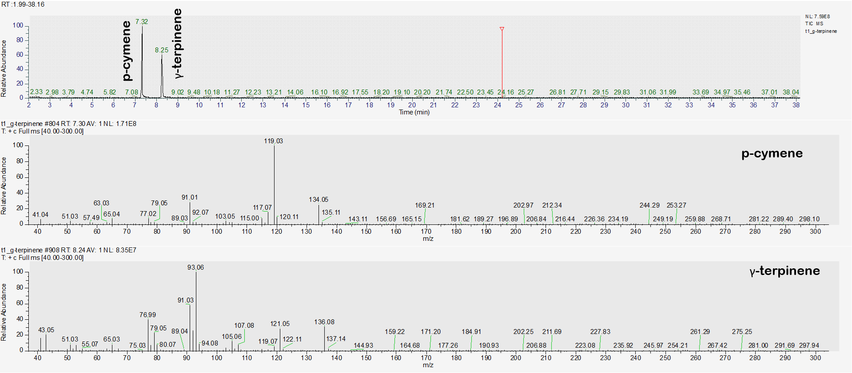
Figure S17: Chromatogram and MS spectrum acquired using GC-MS equipped with a DB-5 MS column of a 1 mg/ml γ-terpinene sample, which was stressed for 168 hours with UV light.

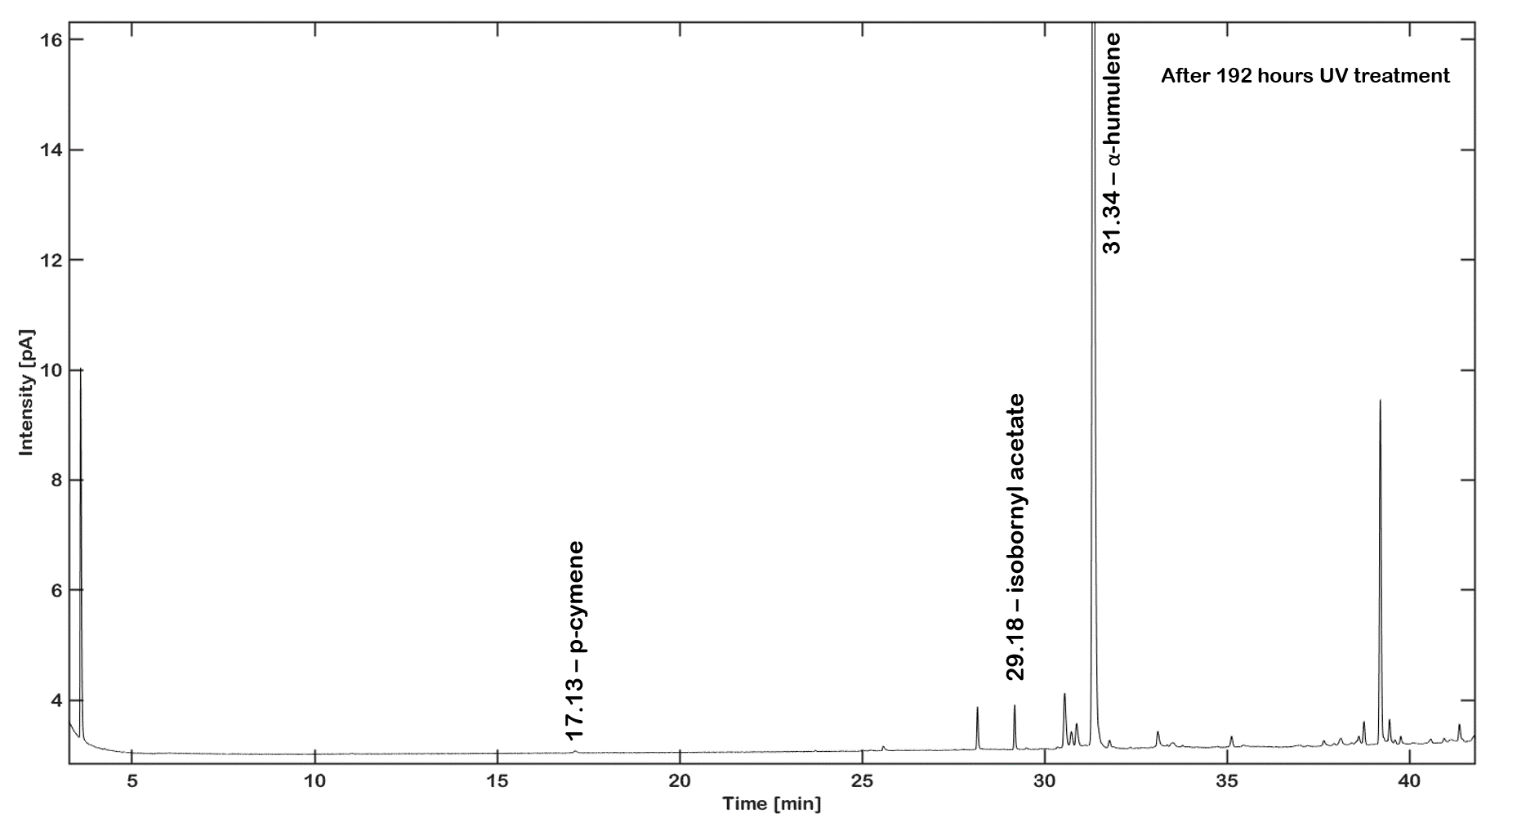
Figure S18: Chromatogram acquired using GC-FID equipped with a BGB-wax column of a 1 mg/ml α-humulene sample, which was stressed for 192 hours.
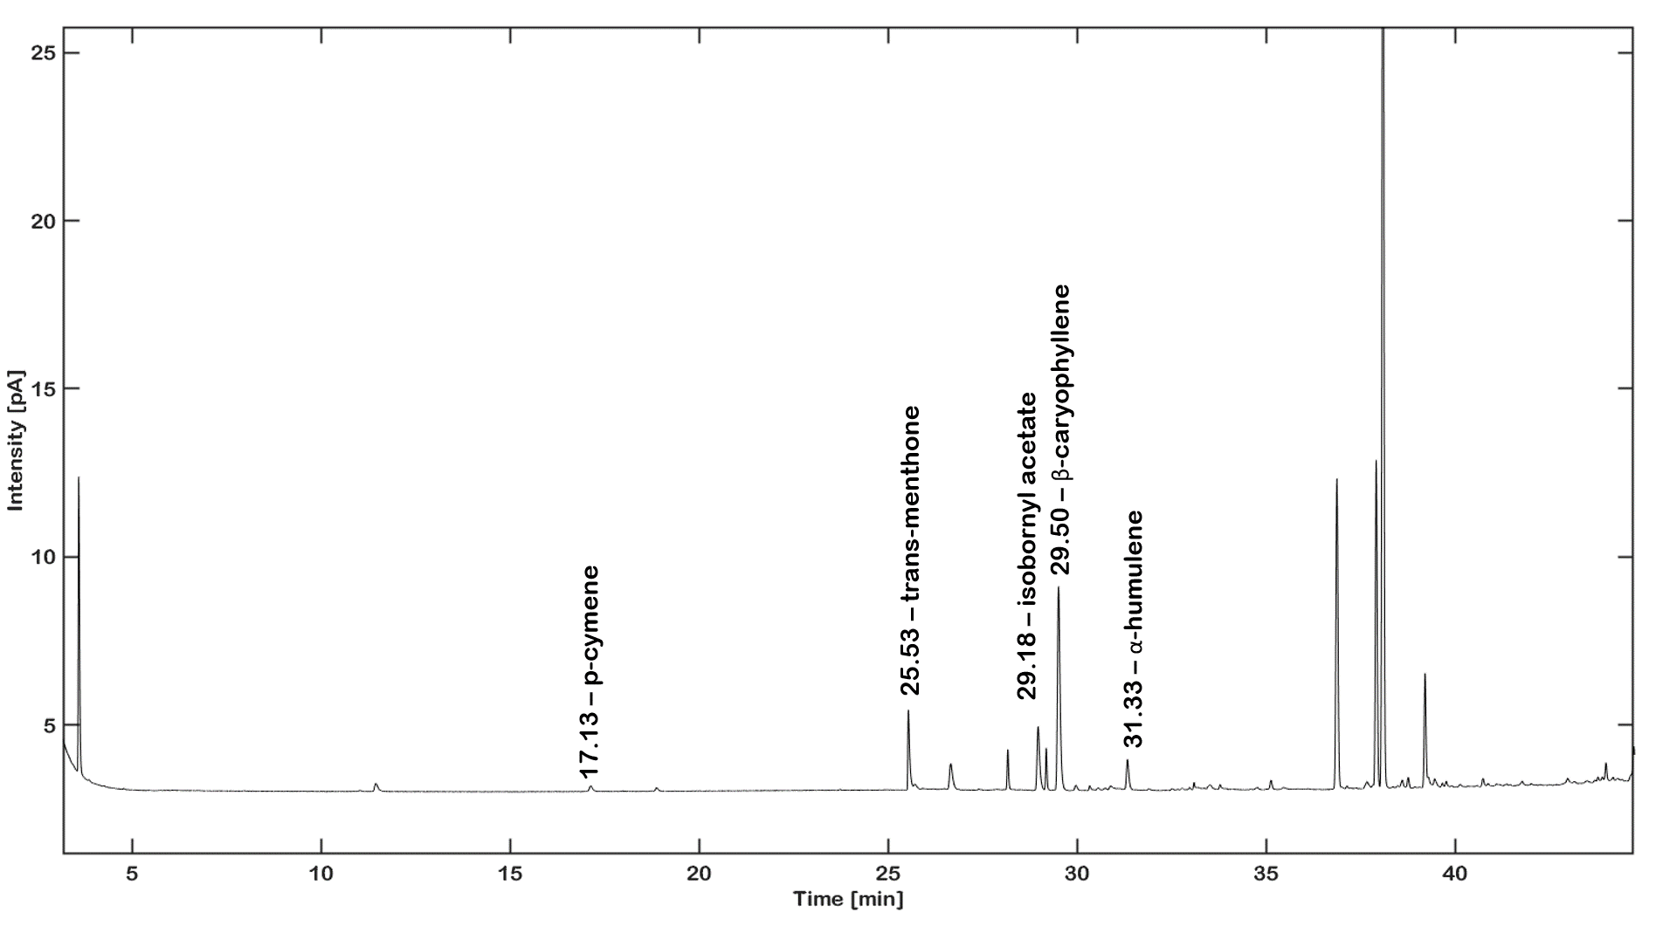
Figure 19: Chromatogram acquired using GC-FID equipped with a BGB-wax column of a 1 mg/ml β-caryophyllene sample, which was stressed for 192 hours.
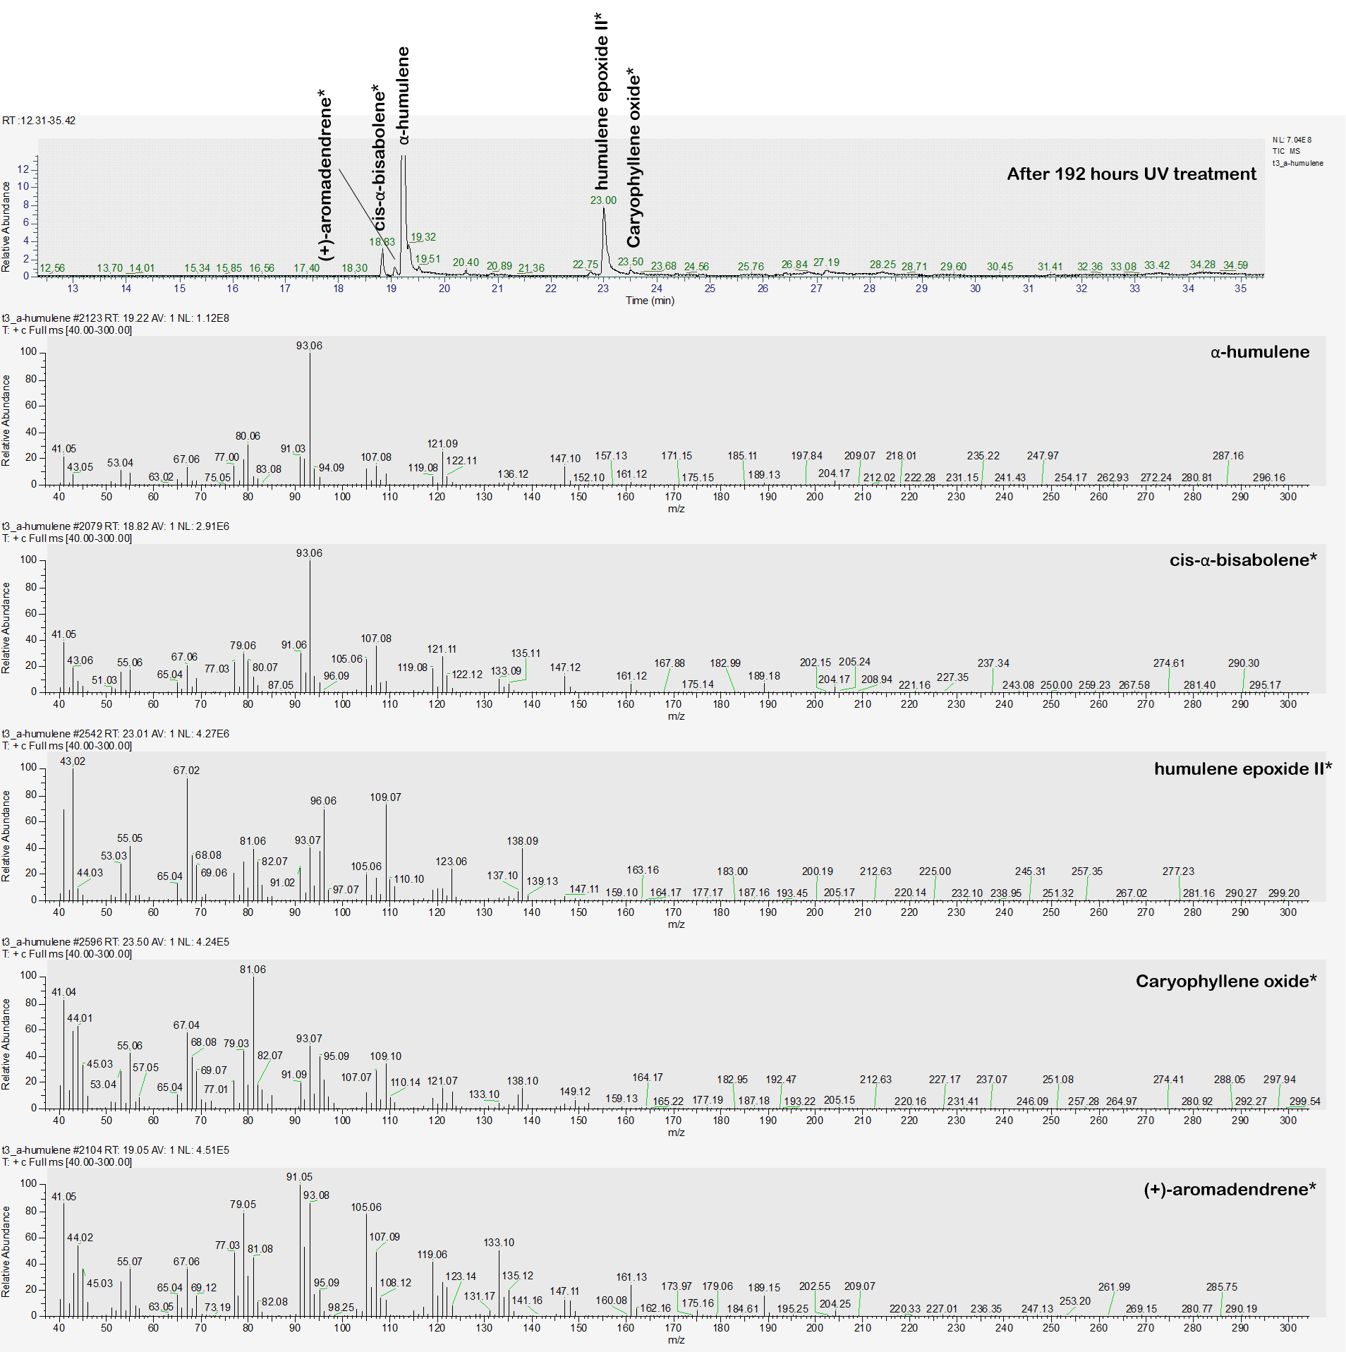
Figure S20: Chromatogram and MS spectrum acquired using GC-MS equipped with a DB-5 MS column of a 1 mg/ml α-humulene sample, which was stressed for 192 hours with UV light.

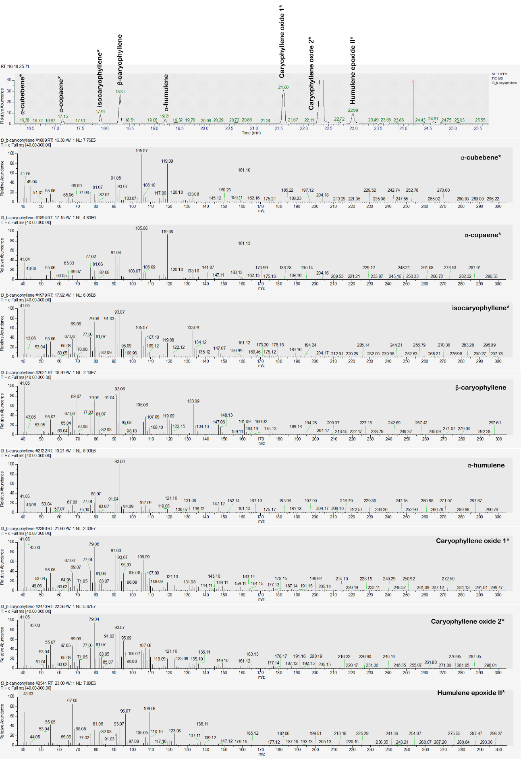
Figure S21: Chromatogram and MS spectrum acquired using GC-MS equipped with a DB-5 MS column of a 1 mg/ml β-caryophyllene sample, which was stressed for 192 hours with UV light.

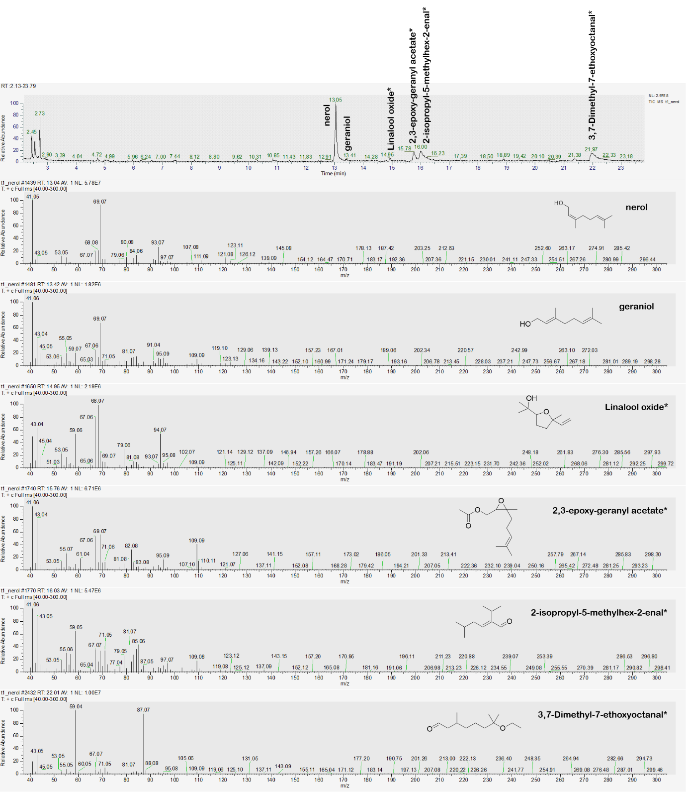
Figure S22: Chromatogram and MS spectrum acquired using GC-MS equipped with a DB-5 MS column of a 1 mg/ml nerol sample, which was stressed for 192 hours with UV light.

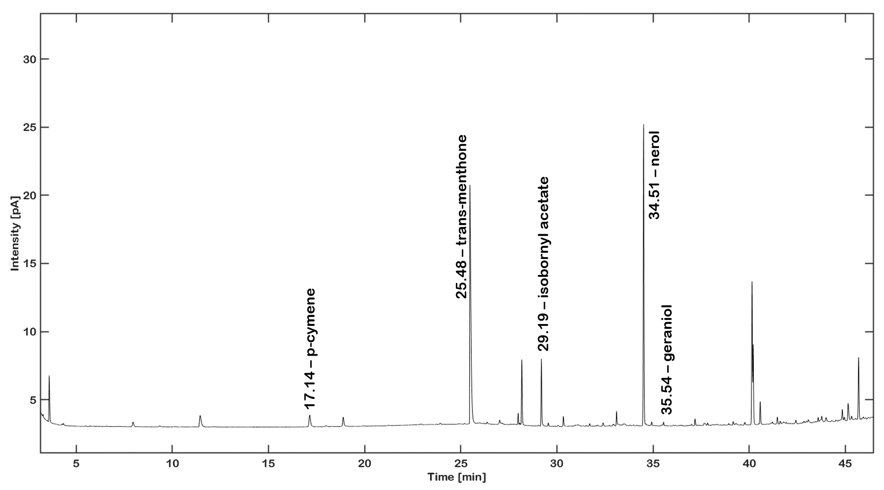
Figure S23: Chromatogram acquired using GC-FID equipped with a BGB-wax column of a 1 mg/ml nerol sample, which was stressed for 192 hours.

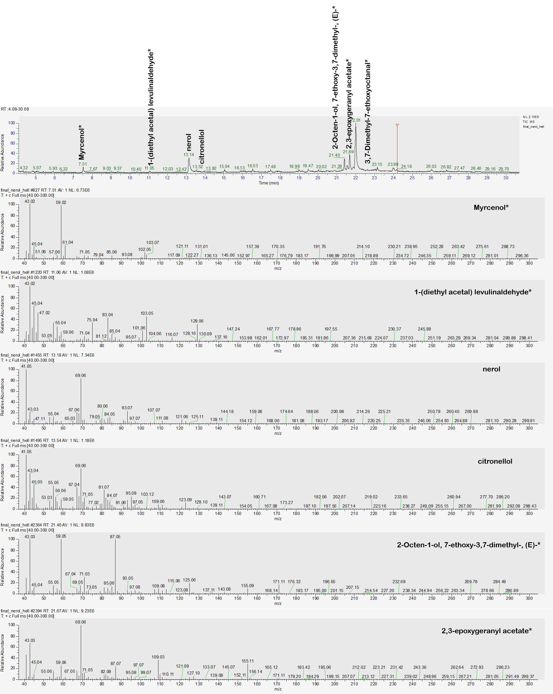
Figure S24: Chromatogram and MS spectrum acquired using GC-MS equipped with a DB-5 MS column of a 1 mg/ml nerol sample, which was stressed for 336 hours with UV light.

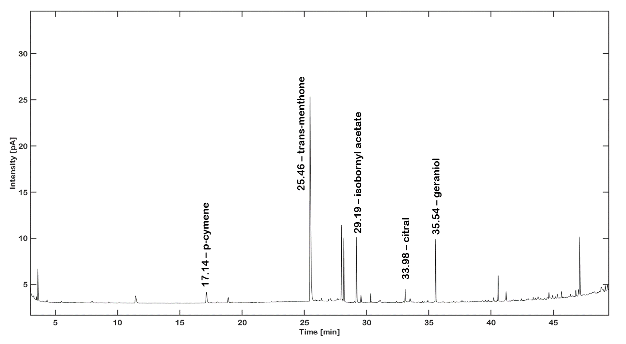
Figure S25: Chromatogram acquired using GC-FID equipped with a BGB-wax column of a 1 mg/ml geraniol sample, which was stressed for 192 hours.

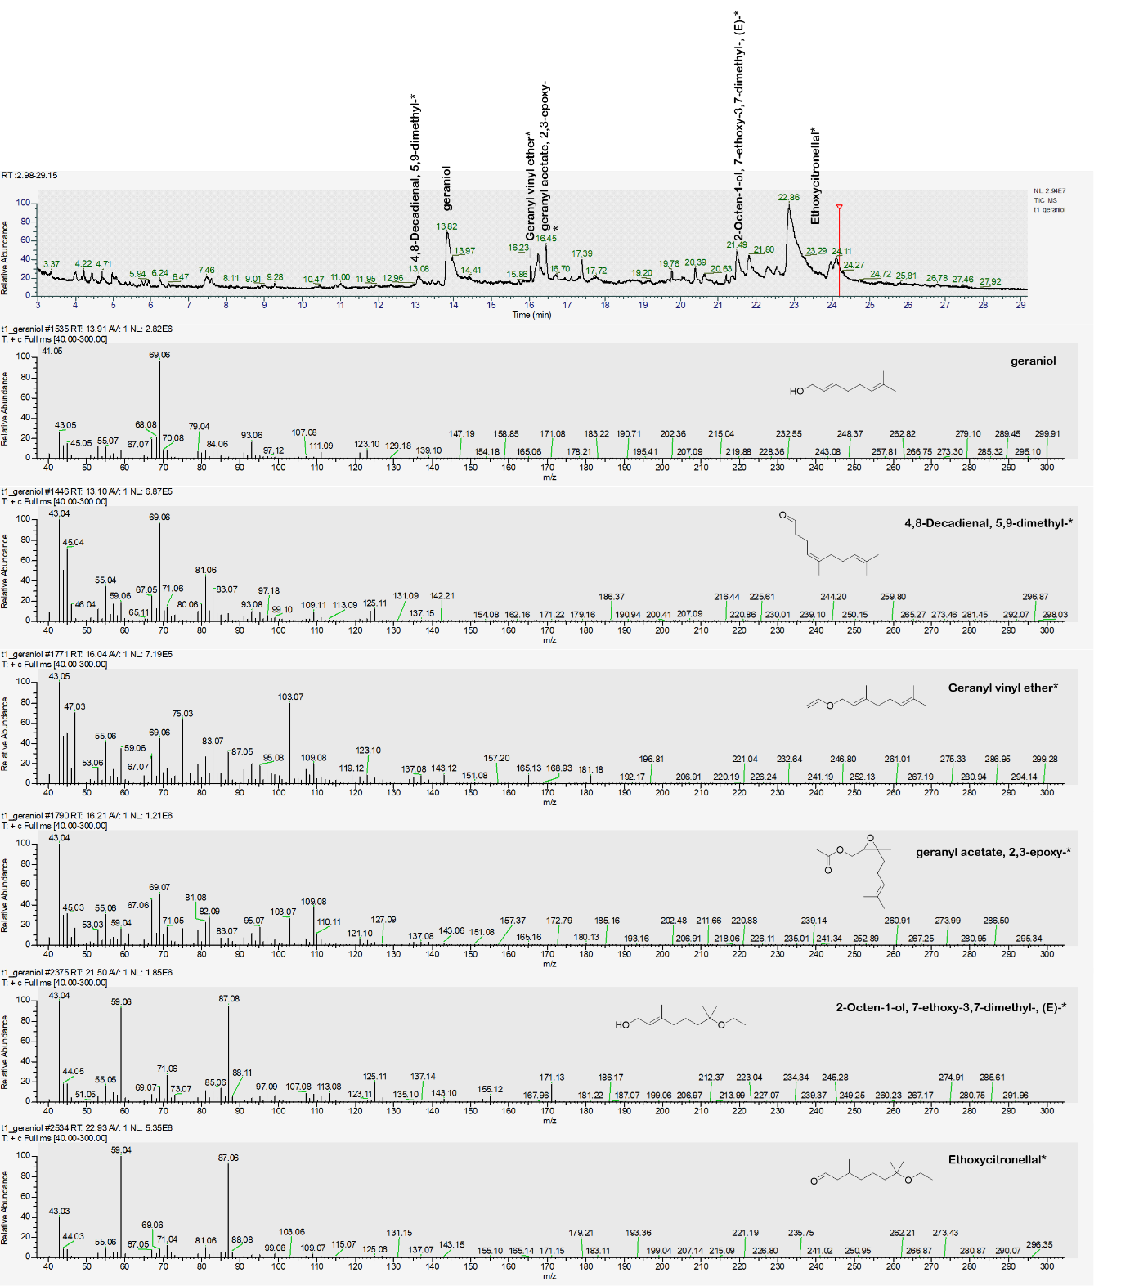
Figure S26: Chromatogram and MS spectrum acquired using GC-MS equipped with a DB-5 MS column of a 1 mg/ml geraniol sample, which was stressed for 192 hours with UV light.

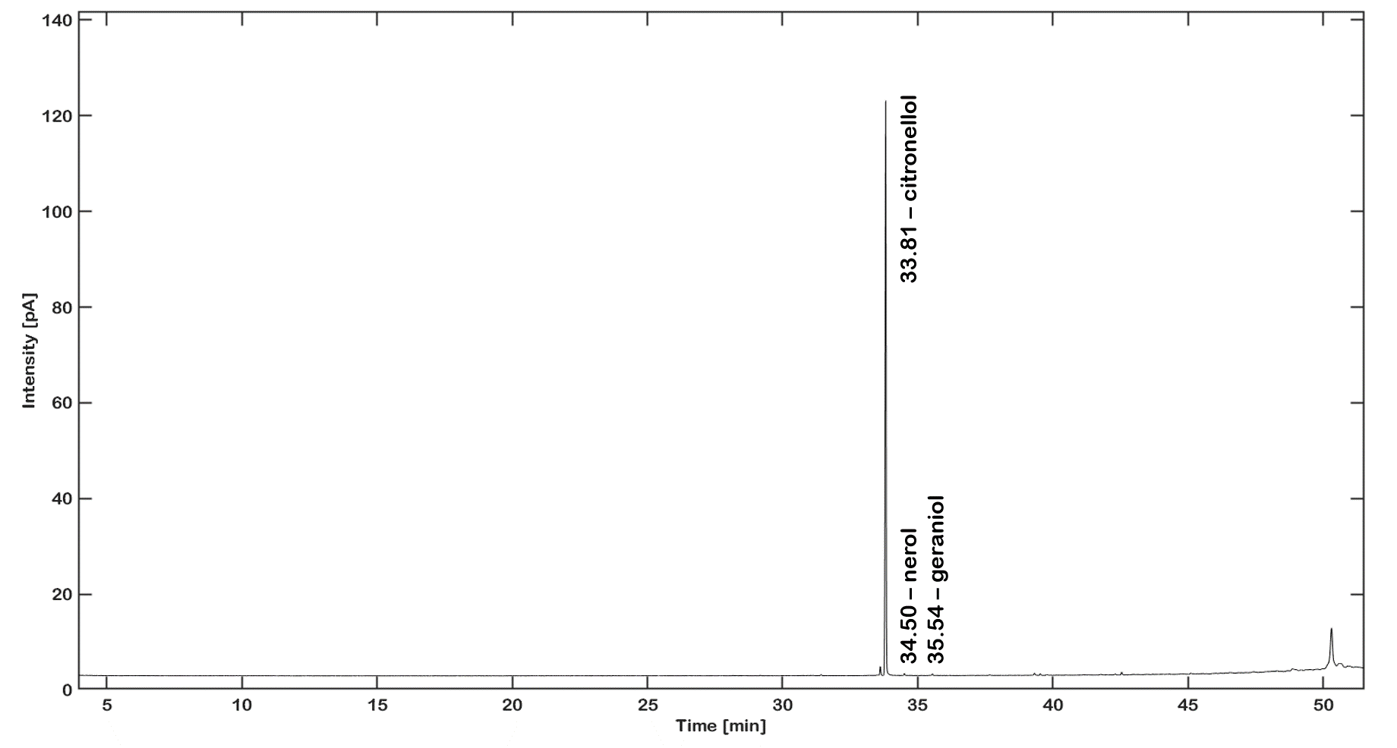
Figure S27: Chromatogram acquired using GC-FID equipped with a BGB-wax column of a 1 mg/ml citronellol sample, which was stressed for 192 hours.
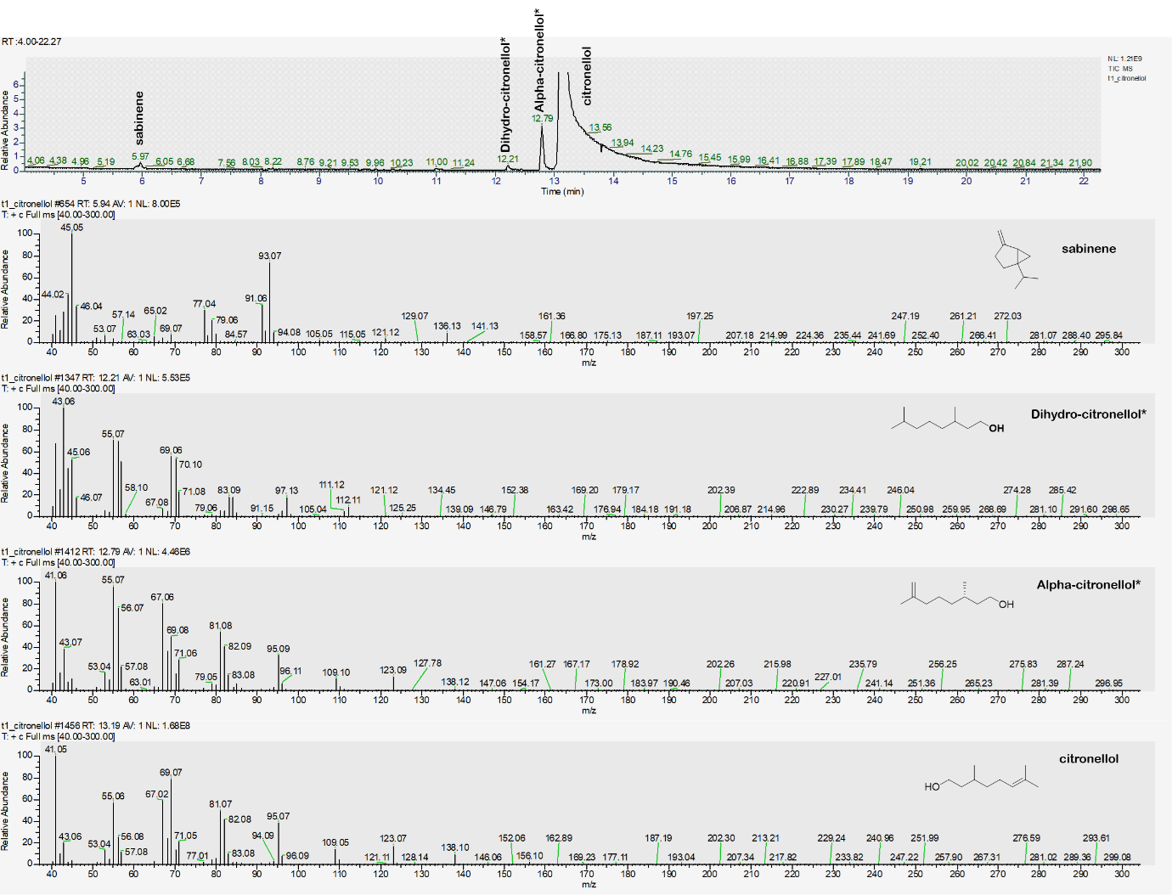
Figure S28: Chromatogram and MS spectrum acquired using GC-MS equipped with a DB-5 MS column of a 1 mg/ml citronellol sample, which was stressed for 192 hours with UV light.
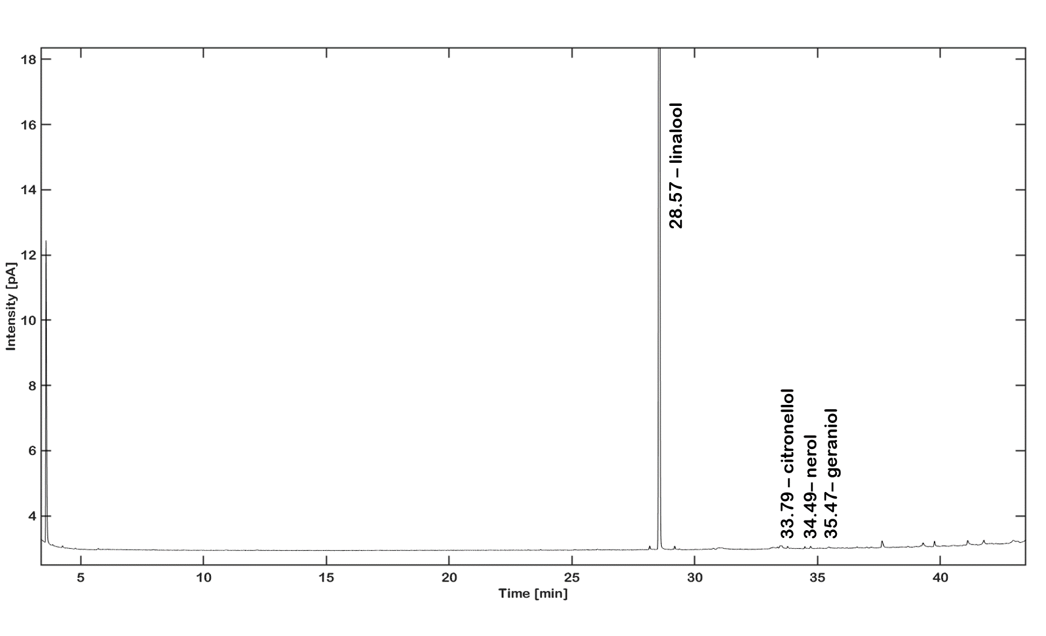
Figure S29: Chromatogram acquired using GC-FID equipped with a BGB-wax column of a 1 mg/ml linalool sample, which was stressed for 192 hours.

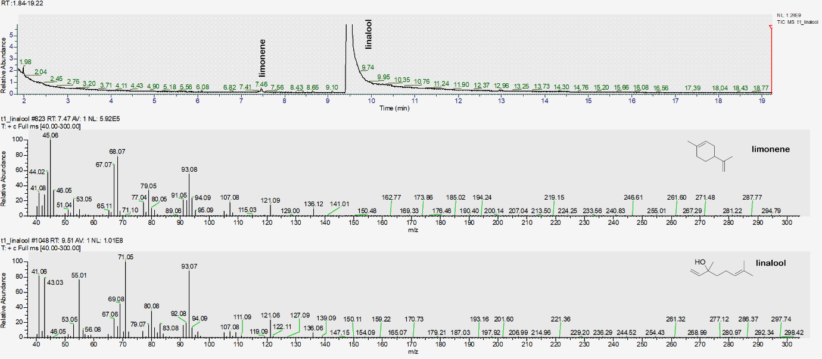
Figure S30: Chromatogram and MS spectrum acquired using GC-MS equipped with a DB-5 MS column of a 1 mg/ml linalool sample, which was stressed for 192 hours with UV light.

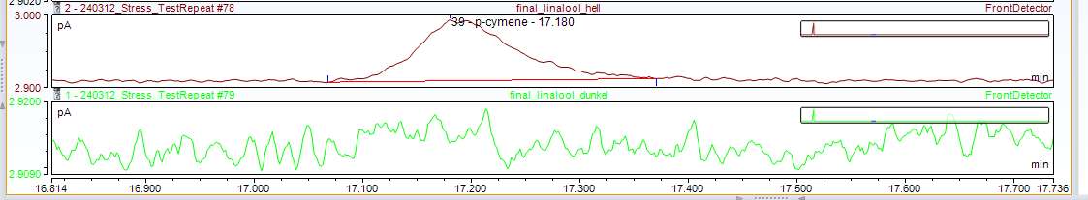
Figure S31: Chromatogram acquired using GC-FID equipped with a BGB-wax column of a 1 mg/ml linalool sample, which was stressed for 336 hours. The above chromatogram presents the linalool sample during UV treatment and the bottom only under heat treatment.

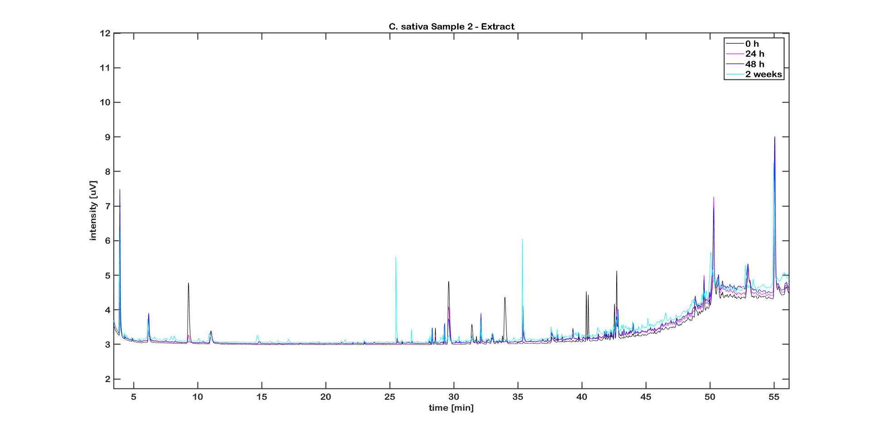
Figure S32: UV treated C. sativa L. sample 2 as an extract. The overlay contains the time points at 0, 24 h, 48 h and 2 weeks of treatment.

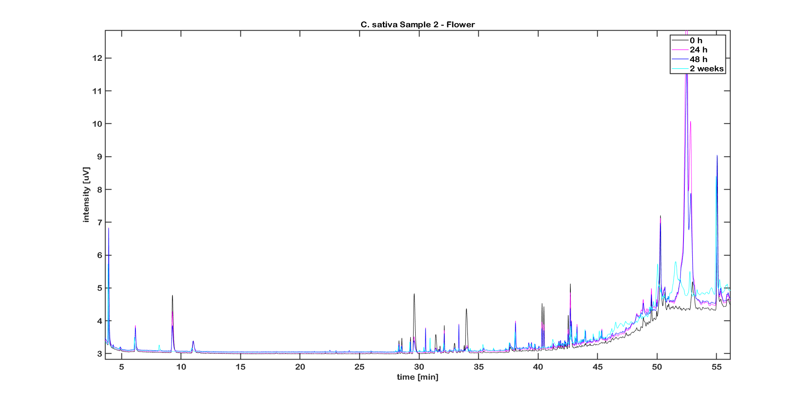
Figure S33: UV treated C. sativa L. sample 2 as a flower. The overlay contains the time points at 0, 24 h, 48 h and 2 weeks of treatment.

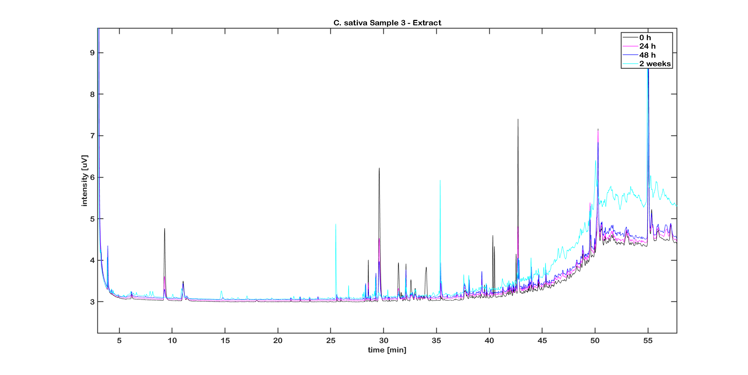
Figure S34: UV treated C. sativa L. sample 3 as an extract. The overlay contains the time points at 0, 24 h, 48 h and 2 weeks of treatment.

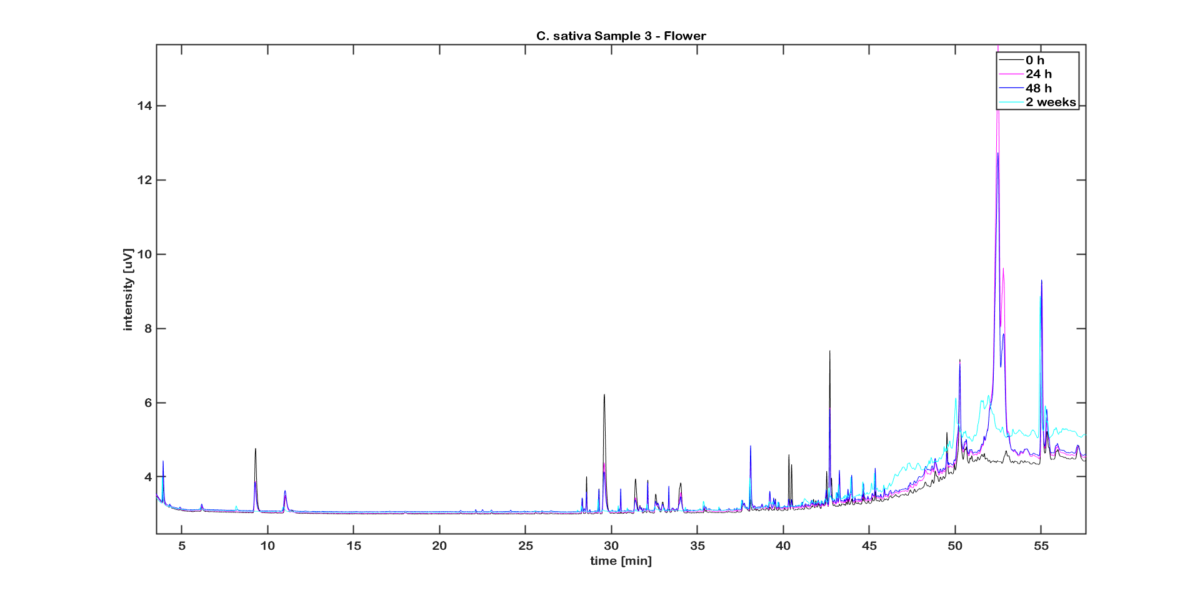
Figure S35: UV treated C. sativa L. sample 3 as a flower. The overlay contains the time points at 0, 24 h, 48 h and 2 weeks of treatment.

GC-FID chromatographic profiles of authentic samples separated on a BGB-178 30% CD capillary column
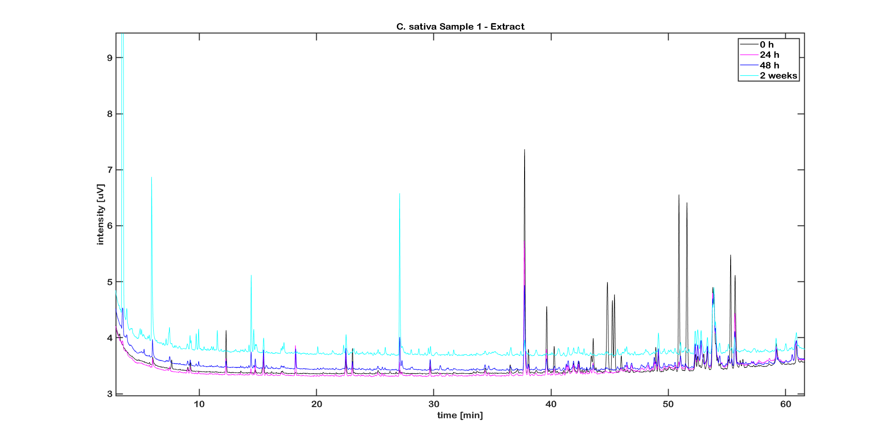
Figure S36: UV treated C. sativa L. sample 1 as an extract. The overlay contains the time points at 0, 24 h, 48 h and 2 weeks of treatment.

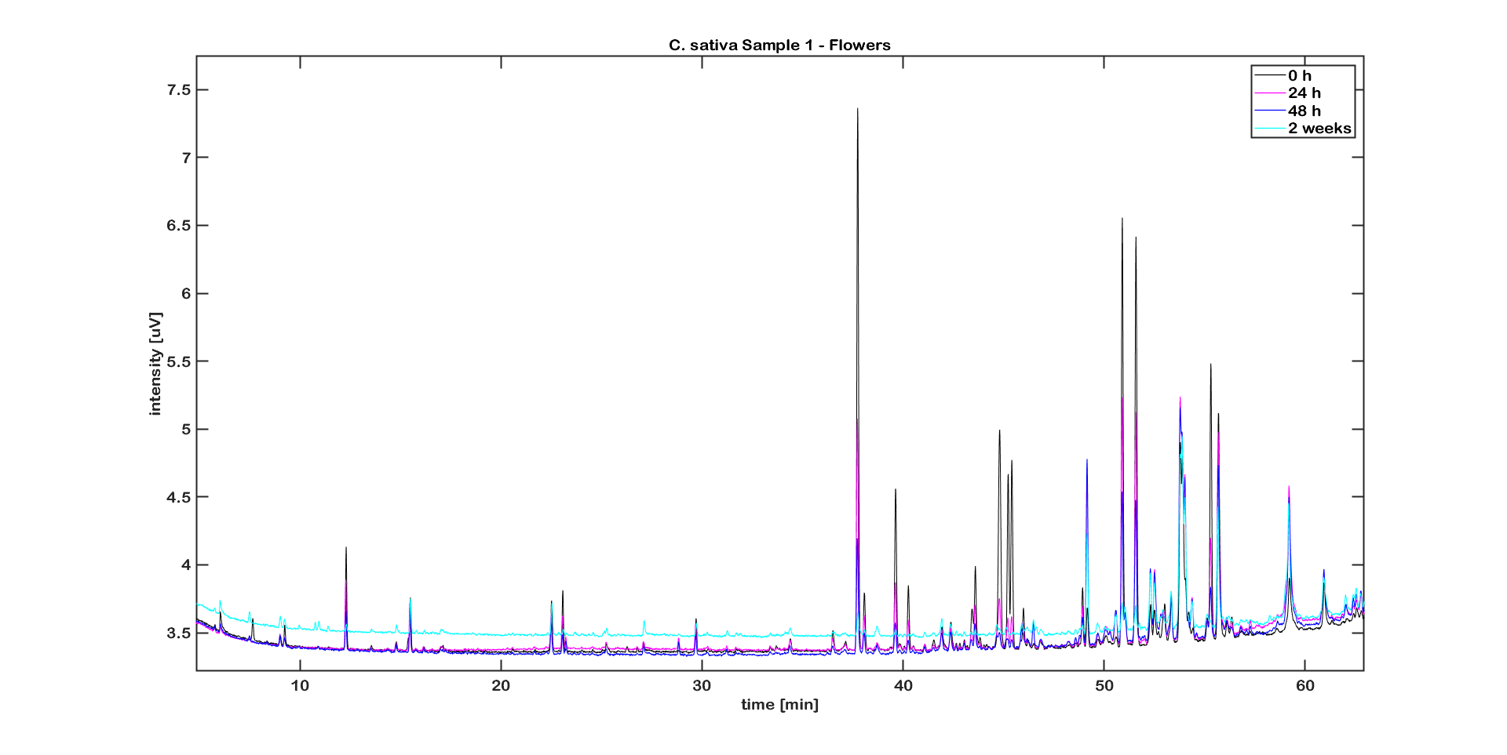
Figure S37: UV treated C. sativa L. sample 1 as a flower. The overlay contains the time points at 0, 24 h, 48 h and 2 weeks of treatment.

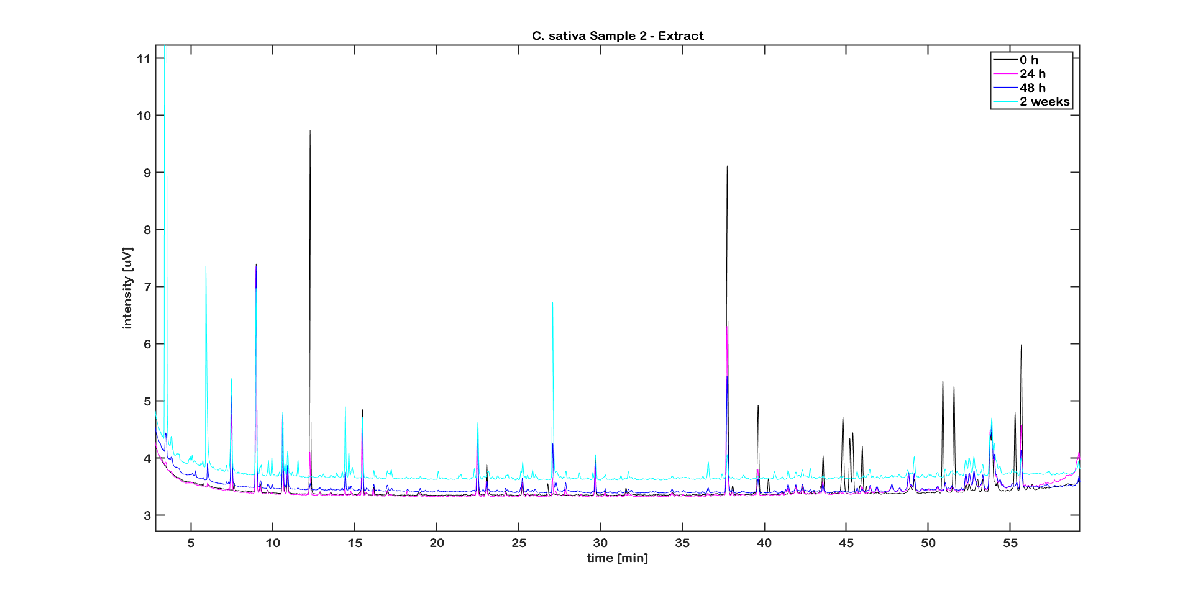
Figure S38: UV treated C. sativa L. sample 2 as an extract. The overlay contains the time points at 0, 24 h, 48 h and 2 weeks of treatment.

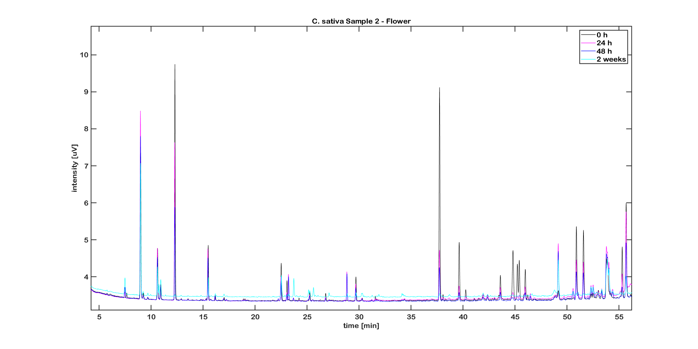
Figure S39: UV treated C. sativa L. sample 2 as a flower. The overlay contains the time points at 0, 24 h, 48 h and 2 weeks of treatment.

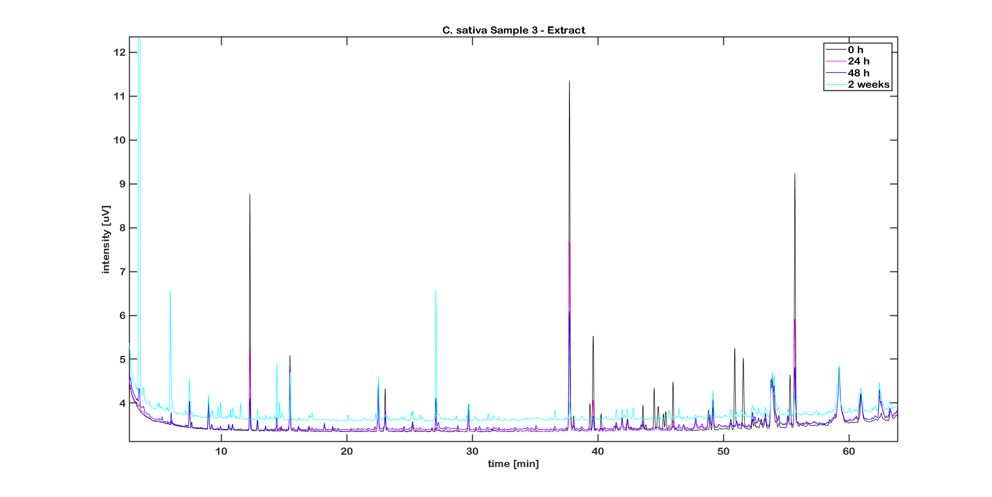
Figure S40: UV treated C. sativa L. sample 3 as an extract. The overlay contains the time points at 0, 24 h, 48 h and 2 weeks of treatment.

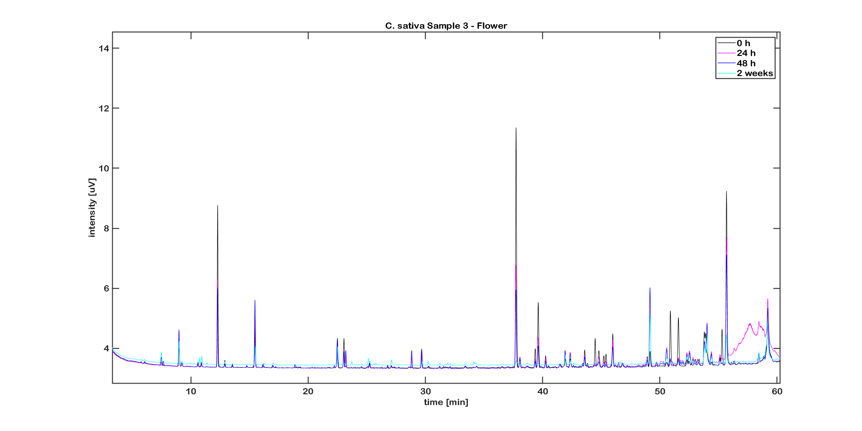
Figure S41: UV treated C. sativa L. sample 3 as a flower. The overlay contains the time points at 0, 24 h, 48 h and 2 weeks of treatment.

GC-FID chromatographic profiles of authentic samples separated on a BGB-176 SE capillary column
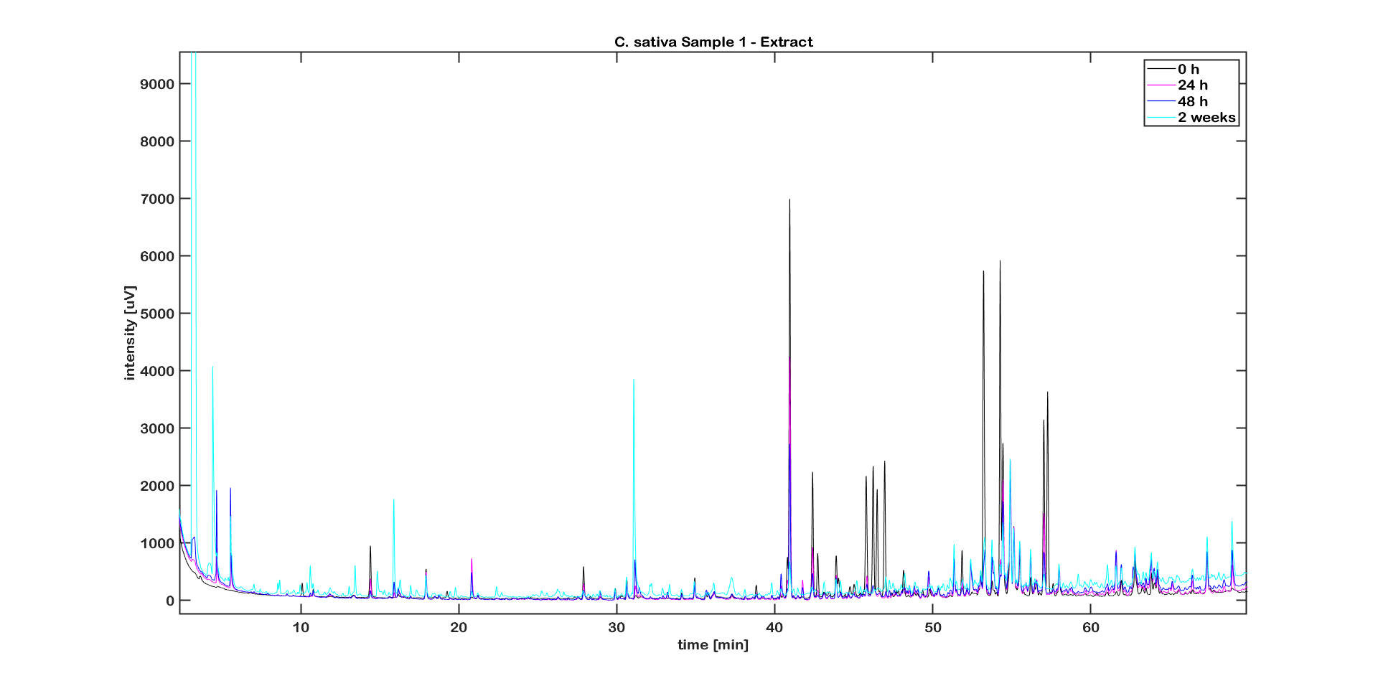
Figure S42: UV treated C. sativa L. sample 1 as an extract. The overlay contains the time points at 0, 24 h, 48 h and 2 weeks of treatment.

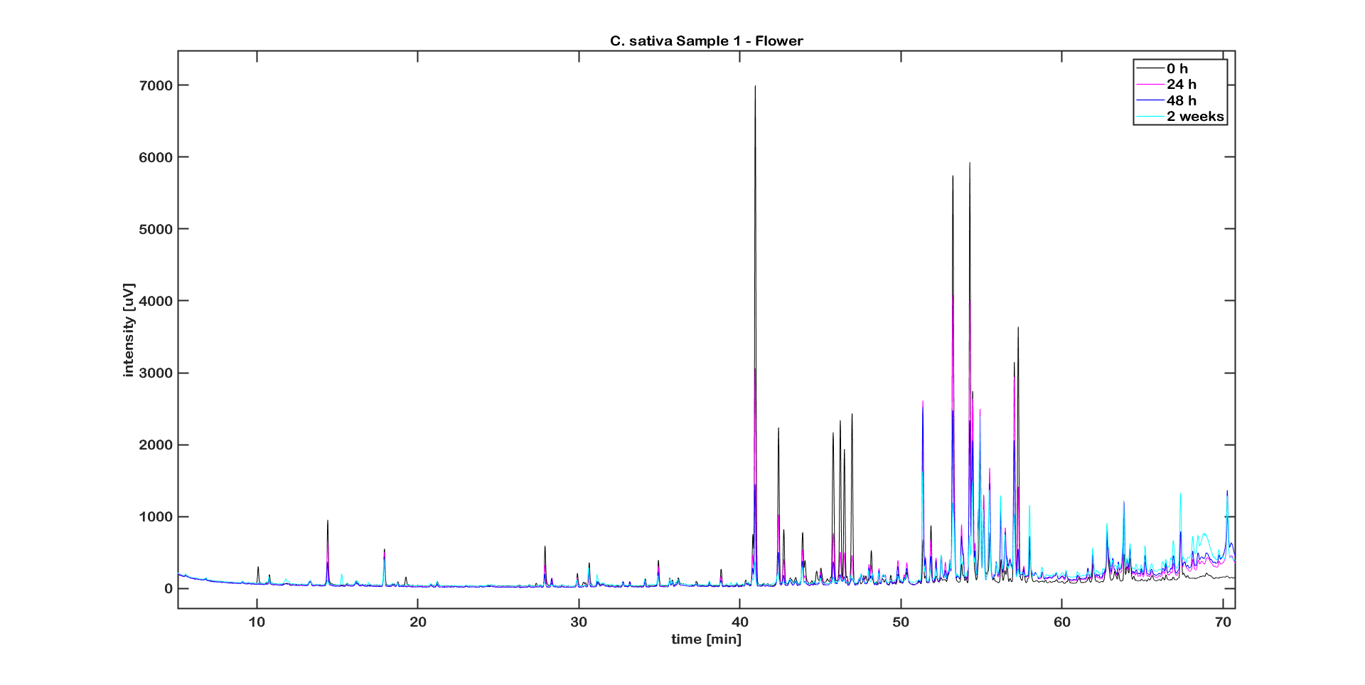
Figure S43: UV treated C. sativa L. sample 1 as a flower. The overlay contains the time points at 0, 24 h, 48 h and 2 weeks of treatment.

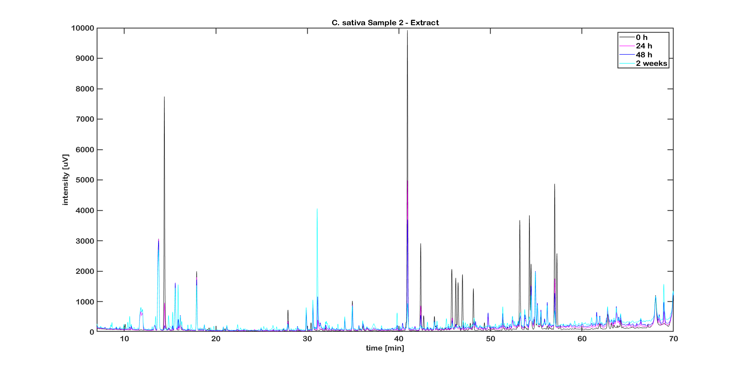
Figure S44: UV treated C. sativa L. sample 2 as an extract. The overlay contains the time points at 0, 24 h, 48 h and 2 weeks of treatment.

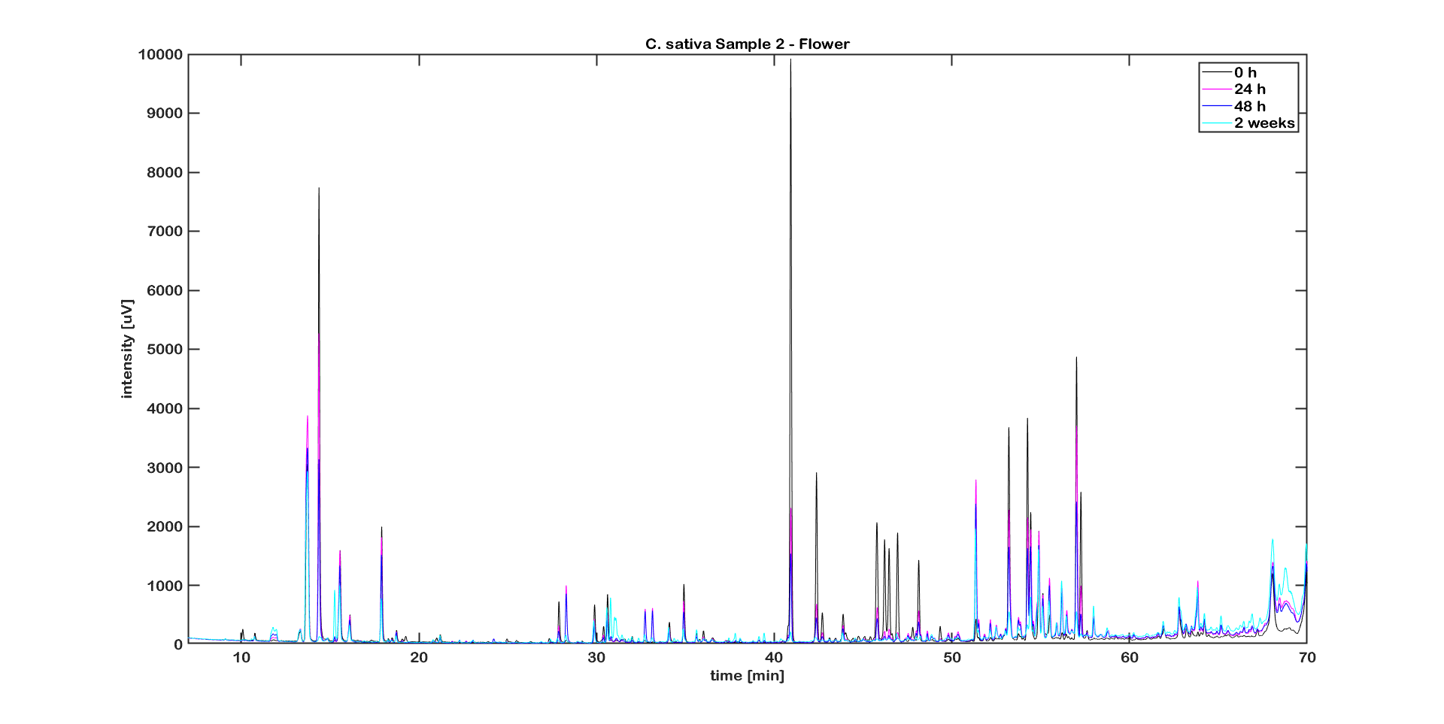
Figure S45: UV treated C. sativa L. sample 2 as a flower. The overlay contains the time points at 0, 24 h, 48 h and 2 weeks of treatment.

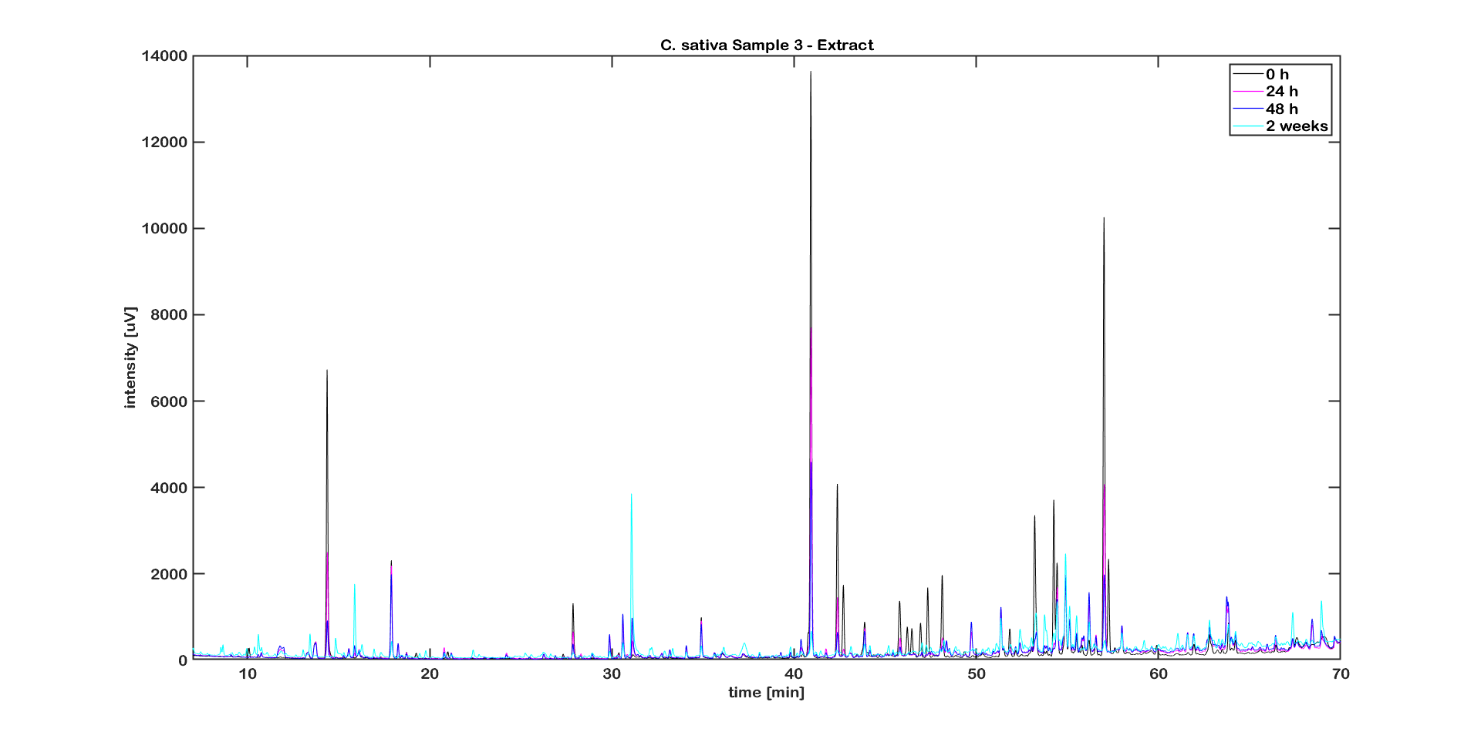
Figure S46: UV treated C. sativa L. sample 3 as an extract. The overlay contains the time points at 0, 24 h, 48 h and 2 weeks of treatment.

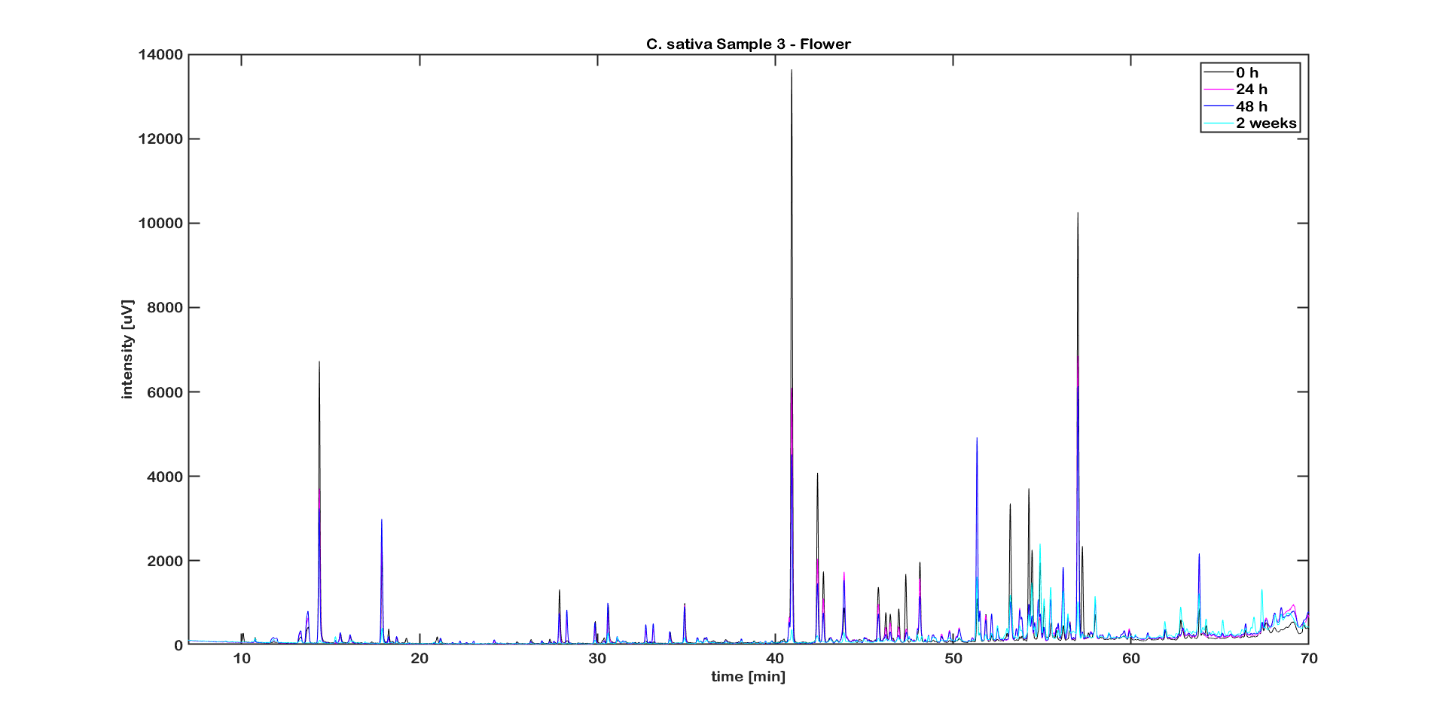
Figure S47: UV treated C. sativa L. sample 3 as a flower. The overlay contains the time points at 0, 24 h, 48 h and 2 weeks of treatment.

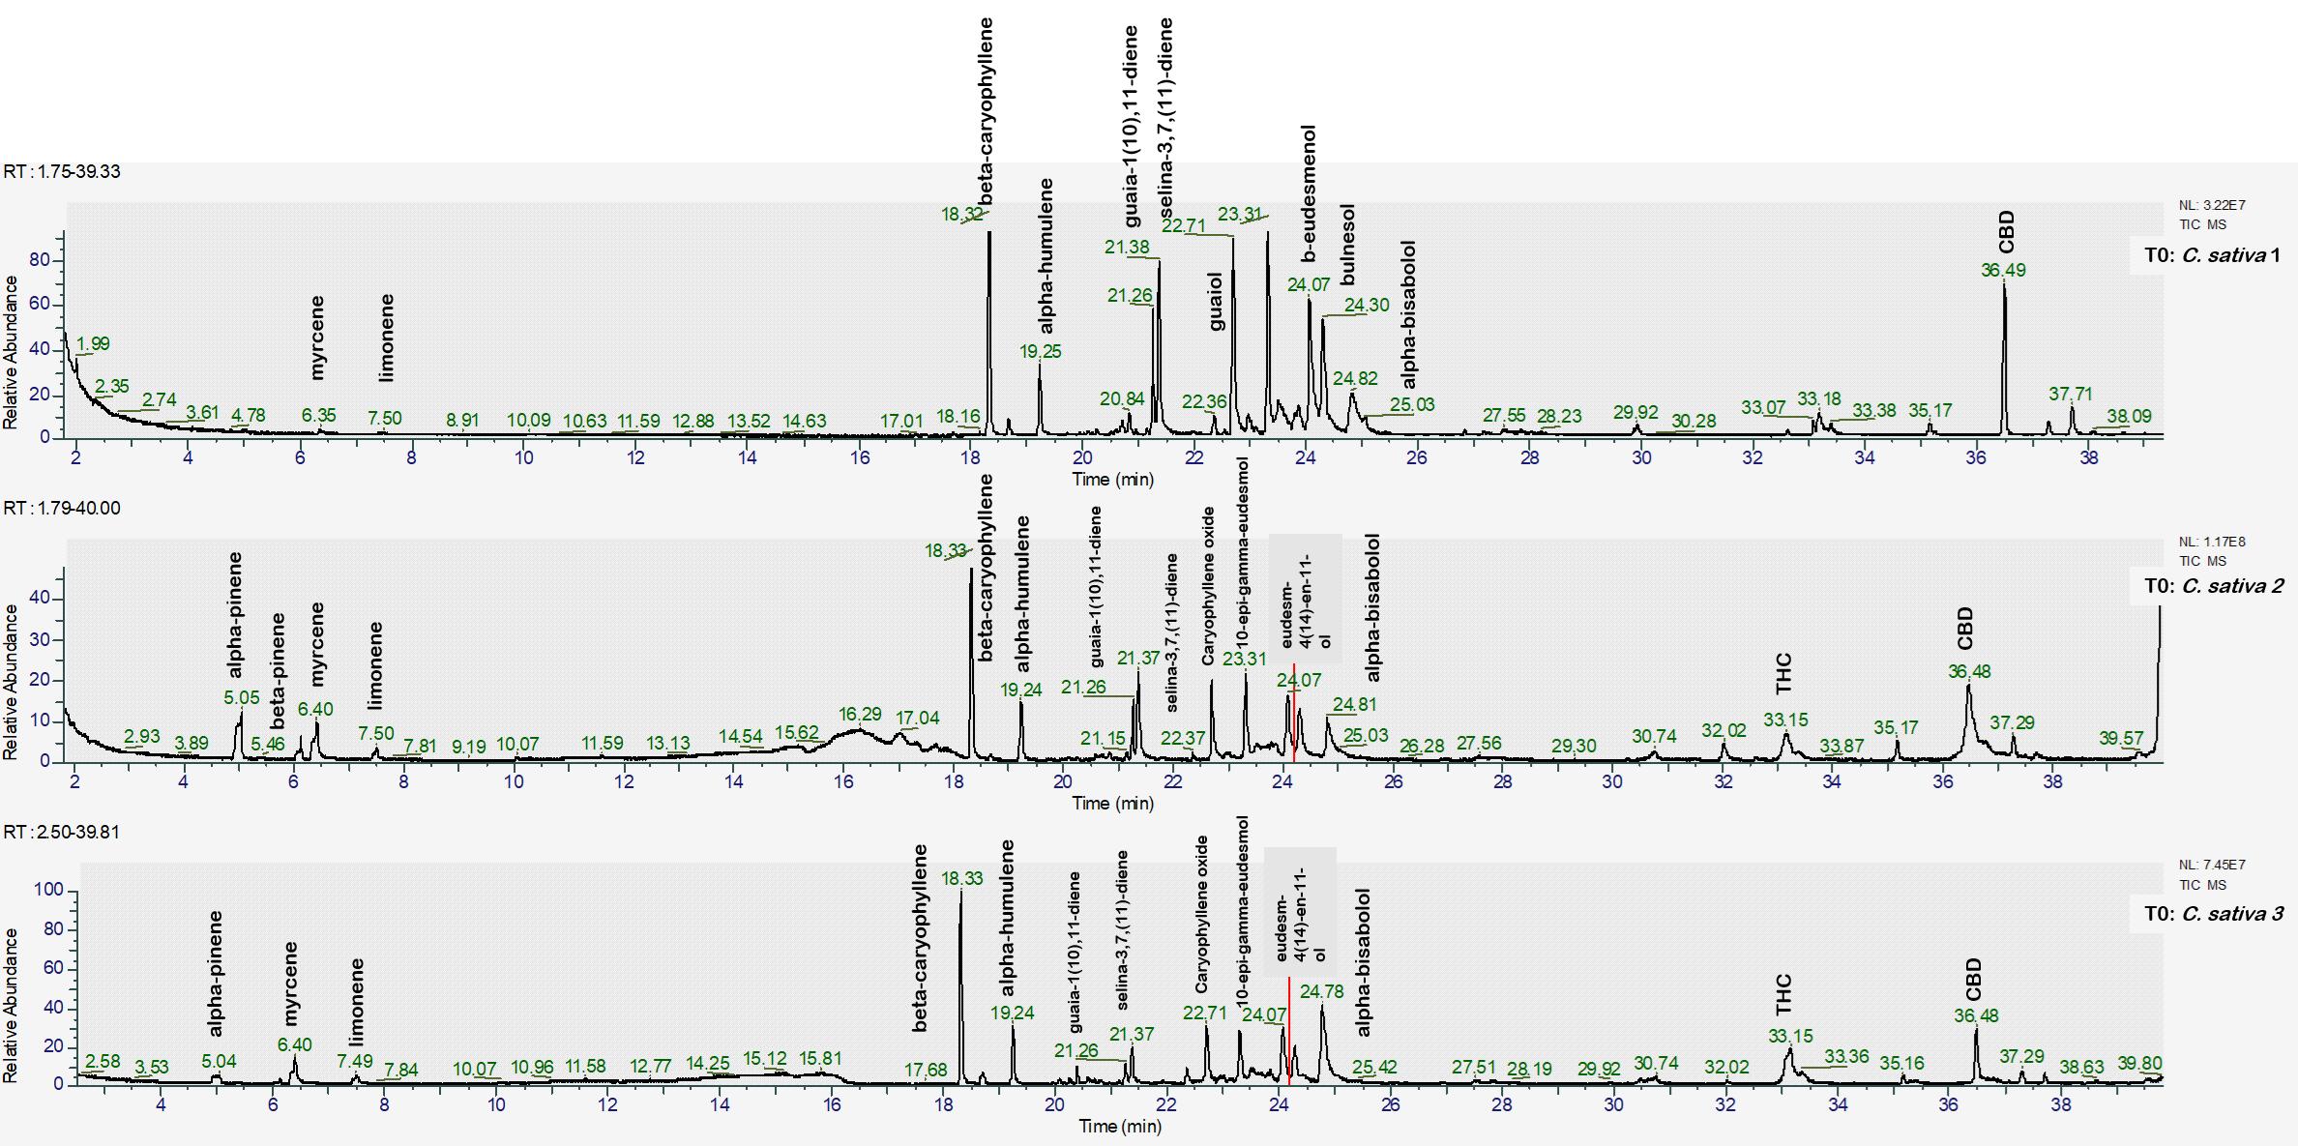
Figure S48: GC-MS chromatographic profile of authentic C. sativa L. samples before stress treatment.

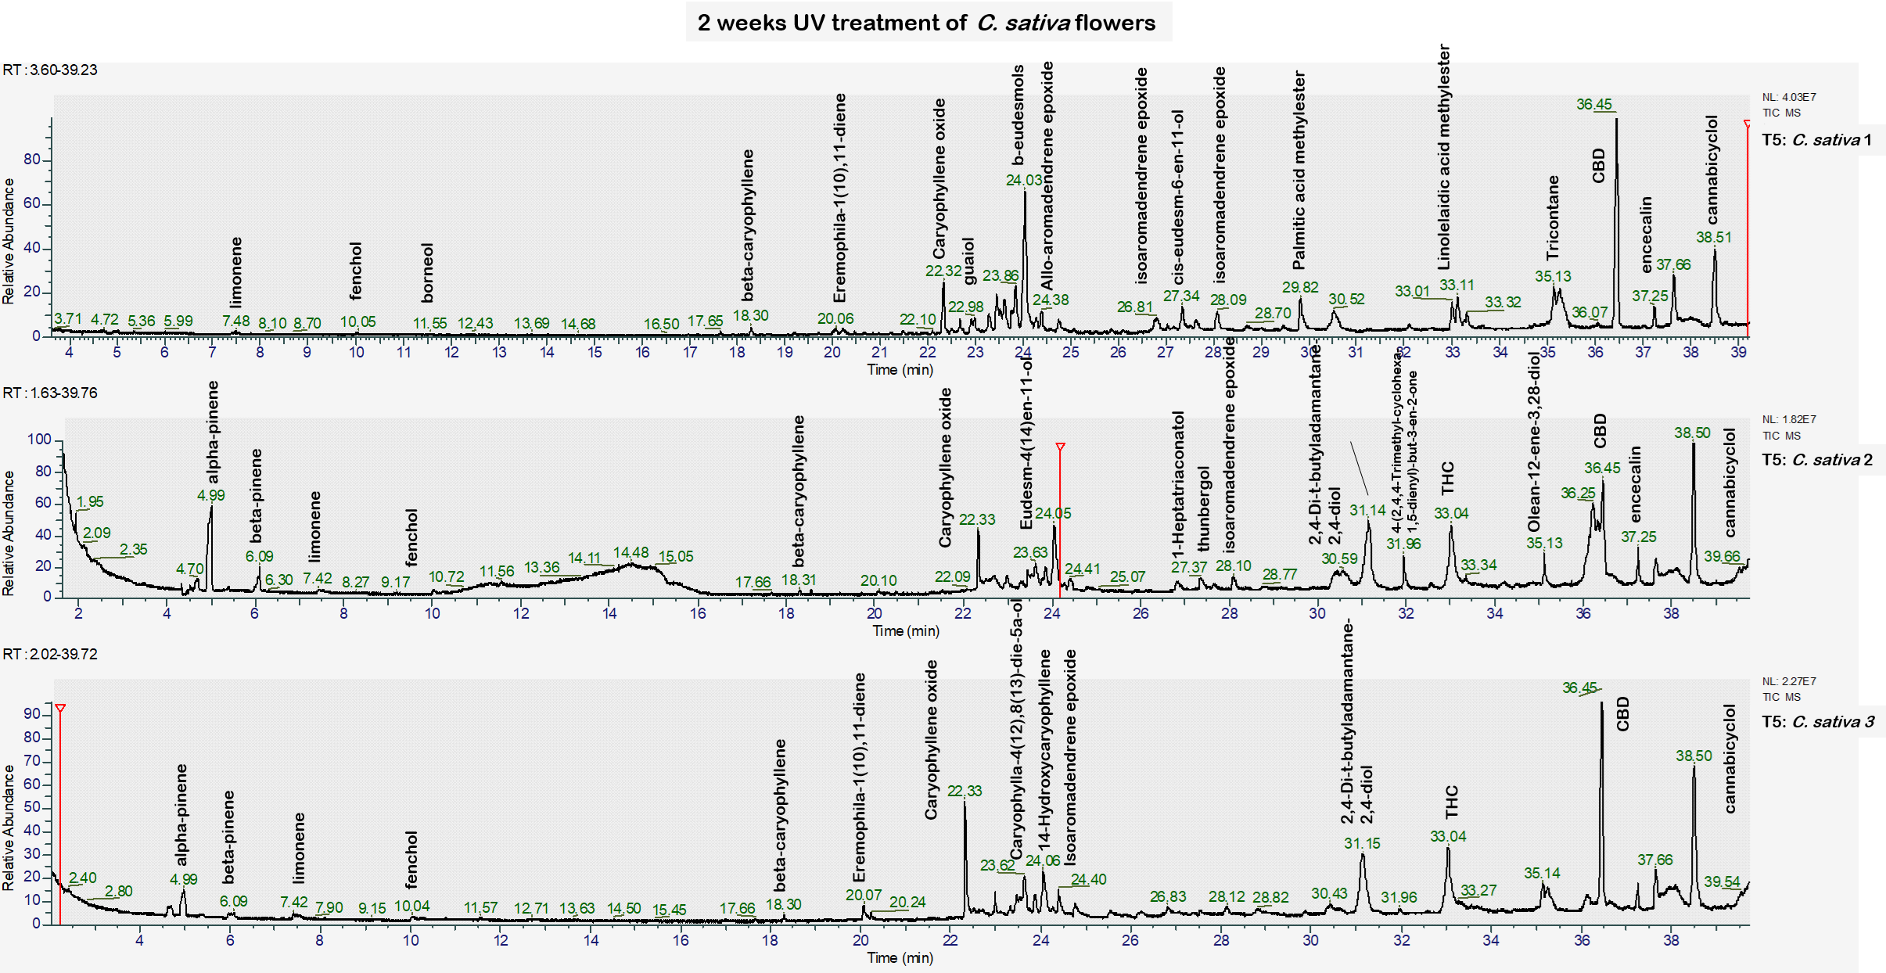
Figure S49: GC-MS chromatographic profile of authentic C. sativa L. flower samples two weeks after stress treatment.

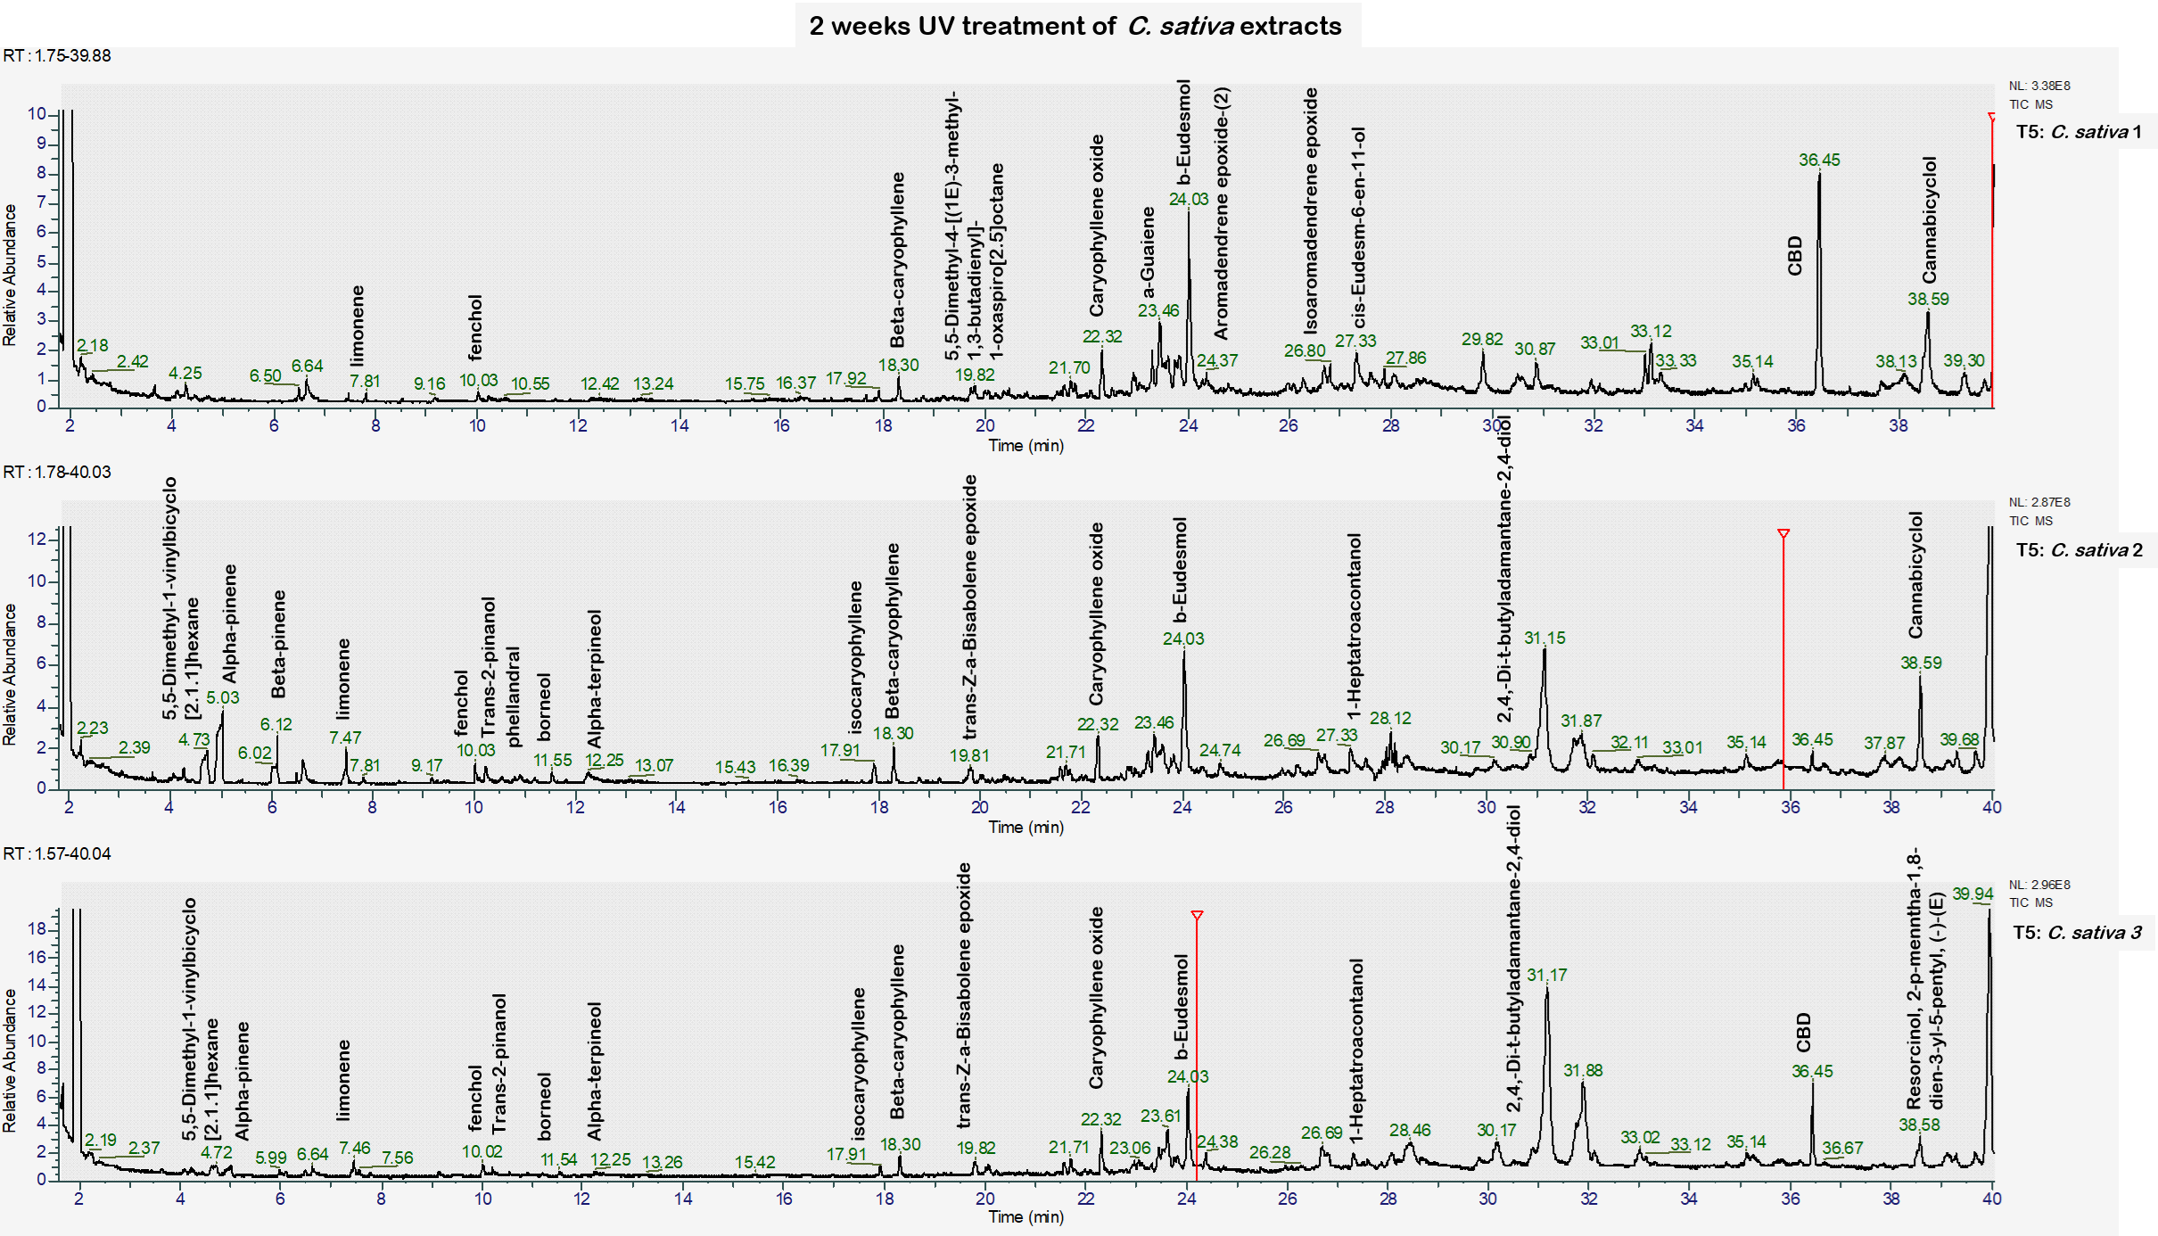
Figure S50: GC-MS chromatographic profile of authentic C. sativa L. extract samples two weeks after stress treatment.

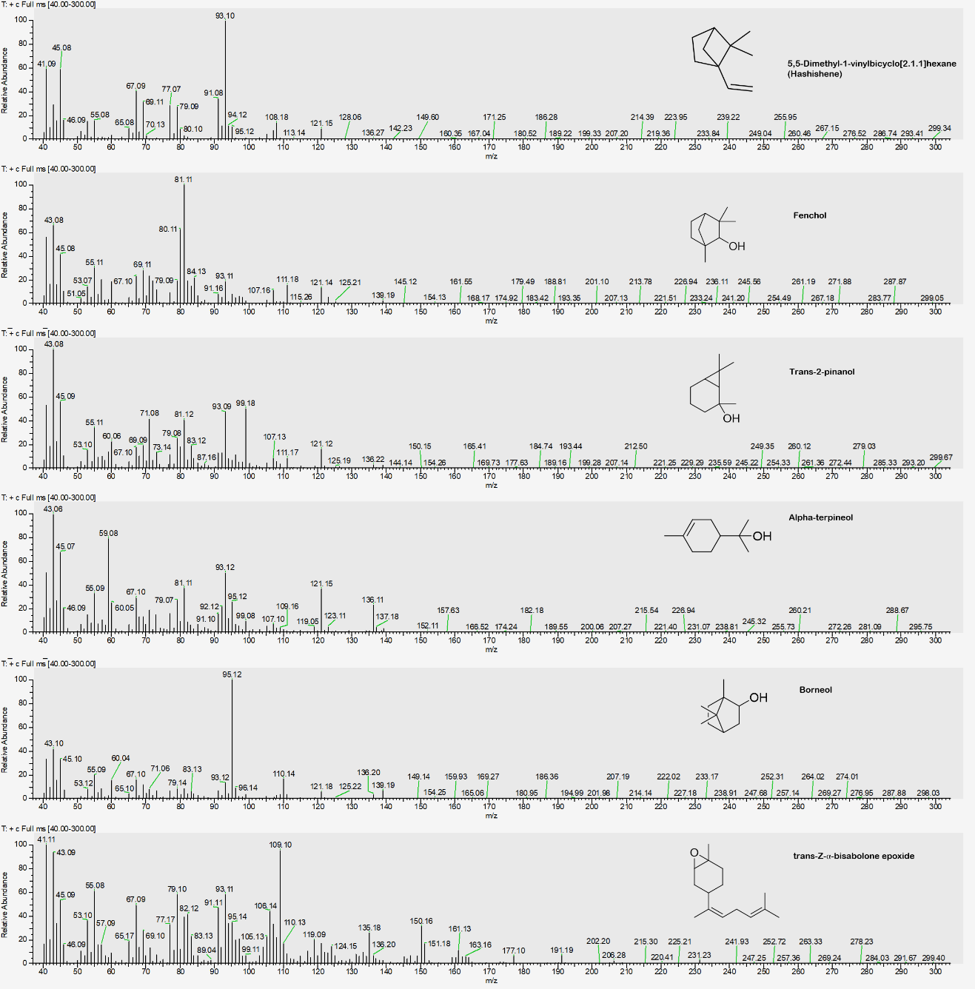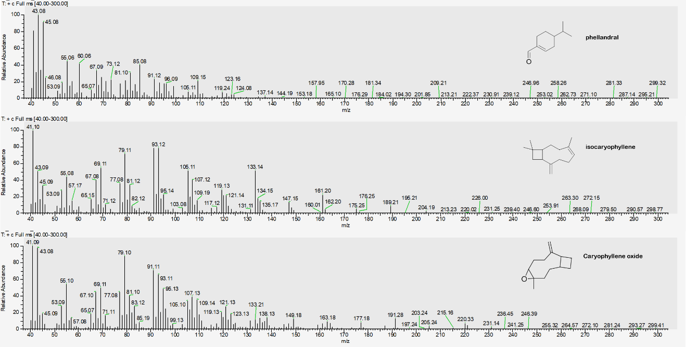
Figure S51: MS spectra of degradation profiles after two weeks after stress treatment.
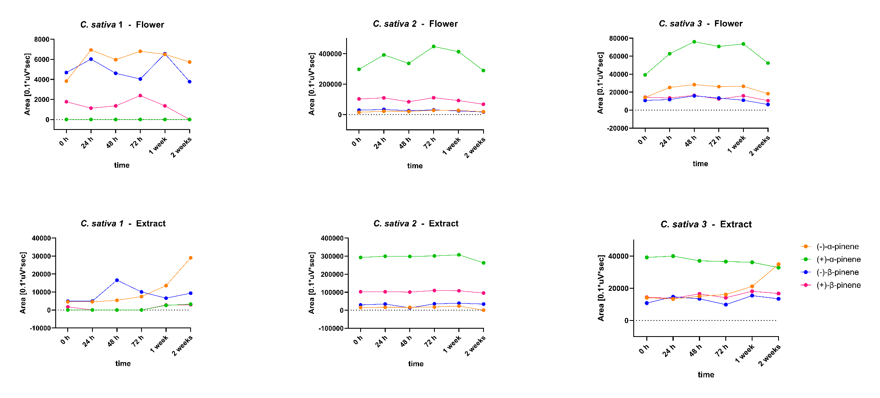
Figure S52: Change of peak areas against time of (-)-α-pinene (orange), (+)-α-pinene (green), (-)-β-pinene (blue) and (+)-β-pinene (pink) after UV treatment. Data was acquired using GC-FID equipped with a BGB 176 SE chiral column. The degradation profile for flowers are presented on top row and for extract on the bottom row.

Table S8: EE [%] for 20 authentic C. sativa L. samples analysed using chiral GC-FID.
 | (+)-α-pinene | (+)-β-pinene | (S)-limonene | (+)-linalool | (-)-citronellol | (-)-camphene | cis-nerolidol 2 | (+)-trans nerolidol | (-)-cis-menthone | Cultivation
C. sativa L. 1 | 82 | 31 | 100 | 100 | n.d. | n.d. | n.d. | n.d. | n.d. | Outdoor
C. sativa L. 2 | -42 | -59 | 93 | 93 | n.d. | 100 | 100 | 100 | 100 | Outdoor
C. sativa L. 3 | 88 | 49 | 89 | 90 | 100 | 100 | n.d. | 100 | 100 | Outdoor
C. sativa L. 4 | 100 | 100 | 88 | 89 | 100 | 100 | n.d. | 100 | 100 | Outdoor
C. sativa L. 5 | 87 | 42 | 89 | 83 | 100 | 100 | n.d. | 100 | 100 | Outdoor
C. sativa L. 6 | 64 | 40 | 84 | 61 | 100 | 100 | n.d. | 100 | n.d. | Outdoor
C. sativa L. 7 | 80 | 6 | 88 | 93 | n.d. | n.d. | n.d. | 100 | n.d. | Indoor
C. sativa L. 8 | -100 | -100 | 93 | 95 | n.d. | 100 | n.d. | 100 | 100 | Indoor
C. sativa L. 9 | 86 | 42 | 89 | 100 | 100 | 44 | n.d. | 100 | 100 | Indoor
C. sativa L. 10 | 83 | 28 | 87 | 90 | 100 | 100 | n.d. | 100 | n.d. | Indoor
C. sativa L. 11 | -100 | -100 | 93 | 93 | n.d. | 100 | n.d. | 100 | n.d. | Indoor
C. sativa L. 12 | 64 | -16 | 96 | 100 | 100 |  | n.d. | 100 | n.d. | Indoor
C. sativa L. 13 | -62 | -53 | 97 | 100 | n.d. | 100 | n.d. | 100 | n.d. | Indoor
C. sativa L. 14 | -100 | -100 | 95 | 98 | n.d. | 100 | n.d. | 100 | n.d. | Indoor
C. sativa L. 15 | -100 | -70 | 92 | 100 | n.d. | 100 | n.d. | 100 | n.d. | Indoor
C. sativa L. 16 | 68 | 6 | 92 | 82 | 100 | 100 | n.d. | n.d. | n.d. | Indoor
C. sativa L. 17 | 83 | 27 | 93 | 88 | 100 | 100 | n.d. | 100 | 100 | Indoor
C. sativa L. 18 | 91 | 50 | 88 | 88 | 100 | 100 | n.d. | 100 | 100 | Greenhouse
C. sativa L. 19 | 85 | 36 | 90 | 87 | 100 | 100 | n.d. | 100 | 100 | Greenhouse
C. sativa L. 20 | 93 | 60 | 85 | 81 | 100 | 100 | n.d. | 100 | n.d. | Greenhouse

Table S9: Enantiomeric ratio for 3 authentic C. sativa L. samples analysed using chiral GC-FID. Undefined is abbreviated as undef and not detected as n.d. The numerator was the analyte in the analyte row.
Enantiomeric ratio of C. sativa L. flowers
Analyte | (+)-α-pinene |  |  | (+)-β-pinene |  |  | (S)-limonene |  |  | (+)-linalool |  |  | (-)-citronellol |  |  | (+/-)-camphene 1 |  |  | (+/-)-cis-nerolidol 2 |  |  | (+/-)-trans nerolidol 2 |  |  | (+/-)-cis-menthone 2
Column | BGB 176 SE |  |  | BGB 176 SE |  |  | BGB 176 SE |  |  | BGB 176 SE |  |  | BGB 176 SE |  |  | BGB 178 30% CD |  |  | BGB 178 30% CD |  |  | BGB 178 30% CD |  |  | BGB 178 30% CD
Sample  Cond. | 1  OD | 2  ID | 3  ID | 1  OD | 2  ID | 3  ID | 1  OD | 2  ID | 3  ID | 1  OD | 2  ID | 3  ID | 1  OD | 2  ID | 3  ID | 1  OD | 2  ID | 3  ID | 1  OD | 2  ID | 3  ID | 1  OD | 2  ID | 3  ID | 1  OD | 2  ID | 3  ID
0 h | 0 | 19.75 | 2.77 | 0.38 | 3.51 | 1.34 | 13.24 | 9.85 | 16.14 | 15.09 | 10.09 | 14.87 | n.d. | Undef | Undef | Undef | 2.67 | Undef | n.d. | Undef | Undef | Undef | Undef | Undef | Undef | Undef | Undef
24 h | 0 | 17.97 | 2.49 | 0.19 | 3.23 | 1.15 | 7.64 | 9.49 | 11.95 | Undef | 8.38 | 16.77 | 0 | Undef | Undef | Undef | 2.00 | n.d. | 0 | Undef | Undef | Undef | n.d. | Undef | Undef | Undef | Undef
48 h | 0.23 | 16.39 | 2.68 | 0.29 | 3.25 | 1.04 | 9.04 | 8.98 | 16.89 | Undef | Undef | Undef | 0 | Undef | Undef | Undef | 1.75 | Undef | 0 | Undef | Undef | Undef | n.d. | Undef | Undef | Undef | Undef
72 h | 0 | 16.24 | 2.71 | 0.59 | 3.62 | 0.92 | 8.37 | 2.86 | 16.06 | Undef | Undef | 15.90 | Undef | Undef | Undef | Undef | 1.57 | Undef | Undef | Undef | Undef | Undef | n.d. | n.d. | Undef | Undef | Undef
1 week | 0 | 15.19 | 2.77 | 0.21 | 3.77 | 1.45 | 12.03 | 10.24 | 17.78 | Undef | Undef | Undef | n.d. | Undef | Undef | Undef | 1.57 | Undef | n.d. | Undef | Undef | Undef | n.d. | n.d. | Undef | Undef | n.d.
2 weeks | 0 | 15.28 | 2.86 | 0 | 3.88 | 1.68 | 11.34 | 6.99 | 14.21 | Undef | Undef | Undef | n.d. | Undef | Undef | Undef | 1.67 | Undef | n.d. | Undef | Undef | Undef | n.d. | n.d. | Undef | Undef | n.d.
Enantiomeric ratio of C. sativa L. extracts
Analyte | (+)-α-pinene | (+)-β-pinene | (S)-limonene | (+)-linalool | (-)-citronellol | (+/-)-camphene 1 | (+/-)-cis-nerolidol 2 | (+/-)-trans nerolidol 2 | (+/-)-cis-menthone 2

Column | BGB 176 SE |  |  | BGB 176 SE |  |  | BGB 176 SE |  |  | BGB 176 SE |  |  | BGB 176 SE |  |  | BGB 178 30% CD |  |  | BGB 178 30% CD |  |  | BGB 178 30% CD |  |  | BGB 178 30% CD
Sample  Cond. | 1  OD | 2  ID | 3  ID | 1  OD | 2  ID | 3  ID | 1  OD | 2  ID | 3  ID | 1  OD | 2  ID | 3  ID | 1  OD | 2  ID | 3  ID | 1  OD | 2  ID | 3  ID | 1  OD | 2  ID | 3  ID | 1  OD | 2  ID | 3  ID | 1  OD | 2  ID | 3  ID
0 h | 0 | 19.75 | 2.8 | 0.4 | 3.51 | 1.3 | 13.2 | 9.85 | 16.14 | 15.09 | 10.09 | 14.87 | n.d. | Undef | Undef | Undef | 2.67 | Undef | n.d. | Undef | Undef | Undef | Undef | Undef | Undef | Undef | Undef
24 h | 0 | 18.11 | 3.00 | 0 | 2.99 | 0.94 | 8.08 | 10.45 | 16.00 | Undef | Undef | Undef | 0 | Undef | Undef | Undef | 2.50 | Undef | 0 | Undef | Undef | 1.07 | n.d. | Undef | Undef | Undef | Undef
48 h | 0 | 18.47 | 2.47 | 0 | 7.79 | 1.23 | 5.14 | 9.26 | 17.55 | 2.56 | Undef | Undef | 0 | Undef | Undef | Undef | 1.75 | Undef | 0 | Undef | Undef | 0.39 | Undef | Undef | Undef | Undef | Undef
72 h | 0 | 16.86 | 2.27 | 0 | 3.10 | 1.43 | 8.30 | 10.99 | 15.77 | 4.04 | Undef | Undef | n.d. | Undef | Undef | 1.43 | 1.08 | 1.60 | n.d. | Undef | Undef | 0.35 | Undef | n.d. | Undef | Undef | Undef
1 week | 0.19 | 13.30 | 1.71 | 0.42 | 2.78 | 1.18 | 7.72 | 8.75 | 12.93 | Undef | Undef | Undef | n.d. | Undef | Undef | 0.47 | 0.85 | 0.43 | n.d. | Undef | Undef | n.d. | Undef | n.d. | Undef | Undef | n.d.
2 weeks | 0.11 | undef | 0.94 | 0.32 | 2.81 | 1.25 | Undef | 8.70 | 17.41 | Undef | Undef | Undef | n.d. | Undef | Undef | 0.77 | 1.14 | 0.43 | n.d. | Undef | Undef | n.d. | Undef | n.d. | Undef | Undef | n.d.

